|  |  |
| --- | --- |
|  | МИНИСТЕРСТВО ОБРАЗОВАНИЯ И НАУКИ РЕСПУБЛИКИ ТАТАРСТАН **Государственное автономное профессиональное образовательное учреждение** **«ЗЕЛЕНОДОЛЬСКИЙ МЕХАНИЧЕСКИЙ КОЛЛЕДЖ»** (ГАПОУ «ЗМК») |

**09.02.07 «Информационные системы и программирование»**

# **МДК 07.01. УПРАВЛЕНИЕ И АВТОМАТИЗАЦИЯ БАЗ ДАННЫХ**

**Отчет о практических работах**

**Исполнитель**: Назаров Михаил Александрович

**Группа**: 227

**Преподаватель:** Алемасов Евгений Павлович

**Дата сдачи** 04.11.2024 **Оценка** ____________

**Подпись преподавателя**  _______________________

**ЗЕЛЕНОДОЛЬСК – 2024**

**Работа №4. Нормализация.Связи в таблицах.**

**Задание 1:**

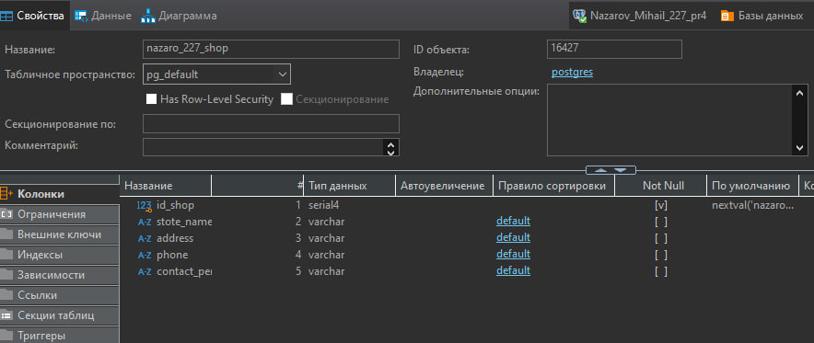

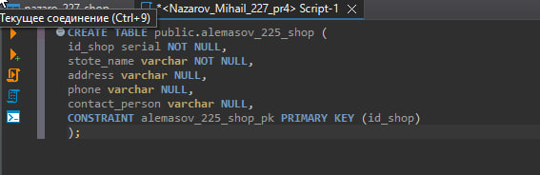

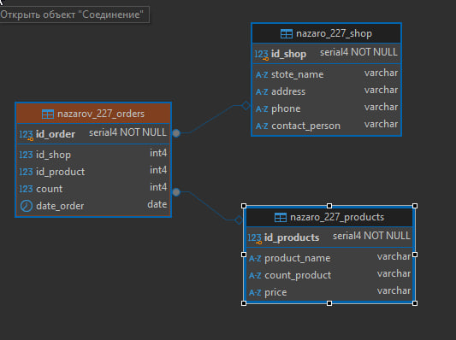

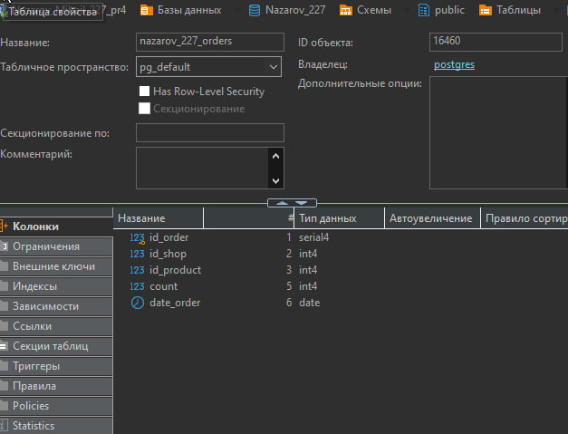

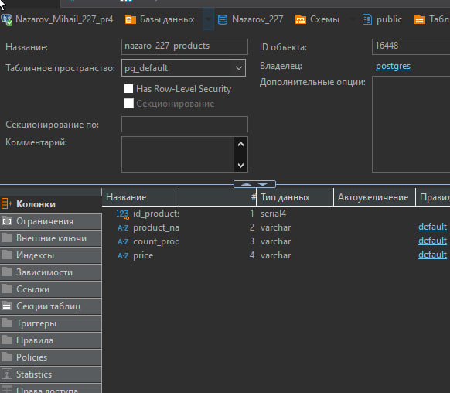

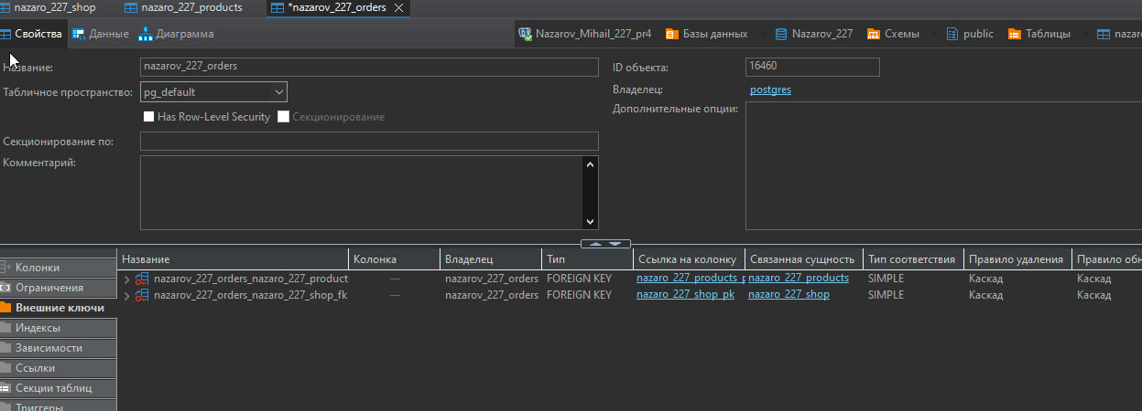

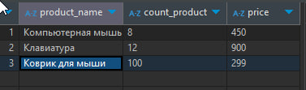

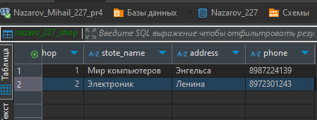

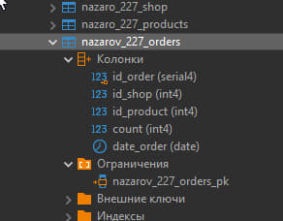

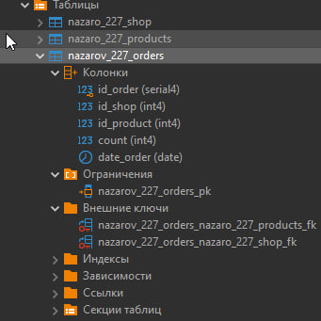

-- DROP SCHEMA public;

CREATE SCHEMA public AUTHORIZATION pg_database_owner;

COMMENT ON SCHEMA public IS 'standard public schema';

-- DROP SEQUENCE doctor_id_doctor_seq;

CREATE SEQUENCE doctor_id_doctor_seq

INCREMENT BY 1

MINVALUE 1

MAXVALUE 2147483647

START 1

CACHE 1

NO CYCLE;

-- Permissions

ALTER SEQUENCE doctor_id_doctor_seq OWNER TO postgres;

GRANT ALL ON SEQUENCE doctor_id_doctor_seq TO postgres;

-- DROP SEQUENCE patients_id_patient_seq;

CREATE SEQUENCE patients_id_patient_seq

INCREMENT BY 1

MINVALUE 1

MAXVALUE 2147483647

START 1

CACHE 1

NO CYCLE;

-- Permissions

ALTER SEQUENCE patients_id_patient_seq OWNER TO postgres;

GRANT ALL ON SEQUENCE patients_id_patient_seq TO postgres;

-- DROP SEQUENCE reception_id_reception_seq;

CREATE SEQUENCE reception_id_reception_seq

INCREMENT BY 1

MINVALUE 1

MAXVALUE 9223372036854775807

START 1

CACHE 1

NO CYCLE;

-- Permissions

ALTER SEQUENCE reception_id_reception_seq OWNER TO postgres;

GRANT ALL ON SEQUENCE reception_id_reception_seq TO postgres;

-- public.nazaro_227_shop определение

-- Drop table

-- DROP TABLE nazaro_227_shop;

CREATE TABLE nazaro_227_shop (

id_shop serial4 NOT NULL,

stote_name varchar NULL,

address varchar NULL,

phone varchar NULL,

contact_person varchar NULL,

CONSTRAINT nazaro_227_shop_pk PRIMARY KEY (id_shop)

);

-- Permissions

ALTER TABLE nazaro_227_shop OWNER TO postgres;

GRANT ALL ON TABLE nazaro_227_shop TO postgres;

-- public.nazaro_227_products определение

-- Drop table

-- DROP TABLE nazaro_227_products;

CREATE TABLE nazaro_227_products (

id_products serial4 NOT NULL,

product_name varchar NULL,

count_product varchar NULL,

price varchar NULL,

CONSTRAINT nazaro_227_products_pk PRIMARY KEY (id_products)

);

-- Permissions

ALTER TABLE nazaro_227_products OWNER TO postgres;

GRANT ALL ON TABLE nazaro_227_products TO postgres;

-- public.nazarov_227_orders определение

-- Drop table

-- DROP TABLE nazarov_227_orders;

CREATE TABLE nazarov_227_orders (

id_order serial4 NOT NULL,

id_shop int4 NULL,

id_product int4 NULL,

count int4 NULL,

date_order date NULL,

CONSTRAINT nazarov_227_orders_pk PRIMARY KEY (id_order),

CONSTRAINT nazarov_227_orders_nazaro_227_products_fk FOREIGN KEY (id_product) REFERENCES nazaro_227_products(id_products) ON DELETE CASCADE ON UPDATE CASCADE,

CONSTRAINT nazarov_227_orders_nazaro_227_shop_fk FOREIGN KEY (id_shop) REFERENCES nazaro_227_shop(id_shop) ON DELETE CASCADE ON UPDATE CASCADE

);

-- Permissions

ALTER TABLE nazarov_227_orders OWNER TO postgres;

GRANT ALL ON TABLE nazarov_227_orders TO postgres;

-- Permissions

GRANT ALL ON SCHEMA public TO pg_database_owner;

GRANT USAGE ON SCHEMA public TO public;

INSERT INTO public.nazaro_227_shop (id_shop,stote_name,address,phone,contact_person) VALUES

(1,'Мир компьютеров','Энгельса','8987224139','Иванов Павел'),

(2,'Электроник','Ленина','8972301243','Васильев Алексей');

INSERT INTO public.nazaro_227_products (id_products,product_name,count_product,price) VALUES

(1,'Компьютерная мышь','8','450'),

(2,'Клавиатура','12','900'),

(3,'Коврик для мыши','100','299');

INSERT INTO public.nazarov_227_orders (id_order,id_shop,id_product,count,date_order) VALUES

(1,1,2,1,'2024-10-27'),

(2,2,3,1,'2024-10-27');

Задание 2

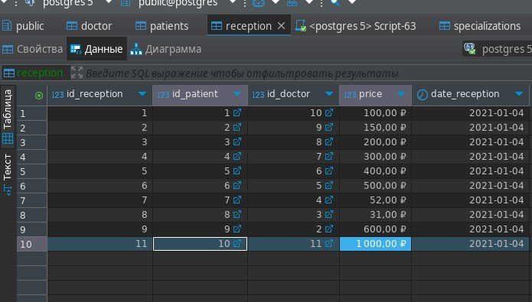

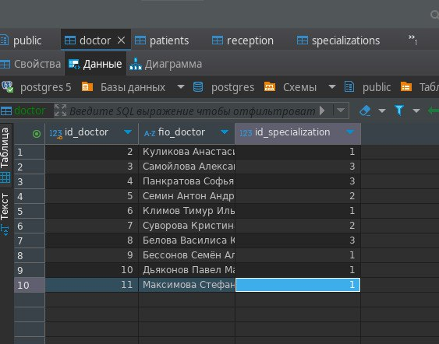

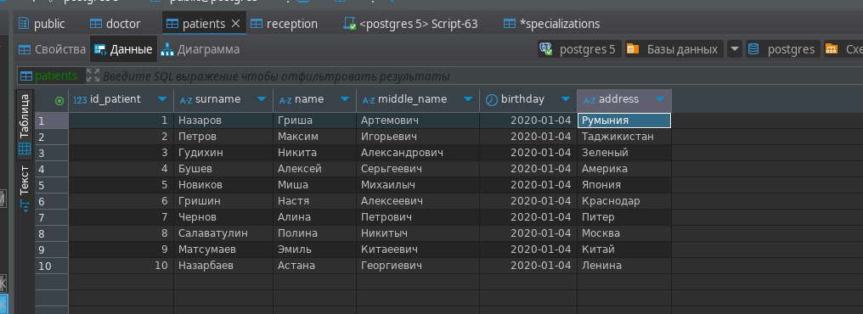

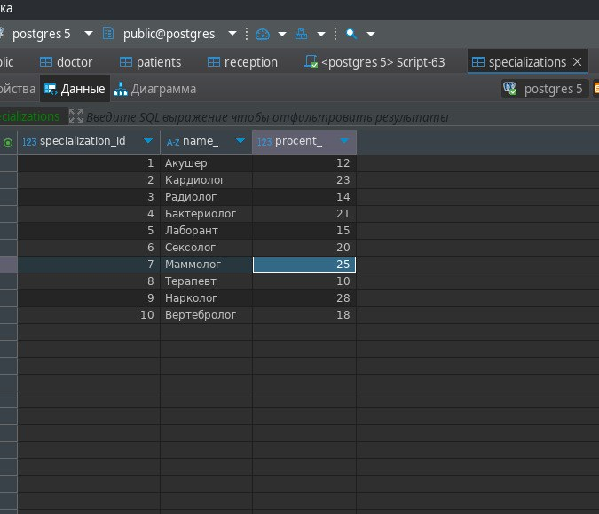

CREATE SEQUENCE public.doctor_id_doctor_seq

INCREMENT BY 1

MINVALUE 1

MAXVALUE 2147483647

START 1

CACHE 1

NO CYCLE;

-- Permissions

ALTER SEQUENCE public.doctor_id_doctor_seq OWNER TO postgres;

GRANT ALL ON SEQUENCE public.doctor_id_doctor_seq TO postgres;

-- DROP SEQUENCE public.patients_id_patient_seq;

CREATE SEQUENCE public.patients_id_patient_seq

INCREMENT BY 1

MINVALUE 1

MAXVALUE 2147483647

START 1

CACHE 1

NO CYCLE;

-- Permissions

ALTER SEQUENCE public.patients_id_patient_seq OWNER TO postgres;

GRANT ALL ON SEQUENCE public.patients_id_patient_seq TO postgres;

-- DROP SEQUENCE public.reception_id_reception_seq;

CREATE SEQUENCE public.reception_id_reception_seq

INCREMENT BY 1

MINVALUE 1

MAXVALUE 9223372036854775807

START 1

CACHE 1

NO CYCLE;

-- Permissions

ALTER SEQUENCE public.reception_id_reception_seq OWNER TO postgres;

GRANT ALL ON SEQUENCE public.reception_id_reception_seq TO postgres;

-- public.doctor определение

-- Drop table

-- DROP TABLE public.doctor;

CREATE TABLE public.doctor (

id_doctor serial4 NOT NULL,

fio_doctor varchar NOT NULL,

id_specialization int4 NOT NULL,

CONSTRAINT doctor_pk PRIMARY KEY (id_doctor)

);

-- Permissions

ALTER TABLE public.doctor OWNER TO postgres;

GRANT ALL ON TABLE public.doctor TO postgres;

-- public.patients определение

-- Drop table

-- DROP TABLE public.patients;

CREATE TABLE public.patients (

id_patient serial4 NOT NULL,

surname varchar NOT NULL,

"name" varchar NOT NULL,

middle_name varchar NULL,

birthday date NOT NULL,

address varchar NULL,

CONSTRAINT patients_pk PRIMARY KEY (id_patient)

);

-- Permissions

ALTER TABLE public.patients OWNER TO postgres;

GRANT ALL ON TABLE public.patients TO postgres;

-- public.reception определение

-- Drop table

-- DROP TABLE public.reception;

CREATE TABLE public.reception (

id_reception bigserial NOT NULL,

id_patient int4 NOT NULL,

id_doctor int4 NOT NULL,

price money NULL,

date_reception date NOT NULL,

CONSTRAINT reception_pk PRIMARY KEY (id_reception),

CONSTRAINT reception_doctor_fk FOREIGN KEY (id_doctor) REFERENCES public.doctor(id_doctor) ON DELETE CASCADE ON UPDATE CASCADE,

CONSTRAINT reception_patients_fk FOREIGN KEY (id_patient) REFERENCES public.patients(id_patient) ON DELETE CASCADE ON UPDATE CASCADE

);

-- Permissions

ALTER TABLE public.reception OWNER TO postgres;

GRANT ALL ON TABLE public.reception TO postgres;

-- Permissions

GRANT ALL ON SCHEMA public TO pg_database_owner;

GRANT USAGE ON SCHEMA public TO public;

INSERT INTO public.doctor (id_doctor,fio_doctor,id_specialization) VALUES

(2,'Куликова Анастасия Артёмовна',1),

(3,'Самойлова Александра Александровна',3),

(4,'Панкратова Софья Павловна',3),

(5,'Семин Антон Андреевич',2),

(6,'Климов Тимур Ильич',1),

(7,'Суворова Кристина Семёновна',2),

(8,'Белова Василиса Юрьевна',3),

(9,'Бессонов Семён Алексеевич',1),

(10,'Дьяконов Павел Максимович',1),

(11,'Максимова Стефания Александровна',1);

INSERT INTO public.patients (id_patient,surname,"name",middle_name,birthday,address) VALUES

(1,'Назаров','Гриша','Артемович','2020-01-04','Румыния'),

(2,'Петров','Максим','Игорьевич','2020-01-04','Таджикистан'),

(3,'Гудихин','Никита','Александрович','2020-01-04','Зеленый'),

(4,'Бушев','Алексей','Серьгеевич','2020-01-04','Америка'),

(5,'Новиков','Миша','Михаилыч','2020-01-04','Япония'),

(6,'Гришин','Настя','Алексеевич','2020-01-04','Краснодар'),

(7,'Чернов','Алина','Петрович','2020-01-04','Питер'),

(8,'Салаватулин','Полина','Никитыч','2020-01-04','Москва'),

(9,'Матсумаев','Эмиль','Китаеевич','2020-01-04','Китай'),

(10,'Назарбаев','Астана','Георгиевич','2020-01-04','Ленина');

INSERT INTO public.reception (id_reception,id_patient,id_doctor,price,date_reception) VALUES

(1,1,10,100,00 ₽,'2021-01-04'),

(2,2,9,150,00 ₽,'2021-01-04'),

(3,3,8,200,00 ₽,'2021-01-04'),

(4,4,7,300,00 ₽,'2021-01-04'),

(5,5,6,400,00 ₽,'2021-01-04'),

(6,6,5,500,00 ₽,'2021-01-04'),

(7,7,4,52,00 ₽,'2021-01-04'),

(8,8,3,31,00 ₽,'2021-01-04'),

(9,9,2,600,00 ₽,'2021-01-04'),

(11,10,11,1 000,00 ₽,'2021-01-04');

INSERT INTO public.specializations (name_,procent_,specialization_id) VALUES

('Акушер',12,1),

('Кардиолог',23,2),

('Радиолог',14,3),

('Бактериолог',21,4),

('Лаборант',15,5),

('Сексолог',20,6),

('Маммолог',25,7),

('Терапевт',10,8),

('Нарколог',28,9),

('Вертебролог',18,10);