FINAL EXIT
USER MANUAL
2D Puzzle / Escape Game
Student No. 23-10715
Section BSIT 4A
Category: Board Games or Brain Games
Platform: Android / Unity 6.6
Date: September 25, 2026

1. Game Overview
FINAL EXIT is a 2D puzzle and escape game. The player moves through five puzzle rooms, chooses answers using three doors, collects code digits, and completes the final code to clear the game.

2. Objective
Solve each puzzle before the timer expires, preserve your lives, collect the four code digits, and complete Room 5.

3. System Requirements
- Android phone capable of running the provided APK.
- Touch input for the on-screen controls.
- Landscape display for gameplay.
- The game was developed using Unity 6.6.

4. Installation and Launch
- Obtain the FINAL EXIT APK from the submission package.
- Open the APK on the Android phone and allow installation if Android requests permission.
- Launch FINAL EXIT from the app list.
- Wait for the loading screen.
- The Main Menu appears.

5. Main Menu
The Main Menu provides PLAY, HOW TO PLAY, and EXIT.
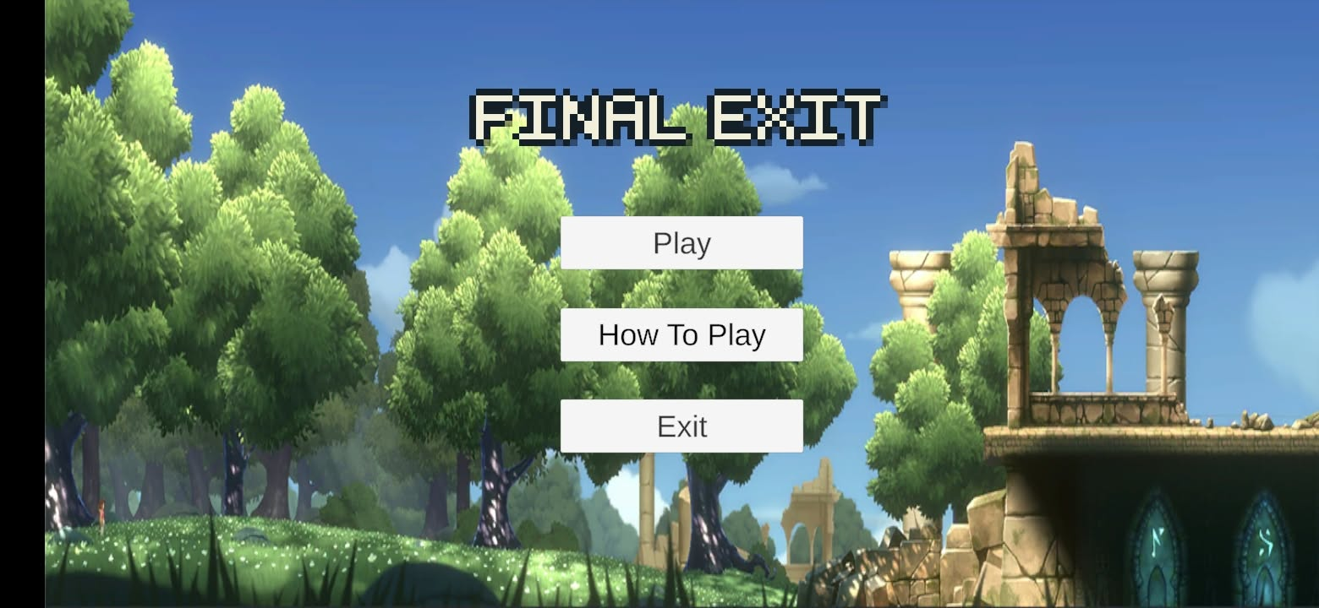
Figure 1. Main Menu.

6. Loading Screen
After selecting PLAY, allow the loading screen to finish before continuing to gameplay.
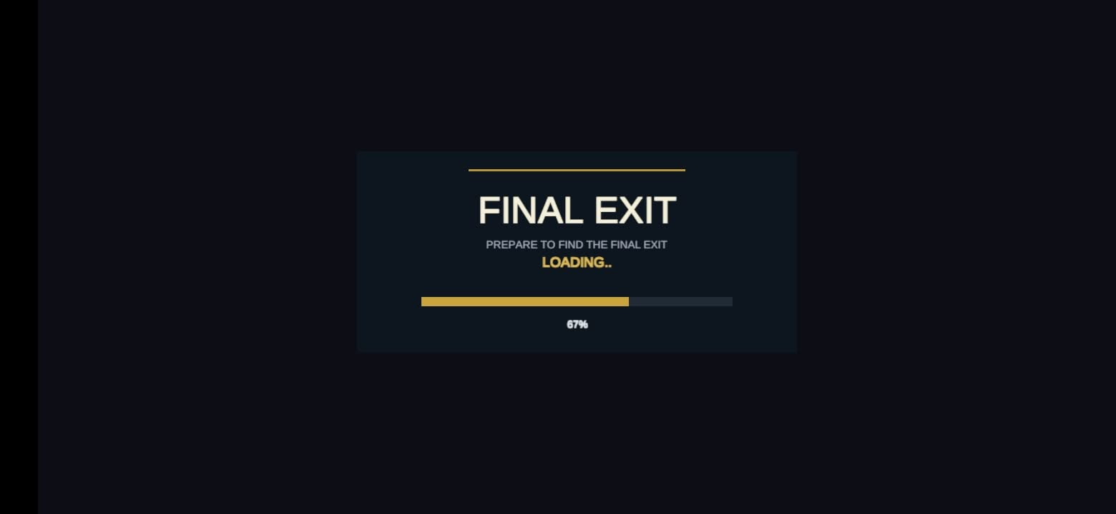
Figure 2. Loading screen.

7. Controls
Control | Action
UP | Move upward
DOWN | Move downward
LEFT | Move left
RIGHT | Move right
CHOOSE | Confirm the selected/touched door
PAUSE | Pause gameplay
Editor W/A/S/D or Arrow Keys | Keyboard movement during Unity testing

8. Gameplay and HUD
Move the player toward one of the three doors. Touching/overlapping a door selects it. Press CHOOSE to submit the answer. The HUD shows lives, score, current room, and remaining time.
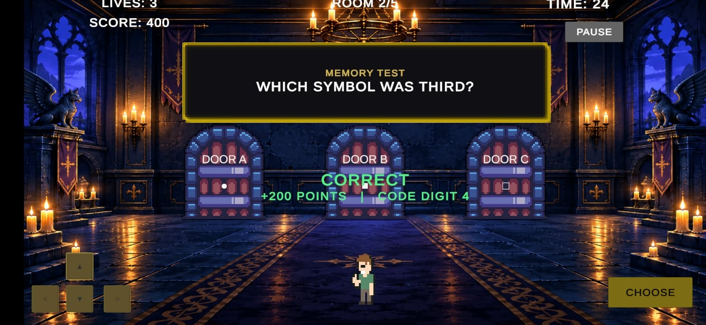
Figure 3. Correct-answer feedback and score/code update.

HOW TO PLAY – STEP-BY-STEP
Follow these steps to play FINAL EXIT from the Main Menu through the puzzle rooms, answer selection, pause/retry states, and the final Game Clear screen.

Step 1 – Start at the Main Menu
Launch FINAL EXIT. The Main Menu provides PLAY, HOW TO PLAY, and EXIT. Press PLAY to begin.
Figure HP1. Main Menu – press PLAY to begin.

Step 2 – Wait for the Loading Screen
After selecting PLAY, allow the loading screen to finish. The game then proceeds to gameplay.
Figure HP2. Loading screen – wait for the transition to finish.

Step 3 – Read the Puzzle and HUD
At the start of a room, read the puzzle prompt in the center. The HUD shows LIVES, SCORE, ROOM, and TIME so you can track your progress.
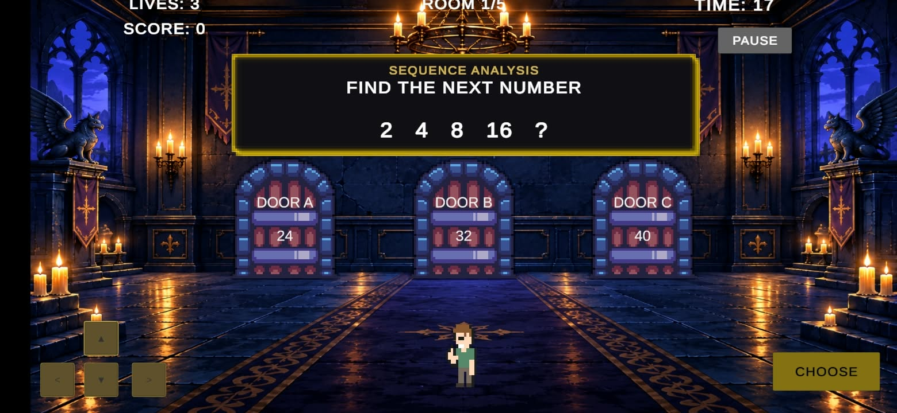
Figure HP3. Gameplay screen – read the puzzle and HUD.

Step 4 – Move the Player
On Android, use the UP, DOWN, LEFT, and RIGHT buttons at the lower-left of the screen. In the Unity Editor, W/A/S/D or the arrow keys can be used.

Figure HP4. Android phone gameplay – use the on-screen controls.

Step 5 – Approach an Answer Door
Move the player toward one of the three doors. Each door displays a different answer. Choose the door that matches your answer to the puzzle.
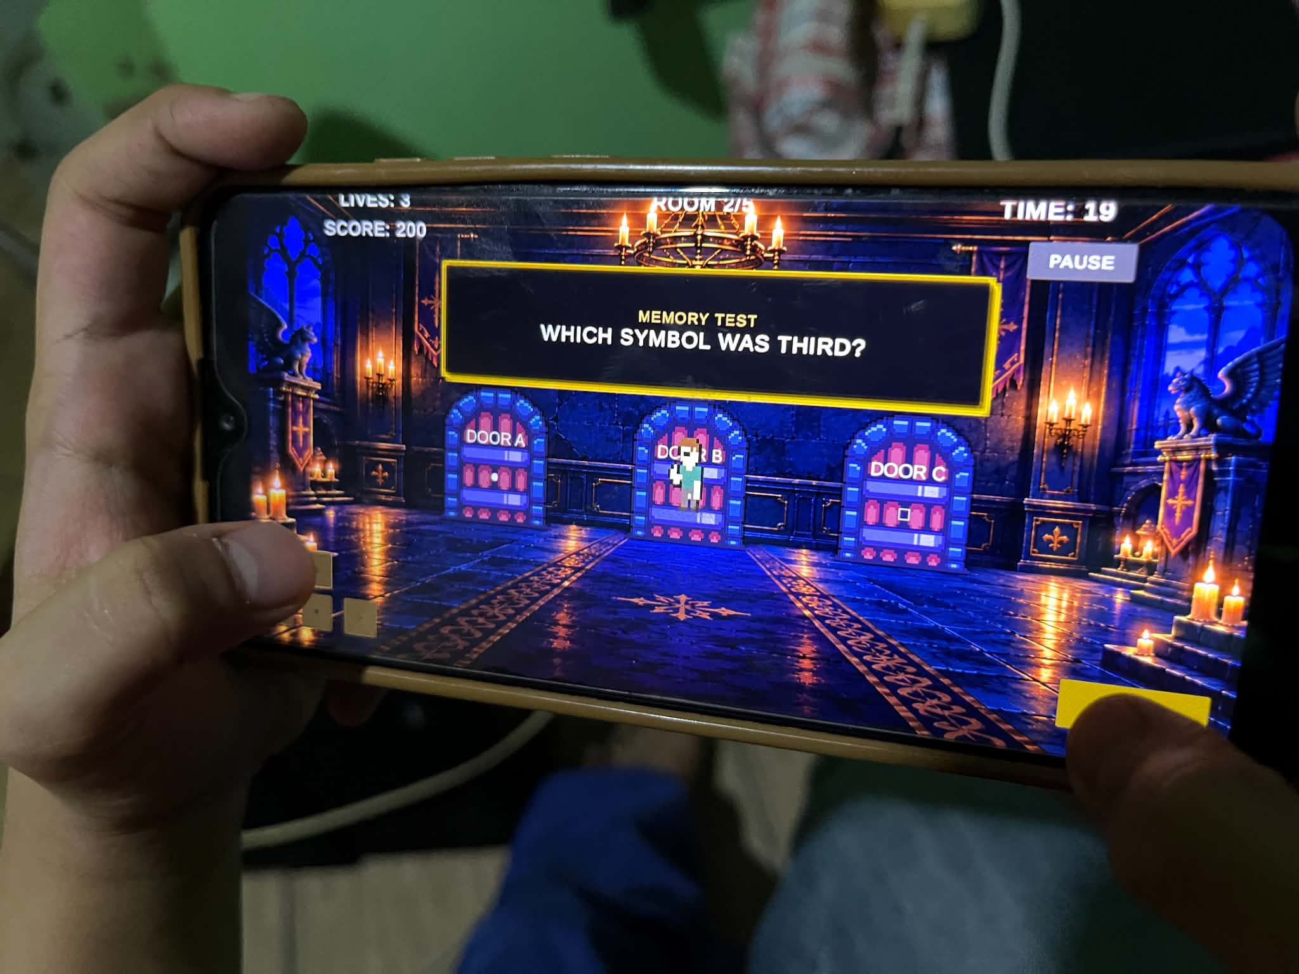

Figure HP5. Three answer doors – move toward the door containing your answer.

Step 6 – Press CHOOSE
After approaching/touching the desired door, press CHOOSE at the lower-right. This confirms and submits the selected answer.

Figure HP6. CHOOSE is used to confirm the selected door.

Step 7 – Check the Result
A correct answer displays positive feedback and updates the score/code progress. A wrong answer displays WRONG ANSWER and removes one life.
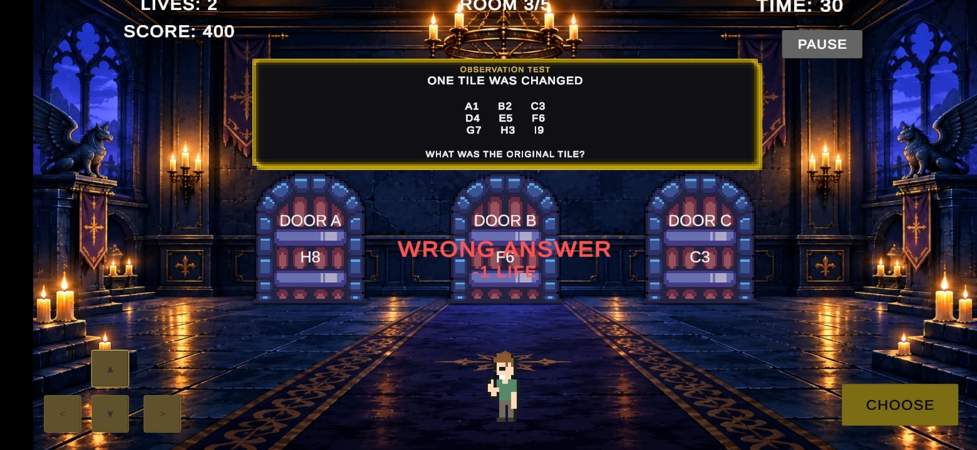
Figure HP7. Wrong-answer feedback – one life is removed.

Step 8 – Use PAUSE When Needed
Press PAUSE at the upper-right to stop gameplay temporarily. Press RESUME to continue.
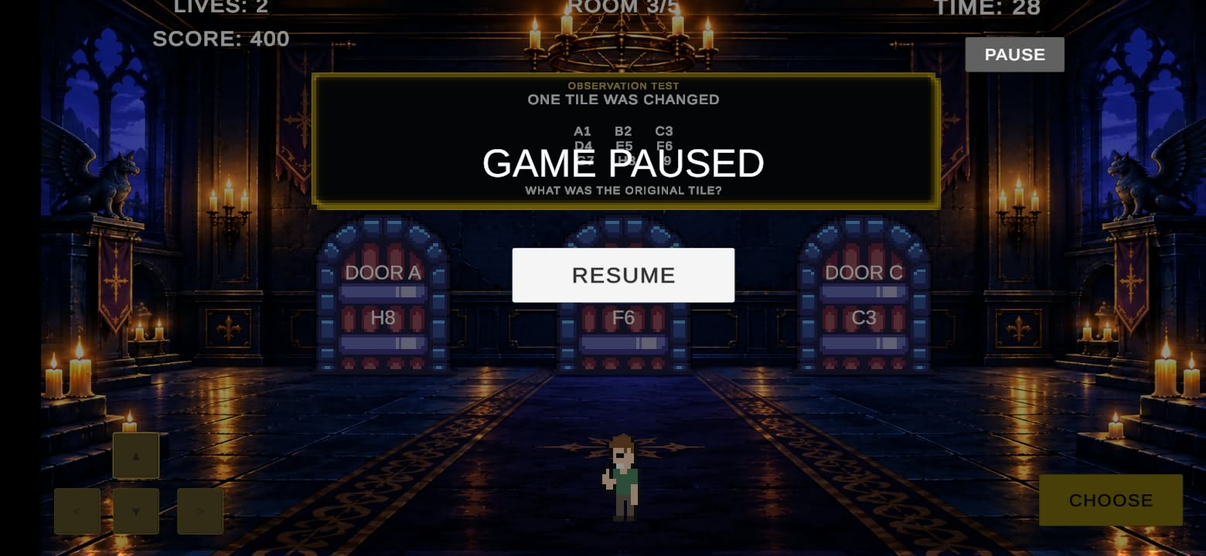
Figure HP8. Pause screen – press RESUME to continue.

Step 9 – Continue Through the Rooms
Solve the five puzzle rooms. Rooms 1–4 provide the code digits used for the final room. Keep an eye on the timer and remaining lives.
Figure HP9. Correct-answer feedback – continue to the next puzzle.

Step 10 – Recover From Game Over
If all lives are lost, the Game Over screen appears. Use the available retry/play-again option or return to the Main Menu.
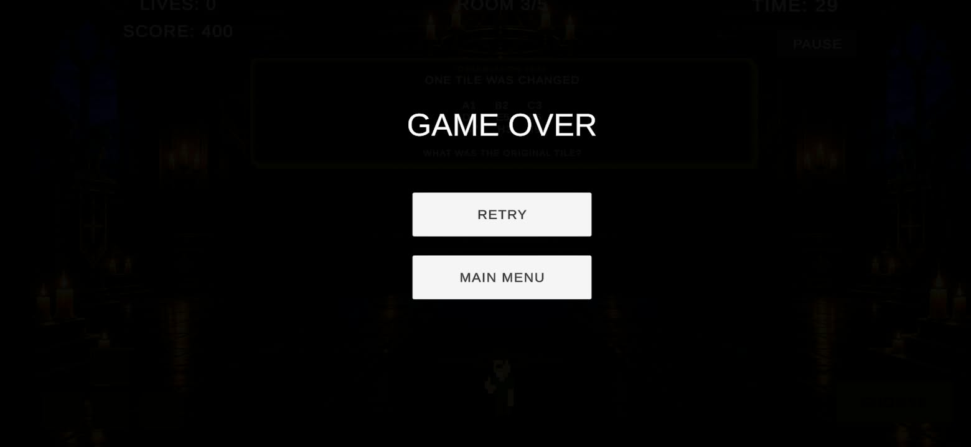
Figure HP10. Game Over – retry or return to the Main Menu.

Step 11 – Complete the Final Code
Reach Room 5 and use the four code digits collected from the earlier rooms to complete the final code.
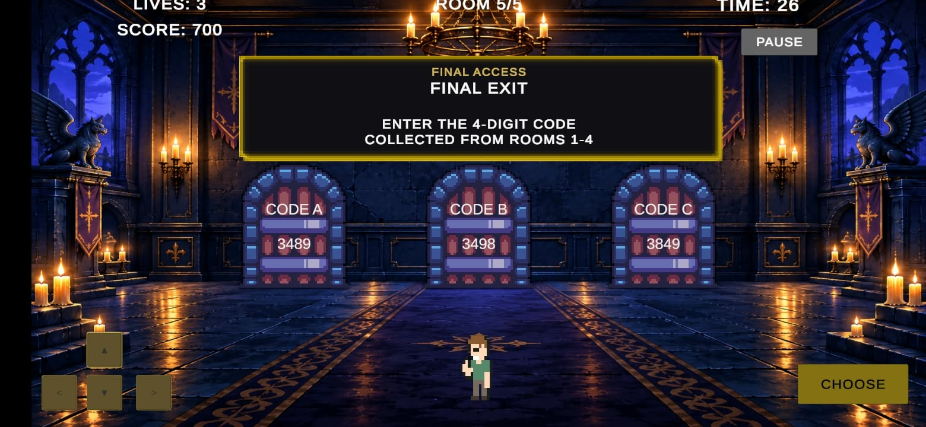

Figure HP11. Gameplay room – continue solving the puzzle sequence.

Step 12 – Finish the Game
A successful final answer displays the Game Clear state and final score. You can then use Play Again or return to the Main Menu.
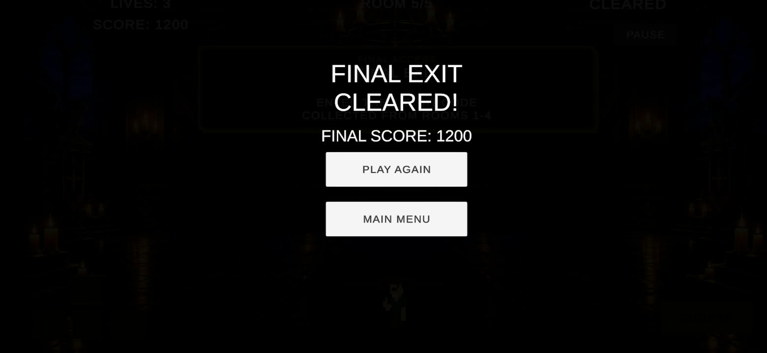
Figure HP12. Game Clear – the final score is displayed.

10. Puzzle Rooms
Room | Puzzle Type | Description
1 | Number sequence | 2, 4, 8, 16, ? — choose the next number.
2 | Memory | Remember the displayed symbol sequence and identify the third symbol.
3 | Observation | Observe the A1–I9 grid and identify the original changed tile.
4 | Logic | Find the number divisible by 6, greater than 30, not divisible by 7, with digit sum 9.
5 | Final code | Use the four collected digits to complete the final code 3489.

11. Scoring and Lives
Event | Score / Effect
Correct answer, >15 seconds | +200 points
Correct answer, 15 seconds or less | +100 points
Wrong answer | -1 life
Timer expires | -1 life
Room 5 completion | +500 final bonus
Maximum score | 1300 points

12. Pause
Press PAUSE to temporarily stop gameplay. Select RESUME to continue.
Figure 13. Pause state.

13. Wrong Answer
A wrong answer displays feedback and removes one life.
Figure 14. Wrong-answer feedback and life loss.

14. Game Over and Game Clear
Game Over appears when the player loses all lives. Game Clear appears after successfully completing the final code.
Figure 15. Game Over state.
Figure 16. Game Clear state.

15. Android Testing
The final game was installed and tested on an Android phone. Mobile controls and gameplay interaction were verified.
Figure 17. FINAL EXIT running on an Android phone.

16. Troubleshooting
Problem | Action
Player does not move | Check that the game is running and use the on-screen direction buttons.
Door answer does not submit | Move/overlap the player with a door, then press CHOOSE.
Game is paused | Press RESUME.
Game Over appears | Use the available retry/play-again option or return to the Main Menu.
APK will not install | Confirm the APK was transferred completely and allow installation from the required Android source.

17. Asset Credits
Final recorded third-party resources: Medieval pixel art asset FREE — Blackspire; Free 2D Mega Pack — Brackeys; 2D Dungeon Art Background — Zhivko Minchev (publisher source supplied for the project record). UI, scripts, and gameplay logic were assembled/created as part of the student project.

