FINAL EXIT – Parts A and B
PEBSIT 004 LAB | AY 2026–2027
Student: Naz Aaron B. Ancheta
Student No.: 23-10715
Section: BSIT 4A
Date: September 25, 2026

Project Information
Item | Final Record
Project Name | PEBSIT004_Prelim_Ancheta_FinalExit
Game Title | FINAL EXIT
Category | Board Games or Brain Games
Target Platform | Android mobile device; landscape gameplay
Engine / Framework | Unity 6.6 (6000.6.0f1)
Language / UI | C#; Unity UI / TextMeshPro
Final Scenes | MainMenuScene; LoadingScene; GameScene

PART A – Game Concept, Requirements, and Development Approach

A.1 Game Concept and Scope
FINAL EXIT is a 2D puzzle and escape game under the Board Games or Brain Games category. The player clears five puzzle rooms, preserves three lives, earns points for correct answers, and collects four code digits before entering the final code in Room 5. The player controls a visible character, approaches one of three answer doors, and presses CHOOSE to confirm the selected door. The prototype uses one reusable gameplay room layout with changing puzzle content, HUD values, pause, feedback, room transitions, Game Over, Game Clear, replay, and Main Menu navigation.

A.2 Functional and Non-functional Requirements
Type | Requirement
Functional | Main Menu provides Play, How To Play, and Exit.
Functional | Player moves using keyboard controls in the Editor and on-screen direction buttons on mobile.
Functional | Player selects one of three doors by approaching/touching it and confirms with CHOOSE.
Functional | Timer, score, lives, room number, feedback, and final score update during play.
Functional | Pause/Resume, room progression, Game Over, Game Clear, Retry/Play Again, and Main Menu transitions work.
Usability | Instructions, controls, puzzle text, HUD values, and feedback remain readable.
Performance / Resource | Prototype uses lightweight 2D/UI assets and a small number of scenes for a mobile target.
Deployment | Android APK was successfully built, installed, and tested on a phone.

A.3 Development Approach Comparison
Criterion | Unity 6.6 | Native Android (Kotlin)
Platform support | Android and other platforms from one project. | Primarily Android; game rendering and gameplay require more manual implementation.
Difficulty | Visual editor, scenes, UI, C# scripts, and reusable components suit a small prototype. | Requires Android UI/app knowledge plus more custom game-loop and rendering work.
Learning resources | Large Unity documentation, tutorials, samples, and community resources. | Strong Android documentation, but less focused on game mechanics.
Performance | Suitable for a lightweight 2D prototype when assets and UI are kept simple. | Can be efficient, but game-oriented implementation is more manual.
Maintainability | Scenes, scripts, and assets can be separated into understandable folders/components. | Maintainable, but rapid game iteration is less convenient.
Mobile features | Android build settings and touch UI are supported. | Direct Android API access, but with more implementation effort.
Prototype suitability | Well suited to rapid scene creation, UI, input, puzzles, and state transitions. | Possible, but less convenient for a short practical prototype.

A.4 Platform and Framework Decision
Unity with C# was selected because FINAL EXIT depends on scenes, Canvas-based UI, a controllable player, door selection, timers, score/lives, puzzle states, and screen transitions. Unity allowed these elements to be assembled and tested quickly before Android deployment.

A.5 Scope, Constraints, and Out-of-Scope Items
The prototype focuses on core puzzle gameplay and mobile interaction. Blockchain, biometric authentication, offline voting-style functionality, third-party service integrations, and a server-side leaderboard are outside the game's scope. The project also prioritizes a working Android prototype over advanced audio and visual polish.

PART B – Interface, Gameplay, and Architecture Design

B.1 Interface / Scene Design
The interface uses a main menu, a lightweight loading scene, and a gameplay scene. The gameplay HUD places lives, score, room number, and timer at the top; the puzzle prompt in the center; three answer doors in the play area; directional controls at the lower left; CHOOSE at the lower right; and PAUSE at the upper right.

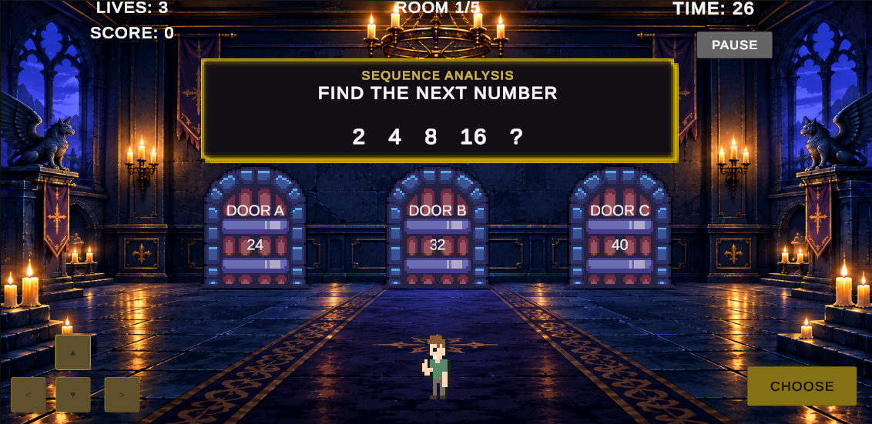
Figure B1. FINAL EXIT Main Menu in the Unity Game view.

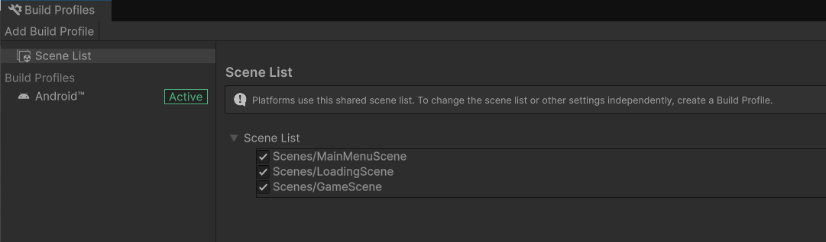
Figure B2. Gameplay interface showing HUD, puzzle panel, three doors, D-pad, CHOOSE, and PAUSE.

B.2 Gameplay Flow
- Launch the application and view the Main Menu.
- Select Play and pass through the loading/game flow.
- Move the player using the D-pad or keyboard in the Editor.
- Approach/touch one of three answer doors.
- Press CHOOSE to submit the selected answer.
- Correct answers award points and reveal a code digit; wrong answers remove one life.
- Progress through Rooms 1–4, then use the collected code in Room 5.
- Reach Game Clear, or Game Over if all lives are lost.
- Use Retry/Play Again or return to the Main Menu as appropriate.

B.3 Component / Architecture Responsibilities
Component | Responsibility
GameManager.cs | Puzzle sequence, timer, score, lives, feedback, code digits, pause, transitions, Game Over and Game Clear.
PlayerMovement.cs | Keyboard/mobile movement, room bounds, door overlap detection, selection, and CHOOSE confirmation.
MainMenuManager.cs | Main Menu navigation and panel switching.
LoadingSceneManager.cs | Scripted loading screen/transition presentation.
TitleAnimation.cs | Title presentation/animation.
Unity UI / TextMeshPro | HUD, puzzle prompts, buttons, feedback, and end-state panels.

B.4 Asset / Resource Classification
Resource | Use / Classification | Final Record
Medieval pixel art asset FREE | Door / gate sprites; third-party visual resource | Blackspire / Unity Asset Store; used
Free 2D Mega Pack | Player/menu visual resources; third-party visual resource | Brackeys / Unity Asset Store; used
2D Dungeon Art Background | Gameplay background; third-party visual resource | Zhivko Minchev / Unity Asset Store publisher source supplied for the project record
UI layout, panels, buttons, HUD | Student-created Unity UI | Used
Game scripts and gameplay logic | Student/course project work | Used
Audio | Optional sound effects/music | Not implemented
Unused/candidate imported packs are not treated as final authored resources in the documentation. The project folder may still contain imported assets from development; the final asset record identifies the resources intended to be credited as used.

B.5 Prototype Success Criteria
- Unity project opens and required scenes/scripts/assets are inspectable.
- Main Menu loads and Play opens the gameplay flow.
- Player movement works using keyboard and on-screen controls.
- Player can select an answer door and confirm it using CHOOSE.
- At least one correct and one wrong answer event visibly update game status.
- Lives, score, timer, room number, and feedback visibly update during play.
- Pause/Resume and room/state transitions work.
- Game Over and Game Clear states are reachable and replay/menu navigation works.
- Android build settings are configured and an APK was produced and installed for testing.
- Incomplete or out-of-scope features and asset information are documented honestly.

Evidence Used for Parts A/B
The final evidence set includes the Unity project structure, Main Menu, gameplay view, Android Build Profiles, Pause state, wrong-answer/life-loss state, Android phone gameplay, and previously captured Room 2 Correct, Game Over, Game Clear, and Loading Scene screenshots.

