UNIVERSITY OF LA SALETTE, INC.
COLLEGE OF INFORMATION TECHNOLOGY
PEBSIT 004 LAB | AY 2026-2027
FINAL EXIT - Build, Testing, Troubleshooting, and Issue Record
Student: Naz Aaron B. Ancheta | Student No.: __________ | Section: __________
Final documentation date: September 25, 2026

PART D. Required Test Record
Test Condition | Expected Result | Actual Result | Status | Action / Finding
Project opens | Unity opens PEBSIT004_Prelim_Ancheta_FinalExit without blocking errors. | Project opened; scenes, scripts and assets were accessible. | PASS | Final inspectable project retained.
Main scene / screen loads | MainMenuScene displays FINAL EXIT and menu controls. | Main Menu loaded with Play, How To Play and Exit. | PASS | No correction required.
Player input / interaction | Player moves with keyboard and on-screen mobile controls. | Keyboard movement and mobile direction controls were tested; player movement worked during gameplay testing. | PASS | Final phone test completed.
Gameplay event / condition | Approaching a door and pressing CHOOSE submits the selected answer. | Door selection and CHOOSE answer checking worked; Room 2 correct-answer evidence captured. | PASS | No correction required.
Score / status update | Correct/wrong answers update score, lives, timer/room state and feedback. | Score, lives, timer, room state and feedback updated during testing; correct answers awarded points. | PASS | No correction required.
Screen / state transition | Game transitions through rooms and shows Pause, Game Over or Game Clear. | Room progression, Pause/Resume, Game Over, Game Clear, Retry/Play Again and Main Menu return were tested. | PASS | Full gameplay sequence tested.
Android build / export | Unity produces an Android APK or the exact build error is documented. | Android APK was successfully built and installed on the phone for final testing. | PASS | Successful build evidence retained.
Test after correction | Corrected defects behave as expected after re-test. | Player layering/door interaction correction was re-tested; final gameplay sequence completed successfully. | PASS | Correction verified.

Test Evidence Included
The following screenshots were supplied as final evidence and are included in the package:
1. Room 2 correct answer - score/code feedback - Screenshots/01_Room2_Correct.jpg
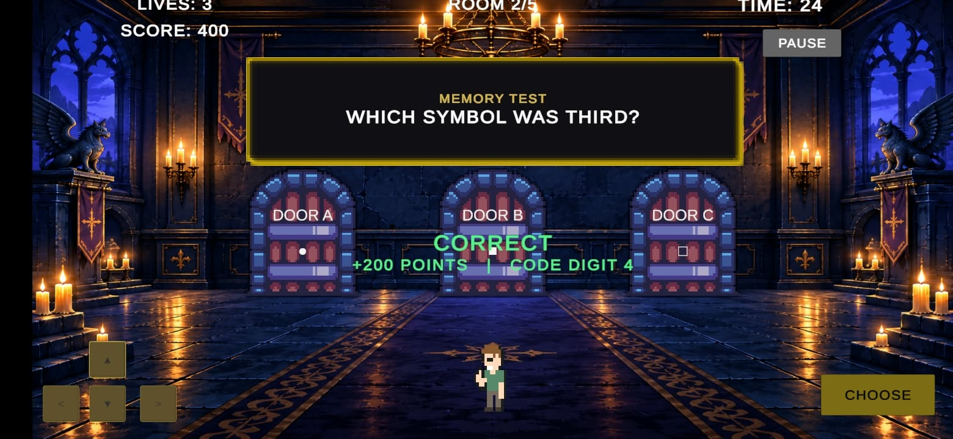

2. Game Over state - Screenshots/02_GameOver.jpg
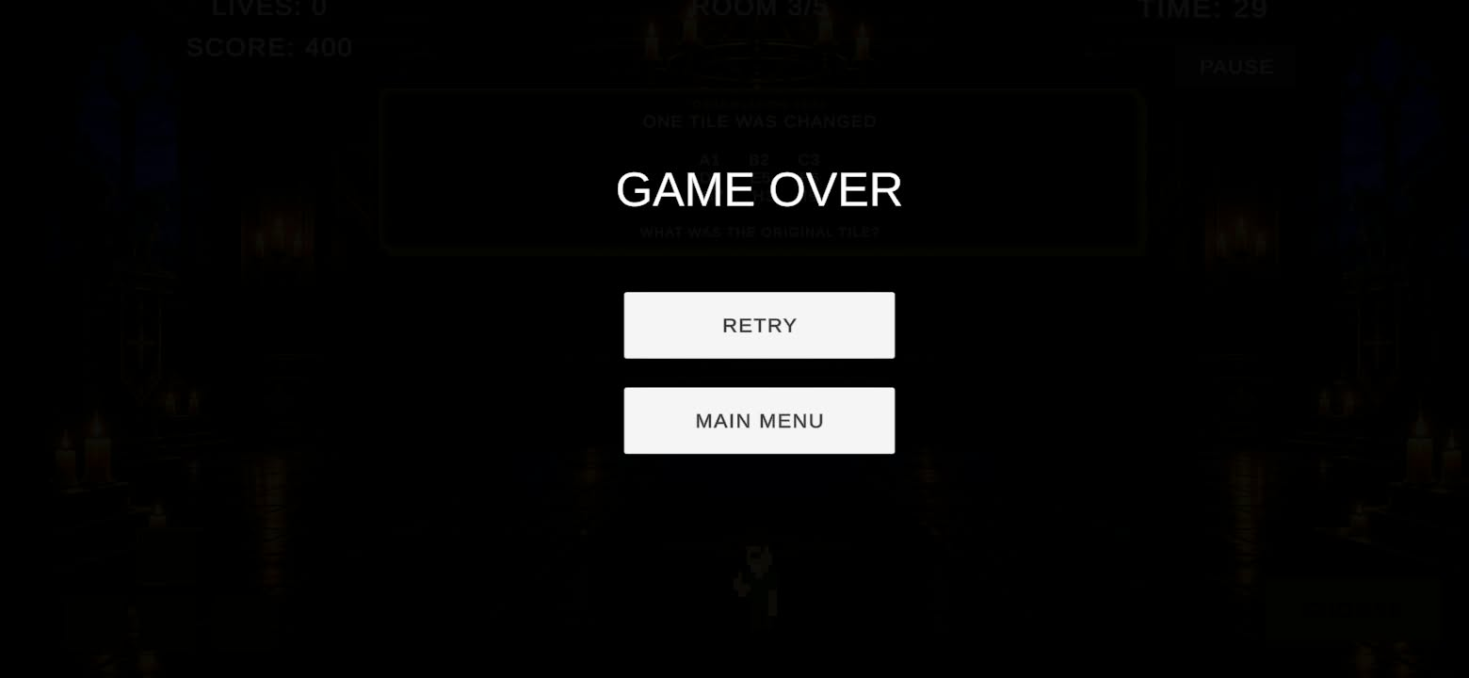

3. Game Clear state - Screenshots/03_GameClear.jpg
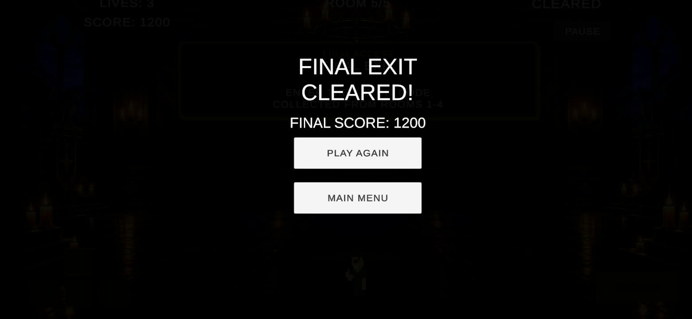

4. Main Menu - Screenshots/04_MainMenu.jpg
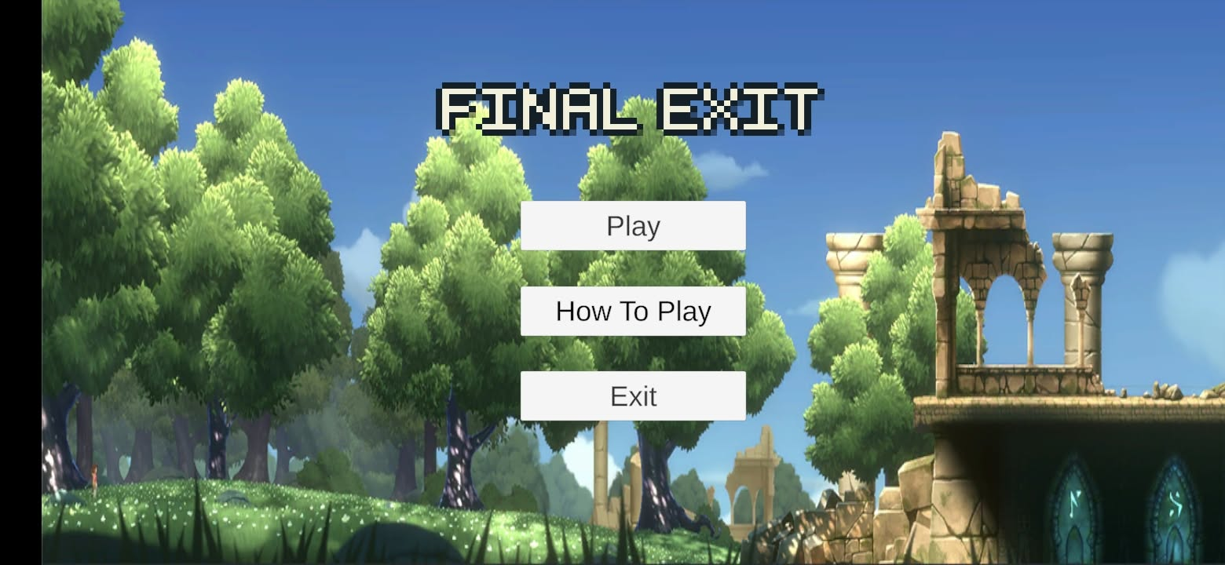

5. Loading screen - Screenshots/05_LoadingScene.jpg
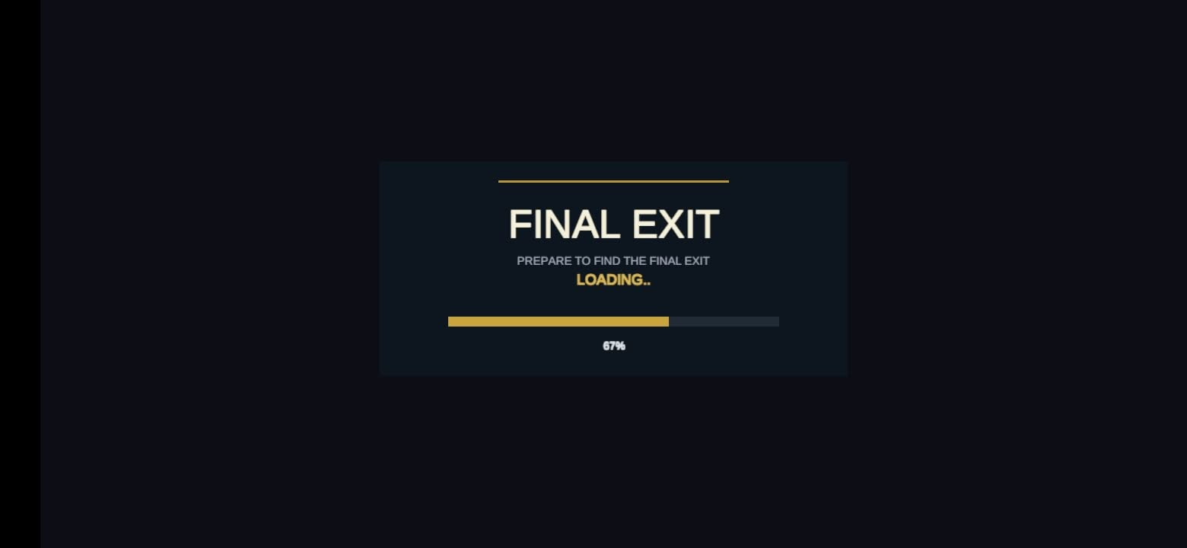

Development Issue Record
Evidence Item | Final Record
Actual error / defect | The player character was initially rendered behind the door and puzzle UI, making the player partially hidden during movement.
Steps / conditions | In GameScene, the Player UI object was placed too early in the Canvas hierarchy, so later UI siblings rendered over it.
Expected behavior | The player should remain visible while moving in front of the gameplay doors and room interface.
Actual behavior | The player could disappear behind the doors or puzzle elements when moving upward.
Probable cause | Canvas UI draw order follows sibling order; the Player object was positioned too early in the hierarchy.
Correction | The Player was moved lower in the Canvas hierarchy so it renders after the doors/puzzle elements, while end-state overlays remain above it.
Result after correction | The player became visible in front of the doors and movement continued to work. The corrected behavior was re-tested.
Additional note | Android testing also required attention to the input/UI configuration. Final phone testing was completed after the controls were wired and the APK was installed.

Final Evaluation
Area | Evaluation
Usability | Controls are simple: move, approach a door, and press CHOOSE. HUD and How To Play explain the rules.
Compatibility | Android is the primary target. Keyboard controls remain available for Editor testing; touch controls were tested on the phone.
Performance | The prototype uses lightweight 2D/UI gameplay and a small number of scenes. No heavy simulation is required.
Completeness | Core gameplay, five puzzles, status updates, pause, room progression, Game Over, Game Clear, replay and menu flow were completed and tested.

