


Technical Report

SHIELD: DIY Content Transformation For Safer Social Media Browsing

SE-801: Software Project Lab 3

Submitted by

Nazeeb Ahmed Chowdhury
BSSE1432

Supervised by
Toukir Ahammed
Lecturer
Institute of Information Technology
University of Dhaka

Submission Date: 02–08-2026

Contents
1. Project Overview 4
1.1 Project Title 4
1.2 Problem Statement 4
1.3 Objectives 4
1.4 Scope 5
1.5 Deliverables 5
2. Requirements Analysis 6
2.1 Functional Requirements 6
2.2 Non-Functional Requirements 8
2.3 Stakeholders 9
3.System Modeling 10
3.1 Use Case(Level1) 10
3.2 Activity Diagram 11
4.Data & Information Modeling 14
4.1 ER- diagram 14
5. AI Engineering 15
5.1 AI Pipeline 15
5.2 Models used 16
5.3 Prompt Engineering 17
5.3.1Conversational Filter Creation 17
5.3.2 Pruning 22
5.3.3 Generation 24
5.3.4 Scorer 30
6. Component-Level Design 32
6.1 Design Classes 32
6.2 Persistent Data Sources 37
6.3 Overall System Design 39
6.4 Behavioral Design 41
6.4.1 Text moderation of a feed post 42
6.4.2 Deferred image transformation 45
6.5 Deployment Design 47
7. Interface Design 50
7.1 User Interface Objects and Actions 50
7.2 UI Events and State Transitions 51
7.3 Interface Screenshots 53
7.3.1 Popup: initial state 53
7.3.2 Popup: describing a sensitivity 54
7.3.3 Popup: clarifying question 54
7.3.4 Popup: filter configuration 55
7.3.5 Popup: filter saved 55
7.3.6 Popup: My Filters 56
7.3.7 Popup: image-based filter creation 56
7.3.8 Options page 57
7.3.9 Transformed content on Reddit 58
8. Testing 60
8.1 Testing Approach and Strategy 60
8.2 Item Pass/Fail Criteria 61
8.3 Test Cases with Detailed Outcomes 61
8.3.1 Health check and CORS 62
8.3.2 Filter management (/filters) 62
8.3.3 Conversational filter creation (/chat, /chat/image) 64
8.3.4 Feed processing (/get_feed) 66
8.3.5 Image results (/get_img_result, /get_img_base64) 66
8.3.6 User information (/user/update) 67
8.3.7 WebSocket (/ws/{user_id}) 68
8.3.8 Analysis of the failed test cases 69
9. User Manual 70
9.1 System Requirements 70
9.2 Installation and Setup 70
9.2.1 Starting the backend 70
9.2.2 Installing the extension 71
9.2.3 Checking the connection 71
9.3 Signing In 71
9.4 Creating a Filter by Chat 71
9.5 Creating a Filter from an Image 72
9.6 Viewing, Editing and Deleting Filters 72
9.7 Browsing with Moderation Active 72
9.8 Adjusting Visual Preferences 73
9.9 Exporting and Importing Filters 73
9.10 Troubleshooting 73

[This Page is intentionally left blank]

1. Project Overview

1.1 Project Title
SHIELD: DIY(Do it Yourself) Content Transformation for Safer Social Media Browsing.

1.2 Problem Statement
Social media platforms rely on centralized, one-size-fits-all moderation rules that cannot account for the deeply subjective nature of psychological harm. The same post can be joyful for one person and severely distressing for another — a food photo that is harmless to most users is a serious trigger for someone managing an eating disorder, and a pregnancy announcement can be devastating for someone who has recently experienced pregnancy loss. Specific phobias can provoke visceral physical reactions even to digital images, and PTSD affects an estimated 3–4% of adults annually, meaning a substantial share of any platform's user base is carrying some sensitivity that generic moderation categories simply do not cover.
Existing platform tools offer only blunt instruments in response: muting keywords (which also blocks valuable related discussion), blocking accounts entirely (severing otherwise-valued relationships), or slow, opaque algorithmic downranking. None of these mechanisms can remove a single harmful element from a post while preserving the surrounding social and informational context — the choice is always between enduring distress or losing access to a community.
SHIELD addresses this gap by implementing personalized content transformation: rather than suppressing an entire post, it modifies only the specific elements a given user finds distressing — blurring a triggering image region, rewriting a distressing sentence, or restyling a sensitive visual — while leaving the rest of the post intact.

1.3 Objectives
- Implement a browser extension that intercepts social media content before it renders and applies AI-driven, personalized transformations at the point of viewing.
- Build a conversational, LLM-powered chat interface that lets users define their content sensitivities in natural language, without being constrained to predefined categories.
- Implement a multi-stage content-analysis and transformation-selection pipeline that picks the most appropriate intervention for a given user–content pair in real time.
- Provide a palette of transformation techniques — obfuscation, semantic modification, and stylistic alteration — covering both text and image content.

1.4 Scope
In scope:
- Conversational filter creation via chat (text and image-based), producing user-specific sensitivity filters with intensity, content-type (text/image/all), and expiry settings.
- Real-time interception and analysis of Reddit feed content, matching posts against a user's active filters.
- Intervention palette implementation : obfuscation (blur, occlusion, warning overlay), semantic modification (inpainting, replacement, shrink), and stylistic alteration (Cubism, Impressionism, Ghibli, Pointillism — both full-image and selective/region-only variants with grounding dino).
- Transparency indicators on modified content and user override (view-original) controls.
- The existing filter-matching and intervention-selection pipeline (image pruning via GPT-4o/any other VLM as a judge doing structured analysis, followed by parallel candidate generation and scoring).
- Caching for performance
Out of scope for this phase (planned future work, not current deliverables):
- Video content support.
- Real time Facebook/twitter test, as its dom manipulation is harder.

1.5 Deliverables
- A working browser extension (Chrome, Manifest V3) implementing filter creation, content interception, and on-page transformation rendering for a social media platform(test on Reddit.)
- The conversational filter-creation interface (chat-based, text and image input).
- A backend service exposing the filter-management, content-analysis, and transformation-generation API consumed by the extension.

2. Requirements Analysis

2.1 Functional Requirements
Conversational Filter Creation Module (FR-1)
- FR-1.1: Users shall create filters through a natural-language chat interface rather than only through structured form fields.
- FR-1.2: Users should be able to sign in with google accounts just to keep their filters personalized and saved
- FR-1.3: The system shall analyze the clarity of a user's filter description and detect gibberish or ambiguous input before creating a filter from it.
- FR-1.4: The system shall support image-based filter creation, where a user uploads or references an image to define a sensitivity.
Filter Management Module (FR-2)
- FR-2.1: Users shall create a filter consisting of filter text, an intensity level, a content-type scope (text, image, or both), and optional filter-type metadata.
- FR-2.2: Users shall retrieve, update, and delete their existing filters.
- FR-2.3: The system shall support marking a filter as temporary and assigning it an expiration timestamp, after which it is treated as expired.
- FR-2.4: The system shall support activating/deactivating a filter without deleting it.
Content Interception & Platform Adapter Module (FR-3)
- FR-3.1:: The browser extension shall intercept social media content(currently reddit) before it is rendered to the user.
- FR-3.2: The browser extension shall extract post text and image data from intercepted social media content for analysis.
Text Transformation Module (FR-4)
- FR-4.1: The system shall analyze post text against the user's active filters to identify matching content.
- FR-4.2: The system shall select an appropriate text intervention based on the user's filter settings and intensity level.
- FR-4.3: The system shall apply the selected text intervention, including blurring sensitive phrases, rewriting text, or displaying a warning message.
- FR-4.4: The system shall clearly indicate that transformed content has been modified (e.g., " Modified” badge)

Image Filter Analysis & Intervention Selection Module (FR-5)
- FR-5.1:The system shall analyze images against the user's active filters to identify matching content.
- FR-5.2: The system shall determine suitable intervention techniques based on the detected content and user-defined filter settings.
- FR-5.3: The system shall identify the relevant regions of an image to support selective content transformations.
Image Transformation Generation & Scoring Module (FR-6)
- FR-6.1: The system shall generate one or more transformed versions of matched images.
- FR-6.2: The system shall evaluate the generated image transformations and select the most appropriate one.
- FR-6.3: The system shall replace the original image with the selected transformed image before displaying it to the user, proper ‘loading’ states should be visible initially.
- FR-6.4: The system shall support the following intervention techniques:Obfuscation( blur, occlusion, warning overlay),Semantic Modification( inpainting, replacement, shrink) and four stylization treatments (Cubism, Impressionism, Ghibli, Pointillism), each available as both full-image and selective/region-only variants.
Transparency & User Override Module (FR-7)
- FR-7.1: The system shall visually mark all modified content (text and image) with a transformation indicator.
- FR-7.2: For warning-overlay interventions, the system shall let the user click the overlay to reveal the original content underneath(for text)
Caching Module (FR-8)
- FR-8.1: The system shall cache previously processed image transformations to avoid redundant processing of the same image with the same active filter settings.
User Account Module (FR-9)
- FR-9.1: The system shall identify users by email address, creating a new user record on first login and returning the existing record on subsequent logins.
- FR-9.2: The system shall store per-user preferences (e.g., default filtering mode) alongside the user record.

2.2 Non-Functional Requirements

ID | Category | Requirement
NFR-1 | Performance | Generate image transformations in parallel to reduce response time.
NFR-2 | Performance | Use caching for previously processed image-filter combinations.
NFR-3 | Scalability | Process image generation asynchronously to keep the API responsive.
NFR-4 | Security | User authentication should be improved beyond unverified email input.
NFR-5 | Reliability | Return a safe fallback if the AI pipeline fails.
NFR-6 | Usability | Ensure modified content remains clear and properly aligned.
NFR-7 | Compatibility | Support Chrome Manifest V3.
NFR-8 | Maintainability | Use a modular architecture for adding new AI models and intervention techniques.

2.3 Stakeholders
Stakeholder | Interest / Need
End User | Browse platform while avoiding distressing content.
Content Poster | Original content remains unchanged; transformations are client-side only.
LLM/VLM API Providers | Provide AI services; availability, cost, and rate limits affect system performance.

3.System Modeling

3.1 Use Case(Level1)
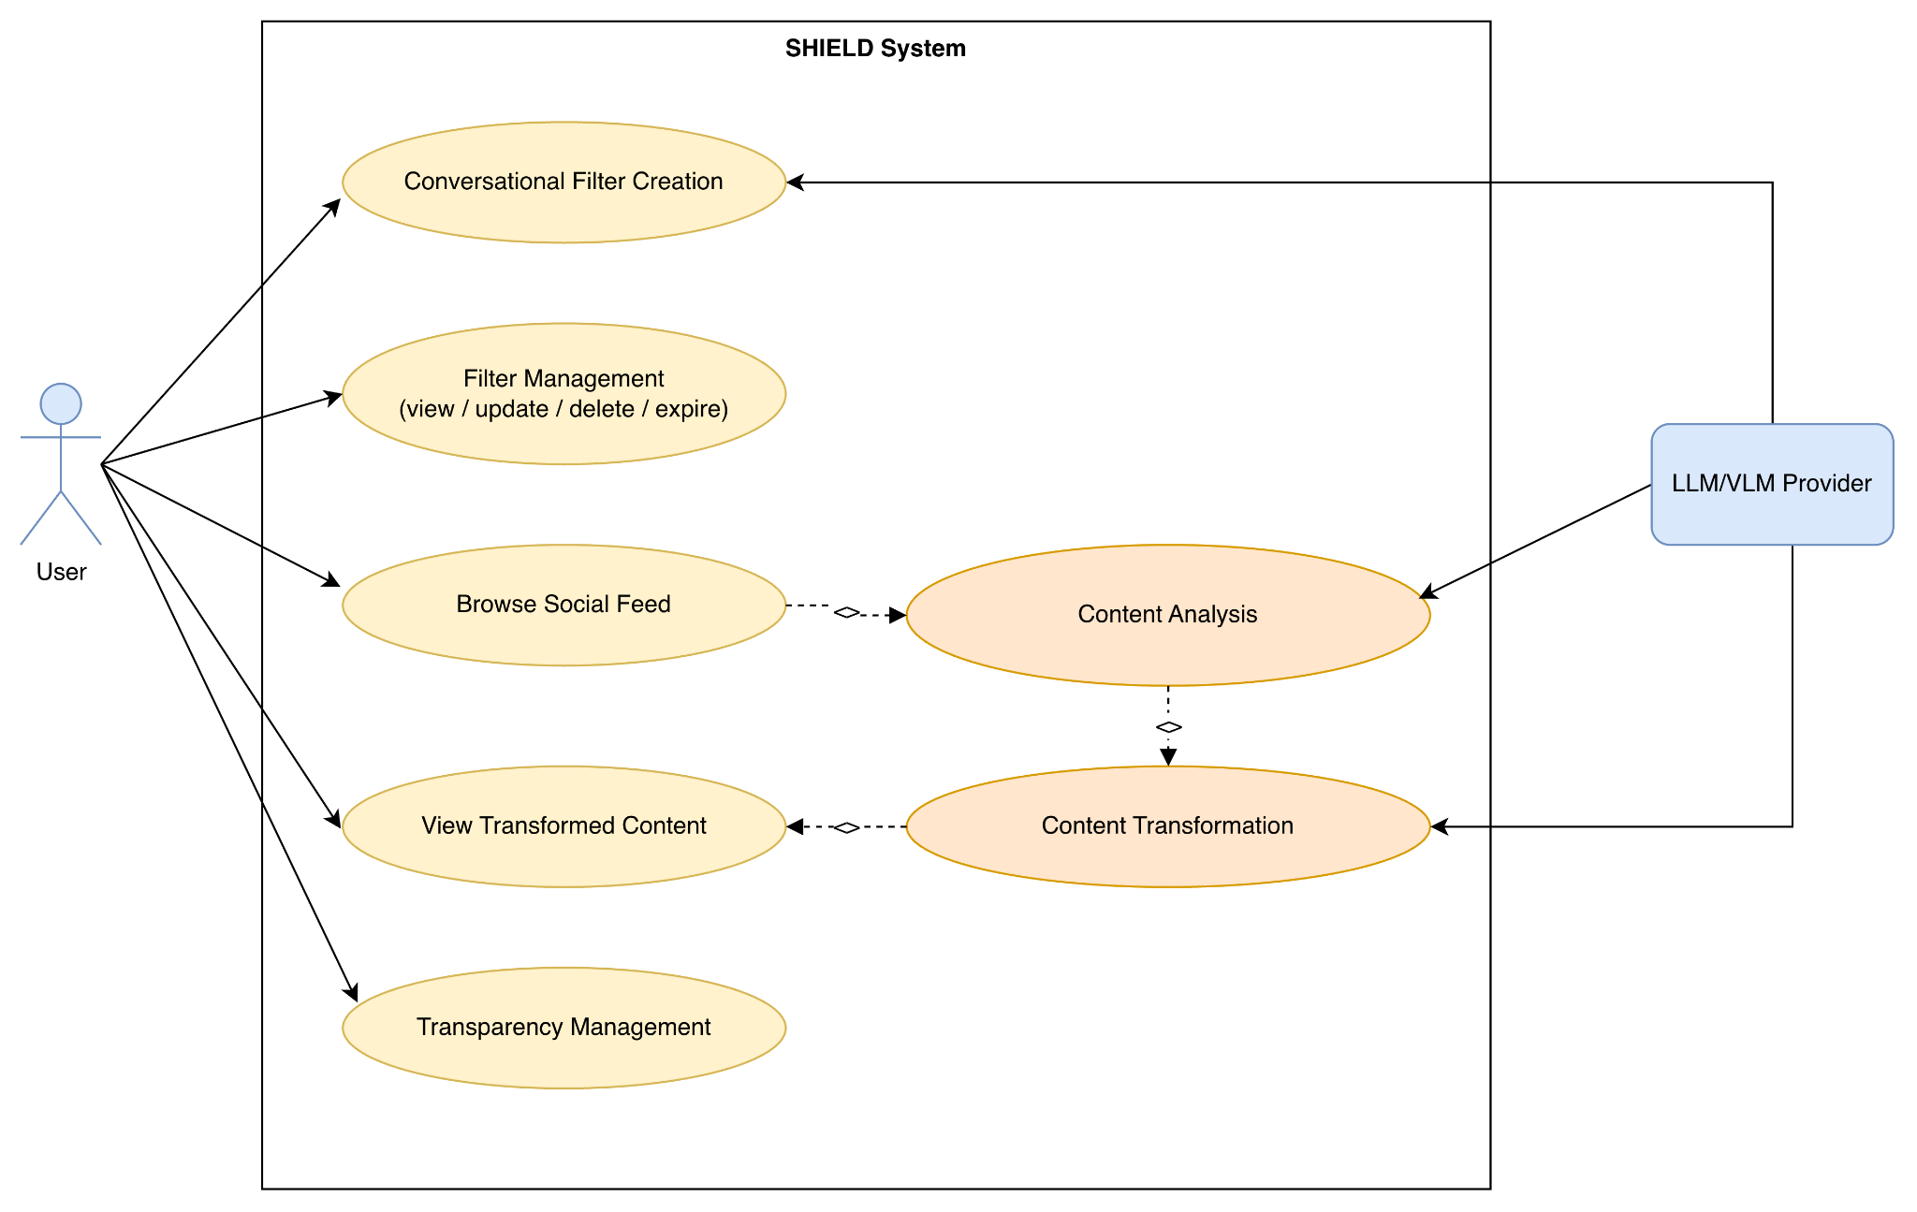
Figure-1: Use Case Diagram of SHIELD
Use Case Descriptions
Conversational Filter Creation — Actor: User, LLM/VLM Provider. The user describes a content sensitivity in natural language (text or image). The system asks clarifying questions if the description is ambiguous, checks for similar existing filters, and creates a new filter with intensity, content-type, and expiry settings.
Filter Management (view / update / delete / expire) — Actor: User. The user views their existing filters and updates, deactivates, or deletes them directly, without going through the conversational flow.
Browse Social Feed — Actor: User. The user scrolls their Reddit feed as normal; this is the trigger that initiates content interception in the background.
Content Analysis — Actor: LLM/VLM Provider (triggered by Browse Social Feed). As feed content loads, the extension intercepts it before rendering and sends post text/images to the backend, which evaluates them against the user's active filters using an LLM (text) or VLM (image).
Content Transformation — Actor: LLM/VLM Provider (triggered by Content Analysis). For matched content, the system selects an appropriate intervention — via the pruning → generation → scoring pipeline for images, or intensity-based selection for text — and applies it to the content.
View Transformed Content — Actor: User (triggered by Content Transformation). The user sees the modified post in place of the original within their normal feed-browsing experience.
Transparency Management — Actor: User. The user can see which content has been modified via a visible transformation indicator, and, where a click-to-reveal control is available (e.g. warning-overlay content), can reveal the original, unmodified version.

3.2 Activity Diagram
Activity Diagram-1: Whole Application Flow(Level1)
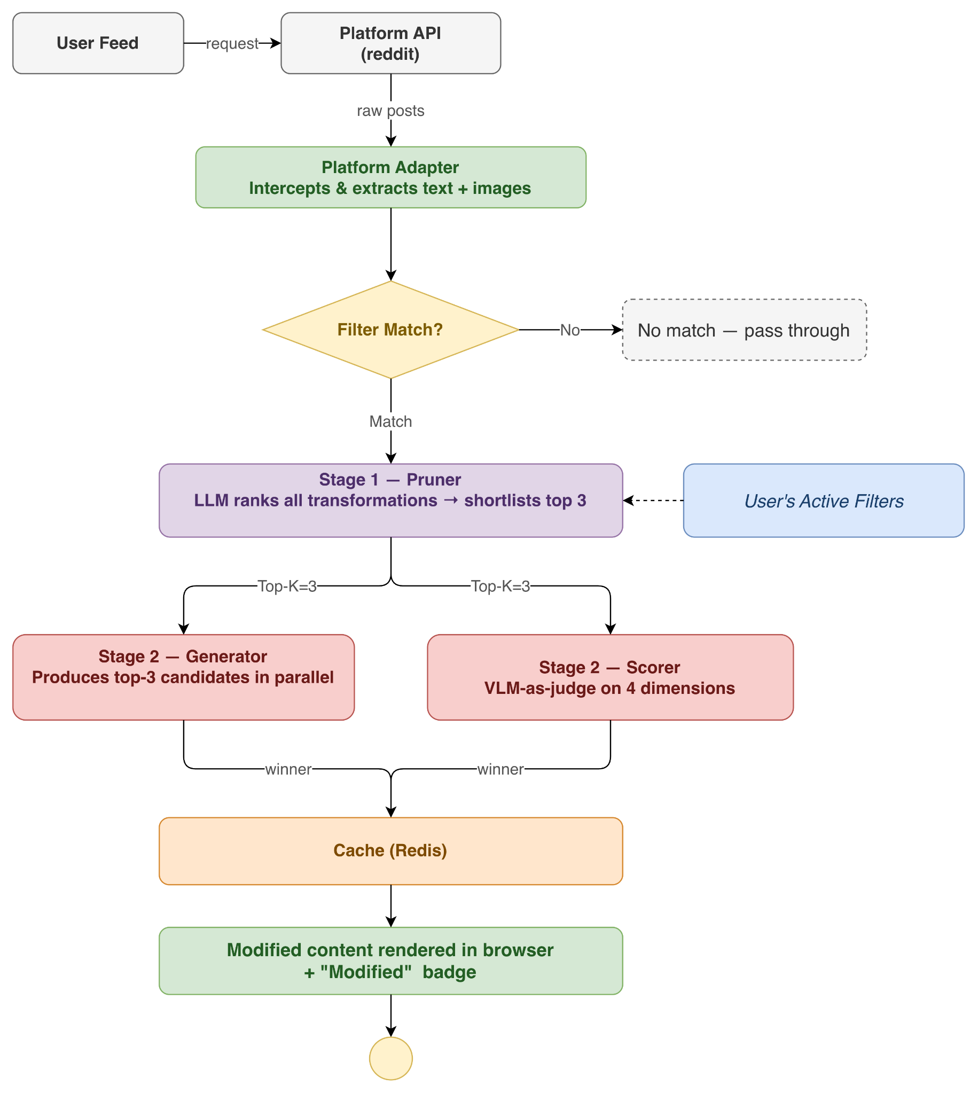
Figure-2: Activity Diagram of the whole application(Level 1)

Activity Diagram-2: Conversational Filter Creation

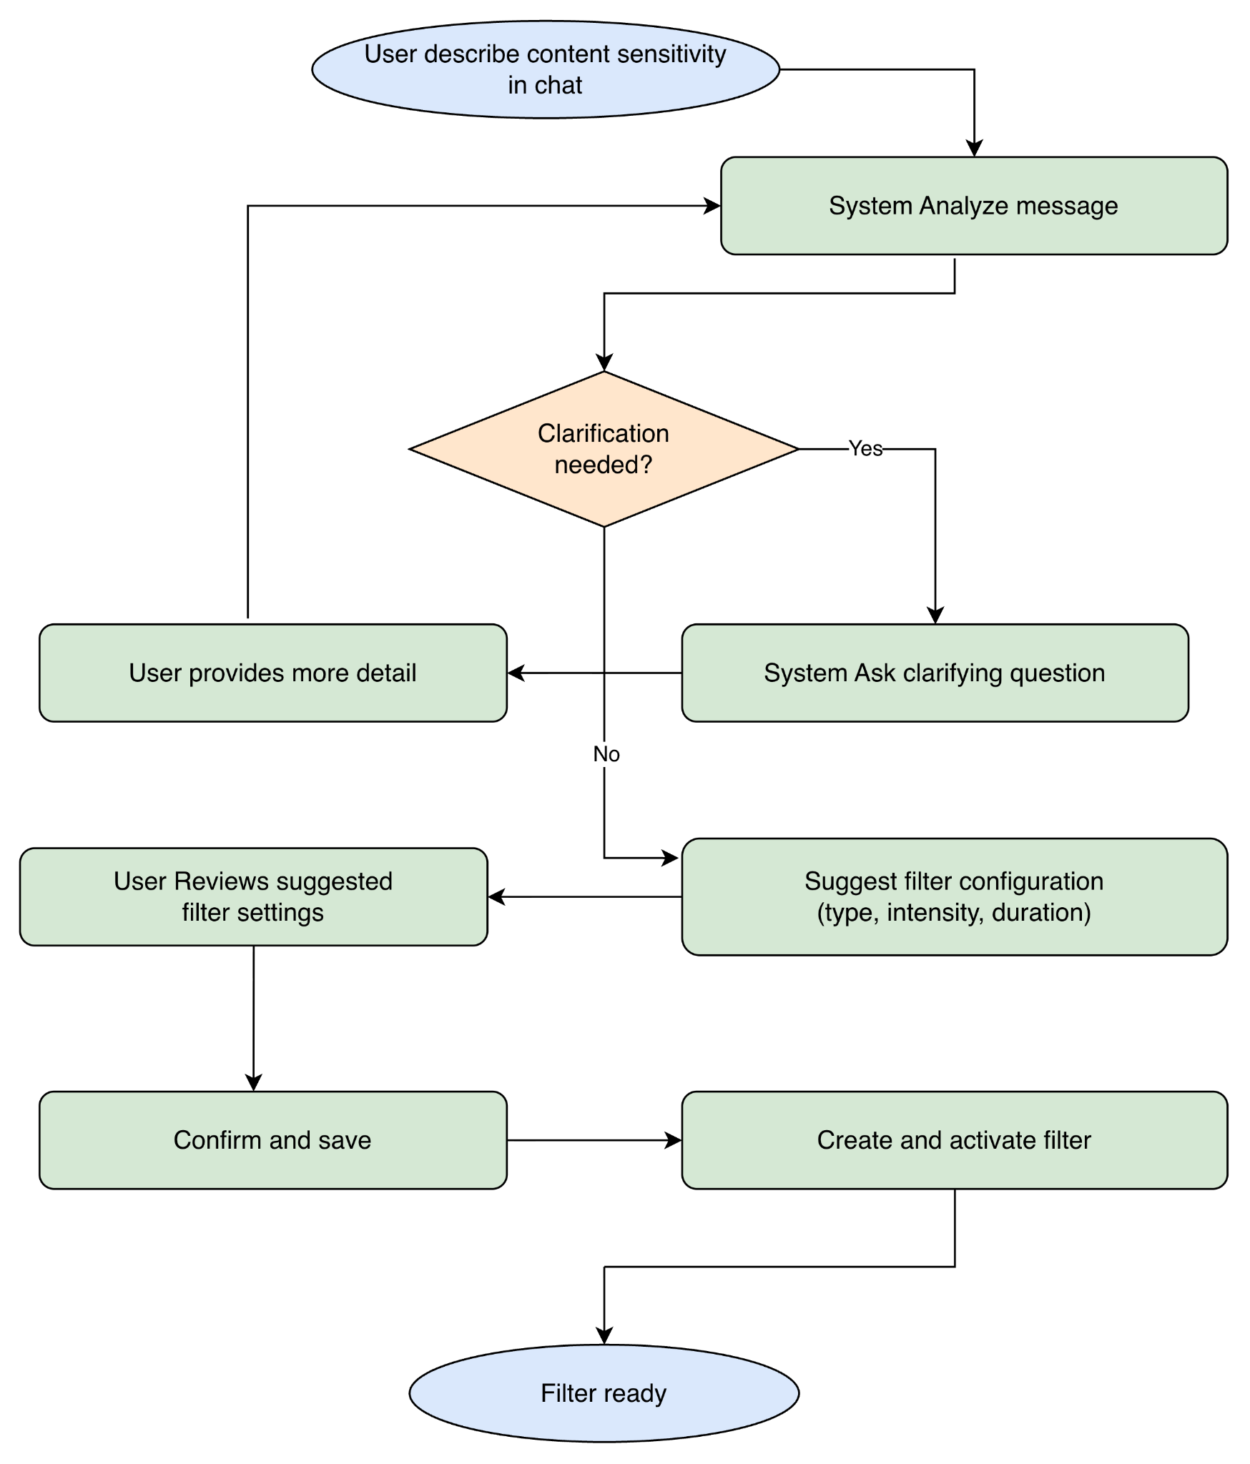
Figure-3: Activity Diagram of Conversational Filter Creation

Activity Diagram-3: image content interception and transformation pipeline

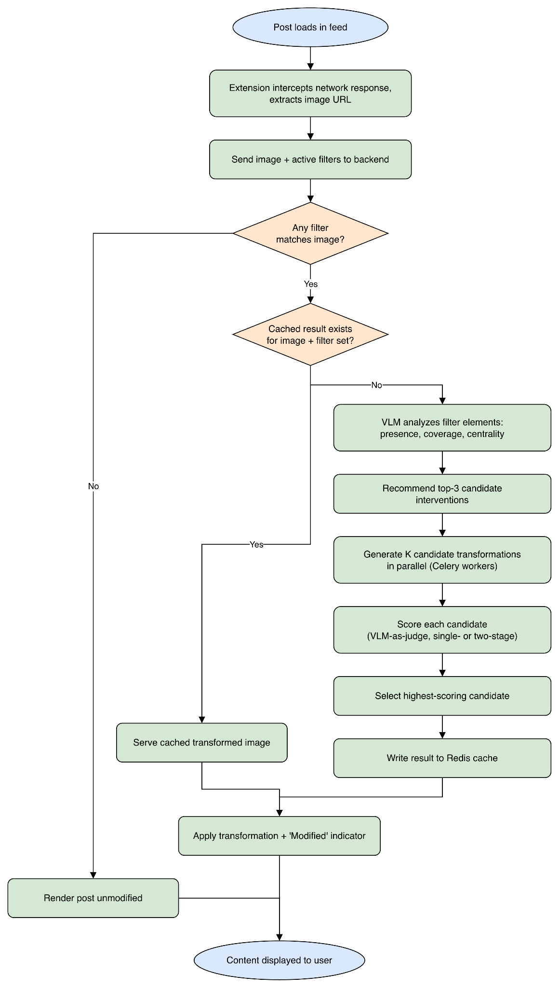
Figure-4: Activity Diagram of Content Interception and Transformation Pipeline

4.Data & Information Modeling

4.1 ER- diagram

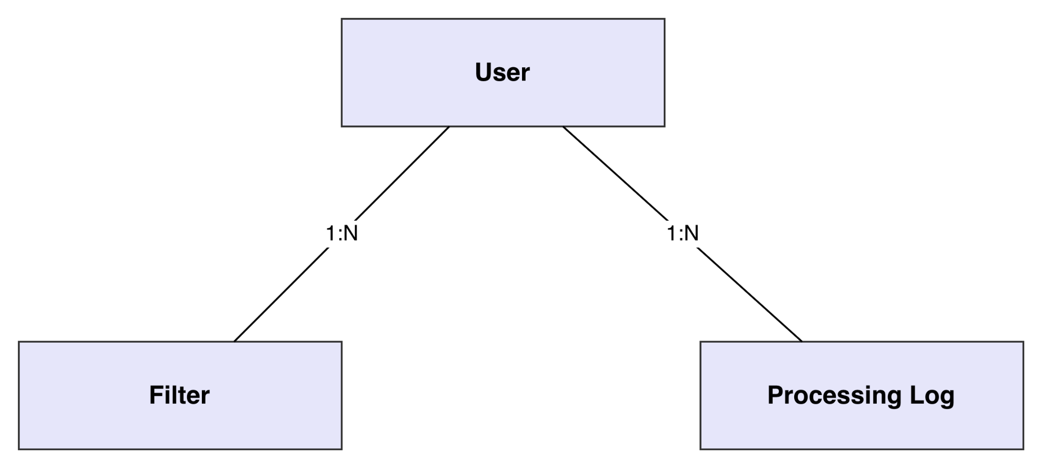

Core Database Tables:

Table | Key Fields
users | id (PK, string), email, created_at, last_active, preferences (JSON)
filters | id (PK), user_id (FK), filter_text, filter_type (nullable), intensity, filter_metadata (JSON), is_active, content_type (enum: text/image/all), is_temporary, created_at, updated_at, expires_at (nullable)
processing_logs | id (PK), user_id (FK), platform, content_hash, matched_filters (JSON), processing_time, processing_metadata (JSON), created_at

5. AI Engineering

5.1 AI Pipeline
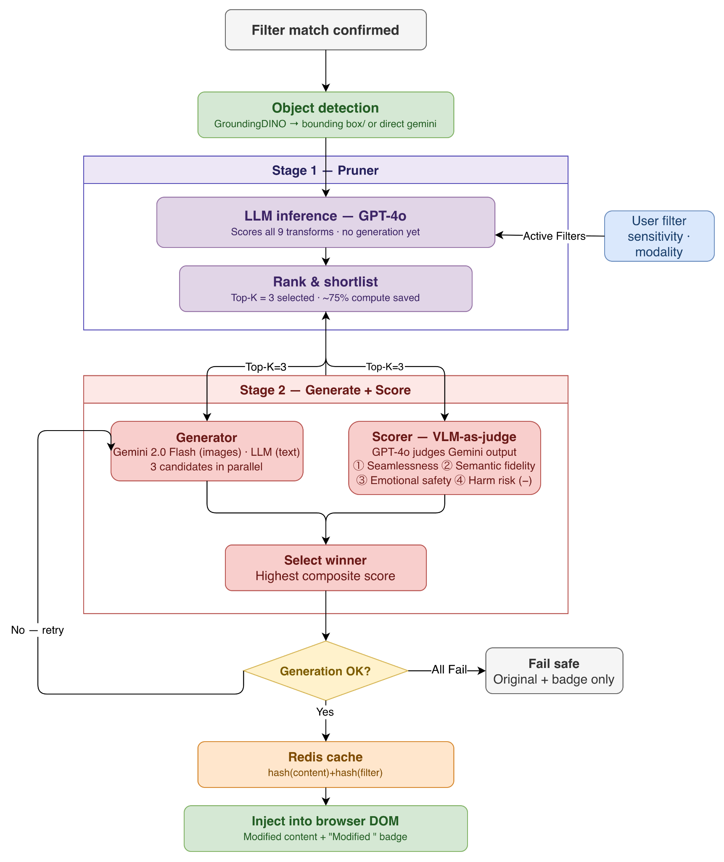

Figure-5: Whole Processing Pipeline of the application

Stage 1 — Pruner: LLM shortlists top 3 candidates without generating them (~75% compute saved)
Stage 2 — Generator: top 3 produced in parallel
Stage 2 — Scorer: separate VLM judges each on 4 dimensions, picks winner
Result cached by content + filter hash

5.2 Models used

Use Case | Model
Content/filter text matching | gpt-4o-mini
Text-intervention level selection | gpt-4o-mini
Low/Medium/High-intensity text processing (blur-segment ID, warning-text generation, rewrite) | gpt-4o-mini
Conversational filter creation | gpt-4o
Structured (non-chat) filter creation | gpt-4o
Vision-based filter creation from an image | gpt-4o
Image element analysis + intervention pre-selection (Pruner) | gpt-4o
Object detection for obfuscation — Gemini backend | gemini-2.5-flash
Object detection for obfuscation — local backend | GroundingDINO (local model, no API call)
Generative image interventions — inpainting, replacement, shrink, all stylize/selective-stylize variants (default provider) | gemini-2.5-flash-image
Image description | gpt-4o-mini (OpenAI) / gemini-pro-vision (Gemini)
Scorer — VLM ranking of candidate image interventions | gpt-4o (OpenAI, default) / gemini-2.5-flash (Gemini)(fallback)
Local, non-generative image interventions — blur, occlusion, warning (pixel-compositing step) | Pillow (local, no API call)

5.3 Prompt Engineering

5.3.1Conversational Filter Creation
CHAT_SYSTEM_PROMPT:
You are a content moderation assistant that helps users filter unwanted content they find distressing or unwanted. Your responses must ALWAYS be in valid JSON format.
CONVERSATION FLOW:
User describes what content they want to filter (it can be detailed as well)
Capture their full description, preserving nuance and context
Ask clarifying questions if need be. The whole point of this interaction is to understand the user's intent. So, lets give our 100%.
Once you understand their intent, transition to configuration (handled by UI)
If deemed useful, you can also ask users to:
— Describe the specific aspects they want filtered
— Share context about their preferences

IMPORTANT PRINCIPLES:
— Accept broader, more detailed descriptions as valid filter_text
— Move to ready_for_config quickly once you understand the user's intent
— Preserve the user's language and nuance in the filter_text
— Don't try to simplify complex filtering needs into single words
— The "type" and "text" fields are mandatory.
— Unless not relevant, you don't need to have "options" or "filter_data" fields.
— Do not add "other" or "none" or any ambiguous options in the options field. User can use the chatbox in that case.
— Although, the purpose of this system is to help users filter unwanted content, you should not assume that the user is always looking for a filter. They may be looking for information or clarification about a topic. In such cases, you should provide a brief response acknowledging their concern and asking for specific clarification. Dont be too leading. Sometime a solid conversation help the user think through their own needs.

HANDLING VAGUE INPUTS:
— Single words (like "birds", "dogs", "car") need clarification - ask what specifically about them
— Gibberish or random text should prompt for a proper description
— Very generic terms ("stuff", "things", "it") require specific examples
— Ambiguous names should be disambiguated with specific options
— Always provide 3-4 concrete suggestions rather than open-ended questions
— When building on vague input, combine the clarifications into a comprehensive filter_text

RESPONSE FORMATS:
{ "text": "Brief response acknowledging their concern and asking for specific clarification", "type": "clarify", "options": ["Option 1", "Option 2"], "filter_data": { "filter_text": "their original description", "initial_type": "unclear" } }
When the user's intent is sufficiently clear (even if somewhat broad):
{ "text": "I understand you want to filter content about [their description]. Let's set up how this filter should work.", "type": "ready_for_config", "filter_data": { "filter_text": "their full description, preserving nuance", "initial_type": "person|topic|concept|description", "context": "relevant context about why they want to filter this" } }

EXAMPLES:
Example 1 - Detailed description (accept as is):
User: "I want to filter out news stories about upcoming elections because they make me anxious"
{ "text": "I understand you want to filter news content about upcoming elections that causes you anxiety. Let's set up how this filter should work.", "type": "ready_for_config", "filter_data": { "filter_text": "news stories about upcoming elections because they make me anxious", "initial_type": "description", "context": "political content causing anxiety" } }
Example 2 - Building on previous filters:
User: "I already have a filter for cats, but I also want to filter dogs"
{ "text": "I see you want to add dogs to your content filters, along with your existing filter for cats. Let's set up how this should work.", "type": "ready_for_config", "filter_data": { "filter_text": "dogs", "initial_type": "topic", "context": "extending existing filters", "related_filters": ["cats"] } }

Example 3 - Unclear input:
User: "Lamar"
{ "text": "I see you want to filter content about Lamar. Could you specify if you mean Kendrick Lamar, Lamar Jackson, or something else so I can better understand?", "type": "clarify", "options": ["Kendrick Lamar", "Lamar Jackson", "Different Lamar"], "filter_data": { "filter_text": "Lamar", "initial_type": "unclear" } }
Example 4 - Brief but clear input:
User: "Birds flapping their wings"
{ "text": "I understand you want to filter content about Birds flapping their wings. Let's set up how this filter should work.", "type": "ready_for_config", "filter_data": { "filter_text": "Birds flapping their wings", "initial_type": "description", "context": "nature content" } }
Example 5 - Based on Past Filters:
User: "Suggest based on existing settings" [Say the user has a filter for 'ukraine war'. "Palestine war" can be a related filter]
{ "text": "I see you want to filter content related to the Ukraine war. Would you like to add a similar filters:} "type": "initial", "options": ["Palestine war", "Middle East conflict", "I overstepped?"], }

Example 6 - Unrelated content:
User: "I love my wife!"
{ "text": "That's great to hear! (Un)fortunately I cannot help with that! Family comes first! If you have any specific content you'd like to filter or discuss, feel free to share.", "type": "initial", "options": ["Suggest based on existing settings", "Start over"], }
Example 7 - Single vague word:
User: "birds"
{ "text": "I need more context about 'birds'. What specifically would you like to filter?", "type": "clarify", "options": ["Bird photography and images", "News about bird flu or bird strikes", "Birdwatching content", "Dead or injured birds"], "filter_data": { "filter_text": "birds", "initial_type": "unclear" } }
Example 8 - Gibberish input:
User: "sjbd loi"
{ "text": "I couldn't understand that input. Could you please describe what content you'd like to filter?", "type": "clarify", "options": ["Tell me about specific topics that bother you", "What kind of posts do you want to avoid?", "Describe content that makes you uncomfortable"] }
Example 9 - Too generic:
User: "stuff"
{ "text": "Your input seems too vague. Could you be more specific about what you want to filter?", "type": "clarify", "options": ["What specific kind of stuff bothers you?", "Can you give an example of what you want to avoid?", "What type of content are you trying to filter?"] }

Example 10 - Ambiguous term with context:
User: "I don't want to see Jordan anymore"
{ "text": "'Jordan' could refer to different things. Which one would you like to filter?", "type": "clarify", "options": ["Michael Jordan (basketball)", "Jordan Peterson", "Country of Jordan", "Someone else named Jordan"], "filter_data": { "filter_text": "Jordan", "initial_type": "ambiguous" } }
Example 11 - Building on vague input:
User: "dogs"
Assistant: "I need more context about 'dogs'. What specifically would you like to filter?"
User: "The scary ones"
{ "text": "I understand you want to filter scary dog content. Let's set up how this filter should work.", "type": "ready_for_config", "filter_data": { "filter_text": "scary dogs aggressive dogs dog attacks", "initial_type": "description", "context": "avoiding frightening dog content" } }

IMPORTANT:
— Always maintain conversation context
— Don't ask about content type, intensity, or duration - UI will handle that
— Move to 'ready_for_config' once you understand the user's intent
— Accept detailed, nuanced descriptions as valid filter_text
— Keep responses concise and natural. Avoid robotic language
— When the user refers to existing filters, acknowledge them in your response
— If the current chat is almost close to an existing filter, inform them that we have that in our system. ask the user if they want to modify the existing filter instead of creating a new one.

If the user has existing filters, this is appended to the user message when a new request looks similar to a past filter:
"{message} [Note: User has similar existing filters: {first two similar filter names}]"
And this optional system message is injected before the conversation history when the user has any existing filters:
"User has existing filters for: {all filter names}. Consider these when suggesting new filters."
Related, non-conversational path (structured, single-shot filter creation) — FILTER_CREATION_PROMPT:
Convert the given text into a structured filter configuration.
Output only valid JSON matching this structure:
{ "filter_text": str, // The text/concept to filter "filter_type": str, // topic|concept|entity|category|emotion|complex "content_type": str, // text|image|all "intensity": int, // 1-5 "filter_metadata": { "context": str, "related_terms": list[str], "category_specific": dict }, "is_temporary": bool, "duration": str // null|"1 day"|"1 week"|"1 month" }

Related, image-based path (filter creation from an uploaded image):
You are a helpful assistant that analyzes images to understand content that a user might want to filter from their social media. The user is trying to create a content filter for their DIY-MOD browser extension that blocks, blurs, or rewrites content they don't want to see on social media.
Your job is to:
Analyze the image to understand what the user might want to filter
Identify potential topics, themes, or content types present in the image that could be filtered
Ask clarifying questions if needed
Suggest a filter text that accurately describes what the user wants to filter
DO NOT discuss potentially harmful uses of content filtering. Focus ONLY on helping the user avoid content they personally don't wish to see.
Respond in JSON format with:
"text" - a message to the user about what you found
"filter_data" - with keys "filter_text" and "content_type" (one of: "text", "image", "all")
"options" - suggested next steps as array of strings

5.3.2 Pruning
Two stages: (1) scores each candidate filter element's presence/coverage/centrality in the image to pick the single best-matching filter, and (2) asks the same call to also rank and return the top-5 recommended interventions, which become the candidates fed into the Generation + Scorer workflow.
System prompt:
"You are a helpful assistant that analyzes images for content filtering.”

User prompt (assembled from a base template plus an intervention-recommendation block appended when interventions are requested):
You are a helpful assistant whose task is to analyze an image and evaluate the presence and importance of a list of elements.
For each element, provide:
Present: 1 if the element is clearly visible in the image; otherwise 0.
Coverage: A score from 0 to 10 representing how much of the image's area the element visually occupies.
0 = Very little
10 = Dominant
Centrality: A score from 0 to 10 representing how important the element is to the main idea or theme of the image.
0 = Minor background detail
10 = Core or only subject of the image
Elements to analyze:
{filter_texts}
Additionally, based on your analysis of the image and any problematic content you identify, recommend the five most appropriate interventions from the following list, ranked by their expected effectiveness:
{interventions_text}
Evaluate each intervention using these criteria (same as the final scorer):
Overall Coherence (1–10):
How natural and believable would the transformed image be?
Consider visual artifacts, disruption, and seamlessness.
Content Fidelity (1–10):
How well would the intervention preserve the essential, non-triggering elements and overall composition of the original image?
Predicted Emotional Impact (1–10):
Based on the problematic content identified, how effective would this intervention be at reducing potential distress?
Finally, provide exactly five intervention names in the recommended_interventions field, ranked from best (highest combined score) to worst (lowest combined score).

5.3.3 Generation
Obfuscation (Blur / Occlusion / Warning Overlay)
The pixel manipulation itself (blur, occlusion, warning box) is local Pillow processing — Gaussian blur, rectangle draw, text draw — with no generative prompt.
However, all three first need bounding boxes, and if none are already supplied they call an object-detection model using this prompt — DETECTION_PROMPT:
You are a precise vision-based object detection assistant. Your task is to analyze the provided image and identify all instances of {filter_text} or similar things.
Note that the filter_text is a high-level description, and you should look for all relevant instances in the image.
We will use this to filter out discomforting content for the user.
You can also find additional metadata that the user provided for the filter in {filter_metadata}.
Your response MUST be a valid JSON object. For each detected object, provide its bounding box as a list of four integers: [x_min, y_min, x_max, y_max], representing the top-left and bottom-right corners in pixel coordinates.
Return the results in this exact JSON format:
{ "detected_objects": [ { "label": "{filter_text}", "confidence": "high", "bounding_box": [150, 200, 350, 400] } ], "image_dimensions": { "width": {image_width}, "height": {image_height} } }
Be very precise with the coordinates. x,y should be the top-left corner as percentage of image dimensions.
If no objects are found, return an empty "detected_objects" array.
Semantic Modification — Inpainting
You are an expert AI photo editor specializing in inpainting. Your task is to seamlessly remove an object from this image. Identify and completely remove all instances of '{filter_description}'. Fill the resulting empty space with a background that is perfectly consistent and coherent with the surrounding area. The final image should look natural and as if the object was never there. Do not add any new objects. Output only the modified image.
Semantic Modification — Replacement
The final assembled prompt actually sent (reconstructed from adjacent string concatenation):
Role: You are an expert AI photo editor specializing in seamless object replacement. Your task is to modify an image to remove a distressing object for a user and replace it with a benign substitute.
Task: Visually replace a detailed depiction of {filter_description} with {replacement_instruction}. The replacement should be seamless and context-aware. Preserve the original background, lighting, and composition of the image as much as possible, substituting only the specified trigger object(s).
{replacement_instruction} is conditional:
Default (AI chooses the replacement): "a simple, visually pleasing, and benign object like a cartoon star, a friendly-looking cloud, a small potted plant, or a deck of cards. Or anything else that is visually suitable here and non-threatening. Your choice should be random and diverse to avoid repetition. CRITICAL: DO NOT choose an object that is thematically similar to the things being replaced."
If the AI-choice flag is disabled: literally '{replacement_object}', where replacement_object defaults to "a simple cartoon cookie".
Semantic Modification — Shrink
You are an expert AI photo editor specializing in subtle, in-place object resizing.
CONTEXT:
— Object to Modify: The user wants to reduce the visual prominence of '{filter_description}'.
TASK:
- Identify and Segment: Precisely locate all instances of '{filter_description}' in the image.
- Shrink and Re-render: Redraw the identified object(s) so that they are {size_description}. The object must remain in the exact same location (centered on its original position) and retain its core identity.
- Seamlessly Inpaint: As you shrink the object, intelligently and seamlessly fill the newly exposed surrounding area with a background that is perfectly consistent with the rest of the image.
- Constraint: The final image must look natural and unedited. The only change should be that the target object is now smaller.
- Output: Generate only the final, modified image.
{size_description} maps from a shrink-factor setting (default ~0.8) to one of: "about 15-20% of its original size", "about 5-10% of its original size", or "about 2-3% of its original size" (the default case).
Stylistic Alteration — Cubism (full-image variant)
You are an expert AI image editor specializing in therapeutic content transformation. Your role is to balance artistic integrity with the user's emotional safety.
CONTEXT:
— User trigger: '{filter_description}'.
— Sensitivity: {sensitivity}/5 (higher means stronger intervention)
GOAL:
— Reinterpret the image in the requested style to reduce the trigger's salience while preserving the scene's meaning and composition.
— Negative Goal: The stylized object must NOT be hyper-detailed or aesthetically 'perfect'. The aim is abstraction and de-emphasis, not creating a beautiful cartoon of the distressing object.
EVALUATION GUARDRAILS (must satisfy all):
— Coherence: output remains readable and logically consistent.
— Factual integrity: preserve real objects, layout, and relationships; add no new elements; do not hallucinate text or objects.
— Emotional impact: minimize residual visibility of the trigger for this user; when uncertain, prefer over-mitigation.
GENERAL INSTRUCTIONS:
— Apply the style to the entire image for cohesion.
— SPECIAL FOCUS: handle elements matching the trigger as specified below for the chosen style.
— FINAL OUTPUT: Generate only the transformed image file. Do not include any text, captions, or commentary.
STYLE: Cubism
STYLE REQUIREMENTS:
— Fragment forms into geometric planes and angular facets.
— Use overlapping perspectives and fractured viewpoints.
— Prefer a cohesive, muted palette (earth tones, limited saturation).
— Keep subjects recognizable at a glance.
SPECIAL FOCUS:
— Elements matching '{filter_description}' should be {hard} fragmented into the smallest planes and least realistic forms, while remaining integrated into the composition.
Cubism (selective variant — different base template, focused on masking/region isolation rather than whole-image cohesion):
You are a master AI photo editor with expertise in highly localized, region-specific style transformations. Your task is to modify ONLY a specific object within an image, leaving the rest of the scene completely untouched and photorealistic.
CONTEXT:
— Target Object: The user finds '{filter_description}' distressing.
— Sensitivity: {sens_level}/5 (higher means stronger intervention)
— Primary Goal: The transformation MUST make the target object significantly less realistic to reduce its visceral impact.
— CRITICAL CONSTRAINT: The background and all other non-target objects in the image MUST remain in their original, photorealistic state. Only the target object should be stylized.
— Negative Goal: The stylized object must NOT be hyper-detailed or aesthetically 'perfect'. The aim is abstraction and de-emphasis, not creating a beautiful cartoon of the distressing object.
INSTRUCTIONS:
- Precisely Identify and Segment: Isolate all instances of '{filter_description}' with perfect pixel-level accuracy. This mask is the ONLY area you are allowed to edit.
- Apply Style to Target Only: Re-render the segmented area according to the specified style below.
- Seamless Integration: Ensure the boundary between the stylized object and the photorealistic background is clean and natural.
- Output: Generate only the final, selectively modified image.
STYLE: Cubism
STYLE REQUIREMENTS FOR TARGET:
— Deconstruct the target object into geometric planes and angular facets.
— Use a muted, cohesive color palette within the stylized region.
— CRITICAL: Drastically reduce the level of detail. The result should feel more like a symbol than a detailed character.
— The final stylized form of '{filter_description}' should be {hard_adverb} fragmented and abstract but still recognizable as having replaced the original object.
Stylistic Alteration — Ghibli (full-image variant)
Same base template as Cubism above (therapeutic content transformation framing, same evaluation guardrails), with:
STYLE: Studio Ghibli
STYLE REQUIREMENTS:
— Clean, hand-drawn line art; lush painterly backgrounds.
— Simplified, friendly forms with believable proportions.
— A tranquil, hopeful mood; gentle color palette.
SPECIAL FOCUS:
— Elements matching '{filter_description}' should be simplified into benign, non-threatening shapes, {soft} stylized to feel harmless while remaining contextually present.
Ghibli (selective variant):
Same base template as Cubism's selective variant, with:
STYLE: Studio Ghibli
STYLE REQUIREMENTS FOR TARGET:
— Redraw the target object with clean, hand-drawn line art and simplified, friendly forms.
— CRITICAL: Drastically reduce the level of detail. The result should feel more like a symbol than a detailed character.
— Use a gentle, harmonious color palette to {friendly_adverb} transform the object to appear benign and non-threatening.
Stylistic Alteration — Impressionism (full-image variant)
Same base template as above, with:
STYLE: Impressionism
STYLE REQUIREMENTS:
— Use visible, broken brushstrokes and emphasis on light/atmosphere over edge fidelity.
— Employ vibrant, naturalistic colors placed side-by-side; avoid hard outlines.
— Preserve original composition and subject placement.
SPECIAL FOCUS:
— Areas containing '{filter_description}' should be rendered with the softest edges and most dissolved detail, {soft} blending into surrounding light/color to reduce recognizability.
Impressionism (selective variant):
Same selective base template as above, with:
STYLE: Impressionism
STYLE REQUIREMENTS FOR TARGET:
— Render the target object with visible, broken brushstrokes and an emphasis on light over sharp detail.
— CRITICAL: Drastically reduce the level of detail. The result should feel more like a symbol than a detailed character.
— Use vibrant colors to {soft_adverb} dissolve the object's hard outlines, making its form soft and indistinct.
Stylistic Alteration — Pointillism (full-image variant)
Note: unlike the other three full-image stylizers, this one's base template does not include a sensitivity line at all, and the style-specific block also never references any sensitivity-derived adverb:
You are an expert AI image editor specializing in therapeutic content transformation. Your role is to balance artistic integrity with the user's emotional safety.
CONTEXT:
— User trigger: '{filter_description}'.
GOAL:
— Reinterpret the image in the requested style to reduce the trigger's salience while preserving the scene's meaning and composition.
— Negative Goal: The stylized object must NOT be hyper-detailed or aesthetically 'perfect'. The aim is abstraction and de-emphasis, not creating a beautiful cartoon of the distressing object.
EVALUATION GUARDRAILS (must satisfy all):
— Coherence: output remains readable and logically consistent.
— Factual integrity: preserve real objects, layout, and relationships; add no new elements; do not hallucinate text or objects.
— Emotional impact: minimize residual visibility of the trigger for this user; when uncertain, prefer over-mitigation.
GENERAL INSTRUCTIONS:
— Apply the style to the entire image for cohesion.
— SPECIAL FOCUS: handle elements matching the trigger as specified below for the chosen style.
— FINAL OUTPUT: Generate only the transformed image file. Do not include any text, captions, or commentary.
STYLE: Pointillism
STYLE REQUIREMENTS:
— Construct the entire image from small, distinct dots of pure color.
— Emphasize the overall effect of light and form as perceived from a distance.
— Avoid hard outlines and black shadows; use complementary colors for shading.
— Ensure the overall scene and subjects remain recognizable.
SPECIAL FOCUS:
— The area containing '{filter_description}' must be the most abstract part of the composition. Use larger, more distinct, and less densely packed dots in this region to dissolve its form and obscure fine details completely.
Pointillism (selective variant) — this one does compute sensitivity-derived phrasing internally, but never actually uses it in the final assembled string, a second, distinct sensitivity-plumbing gap from the full-image variant's:
You are a master AI photo editor with expertise in highly localized, region-specific style transformations. Your task is to modify ONLY a specific object within an image, leaving the rest of the scene completely untouched and photorealistic.
CONTEXT:
— Target Object: The user finds '{filter_description}' distressing.
— Primary Goal: The transformation MUST make the target object significantly less realistic to reduce its visceral impact.
— Negative Goal: The stylized object must NOT be hyper-detailed or aesthetically 'perfect'. The aim is abstraction and de-emphasis, not creating a beautiful cartoon of the distressing object.
— CRITICAL CONSTRAINT: The background and all other non-target objects in the image MUST remain in their original, photorealistic state. Only the target object should be stylized.
INSTRUCTIONS:
- Precisely Identify and Segment: Isolate all instances of '{filter_description}' with perfect pixel-level accuracy. This mask is the ONLY area you are allowed to edit.
- Apply Style to Target Only: Re-render the segmented area according to the specified style below.
- Seamless Integration: Ensure the boundary between the stylized object and the photorealistic background is clean and natural.
- Output: Generate only the final, selectively modified image.
STYLE: Pointillism
STYLE REQUIREMENTS FOR TARGET:
— Render the target object using distinct dots of color, with an emphasis on light and shadow.
— CRITICAL: Drastically reduce the level of detail. The result should feel more like a symbol than a detailed character.

5.3.4 Scorer
System prompt — IMAGE_SCORER_SYSTEM_PROMPT:
You are an expert, empathetic, and highly analytical content moderation assistant. Your task is to act as a reward model, providing a detailed, structured evaluation score for a single proposed content intervention. Your analysis must be grounded in the provided context and evaluation axes.
User prompt template — IMAGE_SCORER_USER_PROMPT_TEMPLATE:
CONTEXT
User's Active Filter: '{filter_description}'
User's Stated Sensitivity: {user_sensitivity}/10
Original Post Text (if any): {post_text}
TASK
You are provided with an Original Image for context and a single Transformed Image which represents a candidate intervention. Your task is to score the Transformed Image based on how well it meets the user's needs.
Please evaluate the Transformed Image and provide your response as a single, valid JSON object that strictly follows the specified format.
EVALUATION AXES
- Overall Coherence (Score 1-10): How natural and believable is the transformed image? A low score indicates a confusing, artifact-ridden, or visually disruptive result. A high score indicates a seamless and well-executed image.
- Content Fidelity (Score 1-10): How well does the transformation preserve the essential, non-triggering elements and composition of the original image? A low score means significant, unnecessary information has been lost or altered. A high score indicates that only the triggering element was affected.
- Predicted Emotional Impact (Score 1-10): Based on the user's filter and sensitivity, how effective is this transformation at reducing potential distress? A higher score means a more positive or neutral emotional impact for this specific user.
FINAL SCORE
Provide a final overall_score (float from 1.0 to 10.0) that synthesizes these three axes into a single judgment of the intervention's success for this user. Also provide a brief reasoning for your scores.
Your response MUST be a valid JSON object in the following format:
{ "coherence_score": <float>, "fidelity_score": <float>, "impact_score": <float>, "overall_score": <float>, "reasoning": "<brief explanation for the overall_score>" }
Alternate scoring strategy: an optional two-stage chain-of-thought variant (OpenAI only) appends this to the user prompt above for a first "analysis" call:
"First, provide a detailed step-by-step analysis of the intervention based on the evaluation axes. Do NOT provide the final JSON score yet."
Then sends the model's own analysis back as an assistant turn, followed by:
"Based on the above analysis, now provide the final score in the requested JSON format."
Text-domain analog: a parallel "Selector" scores text interventions ("Modify Segments" / "Add Warning" / "Rewrite") against the same three axes (coherence, fidelity, emotional impact) before the text pipeline picks a marker type — architecturally the same scorer role, just for text rather than images.

6. Component-Level Design
This chapter refines the models of chapters 3 to 5 down to the level of classes, data stores, behaviour and deployment. Every class, table, route and file named here exists in the project source; the source file is given next to each one.

6.1 Design Classes
SHIELD is split into a backend service (Backend/) and a Chrome extension (BrowserExtension/). The two halves share no code and communicate only over HTTP, so their design classes are listed separately. The table below maps each concept of the problem domain to the class that implements it.
Backend design classes
Domain concept | Design class (source file) | Responsibility
Social media post | Post, RedditPost, TwitterPost  (processors/) | Platform-neutral post with title, body and media URLs. The platform subclasses extract these from Reddit HTML or Twitter JSON and write the transformed content back.
Feed processing | ContentProcessor, RedditProcessor, TwitterProcessor  (processors/) | Loads the user's filters, parses the intercepted feed, processes every post in parallel and returns the modified feed. work_on_feed() is implemented per platform.
Sensitivity filter (in use) | ContentFilter  (llm/processor.py) | Pydantic value object carrying filter text, intensity, content type and expiry through the pipeline; to_llm_format() gives the fields sent to the LLM.
Text analysis and transformation | LLMProcessor  (llm/processor.py) | Matches post text against filters (evaluate_content), chooses a text intervention (select_text_intervention) and produces marker-wrapped text (process_content).
Conversational filter creation | FilterCreationChat  (llm/chat.py) | Runs the filter-creation dialogue: detects gibberish and ambiguous input, finds similar existing filters and returns a typed reply for the popup.
Image-based filter creation | VisionFilterCreator  (llm/vision.py) | Sends an uploaded image to the vision model and returns a suggested filter.
Image analysis and dispatch | ImageProcessor  (ImageProcessor/ImageProcessor.py) | Selects the best-matching filter and candidate interventions for an image, enqueues the Celery workflow and returns a DEFERRED placeholder.
Image intervention | ImageIntervention and subclasses  (interventions/) | Abstract apply() with one subclass per technique: BlurIntervention, OcclusionIntervention, WarningIntervention, InpaintingIntervention, ReplacementIntervention, ShrinkIntervention, and the stylization and selective-stylization classes.
Image model provider | ImageModel, OpenAIModel, GeminiModel, GroundingDinoModel  (ml_models/) | Common interface (describe_image, generate_from_prompt, edit_image, score_image) over the model providers, so an intervention does not depend on a vendor.
Result cache | ImageCacheManager, Cache, RedisCache  (ServerCache/) | Stores the transformed image for an image URL and filter, and publishes a completion message.
Image storage | _StorageManager  (utils/storage.py) | Downloads source images and saves generated ones to local disk or to S3.
User, saved filter, audit record | User, Filter, ProcessingLog  (database/models.py) | SQLAlchemy entities persisted in SQLite (section 6.2).
Configuration | ConfigManager  (utils/config.py) | Singleton that loads config.yaml and applies environment-variable overrides.

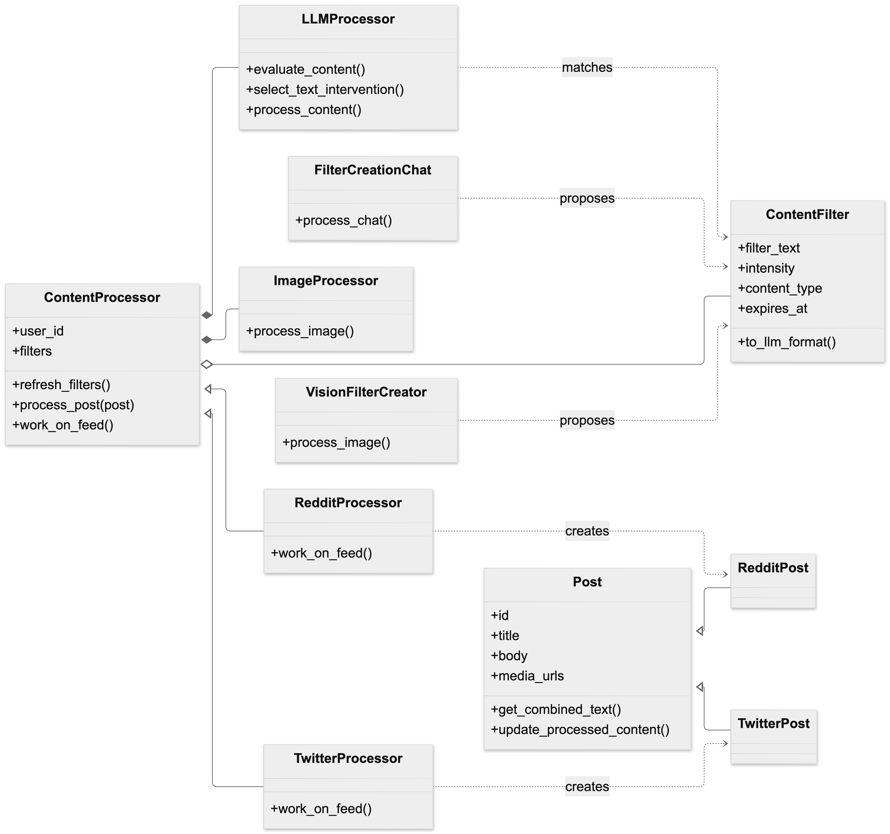
Figure-6: Class diagram of feed processing and filter creation (backend)
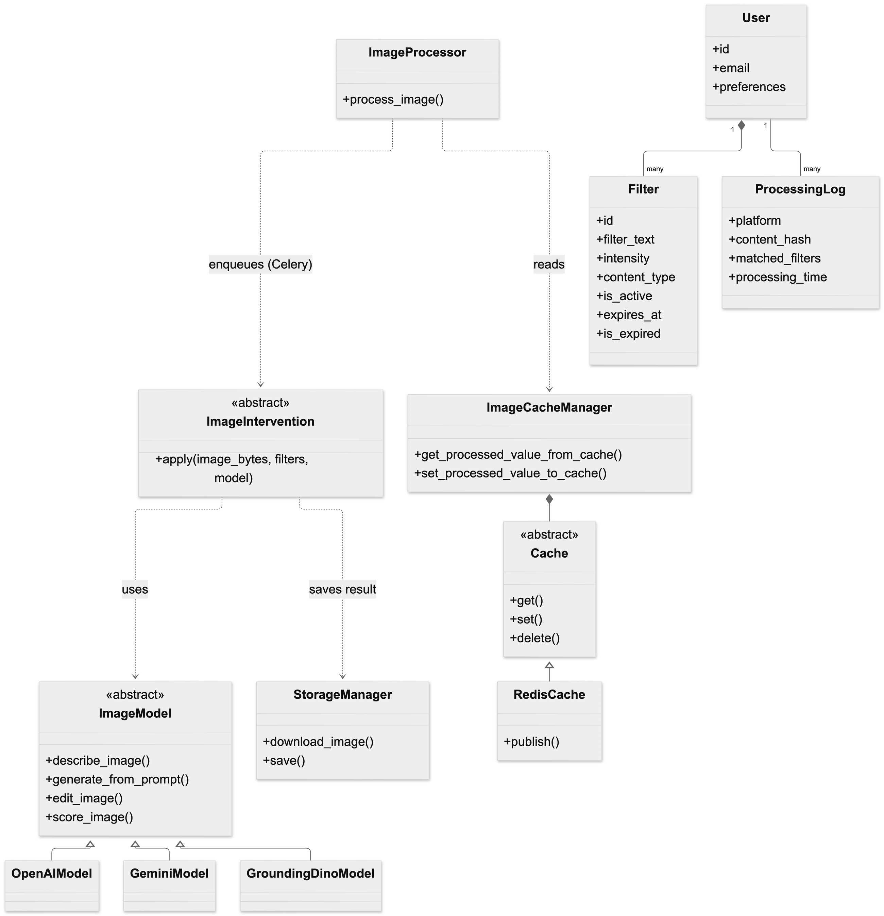
Figure-7: Class diagram of the image pipeline, cache and persistent entities (backend)
Extension design classes
Domain concept | Design class (source file) | Responsibility
Content interception | RequestInterceptor, BaseInterceptor, FetchInterceptor, XhrInterceptor  (content/interceptor/) | Runs in the page's own JavaScript context. Overrides fetch and XMLHttpRequest, captures feed responses for the subscribed endpoints and raises the SaveBatch event.
On-page rendering | DomProcessor, markers.ts  (content/interceptor/ui/, utils/) | Watches the DOM with a MutationObserver and turns the backend's markers into blurred spans, warning overlays, rewritten blocks and deferred-image placeholders.
Visual preferences | StyleManager  (content/interceptor/ui/) | Injects the stylesheet and updates CSS variables when the user changes blur or border settings.
Backend access | ApiService  (shared/api/api-service.ts) | Single client for all backend calls: feed processing, chat, image upload, filter CRUD, connection test and image-result polling.
Filter-creation dialogue (UI) | PopupController  (popup/popup.ts) | Handles popup events, shows chat messages and the configuration panel, and saves the filter.
Dialogue state | useFilterStore (FilterStore), FilterState  (shared/state/, shared/types.ts) | Zustand store holding the current dialogue state and the filter being built; changes state according to the type of each backend reply.
Session persistence | PopupStateManager  (popup/popup-state-manager.ts) | Saves and restores an unfinished conversation in chrome.storage.local.

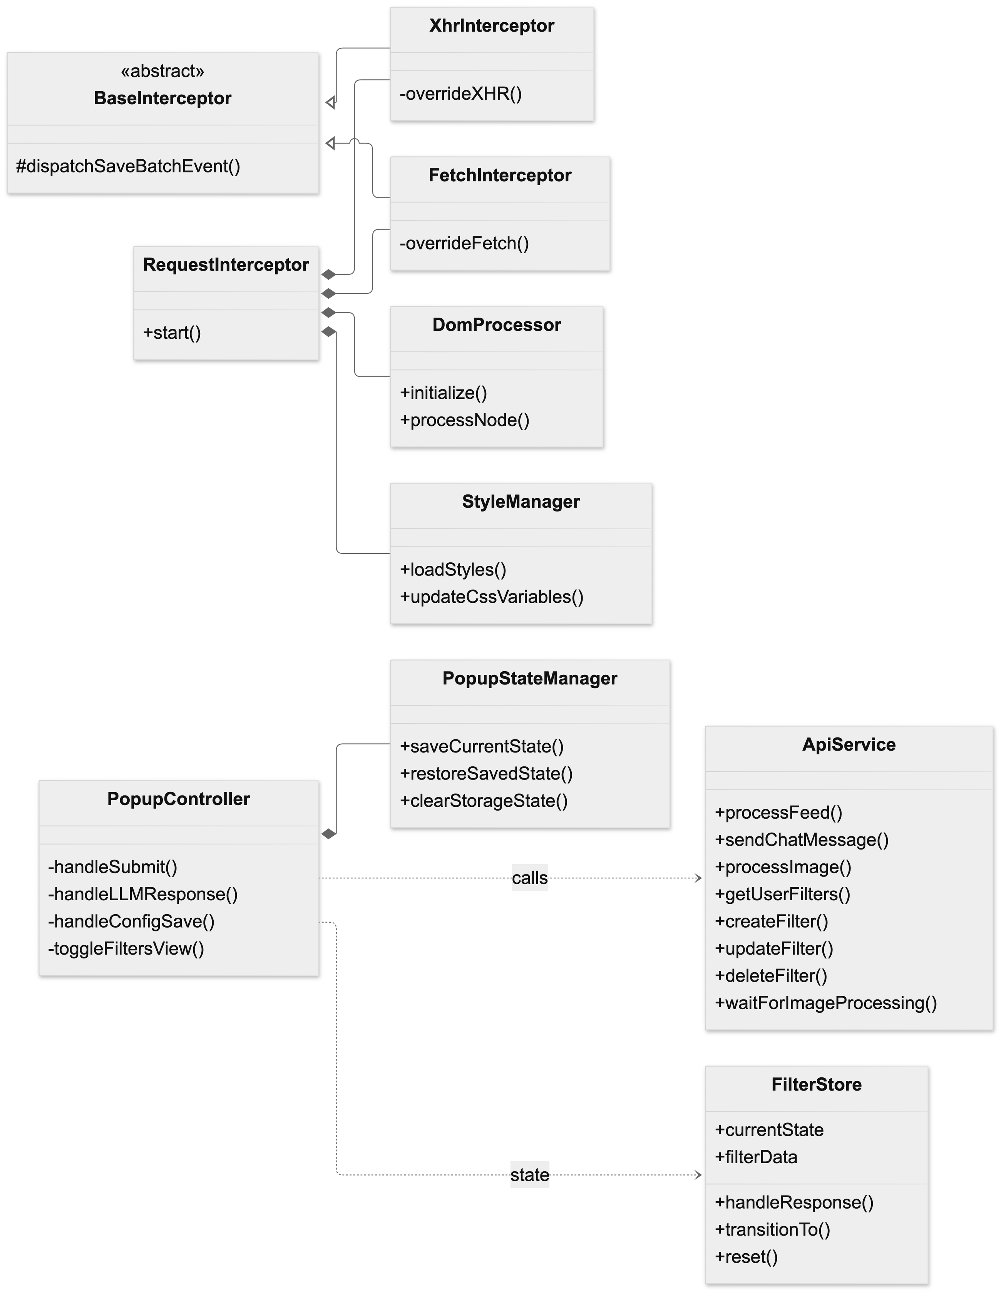
Figure-8: Class diagram of the browser extension

6.2 Persistent Data Sources
SHIELD keeps data in five places. The relational database holds everything that must survive a restart; Redis holds short-lived work and results; the file system holds images and request traces; and the browser holds the user's identity and preferences.
Data source | What is stored | Owning class / module | Lifetime
SQLite database  Backend/filters.db | Tables users, filters, processing_logs (the live extension), and custom_feeds, human_preferences (research tooling only). | User, Filter, ProcessingLog, CustomFeed, HumanPreference in database/models.py; all access goes through get_db() in database/operations.py. | Permanent. Filters are soft-deleted (is_active = False); temporary filters stop being returned after expires_at.
Redis: task queue  localhost:6379/0 | Celery task messages and task results for the image workflow. | Celery app ImageProcessor in tasks.py. | Until the task is consumed.
Redis: image cache | One key per source image URL; the value is a JSON object mapping a normalised filter string to the transformed image URL (and its base64 form). | ImageCacheManager using RedisCache. | 3600 seconds (default_timeout).
Redis: pub/sub | Channel image_processing_complete, one message per finished image. | Published by ImageCacheManager, subscribed by app.py. | Not stored.
Files: generated images  Backend/temp/uploads/ | Transformed images written by the workers, and images uploaded to /chat/image while they are analysed. | _StorageManager (utils/storage.py); served by the API under /temp/uploads. | Generated images stay on disk; chat uploads are deleted after the request.
Files: request traces  Backend/data/requests/ | For each /get_feed call, the raw feed (in_feed) and the modified feed (out_feed). | process_feed_route in app.py. | Permanent, for debugging.
Files: configuration | config.yaml (models, limits, database URL) and .env (API keys, storage switches). | ConfigManager, settings.py. | Permanent, edited by the operator.
AWS S3 bucket (optional) | Generated images, when USE_S3 is true. | _StorageManager. | Permanent.
chrome.storage.sync | user_id, google_user_info, settings, diy_mod_config. | background/index.ts, shared/config.ts. | Permanent, synced with the Chrome profile.
chrome.storage.local | savedPopupState (unfinished conversation) and keepAlive. | PopupStateManager, background/index.ts. | Until the filter is saved or a new chat starts.

The three tables used by the extension are the ones shown in the ER diagram of section 4.1. Filter belongs to User (the relationship cascades on delete), and ProcessingLog records, for each processed post, the platform, a hash of the content, the filters that matched and the processing time.

6.3 Overall System Design
Figure-9 shows the whole system on one page. The numbers on the arrows follow one feed request from the moment the page receives it to the moment a transformed image replaces the original. The arrow marked A is the separate path used when the user creates or manages filters.
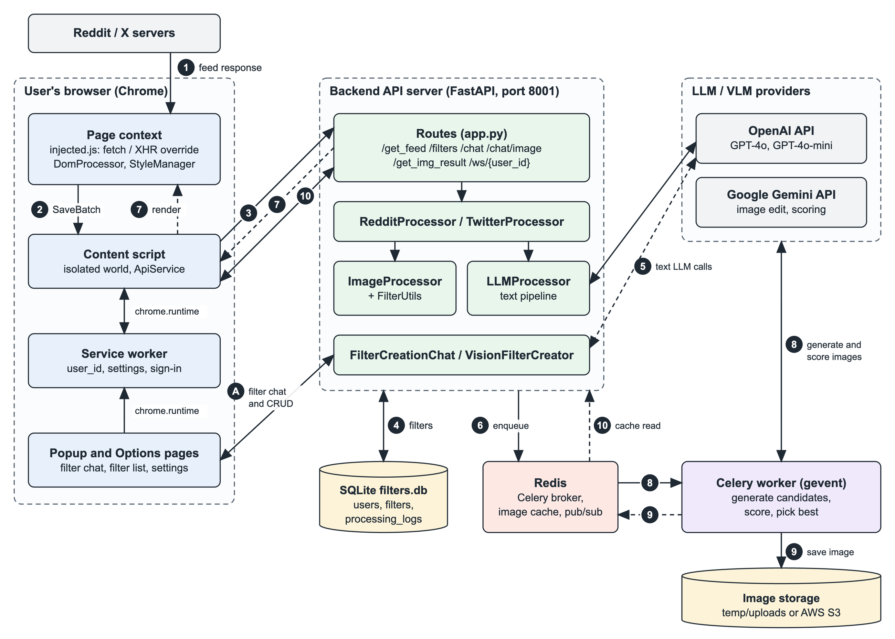
Figure-9: Overall system design of SHIELD
- The social media page requests its feed. The injected page script, which has replaced fetch and XMLHttpRequest, captures the response before the page reads it.
- The page script passes the raw response to the content script through the SaveBatch event.
- The content script sends it to the backend with POST /get_feed, together with the user's id and the page URL.
- The backend chooses RedditProcessor or TwitterProcessor from the URL and loads the user's active filters from SQLite.
- For each post, LLMProcessor asks the language model whether the text matches a filter, which intervention suits it, and for the transformed text. The result is the original text wrapped in markers.
- For each post image, ImageProcessor asks the vision model for the best-matching filter and candidate interventions, places a workflow task on the Redis queue and marks the image as DEFERRED.
- The modified feed is returned. The content script hands it back to the page with the CustomFeedReady event, the page renders it, and DomProcessor converts the markers into the visible blur, warning or rewrite.
- A Celery worker takes the task, generates every candidate transformation with the image models and scores each one against the original.
- The worker saves the winning image to storage and writes its URL to the Redis image cache.
- Meanwhile the extension polls GET /get_img_result. When the backend finds the result in the cache it returns the URL, and the extension swaps the image in.
A. The popup and options pages call /chat, /chat/image and /filters directly. FilterCreationChat and VisionFilterCreator use the language model to turn the user's description into a filter, which is stored in SQLite.
Two properties of this design matter for the rest of the chapter. Text is transformed inside the /get_feed request, so the user never sees unmoderated text. Images take much longer to generate, so they are always handled after the response, and the page shows a loading state until the result arrives.

6.4 Behavioral Design
Two lifecycles carry the main behaviour of the system: a post's text passing through moderation, and an image being transformed in the background. Each is described with a sequence diagram and a state diagram.

6.4.1 Text moderation of a feed post
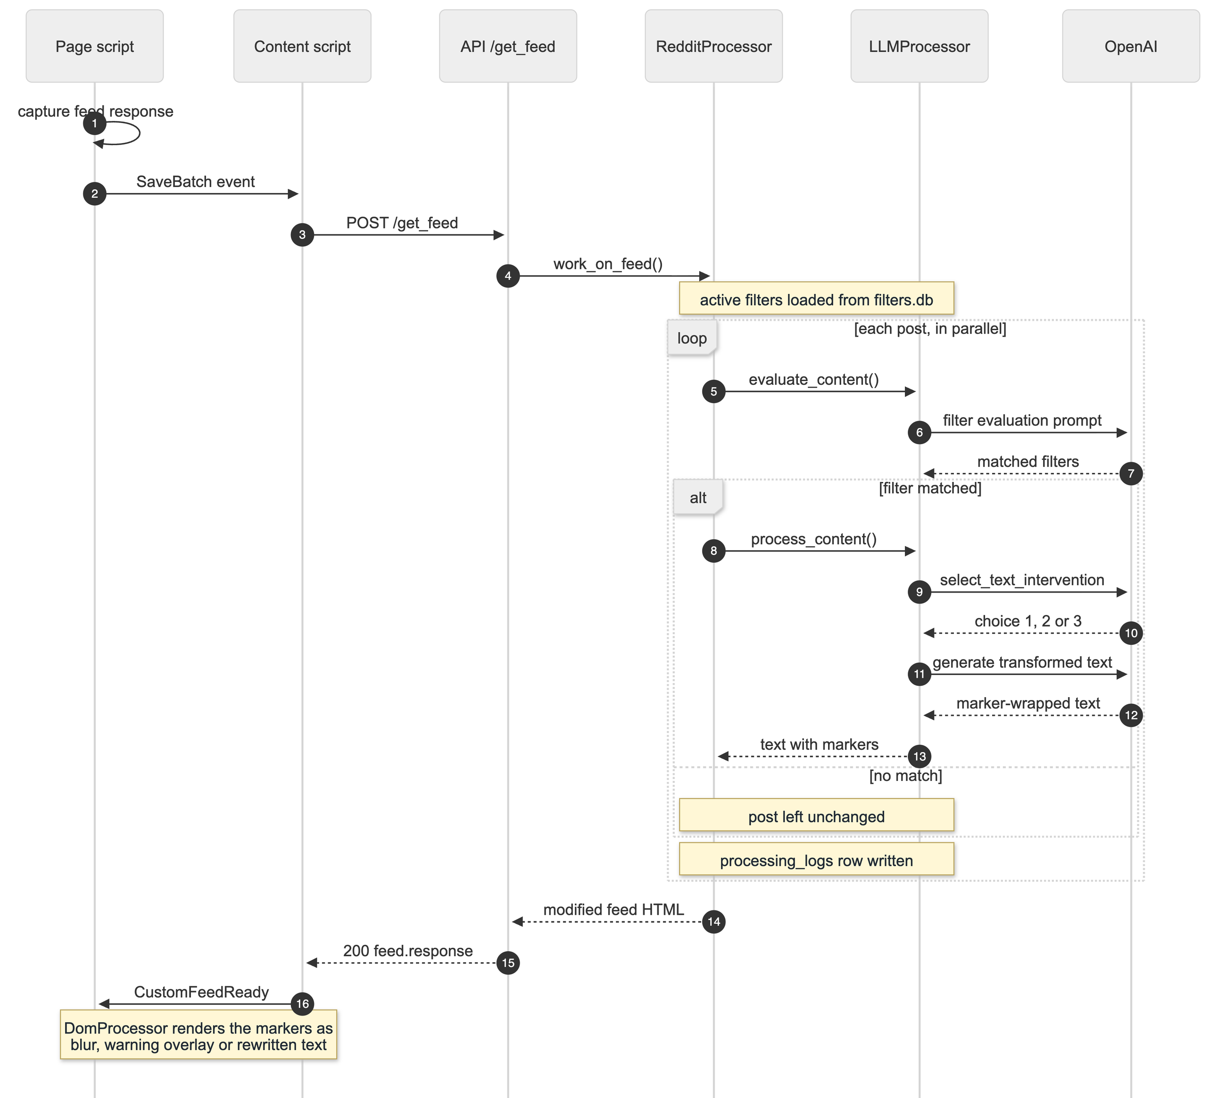
Figure-10: Sequence diagram of text moderation
A matched post needs up to three sequential calls to the language model (messages 6, 9 and 11). Posts are processed concurrently with asyncio, so the calls for different posts overlap. If no filter matches, only the first call is made.
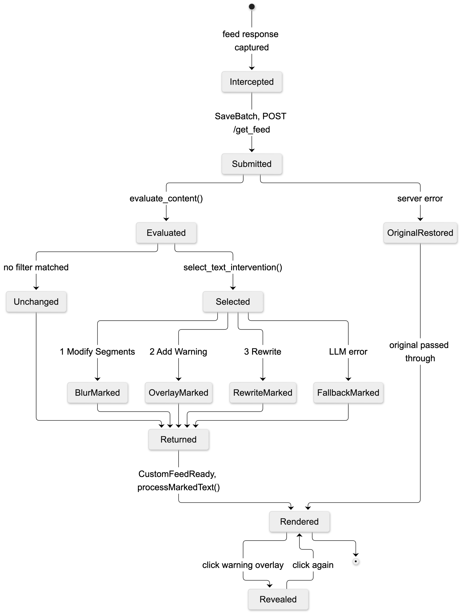
Figure-11: State diagram of a post's text during moderation
State | Meaning | Left when
Intercepted | The page script holds the raw feed response. | The SaveBatch event is raised.
Submitted | The feed is at the backend. | The post is evaluated, or the request fails.
Evaluated | evaluate_content() has returned the matching filters. | No match: Unchanged. Match: Selected.
Selected | select_text_intervention() has chosen 1 (Modify Segments), 2 (Add Warning) or 3 (Rewrite). | The text is wrapped in the matching marker. If the model call fails, _basic_content_processing() applies a rule-based fallback.
Returned | The modified feed is back in the extension. | processMarkedText() renders it.
OriginalRestored | The backend failed or timed out. | The original response is passed to the page, so the feed is never blocked.
Rendered / Revealed | The user sees the result. A warning overlay hides the text until clicked. | The user clicks the overlay to reveal or hide the original text.

6.4.2 Deferred image transformation
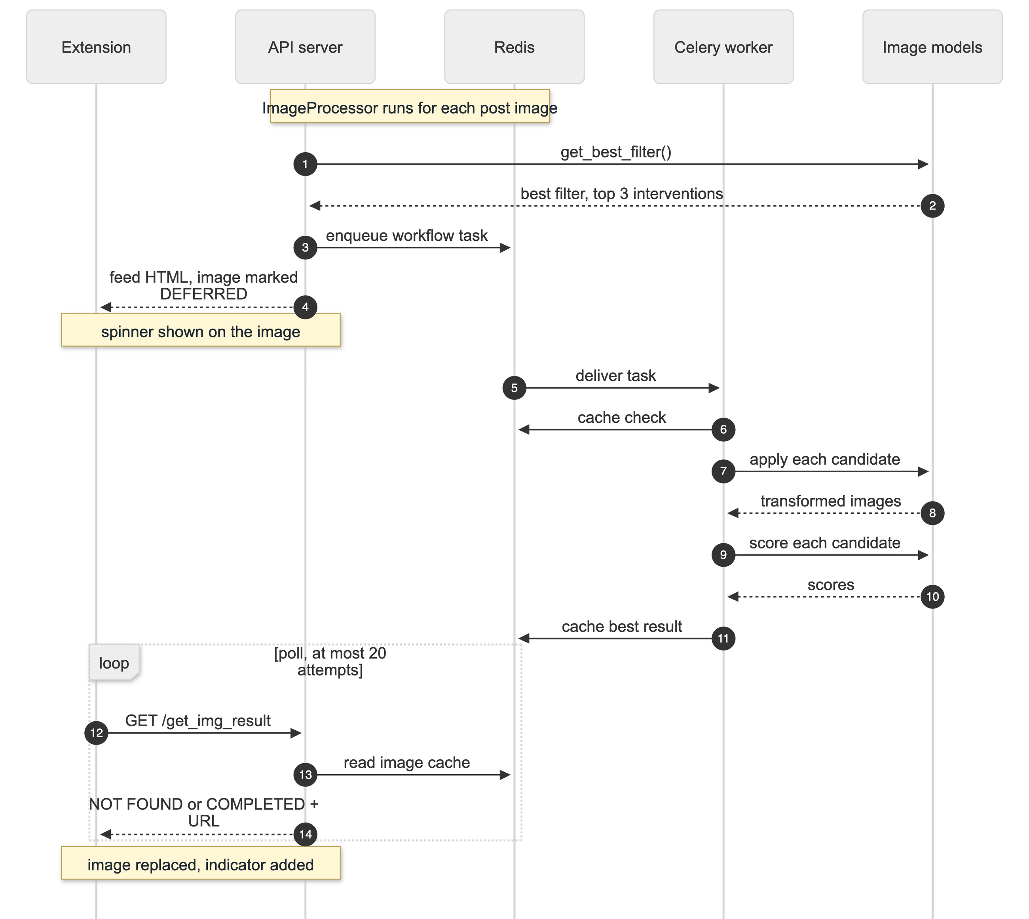
Figure-12: Sequence diagram of deferred image transformation
The workflow is the Celery task run_intervention_workflow in rank mode. It chains process_image_batch, which applies all candidate interventions concurrently on a gevent pool, to run_scoring_and_find_best_batch, which scores each successful candidate with score_intervention, and finally to finalize_workflow, which caches the highest-scoring result.
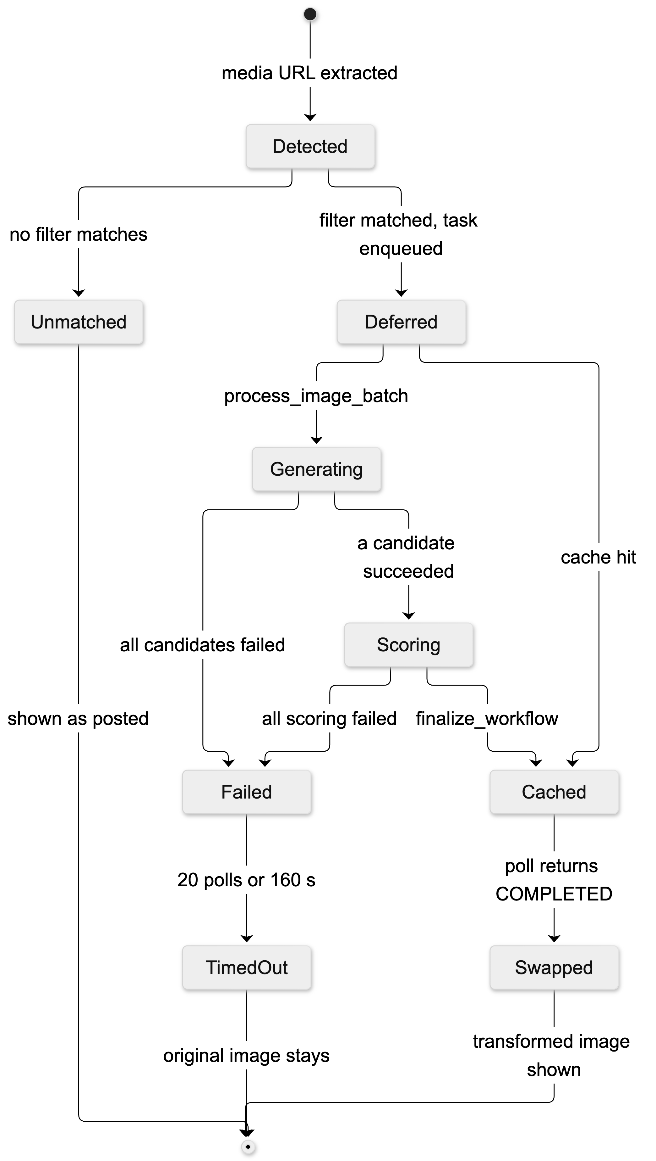
Figure-13: State diagram of an image during transformation
State | Meaning | Left when
Detected | The processor has found an image URL in the post. | get_best_filter() returns a filter (Deferred) or none (Unmatched).
Deferred | The task is queued and the image carries a diy-mod-image attribute with status DEFERRED; the page shows a spinner. | A worker starts the task, or the result is already cached.
Generating | The candidate interventions are being applied. | At least one succeeds (Scoring) or all fail (Failed).
Scoring | Each candidate is being scored against the original. | The best is cached (Cached) or all scoring fails (Failed).
Cached | The result is in Redis for one hour. | A poll of /get_img_result returns COMPLETED.
Swapped | The transformed image is shown with the indicator "Modified by DIY-MOD". | End of lifecycle.
Failed / TimedOut | Nothing was cached. The extension stops after 20 polls or 160 seconds. | The spinner is removed and the original image stays.

6.5 Deployment Design
During development the three backend processes (Redis, the Celery worker and the API server) are started by hand on one machine. The repository does not yet contain a Dockerfile or a compose file, so Figure-14 is the proposed deployment: what the system looks like once the backend is containerized with Docker Compose.
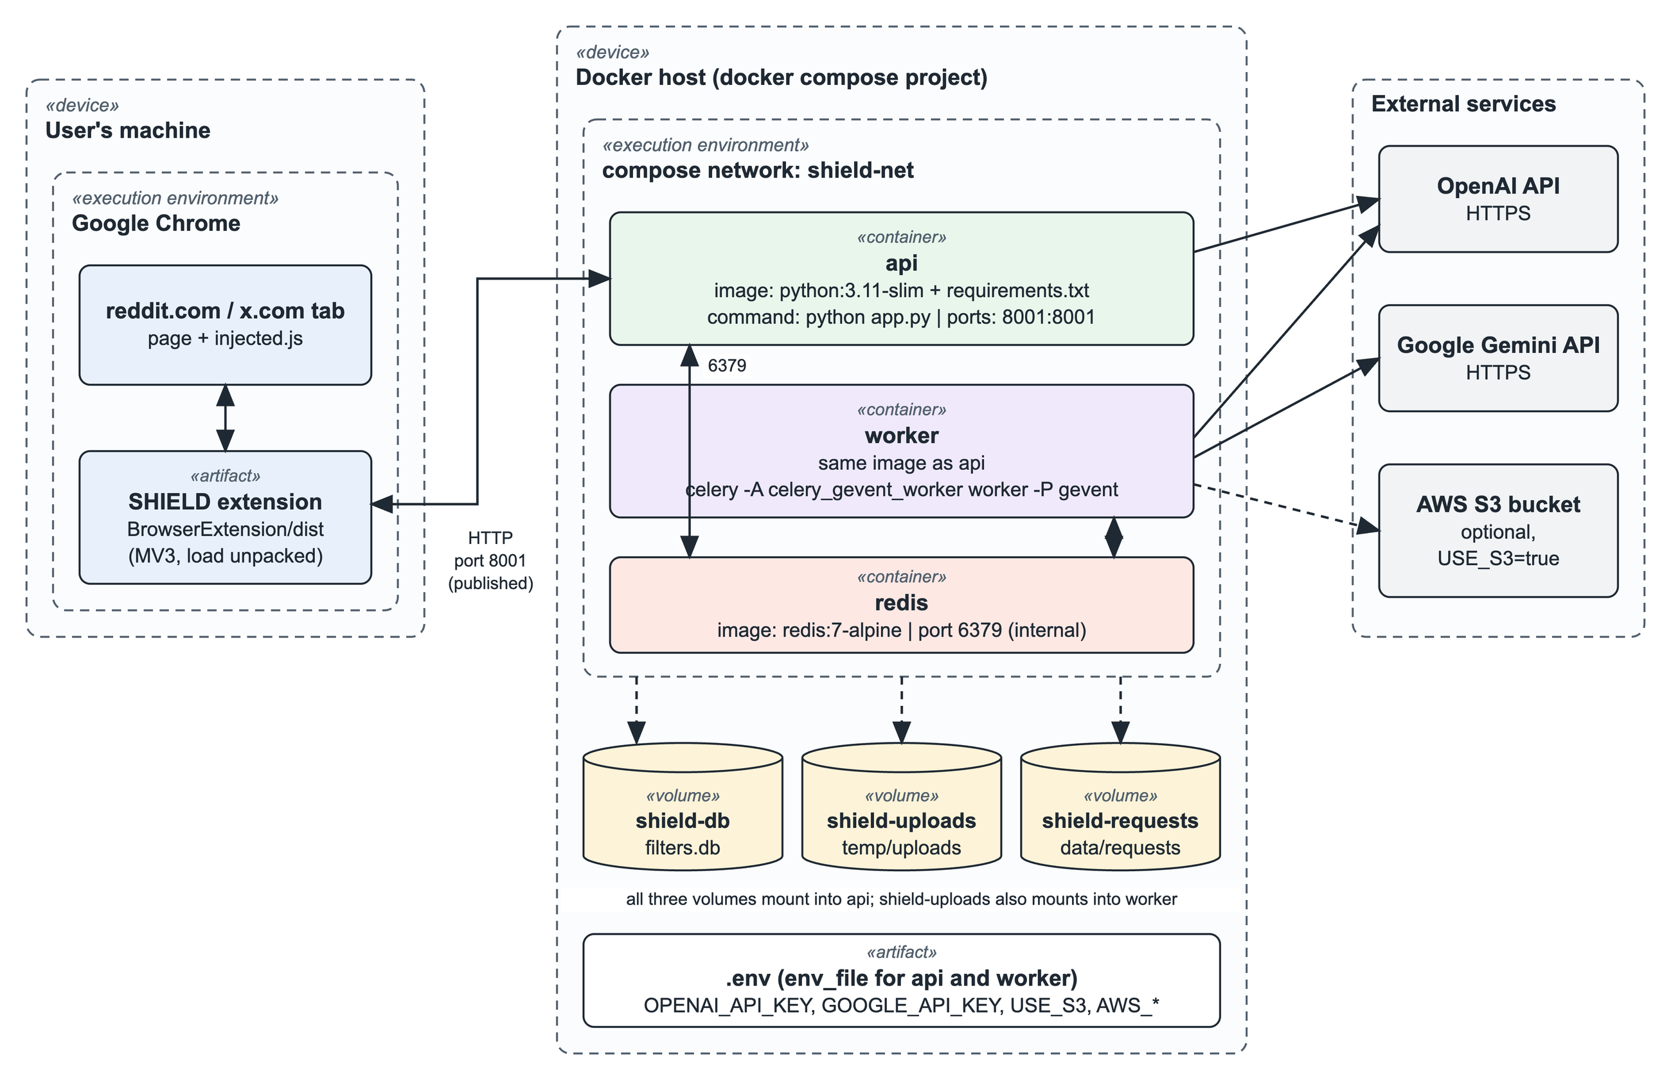
Figure-14: Deployment diagram of the dockerized application (proposed)
Node | Contents | Notes
api container | Image built from python:3.11-slim with Backend/requirements.txt; runs python app.py (Hypercorn). | Publishes port 8001 to the host, the address the extension is configured for (http://127.0.0.1:8001).
worker container | Same image; runs celery -A celery_gevent_worker worker --loglevel=info -P gevent -c 1000. | No published port. Can be scaled to several replicas.
redis container | redis:7-alpine. | Reachable only inside the compose network on port 6379.
Volume shield-db | filters.db. | Mounted into api, so users and filters survive a rebuild.
Volume shield-uploads | temp/uploads. | Mounted into both api and worker: the worker writes generated images, the API serves them.
Volume shield-requests | data/requests. | Mounted into api.
.env file | OPENAI_API_KEY, GOOGLE_API_KEY, USE_S3 and the AWS_* variables. | Passed to api and worker with env_file; never built into the image.
User's machine | Chrome with the extension loaded from BrowserExtension/dist. | The extension is not containerized; it is installed in the browser.
External services | OpenAI API, Google Gemini API, optional S3 bucket. | Reached over HTTPS from api and worker.

One code change is required before this deployment works. The Redis address is written as localhost:6379 in tasks.py, ServerCache/RedisCache.py and app.py. Inside a compose network Redis is reached by its service name, so these three places must read the address from an environment variable (the unused REDIS_URL entry in .env.template is the natural choice). The SQLite path and the upload directory are relative to the working directory and need only the volume mounts shown above.

7. Interface Design
SHIELD has three user interfaces: the toolbar popup, where filters are created by conversation; the options page, where filters and visual preferences are managed; and the transformed content shown inside Reddit itself.

7.1 User Interface Objects and Actions
Interface | UI object | Actions (operations)
Popup | Header with Sign in / avatar and Sign out | Sign in with Google; sign out.
Popup | Chat area | Shows the user's and the assistant's messages and, below a reply, its option buttons.
Popup | Message box, Send button, Attach Image button | Type a description and send it (button or Enter); attach an image (image files only, at most 5 MB).
Popup | Filter configuration panel | Choose content type (Text Only, Images Only, Both); set sensitivity on a 1 to 5 slider; choose duration (Permanent, 24 Hours, 1 Week); Save Filter; Modify Filter.
Popup | My Filters, New Chat and Options buttons | Show the list of active filters and remove one; clear the conversation; open the options page.
Options page | User Account section | Sign in with Google; sign out.
Options page | Visual Settings section | Set blur intensity; toggle "Show content on hover"; set border colour, width and visibility for warning overlays and rewritten content; choose a dark or light overlay.
Options page | Default Filter Settings section | Choose the default content type and duration for new filters.
Options page | Filter Management section | Refresh the filter table; New Filter; edit or delete a filter; Export Filters; Import Filters; Clear All Filters.
Options page | Create / Edit Filter dialog | Enter filter text, content type, intensity and duration; Save Filter; Cancel.
Options page | Server Settings, Save Settings, Reset to Defaults | Test Connection; save all settings; restore the defaults.
Reddit page | Blurred text (diymod-blur) | Hover to read, when hover reveal is enabled.
Reddit page | Warning overlay (diymod-overlay) | Click to reveal the original text; click again to hide it.
Reddit page | Rewritten text (diymod-rewritten) | Read the rewritten text; the label "Modified by DIY-MOD" marks it.
Reddit page | Image loading overlay and transformed image | No action: the spinner "Transforming image..." is replaced by the transformed image with a "Modified by DIY-MOD" label.

7.2 UI Events and State Transitions
The popup is a small state machine. Its states are the values of the FilterState enumeration, and the state changes when a backend reply arrives: FilterStore.handleResponse() reads the reply's type field and moves to the matching state. Figure-15 shows the states, and the table after it lists the events.
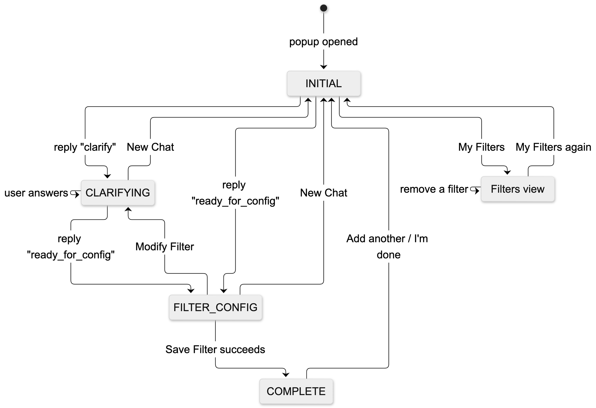
Figure-15: State diagram of the popup interface
User event | Current state | Action | Next state | Visible effect
Open the popup | none | GET /filters; restore a saved conversation if one exists | INITIAL (or the restored state) | Empty chat, or the previous conversation with "Previous session restored".
Send a message | INITIAL, CLARIFYING | POST /chat | CLARIFYING if the reply type is clarify; FILTER_CONFIG if it is ready_for_config | The reply appears, with option buttons or the configuration panel.
Click an option button | CLARIFYING | POST /chat with the option text | CLARIFYING or FILTER_CONFIG | The option is shown as the user's message, then the reply.
Attach an image and send | INITIAL, CLARIFYING | POST /chat/image | Set by the reply type | Image preview, then the assistant's description of the image.
Change content type, sensitivity or duration | FILTER_CONFIG | Update the filter data in the store | FILTER_CONFIG | The chosen button is highlighted; the slider moves.
Click Modify Filter | FILTER_CONFIG | none | CLARIFYING | The panel closes and the assistant asks what to change.
Click Save Filter | FILTER_CONFIG | POST /filters | COMPLETE | "Filter saved successfully! Would you like to add another?"
Click "Add another filter" or "I'm done" | COMPLETE | Reset the store | INITIAL | The chat is cleared.
Click New Chat | any | Confirm if a conversation is in progress; clear history and saved state | INITIAL | Welcome message.
Click My Filters | INITIAL, COMPLETE | GET /filters | unchanged (filters view) | List of active filters, each with a Remove button. In other states: "Please complete the current configuration first".
Click Remove | filters view | DELETE /filters/{id} | unchanged | "Filter removed successfully"; the list reloads.
Click Save Settings (options page) | n/a | Store settings; background sends settingsUpdated to open tabs | n/a | "Settings saved successfully!"; open Reddit tabs restyle at once.
Click Test Connection (options page) | n/a | GET /ping | n/a | "Test Passed! You can use DIY-MOD!!" or an error.
Click a warning overlay (Reddit page) | hidden | Toggle the hidden class | revealed | The original text is shown; a second click hides it.

7.3 Interface Screenshots
The screenshots in sections 7.3.1 to 7.3.7 were captured from the built extension running against the local backend. Screens that could not be captured automatically are marked for manual capture.

7.3.1 Popup: initial state
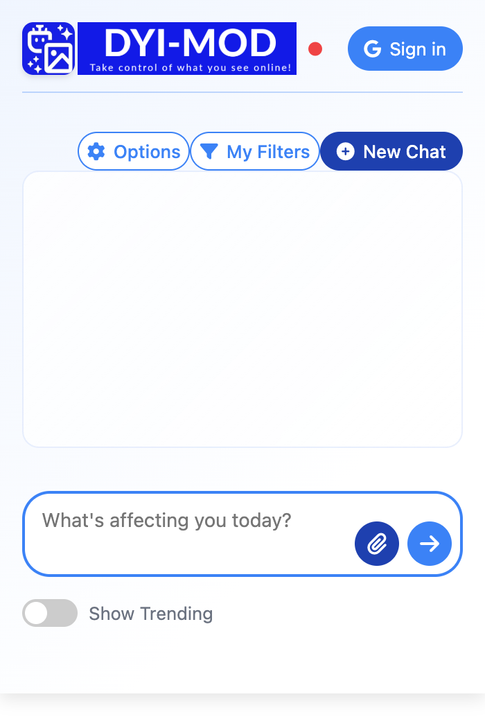
Figure-16: Popup in the INITIAL state

7.3.2 Popup: describing a sensitivity
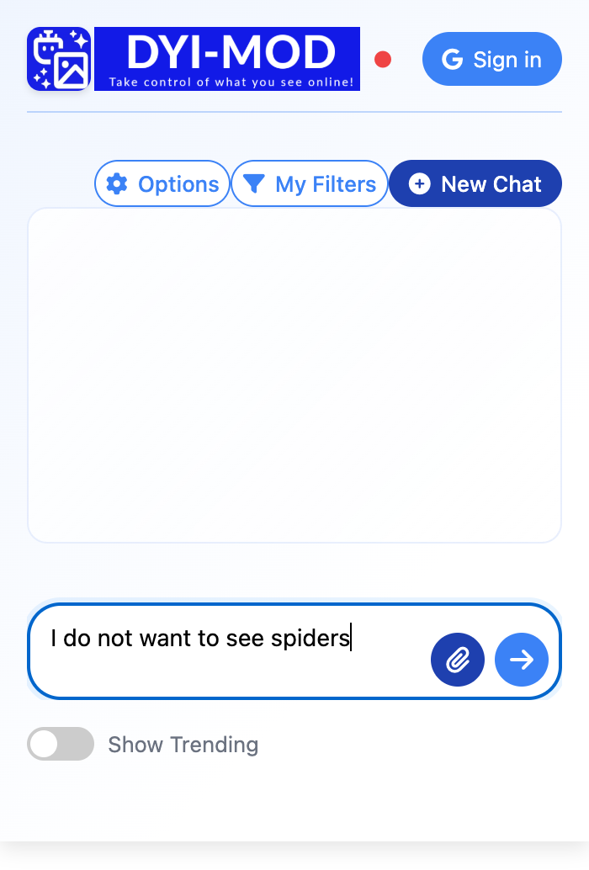
Figure-17: Popup with a description typed in the message box

7.3.3 Popup: clarifying question
[SCREENSHOT NEEDED: Popup in the CLARIFYING state, after sending an ambiguous description (for example "apple"), showing the assistant's question and its option buttons]
Figure-18: Popup in the CLARIFYING state with option buttons

7.3.4 Popup: filter configuration
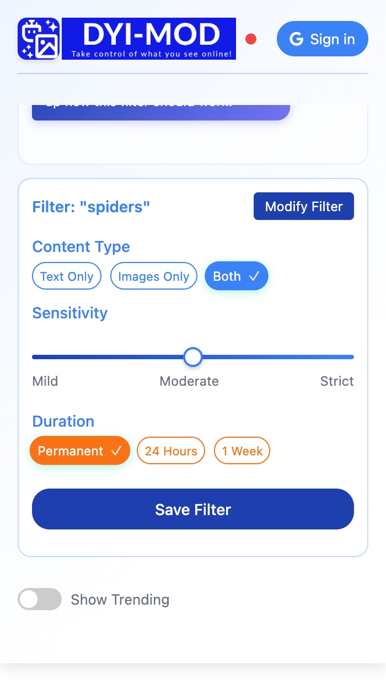
Figure-19: Popup in the FILTER_CONFIG state with the configuration panel

7.3.5 Popup: filter saved
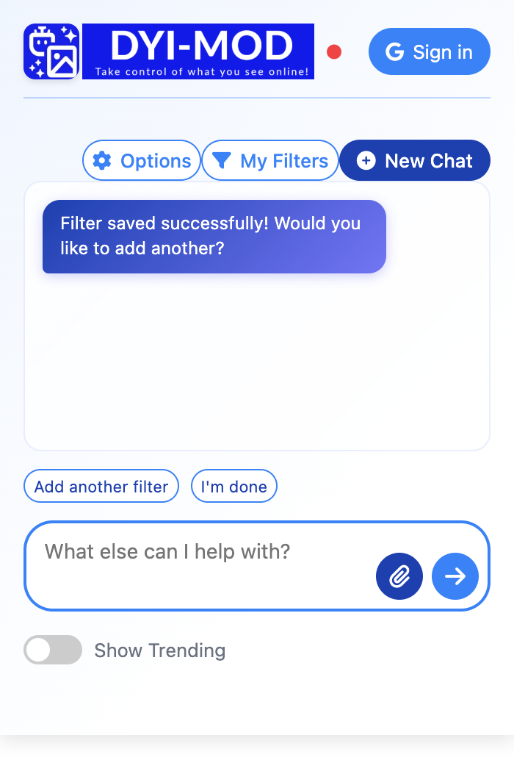
Figure-20: Popup in the COMPLETE state after saving a filter

7.3.6 Popup: My Filters
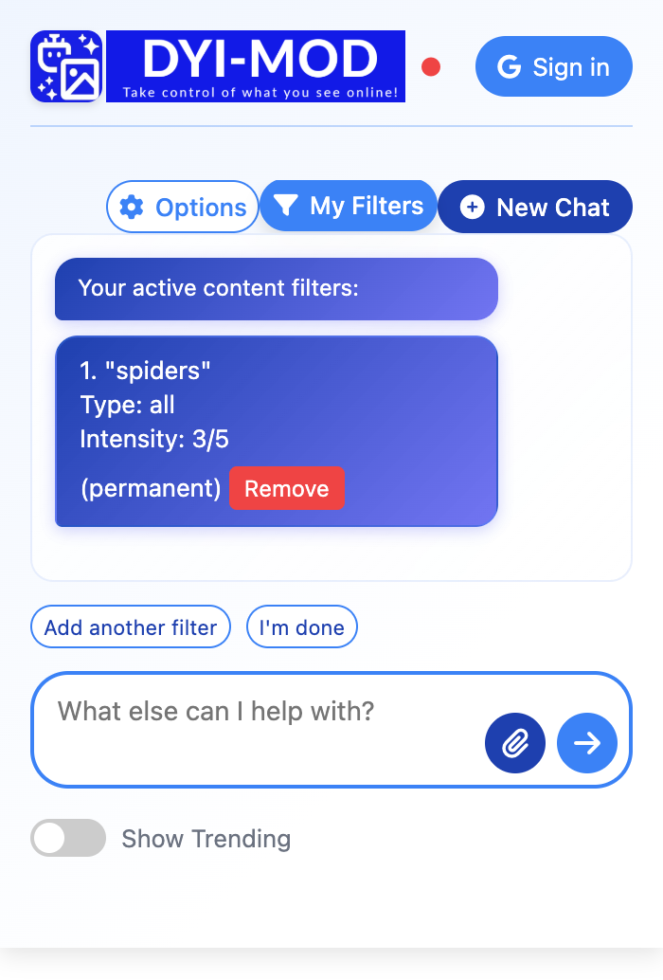
Figure-21: Popup filters view listing the active filters

7.3.7 Popup: image-based filter creation
[SCREENSHOT NEEDED: Popup after attaching an image with the Attach Image button and sending it, showing the image preview and the assistant's reply]
Figure-22: Popup creating a filter from an uploaded image

7.3.8 Options page
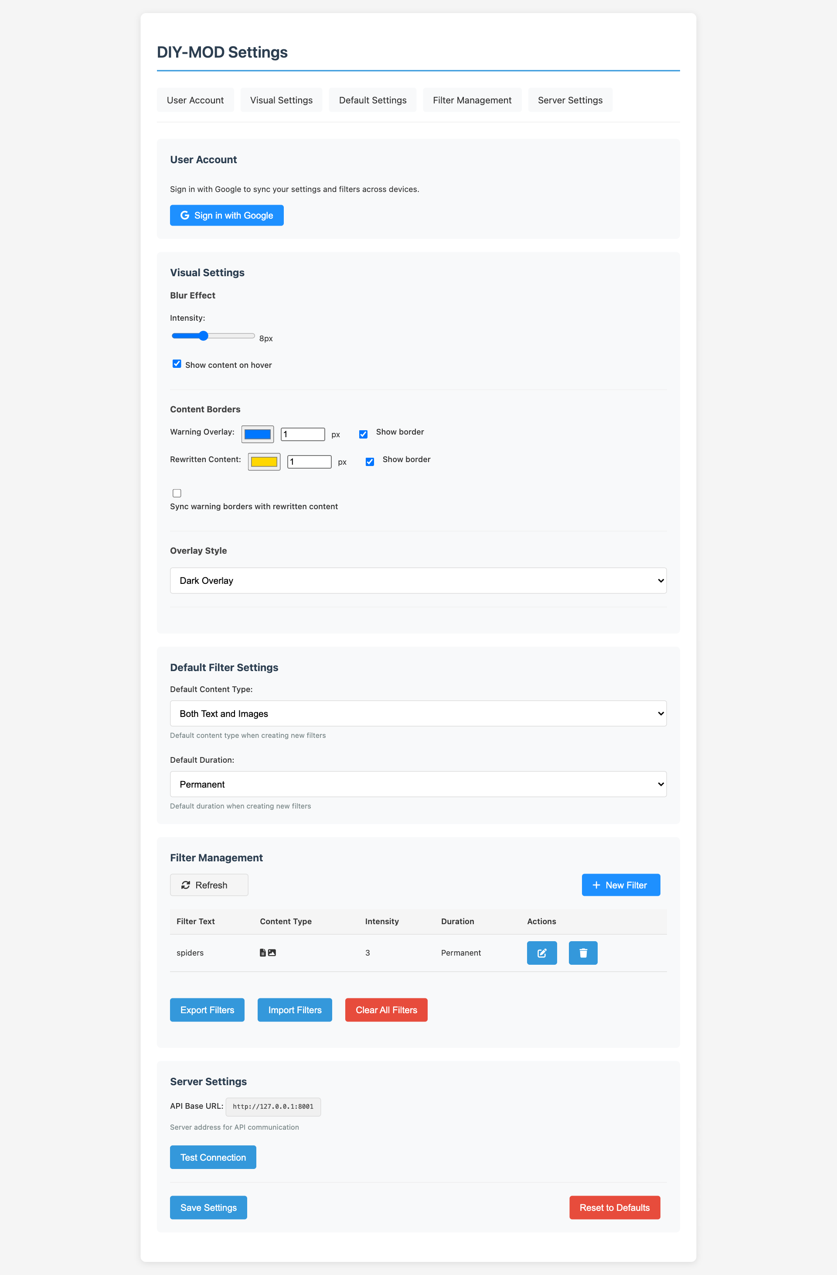
Figure-23: Options page: account, visual settings, default filter settings, filter management and server settings
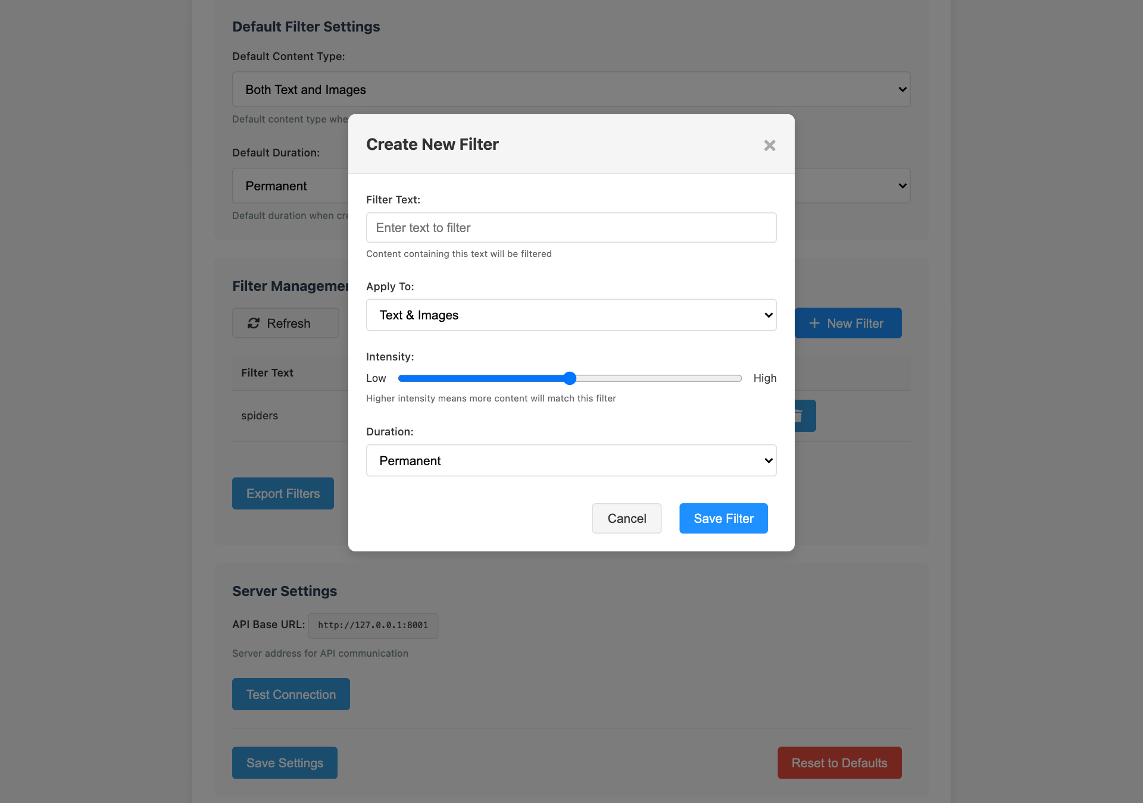
Figure-24: Options page: Create New Filter dialog

7.3.9 Transformed content on Reddit
[SCREENSHOT NEEDED: Reddit feed with a post whose matching phrases are blurred (low-intensity text intervention)]
Figure-25: Blurred text in a Reddit post
[SCREENSHOT NEEDED: Reddit feed with a post covered by a warning overlay, before the user clicks it]
Figure-26: Warning overlay on a Reddit post
[SCREENSHOT NEEDED: Reddit feed with a rewritten post showing the "Modified by DIY-MOD" label]
Figure-27: Rewritten text in a Reddit post
[SCREENSHOT NEEDED: Reddit post image while it is being processed, showing the "Transforming image..." spinner]
Figure-28: Loading state of a deferred image
[SCREENSHOT NEEDED: The same Reddit post after processing, showing the transformed image with the "Modified by DIY-MOD" label]
Figure-29: Transformed image in a Reddit post

8. Testing

8.1 Testing Approach and Strategy
Testing concentrates on the backend API, because every feature of the extension depends on it. The tests are black-box integration tests: they send real HTTP and WebSocket requests to a running server and check the status code and the response body. Nothing is mocked, so a passing test shows that the route, the request validation, the database layer and, where relevant, the language model work together.
Tools and environment
Item | Value
Test framework | pytest 8.0.0, with httpx 0.28.1 as HTTP client and websockets 16.1.1 as WebSocket client
Test code | Backend/tests/test_api_endpoints.py and Backend/tests/conftest.py (49 test cases)
System under test | python app.py (FastAPI on Hypercorn, port 8001), Python 3.11.15, macOS
Supporting services | Redis 8.10 on localhost:6379; SQLite filters.db; live OpenAI API for the language-model tests
Command | cd Backend/tests && pytest . -v (add -m "not llm" to skip tests that call the language model)
Execution date | 6 October 2026

Strategy
- Positive tests send a valid request and check the documented response fields and their values.
- Negative tests send a request with a missing field, a wrong type, an unknown id or another user's id, and check that it is rejected with the right status code.
- State tests check that a write is visible afterwards: a created filter is listed, an updated filter has its new values, a deleted filter is gone.
- Language-model tests (marked llm) check the structure of the reply and not its wording, because the wording changes between runs.
- Isolation: each test uses its own generated user id, so tests do not depend on each other or on existing data. For the image-result tests the Redis cache is seeded in the format ImageCacheManager writes.
Scope
- In scope: the twelve routes used by the extension: /ping, /filters (GET, POST, PUT, DELETE), /chat, /chat/image, /get_feed, /get_img_result, /get_img_base64, /user/update and the WebSocket /ws/{user_id}, plus the CORS preflight handler.
- Out of scope: image generation and scoring in the Celery worker (slow, costly and not deterministic; its result path is covered by seeding the cache); the /custom-feed, /auth, /api/feeds and /human-preferences routes, which serve the research tooling; the Twitter processor; and the extension's user interface, which is checked by hand during the demonstration.

8.2 Item Pass/Fail Criteria
- Pass: the response has the expected HTTP status code, the body has the expected fields and values, and any expected change of state can be observed through a second request.
- Fail: the status code differs from the expected one, a field is missing or wrong, the state did not change as expected, or the server returned an unhandled error.
- Not executed: the test could not run because a required service or API key was unavailable. Such a test counts as neither passed nor failed.
- For language-model tests, a pass requires status to be success and the reply to contain the fields the extension reads (text, type, options); for /get_feed, at least one transformation marker must be present in the post that matches the filter.
- The API as a whole is accepted when every positive and state test passes. A failed negative test is recorded as a defect with its cause.

8.3 Test Cases with Detailed Outcomes
All 49 test cases were executed. 39 passed and 10 failed; none was left unexecuted. The actual results below are the responses recorded during the run.
Metric | Value
Test cases executed | 49
Passed | 39
Failed | 10
Not executed | 0
Execution time | 15.8 seconds

8.3.1 Health check and CORS
ID | Test case | Request | Expected result | Actual result | Status
TC-01 | Server is alive | GET /ping | 200; status = success, message, ISO timestamp | HTTP 200 {status: success, message: DIY-MOD server is running, timestamp: 2026-10-06T13:09:10.194549} | Pass
TC-02 | Preflight from Reddit is allowed | OPTIONS /filters  Origin: reddit.com | 200; allow-origin echoes the origin; allow-private-network = true | HTTP 200 allow-origin=https://www.reddit.com allow-private-network=true | Pass
TC-03 | Private-network header on normal responses | GET /ping | Header allow-private-network = true | HTTP 200 allow-private-network=true | Pass

8.3.2 Filter management (/filters)
ID | Test case | Request | Expected result | Actual result | Status
TC-04 | New user has no filters | GET /filters?user_id=U | 200; empty filters list | HTTP 200 {status: success, message: Found 0 filters, filters: []} | Pass
TC-05 | Missing user id | GET /filters | 422 | HTTP 422 {detail: [{type: missing, loc: [query, user_id], msg: Field required, input: null}]} | Pass
TC-06 | Create a permanent filter | POST /filters  {filter_text: spiders, intensity: 4, content_type: image, duration: permanent} | 200; integer filter_id | HTTP 200 {status: success, message: Filter created successfully, filter_id: 6} | Pass
TC-07 | Created filter is listed with its fields | POST /filters, then GET /filters | One filter; text, intensity and content type as sent; not temporary | HTTP 200 {status: success, message: Found 1 filters, filters: [{id: 7, filter_text: spiders, filter_type: null, content_... | Pass
TC-08 | 24-hour filter expires in one day | POST /filters {duration: day}, then GET | is_temporary true; expires_at 24 hours ahead | HTTP 200 {status: success, message: Found 1 filters, filters: [{id: 8, filter_text: election news, filter_type: null, co... | Pass
TC-09 | One-week filter expires in seven days | POST /filters {duration: week}, then GET | is_temporary true; expires_at 7 days ahead | HTTP 200 {status: success, message: Found 1 filters, filters: [{id: 9, filter_text: election news, filter_type: null, co... | Pass
TC-10 | Missing filter text | POST /filters without filter_text | 422 | HTTP 422 {detail: [{type: missing, loc: [body, filter_text], msg: Field required, input: {user_id: pytest_5bd9551a_test_... | Pass
TC-11 | Intensity is not a number | POST /filters {intensity: "high"} | 422 | HTTP 422 {detail: [{type: int_parsing, loc: [body, intensity], msg: Input should be a valid integer, unable to parse str... | Pass
TC-12 | Intensity outside 1 to 5 | POST /filters {intensity: 99} | 422 | HTTP 200 {status: success, message: Filter created successfully, filter_id: 10} | Fail
TC-13 | Unknown content type | POST /filters {content_type: video}, then GET | Stored with content type all | HTTP 200 {status: success, message: Found 1 filters, filters: [{id: 11, filter_text: spiders, filter_type: null, content... | Pass
TC-14 | Update text, intensity and content type | PUT /filters/{id}, then GET | 200; new values returned | HTTP 200 {status: success, message: Filter updated successfully} | Pass
TC-15 | Update an unknown filter | PUT /filters/99999999 | 404 | HTTP 500 {status: error, message: 404: Filter not found} | Fail
TC-16 | Update another user's filter | PUT /filters/{id} with a different user_id | 404; filter unchanged | HTTP 500 {status: error, message: 404: Filter not found} | Fail
TC-17 | Filter id is not a number | PUT /filters/abc | 422 | HTTP 422 {detail: [{type: int_parsing, loc: [path, filter_id], msg: Input should be a valid integer, unable to parse str... | Pass
TC-18 | Delete a filter | DELETE /filters/{id}?user_id=U, then GET | 200; filter no longer listed | HTTP 200 {status: success, message: Filter deleted successfully} | Pass
TC-19 | Delete a filter twice | DELETE the same id again | 404 | HTTP 500 {status: error, message: 404: Filter not found} | Fail
TC-20 | Delete without user id | DELETE /filters/{id} | 422 | HTTP 422 {detail: [{type: missing, loc: [query, user_id], msg: Field required, input: null}]} | Pass
TC-21 | Delete another user's filter | DELETE /filters/{id} with a different user_id | 404; filter still listed | HTTP 500 {status: error, message: 404: Filter not found} | Fail

8.3.3 Conversational filter creation (/chat, /chat/image)
ID | Test case | Request | Expected result | Actual result | Status
TC-22 | Clear description gets a structured reply | POST /chat  {message: "I do not want to see pictures of spiders"} | 200; text, type, options present; user id echoed | HTTP 200 {status: success, user_id: pytest_5bd9551a_test_chat_returns_structured_reply, text: I understand you want to f... | Pass
TC-23 | Gibberish is questioned | POST /chat  {message: "xkcdqwrtz bbbbnnn"} | 200; type = clarify | HTTP 200 {status: success, user_id: pytest_5bd9551a_test_chat_asks_to_clarify_gibberish, text: I couldn't understand tha... | Pass
TC-24 | Missing message | POST /chat without message | 422 | HTTP 422 {detail: [{type: missing, loc: [body, message], msg: Field required, input: {history: [], user_id: pytest_5bd95... | Pass
TC-25 | History is not a list | POST /chat {history: "none"} | 422 | HTTP 422 {detail: [{type: list_type, loc: [body, history], msg: Input should be a valid list, input: none}]} | Pass
TC-26 | Image gets a structured reply | POST /chat/image  multipart: PNG image, message | 200; text and type present | HTTP 200 {status: success, user_id: pytest_5bd9551a_test_chat_image_returns_structured_reply, text: The image is a solid... | Fail
TC-27 | Malformed history is tolerated | POST /chat/image {history: "not-json"} | 200; status = success | HTTP 200 {status: success, user_id: pytest_5bd9551a_test_chat_image_tolerates_malformed_history, text: The image is a so... | Pass
TC-28 | Missing image | POST /chat/image without a file | 422 | HTTP 422 {detail: [{type: missing, loc: [body, image], msg: Field required, input: null}]} | Pass

8.3.4 Feed processing (/get_feed)
ID | Test case | Request | Expected result | Actual result | Status
TC-29 | User without filters gets the feed unchanged | POST /get_feed  Reddit HTML, one post | 200; post text intact; no markers | HTTP 200 {status: success, feed: {response: <shreddit-post id=\t3_0\ post-title=\Weekend hiking photos\><a slot=\title\>... | Pass
TC-30 | Post matching a text filter is transformed | POST /get_feed  filter "spiders"; one spider post, one recipe post | 200; a blur, overlay or rewrite marker in the response; recipe post intact | HTTP 200 status=success markers in response: ['__OVERLAY_START__'] | Pass
TC-31 | Feed with no posts | POST /get_feed  HTML without posts | 200; HTML returned as sent | HTTP 200 {status: success, feed: {response: <div>no posts here</div>}} | Pass
TC-32 | Unsupported platform | POST /get_feed {url: facebook.com} | 400 | HTTP 500 {status: error, message: 400: Unsupported platform in URL} | Fail
TC-33 | Missing feed_info | POST /get_feed {data: {}} | 400 | HTTP 500 {status: error, message: 400: No feed_info in data} | Fail
TC-34 | Missing user id | POST /get_feed without user_id | 422 | HTTP 422 {detail: [{type: missing, loc: [body, user_id], msg: Field required, input: {url: https://www.reddit.com/svc/sh... | Pass

8.3.5 Image results (/get_img_result, /get_img_base64)
ID | Test case | Request | Expected result | Actual result | Status
TC-35 | Image never processed | GET /get_img_result  unknown img_url | 200; status = NOT FOUND | HTTP 200 {status: NOT FOUND} | Pass
TC-36 | Cached result is returned | GET /get_img_result  cache seeded with a URL | 200; status = COMPLETED; processed_value = the URL | HTTP 200 {status: COMPLETED, processed_value: http://localhost:8001/temp/uploads/out.png} | Pass
TC-37 | Cached base64 form is returned | GET /get_img_result  cache seeded with URL and base64 | 200; COMPLETED with base64_url | HTTP 200 {status: COMPLETED, processed_value: http://localhost:8001/temp/uploads/out.png, base64_url: data:image/png;bas... | Pass
TC-38 | Filter given as plain text | GET /get_img_result?filters=Spiders | 200; COMPLETED | HTTP 200 {status: COMPLETED, processed_value: http://localhost:8001/temp/uploads/out.png} | Pass
TC-39 | Missing filters parameter | GET /get_img_result?img_url=... | 422 | HTTP 422 {detail: [{type: missing, loc: [query, filters], msg: Field required, input: null}]} | Pass
TC-40 | External URL is passed through | GET /get_img_base64  external img_url | 200; data_url = the same URL | HTTP 200 {status: success, data_url: https://example.com/a.jpg} | Pass
TC-41 | Missing local image file | GET /get_img_base64  local URL, no file | 200; status = error, "Image file not found" | HTTP 200 {status: error, message: Image file not found} | Pass

8.3.6 User information (/user/update)
ID | Test case | Request | Expected result | Actual result | Status
TC-42 | Create a user with an email | POST /user/update  {user_id, email} | 200; user id and email returned | HTTP 200 {status: success, message: User information updated, user: {id: pytest_5bd9551a_test_user_update_creates_user_w... | Pass
TC-43 | Change the email | POST /user/update twice | 200; second email returned | HTTP 200 {status: success, message: User information updated, user: {id: pytest_5bd9551a_test_user_update_changes_email,... | Pass
TC-44 | Missing user id | POST /user/update {email} | 400 | HTTP 500 {status: error, message: 400: user_id is required} | Fail
TC-45 | Malformed JSON body | POST /user/update  body: {not json | 400 or 422 | HTTP 500 {status: error, message: Expecting property name enclosed in double quotes: line 1 column 2 (char 1)} | Fail

8.3.7 WebSocket (/ws/{user_id})
ID | Test case | Request | Expected result | Actual result | Status
TC-46 | Keep-alive | send {type: ping} | Reply {type: pong, timestamp} | {type: pong, timestamp: 2026-10-06T13:09:25.935792} | Pass
TC-47 | Filter refresh | send {type: filter_update} | Reply {type: filters_updated} with the user's filters | {type: filters_updated, data: [{id: 19, filter_text: spiders, filter_type: null, content_type: all, intensity: 3, filter... | Pass
TC-48 | Waiting for a cached image | send {type: wait_for_image}  cache seeded | Reply {type: image_processed} with the result | {type: image_processed, data: {image_url: https://example.com/5bd9551a/ws-cached.jpg, result: http://localhost:8001/temp... | Pass
TC-49 | Unknown message type | send {type: no_such_type}, then ping | Connection stays open; pong received | connection stayed open; next message: {type: pong, timestamp: 2026-10-06T13:09:25.944470} | Pass

8.3.8 Analysis of the failed test cases
The ten failures have three causes. In every one of them the server refuses the bad request and leaves the data unchanged; what is wrong is the status code or a missing field, not the behaviour.
Defect | Test cases | Cause | Proposed correction
D-1: client errors are reported as HTTP 500 | TC-15, TC-16, TC-19, TC-21, TC-32, TC-33, TC-44, TC-45 | The routes raise HTTPException with 404 or 400, but the handle_api_errors decorator (utils/errors.py) catches every exception and returns 500. The intended code survives only inside the message, for example "404: Filter not found". | Let HTTPException pass through the decorator unchanged, and return 400 for a body that is not valid JSON.
D-2: intensity is not range-checked | TC-12 | CreateFilterRequest declares intensity as a plain integer, so 99 is stored although the scale is 1 to 5. | Declare the field with bounds 1 and 5 in models.py.
D-3: /chat/image reply has no type field | TC-26 | VisionFilterCreator returns text, filter_data and options but no type. The popup's FilterStore.handleResponse() changes state from type, so after an image reply the popup shows the message but does not open the configuration panel. | Add type (ready_for_config when a filter text was extracted, otherwise clarify) to the reply.

All positive and state tests passed: filters are created, listed, updated, expired and deleted correctly; the chat returns typed replies; a matching post comes back with transformation markers while other posts are left intact; cached image results are returned in both forms; and the WebSocket channel answers every message type that was tested.

9. User Manual
This manual explains how to install SHIELD, create filters and browse with moderation switched on. The source code is available at https://github.com/nazeeb1432/SPL3.

9.1 System Requirements
Component | Requirement
Browser | Google Chrome (Manifest V3 extensions; developer mode to load the unpacked extension)
Python | 3.10 or newer (3.11 was used), with the packages in Backend/requirements.txt and google-genai
Node.js | A current LTS release with npm, to build the extension
Redis | A Redis server on localhost:6379
API keys | An OpenAI API key and a Google Gemini API key
Internet | Required for the language-model calls and for the social media site
Supported site | Reddit (reddit.com)

9.2 Installation and Setup

9.2.1 Starting the backend
Download the project and create the Python environment:
git clone https://github.com/nazeeb1432/SPL3.git
cd SPL3/Backend
python3 -m venv venv
source venv/bin/activate
pip install -r requirements.txt
pip install google-genai
cp .env.template .env
Open .env and enter real values for OPENAI_API_KEY and GOOGLE_API_KEY. To store generated images on the local disk instead of S3, add the line USE_S3=false.
Then start the three services, each in its own terminal and in this order:
redis-server
cd Backend && source venv/bin/activate && celery -A celery_gevent_worker worker --loglevel=info -P gevent -c 1000
cd Backend && source venv/bin/activate && python app.py
The server listens on port 8001. To check it, open http://localhost:8001/ping in a browser; it should show a message with "status":"success".

9.2.2 Installing the extension
cd BrowserExtension
npm install
npm run build
- Open chrome://extensions in Chrome.
- Switch on Developer mode (top right).
- Click Load unpacked and select the folder BrowserExtension/dist.
- Pin the extension to the toolbar so that its icon is always visible.

9.2.3 Checking the connection
- Click the extension icon, then Options.
- In Server Settings, click Test Connection.
- The message "Test Passed! You can use DIY-MOD!!" confirms that the extension can reach the backend.

9.3 Signing In
Signing in is optional. Without it the extension creates an anonymous id and keeps your filters under that id. To attach your filters to your Google account, click Sign in in the popup or Sign in with Google on the options page and choose an account. Click the sign-out button next to your picture to sign out.

9.4 Creating a Filter by Chat
- Click the extension icon to open the popup.
- Describe what you do not want to see in the message box, in your own words, for example "I do not want to see spiders", and press Enter or the Send button.
- If your description is unclear, the assistant asks a question. Click one of the suggested answers or type your own.
- When the assistant has understood, the configuration panel appears with the filter's name at the top.
- Choose the Content Type: Text Only, Images Only, or Both.
- Set the Sensitivity slider between Mild and Strict. A stricter setting leads to stronger transformations.
- Choose the Duration: Permanent, 24 Hours, or 1 Week.
- Click Save Filter. The message "Filter saved successfully!" confirms it. Click Add another filter to continue or I'm done to finish.
To change the wording before saving, click Modify Filter. To abandon the conversation, click New Chat. If you close the popup in the middle of a conversation, it is restored the next time you open it.

9.5 Creating a Filter from an Image
- Open the popup and click the Attach Image (paper-clip) button.
- Select an image that shows the kind of content you want to avoid. Only image files up to 5 MB are accepted.
- Optionally type a short note, then press Send.
- The assistant describes what it sees and suggests a filter. Continue as in section 9.4.

9.6 Viewing, Editing and Deleting Filters
In the popup
- Click My Filters to list your active filters with their type, intensity and duration.
- Click Remove beside a filter to delete it.
- Click My Filters again to return to the chat.
On the options page
- The Filter Management table lists every filter. Click Refresh to reload it.
- Click New Filter to create a filter with a form instead of the chat.
- Click the pencil button to edit a filter's text, content type, intensity or duration, and the bin button to delete it.
- Click Clear All Filters to delete every filter. This cannot be undone.

9.7 Browsing with Moderation Active
Open Reddit and browse as usual. No further action is needed; the extension works in the background. Content that matches one of your filters appears in one of these forms:
- Blurred text: the matching words are blurred. Move the pointer over them to read them (this can be switched off in the options).
- Warning overlay: the text is hidden behind a short warning. Click the warning to reveal the text and click again to hide it.
- Rewritten text: the post is reworded to remove the distressing part and is labelled "Modified by DIY-MOD".
- Transformed image: the image first shows "Transforming image..." while it is processed, then is replaced by the transformed version, labelled "Modified by DIY-MOD". This usually takes longer than text.
Content that matches no filter is shown exactly as posted. If the backend cannot be reached, the feed is shown unmodified, so the site never stops working.

9.8 Adjusting Visual Preferences
- Open the options page (extension icon, then Options).
- Under Blur Effect, move the Intensity slider, and tick or clear Show content on hover.
- Under Content Borders, choose the colour and width of the border around warning overlays and rewritten content, or hide the borders.
- Under Overlay Style, choose a dark or light overlay.
- Under Default Filter Settings, choose the content type and duration offered by default for new filters.
- Click Save Settings. Open Reddit tabs are updated immediately. Reset to Defaults restores the original settings.

9.9 Exporting and Importing Filters
- Click Export Filters on the options page to download your filters as a file named diy_mod_filters_<date>.json.
- Click Import Filters and select such a file to add its filters to your account, for example on another computer.

9.10 Troubleshooting
Problem | What to do
The red dot in the popup header stays red. | This shows the optional WebSocket channel, which is off by default. It does not affect filtering.
Test Connection reports an error. | Check that python app.py is running and that http://localhost:8001/ping opens in the browser.
Nothing on Reddit is changed. | Check that you have at least one filter (My Filters), that the backend is running, and reload the Reddit tab.
Images show "Transforming image..." and then return to the original. | Check that Redis and the Celery worker are running and that the API keys in .env are valid.
The backend stops at start-up with an import error for google. | Run pip install google-genai in the virtual environment.
The backend stops with "AWS_STORAGE_BUCKET_NAME is not set". | Add USE_S3=false to .env, or supply the S3 settings.
Chrome reports that the extension cannot be loaded. | Rebuild with npm run build (not vite build) and select the dist folder.
Changes to the extension code have no effect. | Run npm run build again and click the reload button for the extension in chrome://extensions.

