


Technical Report

SHIELD: DIY Content Transformation For Safer Social Media Browsing

SE-801: Software Project Lab 3

Submitted by

Nazeeb Ahmed Chowdhury
BSSE1432

Supervised by
Toukir Ahammed
Lecturer
Institute of Information Technology
University of Dhaka

Submission Date: 02–08-2026

Contents
1. Project Overview 4
1.1 Project Title 4
1.2 Problem Statement 4
1.3 Objectives 4
1.4 Scope 5
1.5 Deliverables 5
2. Requirements Analysis 6
2.1 Functional Requirements 6
2.2 Non-Functional Requirements 8
2.3 Stakeholders 9
3.System Modeling 10
3.1 Use Case(Level1) 10
3.2 Activity Diagram 11
4.Data & Information Modeling 14
4.1 ER- diagram 14
5. AI Engineering 15
5.1 AI Pipeline 15
5.2 Models used 16
5.3 Prompt Engineering 17
5.3.1Conversational Filter Creation 17
5.3.2 Pruning 22
5.3.3 Generation 24
5.3.4 Scorer 30

[This Page is intentionally left blank]

1. Project Overview

1.1 Project Title
SHIELD: DIY(Do it Yourself) Content Transformation for Safer Social Media Browsing.

1.2 Problem Statement
Social media platforms rely on centralized, one-size-fits-all moderation rules that cannot account for the deeply subjective nature of psychological harm. The same post can be joyful for one person and severely distressing for another — a food photo that is harmless to most users is a serious trigger for someone managing an eating disorder, and a pregnancy announcement can be devastating for someone who has recently experienced pregnancy loss. Specific phobias can provoke visceral physical reactions even to digital images, and PTSD affects an estimated 3–4% of adults annually, meaning a substantial share of any platform's user base is carrying some sensitivity that generic moderation categories simply do not cover.
Existing platform tools offer only blunt instruments in response: muting keywords (which also blocks valuable related discussion), blocking accounts entirely (severing otherwise-valued relationships), or slow, opaque algorithmic downranking. None of these mechanisms can remove a single harmful element from a post while preserving the surrounding social and informational context — the choice is always between enduring distress or losing access to a community.
SHIELD addresses this gap by implementing personalized content transformation: rather than suppressing an entire post, it modifies only the specific elements a given user finds distressing — blurring a triggering image region, rewriting a distressing sentence, or restyling a sensitive visual — while leaving the rest of the post intact.

1.3 Objectives
- Implement a browser extension that intercepts social media content before it renders and applies AI-driven, personalized transformations at the point of viewing.
- Build a conversational, LLM-powered chat interface that lets users define their content sensitivities in natural language, without being constrained to predefined categories.
- Implement a multi-stage content-analysis and transformation-selection pipeline that picks the most appropriate intervention for a given user–content pair in real time.
- Provide a palette of transformation techniques — obfuscation, semantic modification, and stylistic alteration — covering both text and image content.

1.4 Scope
In scope:
- Conversational filter creation via chat (text and image-based), producing user-specific sensitivity filters with intensity, content-type (text/image/all), and expiry settings.
- Real-time interception and analysis of Reddit feed content, matching posts against a user's active filters.
- Intervention palette implementation : obfuscation (blur, occlusion, warning overlay), semantic modification (inpainting, replacement, shrink), and stylistic alteration (Cubism, Impressionism, Ghibli, Pointillism — both full-image and selective/region-only variants with grounding dino).
- Transparency indicators on modified content and user override (view-original) controls.
- The existing filter-matching and intervention-selection pipeline (image pruning via GPT-4o/any other VLM as a judge doing structured analysis, followed by parallel candidate generation and scoring).
- Caching for performance
Out of scope for this phase (planned future work, not current deliverables):
- Video content support.
- Real time Facebook/twitter test, as its dom manipulation is harder.

1.5 Deliverables
- A working browser extension (Chrome, Manifest V3) implementing filter creation, content interception, and on-page transformation rendering for a social media platform(test on Reddit.)
- The conversational filter-creation interface (chat-based, text and image input).
- A backend service exposing the filter-management, content-analysis, and transformation-generation API consumed by the extension.

2. Requirements Analysis

2.1 Functional Requirements
Conversational Filter Creation Module (FR-1)
- FR-1.1: Users shall create filters through a natural-language chat interface rather than only through structured form fields.
- FR-1.2: Users should be able to sign in with google accounts just to keep their filters personalized and saved
- FR-1.3: The system shall analyze the clarity of a user's filter description and detect gibberish or ambiguous input before creating a filter from it.
- FR-1.4: The system shall support image-based filter creation, where a user uploads or references an image to define a sensitivity.
Filter Management Module (FR-2)
- FR-2.1: Users shall create a filter consisting of filter text, an intensity level, a content-type scope (text, image, or both), and optional filter-type metadata.
- FR-2.2: Users shall retrieve, update, and delete their existing filters.
- FR-2.3: The system shall support marking a filter as temporary and assigning it an expiration timestamp, after which it is treated as expired.
- FR-2.4: The system shall support activating/deactivating a filter without deleting it.
Content Interception & Platform Adapter Module (FR-3)
- FR-3.1:: The browser extension shall intercept social media content(currently reddit) before it is rendered to the user.
- FR-3.2: The browser extension shall extract post text and image data from intercepted social media content for analysis.
Text Transformation Module (FR-4)
- FR-4.1: The system shall analyze post text against the user's active filters to identify matching content.
- FR-4.2: The system shall select an appropriate text intervention based on the user's filter settings and intensity level.
- FR-4.3: The system shall apply the selected text intervention, including blurring sensitive phrases, rewriting text, or displaying a warning message.
- FR-4.4: The system shall clearly indicate that transformed content has been modified (e.g., " Modified” badge)

Image Filter Analysis & Intervention Selection Module (FR-5)
- FR-5.1:The system shall analyze images against the user's active filters to identify matching content.
- FR-5.2: The system shall determine suitable intervention techniques based on the detected content and user-defined filter settings.
- FR-5.3: The system shall identify the relevant regions of an image to support selective content transformations.
Image Transformation Generation & Scoring Module (FR-6)
- FR-6.1: The system shall generate one or more transformed versions of matched images.
- FR-6.2: The system shall evaluate the generated image transformations and select the most appropriate one.
- FR-6.3: The system shall replace the original image with the selected transformed image before displaying it to the user, proper ‘loading’ states should be visible initially.
- FR-6.4: The system shall support the following intervention techniques:Obfuscation( blur, occlusion, warning overlay),Semantic Modification( inpainting, replacement, shrink) and four stylization treatments (Cubism, Impressionism, Ghibli, Pointillism), each available as both full-image and selective/region-only variants.
Transparency & User Override Module (FR-7)
- FR-7.1: The system shall visually mark all modified content (text and image) with a transformation indicator.
- FR-7.2: For warning-overlay interventions, the system shall let the user click the overlay to reveal the original content underneath(for text)
Caching Module (FR-8)
- FR-8.1: The system shall cache previously processed image transformations to avoid redundant processing of the same image with the same active filter settings.
User Account Module (FR-9)
- FR-9.1: The system shall identify users by email address, creating a new user record on first login and returning the existing record on subsequent logins.
- FR-9.2: The system shall store per-user preferences (e.g., default filtering mode) alongside the user record.

2.2 Non-Functional Requirements

ID | Category | Requirement
NFR-1 | Performance | Generate image transformations in parallel to reduce response time.
NFR-2 | Performance | Use caching for previously processed image-filter combinations.
NFR-3 | Scalability | Process image generation asynchronously to keep the API responsive.
NFR-4 | Security | User authentication should be improved beyond unverified email input.
NFR-5 | Reliability | Return a safe fallback if the AI pipeline fails.
NFR-6 | Usability | Ensure modified content remains clear and properly aligned.
NFR-7 | Compatibility | Support Chrome Manifest V3.
NFR-8 | Maintainability | Use a modular architecture for adding new AI models and intervention techniques.

2.3 Stakeholders
Stakeholder | Interest / Need
End User | Browse platform while avoiding distressing content.
Content Poster | Original content remains unchanged; transformations are client-side only.
LLM/VLM API Providers | Provide AI services; availability, cost, and rate limits affect system performance.

3.System Modeling

3.1 Use Case(Level1)
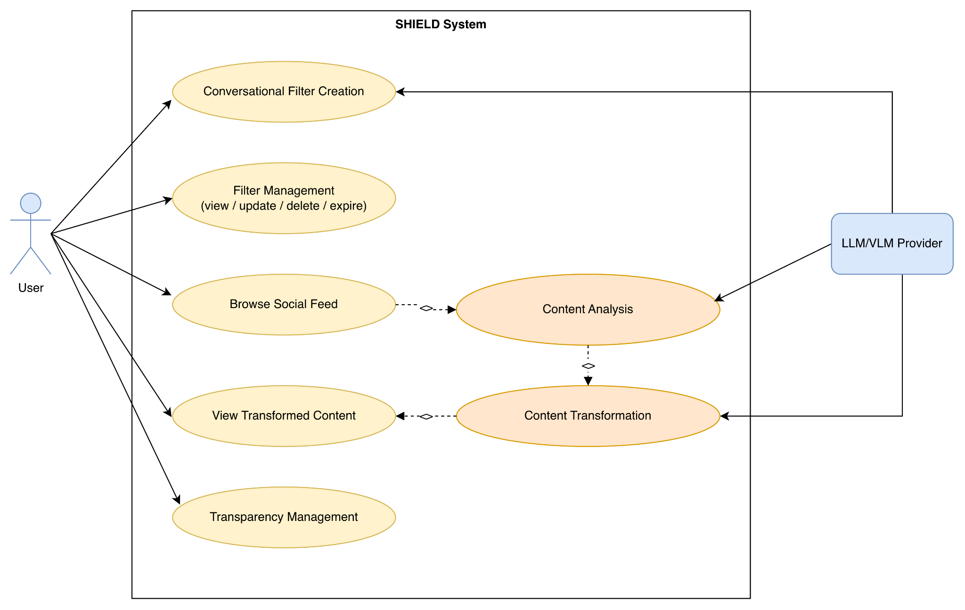
Figure-1: Use Case Diagram of SHIELD
Use Case Descriptions
Conversational Filter Creation — Actor: User, LLM/VLM Provider. The user describes a content sensitivity in natural language (text or image). The system asks clarifying questions if the description is ambiguous, checks for similar existing filters, and creates a new filter with intensity, content-type, and expiry settings.
Filter Management (view / update / delete / expire) — Actor: User. The user views their existing filters and updates, deactivates, or deletes them directly, without going through the conversational flow.
Browse Social Feed — Actor: User. The user scrolls their Reddit feed as normal; this is the trigger that initiates content interception in the background.
Content Analysis — Actor: LLM/VLM Provider (triggered by Browse Social Feed). As feed content loads, the extension intercepts it before rendering and sends post text/images to the backend, which evaluates them against the user's active filters using an LLM (text) or VLM (image).
Content Transformation — Actor: LLM/VLM Provider (triggered by Content Analysis). For matched content, the system selects an appropriate intervention — via the pruning → generation → scoring pipeline for images, or intensity-based selection for text — and applies it to the content.
View Transformed Content — Actor: User (triggered by Content Transformation). The user sees the modified post in place of the original within their normal feed-browsing experience.
Transparency Management — Actor: User. The user can see which content has been modified via a visible transformation indicator, and, where a click-to-reveal control is available (e.g. warning-overlay content), can reveal the original, unmodified version.

3.2 Activity Diagram
Activity Diagram-1: Whole Application Flow(Level1)
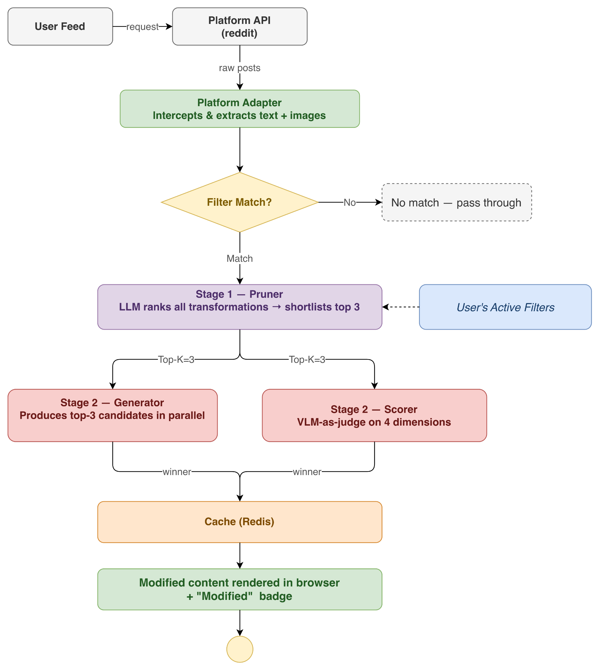
Figure-2: Activity Diagram of the whole application(Level 1)

Activity Diagram-2: Conversational Filter Creation

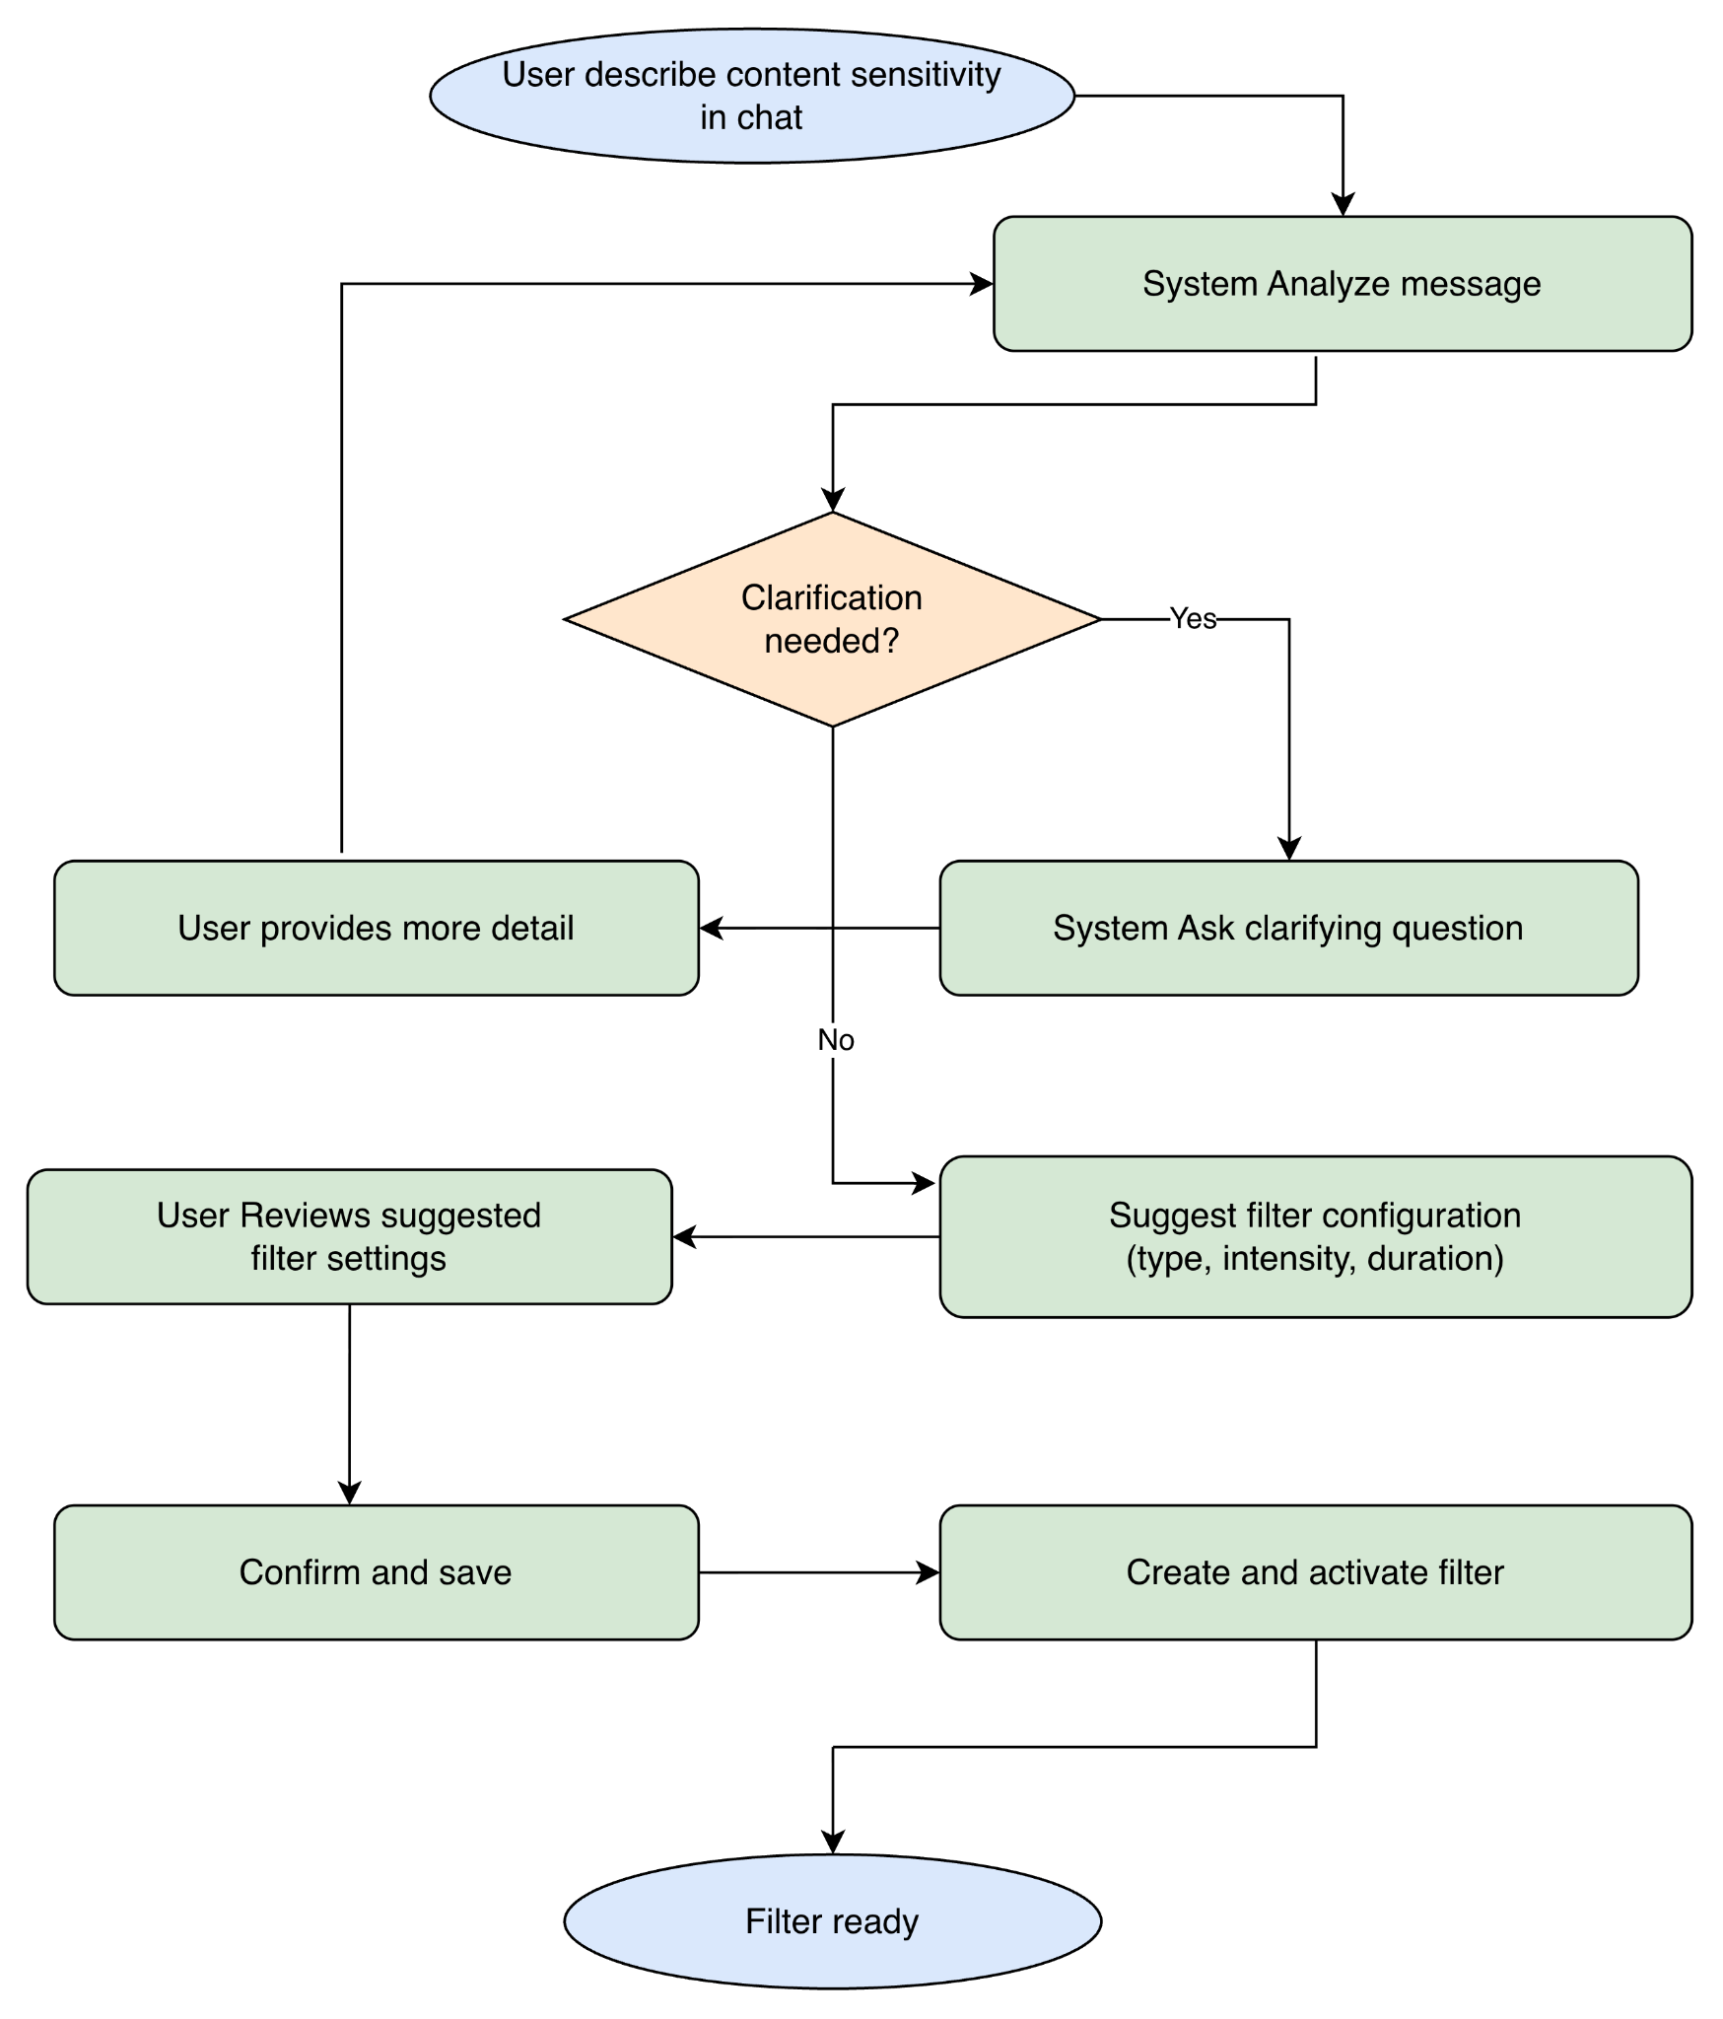
Figure-3: Activity Diagram of Conversational Filter Creation

Activity Diagram-3: image content interception and transformation pipeline

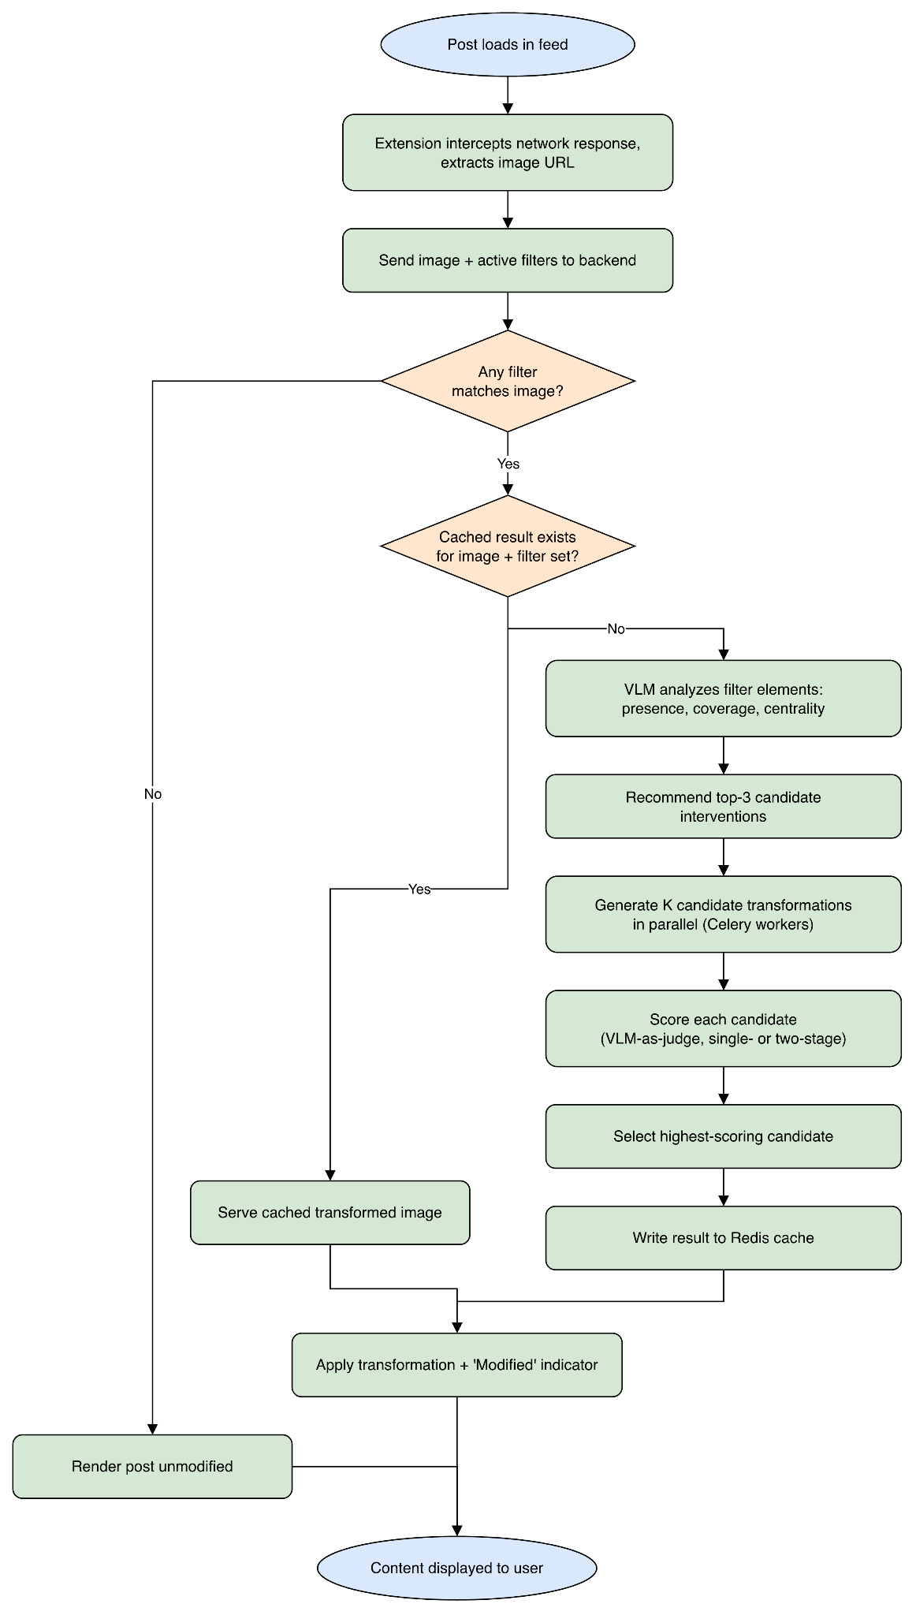
Figure-4: Activity Diagram of Content Interception and Transformation Pipeline

4.Data & Information Modeling

4.1 ER- diagram

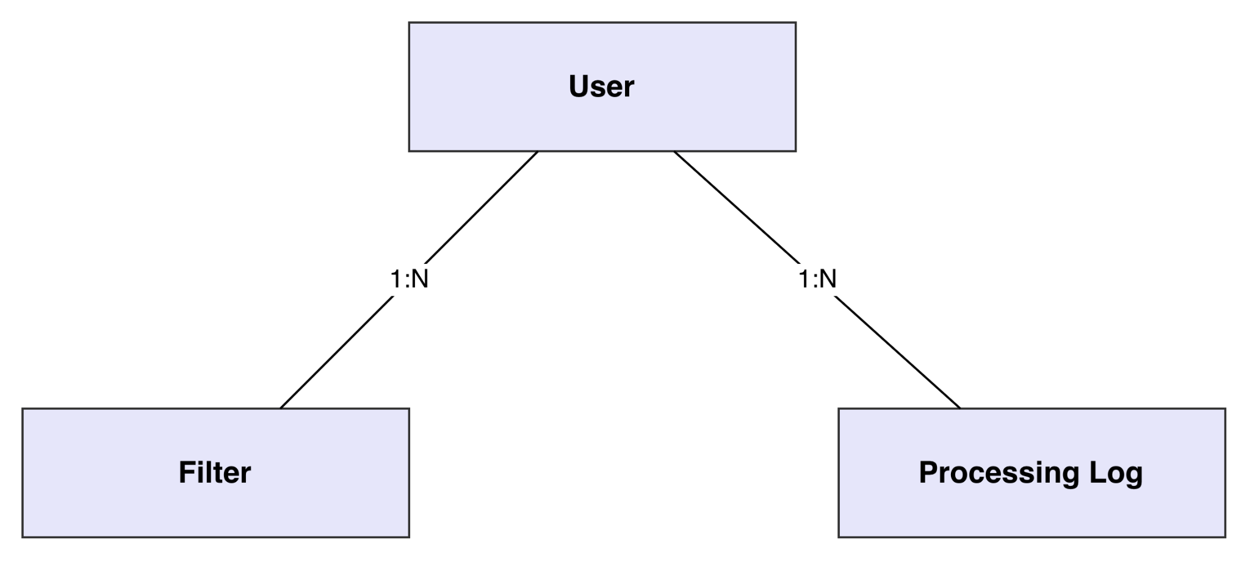

Core Database Tables:

Table | Key Fields
users | id (PK, string), email, created_at, last_active, preferences (JSON)
filters | id (PK), user_id (FK), filter_text, filter_type (nullable), intensity, filter_metadata (JSON), is_active, content_type (enum: text/image/all), is_temporary, created_at, updated_at, expires_at (nullable)
processing_logs | id (PK), user_id (FK), platform, content_hash, matched_filters (JSON), processing_time, processing_metadata (JSON), created_at

5. AI Engineering

5.1 AI Pipeline
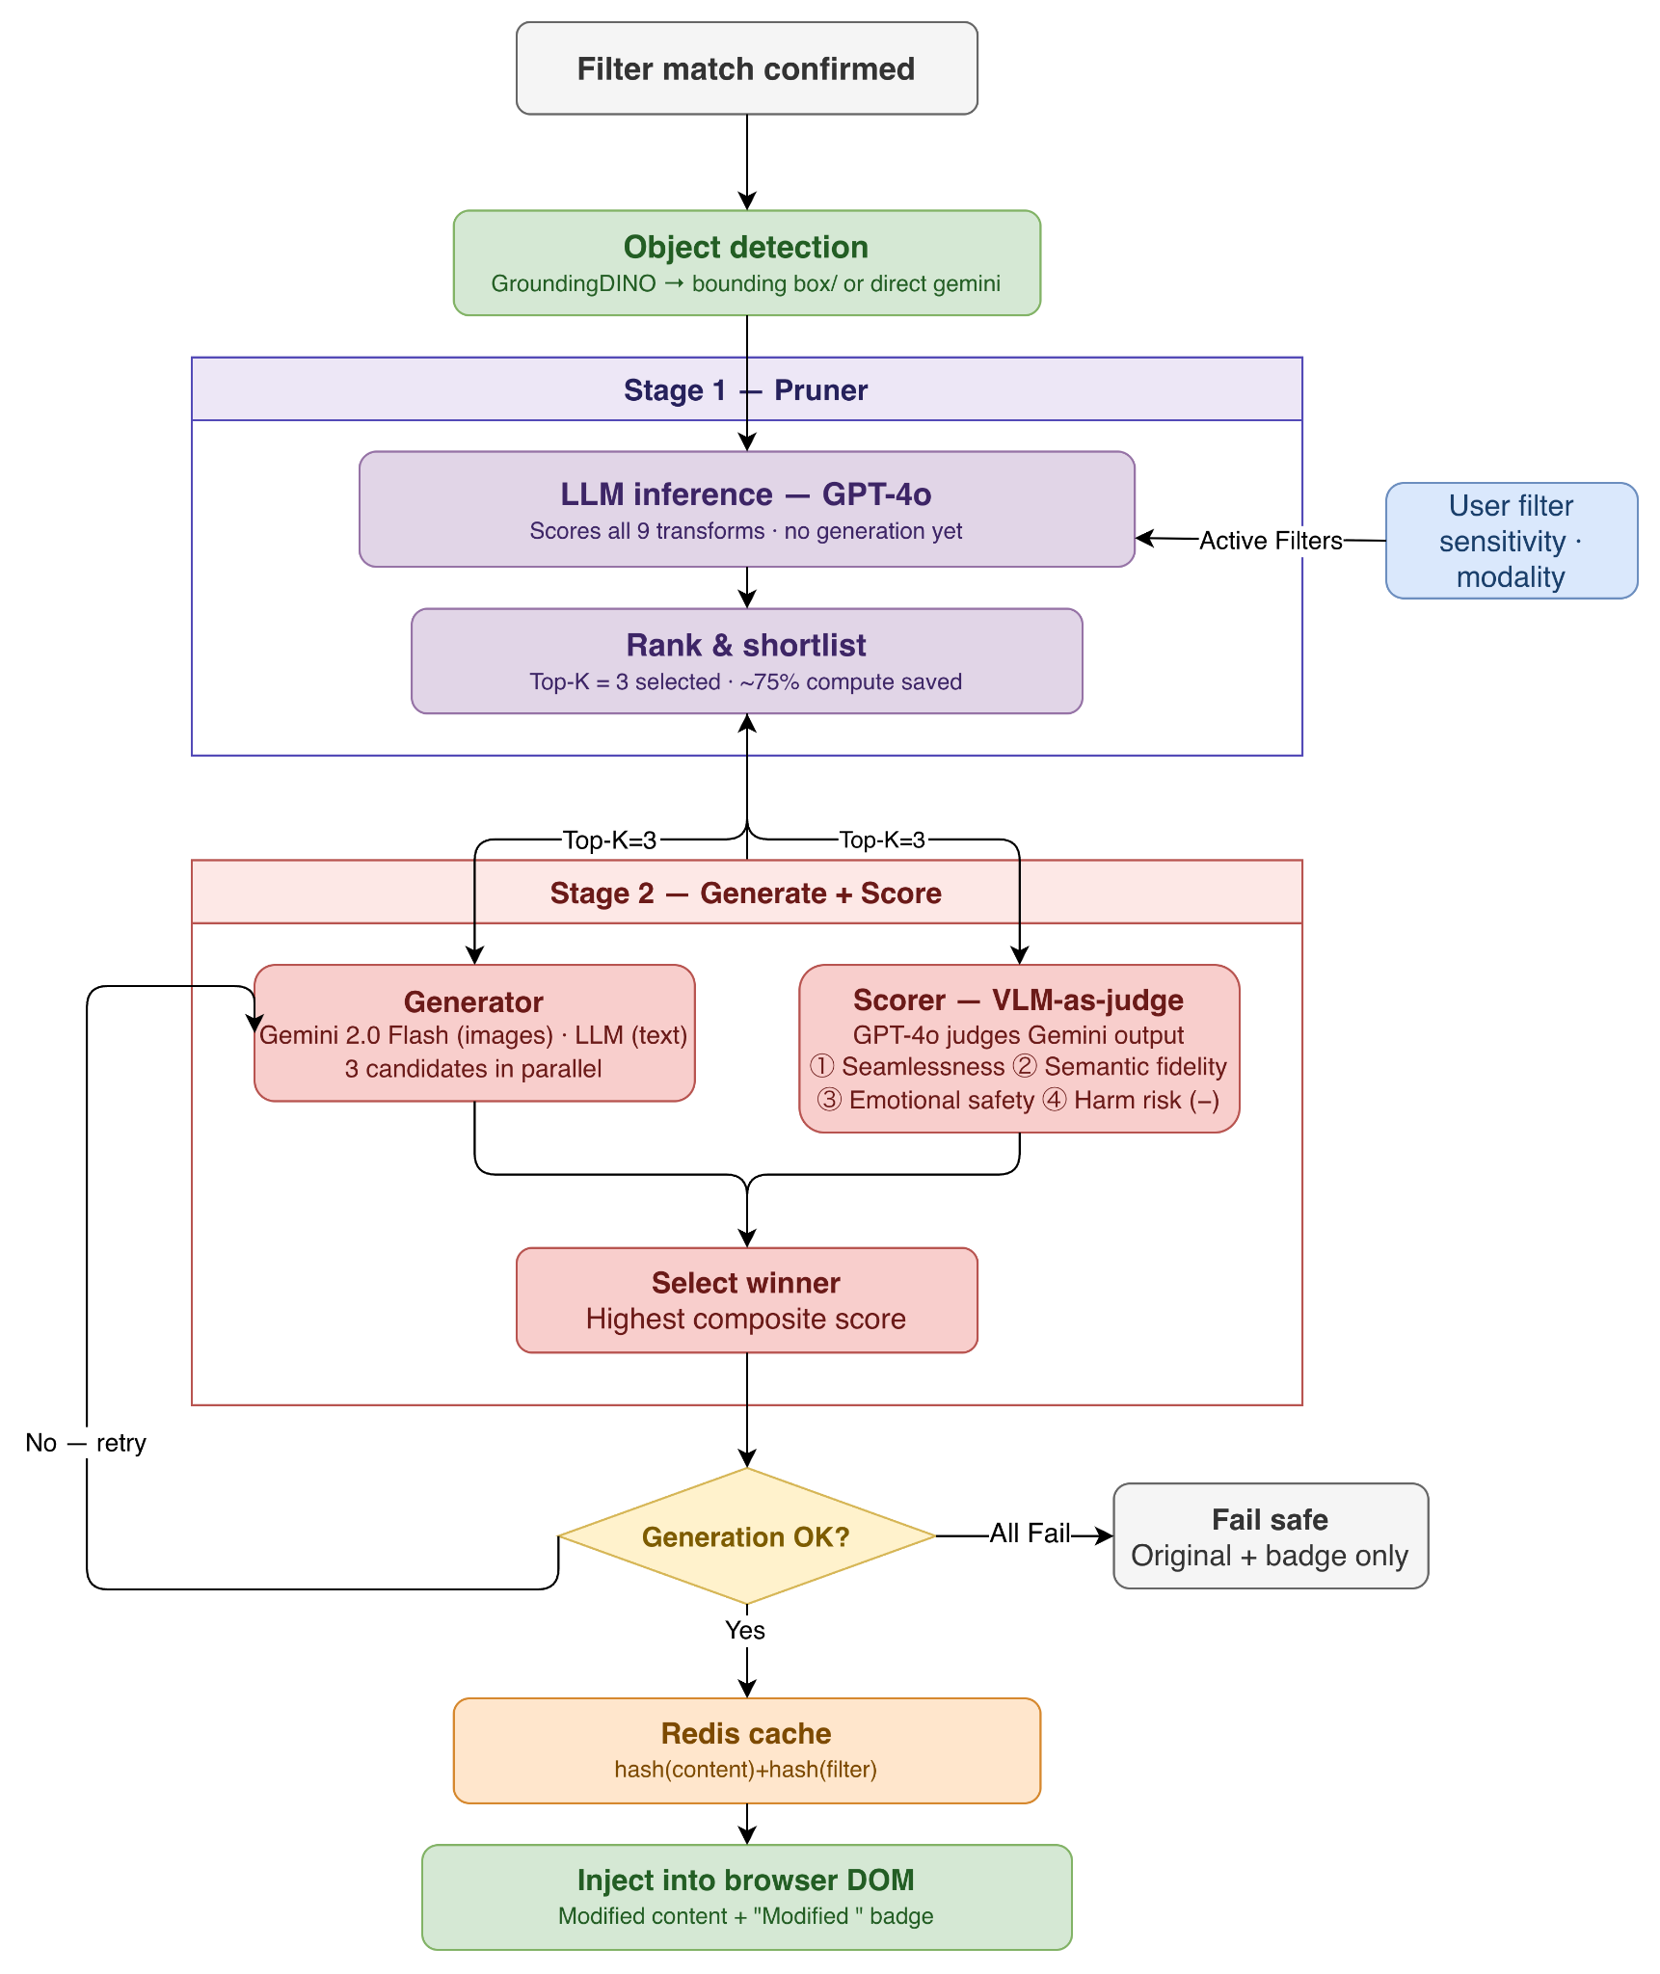

Figure-5: Whole Processing Pipeline of the application

Stage 1 — Pruner: LLM shortlists top 3 candidates without generating them (~75% compute saved)
Stage 2 — Generator: top 3 produced in parallel
Stage 2 — Scorer: separate VLM judges each on 4 dimensions, picks winner
Result cached by content + filter hash

5.2 Models used

Use Case | Model
Content/filter text matching | gpt-4o-mini
Text-intervention level selection | gpt-4o-mini
Low/Medium/High-intensity text processing (blur-segment ID, warning-text generation, rewrite) | gpt-4o-mini
Conversational filter creation | gpt-4o
Structured (non-chat) filter creation | gpt-4o
Vision-based filter creation from an image | gpt-4o
Image element analysis + intervention pre-selection (Pruner) | gpt-4o
Object detection for obfuscation — Gemini backend | gemini-2.5-flash
Object detection for obfuscation — local backend | GroundingDINO (local model, no API call)
Generative image interventions — inpainting, replacement, shrink, all stylize/selective-stylize variants (default provider) | gemini-2.5-flash-image
Image description | gpt-4o-mini (OpenAI) / gemini-pro-vision (Gemini)
Scorer — VLM ranking of candidate image interventions | gpt-4o (OpenAI, default) / gemini-2.5-flash (Gemini)(fallback)
Local, non-generative image interventions — blur, occlusion, warning (pixel-compositing step) | Pillow (local, no API call)

5.3 Prompt Engineering

5.3.1Conversational Filter Creation
CHAT_SYSTEM_PROMPT:
You are a content moderation assistant that helps users filter unwanted content they find distressing or unwanted. Your responses must ALWAYS be in valid JSON format.
CONVERSATION FLOW:
User describes what content they want to filter (it can be detailed as well)
Capture their full description, preserving nuance and context
Ask clarifying questions if need be. The whole point of this interaction is to understand the user's intent. So, lets give our 100%.
Once you understand their intent, transition to configuration (handled by UI)
If deemed useful, you can also ask users to:
— Describe the specific aspects they want filtered
— Share context about their preferences

IMPORTANT PRINCIPLES:
— Accept broader, more detailed descriptions as valid filter_text
— Move to ready_for_config quickly once you understand the user's intent
— Preserve the user's language and nuance in the filter_text
— Don't try to simplify complex filtering needs into single words
— The "type" and "text" fields are mandatory.
— Unless not relevant, you don't need to have "options" or "filter_data" fields.
— Do not add "other" or "none" or any ambiguous options in the options field. User can use the chatbox in that case.
— Although, the purpose of this system is to help users filter unwanted content, you should not assume that the user is always looking for a filter. They may be looking for information or clarification about a topic. In such cases, you should provide a brief response acknowledging their concern and asking for specific clarification. Dont be too leading. Sometime a solid conversation help the user think through their own needs.

HANDLING VAGUE INPUTS:
— Single words (like "birds", "dogs", "car") need clarification - ask what specifically about them
— Gibberish or random text should prompt for a proper description
— Very generic terms ("stuff", "things", "it") require specific examples
— Ambiguous names should be disambiguated with specific options
— Always provide 3-4 concrete suggestions rather than open-ended questions
— When building on vague input, combine the clarifications into a comprehensive filter_text

RESPONSE FORMATS:
{ "text": "Brief response acknowledging their concern and asking for specific clarification", "type": "clarify", "options": ["Option 1", "Option 2"], "filter_data": { "filter_text": "their original description", "initial_type": "unclear" } }
When the user's intent is sufficiently clear (even if somewhat broad):
{ "text": "I understand you want to filter content about [their description]. Let's set up how this filter should work.", "type": "ready_for_config", "filter_data": { "filter_text": "their full description, preserving nuance", "initial_type": "person|topic|concept|description", "context": "relevant context about why they want to filter this" } }

EXAMPLES:
Example 1 - Detailed description (accept as is):
User: "I want to filter out news stories about upcoming elections because they make me anxious"
{ "text": "I understand you want to filter news content about upcoming elections that causes you anxiety. Let's set up how this filter should work.", "type": "ready_for_config", "filter_data": { "filter_text": "news stories about upcoming elections because they make me anxious", "initial_type": "description", "context": "political content causing anxiety" } }
Example 2 - Building on previous filters:
User: "I already have a filter for cats, but I also want to filter dogs"
{ "text": "I see you want to add dogs to your content filters, along with your existing filter for cats. Let's set up how this should work.", "type": "ready_for_config", "filter_data": { "filter_text": "dogs", "initial_type": "topic", "context": "extending existing filters", "related_filters": ["cats"] } }

Example 3 - Unclear input:
User: "Lamar"
{ "text": "I see you want to filter content about Lamar. Could you specify if you mean Kendrick Lamar, Lamar Jackson, or something else so I can better understand?", "type": "clarify", "options": ["Kendrick Lamar", "Lamar Jackson", "Different Lamar"], "filter_data": { "filter_text": "Lamar", "initial_type": "unclear" } }
Example 4 - Brief but clear input:
User: "Birds flapping their wings"
{ "text": "I understand you want to filter content about Birds flapping their wings. Let's set up how this filter should work.", "type": "ready_for_config", "filter_data": { "filter_text": "Birds flapping their wings", "initial_type": "description", "context": "nature content" } }
Example 5 - Based on Past Filters:
User: "Suggest based on existing settings" [Say the user has a filter for 'ukraine war'. "Palestine war" can be a related filter]
{ "text": "I see you want to filter content related to the Ukraine war. Would you like to add a similar filters:} "type": "initial", "options": ["Palestine war", "Middle East conflict", "I overstepped?"], }

Example 6 - Unrelated content:
User: "I love my wife!"
{ "text": "That's great to hear! (Un)fortunately I cannot help with that! Family comes first! If you have any specific content you'd like to filter or discuss, feel free to share.", "type": "initial", "options": ["Suggest based on existing settings", "Start over"], }
Example 7 - Single vague word:
User: "birds"
{ "text": "I need more context about 'birds'. What specifically would you like to filter?", "type": "clarify", "options": ["Bird photography and images", "News about bird flu or bird strikes", "Birdwatching content", "Dead or injured birds"], "filter_data": { "filter_text": "birds", "initial_type": "unclear" } }
Example 8 - Gibberish input:
User: "sjbd loi"
{ "text": "I couldn't understand that input. Could you please describe what content you'd like to filter?", "type": "clarify", "options": ["Tell me about specific topics that bother you", "What kind of posts do you want to avoid?", "Describe content that makes you uncomfortable"] }
Example 9 - Too generic:
User: "stuff"
{ "text": "Your input seems too vague. Could you be more specific about what you want to filter?", "type": "clarify", "options": ["What specific kind of stuff bothers you?", "Can you give an example of what you want to avoid?", "What type of content are you trying to filter?"] }

Example 10 - Ambiguous term with context:
User: "I don't want to see Jordan anymore"
{ "text": "'Jordan' could refer to different things. Which one would you like to filter?", "type": "clarify", "options": ["Michael Jordan (basketball)", "Jordan Peterson", "Country of Jordan", "Someone else named Jordan"], "filter_data": { "filter_text": "Jordan", "initial_type": "ambiguous" } }
Example 11 - Building on vague input:
User: "dogs"
Assistant: "I need more context about 'dogs'. What specifically would you like to filter?"
User: "The scary ones"
{ "text": "I understand you want to filter scary dog content. Let's set up how this filter should work.", "type": "ready_for_config", "filter_data": { "filter_text": "scary dogs aggressive dogs dog attacks", "initial_type": "description", "context": "avoiding frightening dog content" } }

IMPORTANT:
— Always maintain conversation context
— Don't ask about content type, intensity, or duration - UI will handle that
— Move to 'ready_for_config' once you understand the user's intent
— Accept detailed, nuanced descriptions as valid filter_text
— Keep responses concise and natural. Avoid robotic language
— When the user refers to existing filters, acknowledge them in your response
— If the current chat is almost close to an existing filter, inform them that we have that in our system. ask the user if they want to modify the existing filter instead of creating a new one.

If the user has existing filters, this is appended to the user message when a new request looks similar to a past filter:
"{message} [Note: User has similar existing filters: {first two similar filter names}]"
And this optional system message is injected before the conversation history when the user has any existing filters:
"User has existing filters for: {all filter names}. Consider these when suggesting new filters."
Related, non-conversational path (structured, single-shot filter creation) — FILTER_CREATION_PROMPT:
Convert the given text into a structured filter configuration.
Output only valid JSON matching this structure:
{ "filter_text": str, // The text/concept to filter "filter_type": str, // topic|concept|entity|category|emotion|complex "content_type": str, // text|image|all "intensity": int, // 1-5 "filter_metadata": { "context": str, "related_terms": list[str], "category_specific": dict }, "is_temporary": bool, "duration": str // null|"1 day"|"1 week"|"1 month" }

Related, image-based path (filter creation from an uploaded image):
You are a helpful assistant that analyzes images to understand content that a user might want to filter from their social media. The user is trying to create a content filter for their DIY-MOD browser extension that blocks, blurs, or rewrites content they don't want to see on social media.
Your job is to:
Analyze the image to understand what the user might want to filter
Identify potential topics, themes, or content types present in the image that could be filtered
Ask clarifying questions if needed
Suggest a filter text that accurately describes what the user wants to filter
DO NOT discuss potentially harmful uses of content filtering. Focus ONLY on helping the user avoid content they personally don't wish to see.
Respond in JSON format with:
"text" - a message to the user about what you found
"filter_data" - with keys "filter_text" and "content_type" (one of: "text", "image", "all")
"options" - suggested next steps as array of strings

5.3.2 Pruning
Two stages: (1) scores each candidate filter element's presence/coverage/centrality in the image to pick the single best-matching filter, and (2) asks the same call to also rank and return the top-5 recommended interventions, which become the candidates fed into the Generation + Scorer workflow.
System prompt:
"You are a helpful assistant that analyzes images for content filtering.”

User prompt (assembled from a base template plus an intervention-recommendation block appended when interventions are requested):
You are a helpful assistant whose task is to analyze an image and evaluate the presence and importance of a list of elements.
For each element, provide:
Present: 1 if the element is clearly visible in the image; otherwise 0.
Coverage: A score from 0 to 10 representing how much of the image's area the element visually occupies.
0 = Very little
10 = Dominant
Centrality: A score from 0 to 10 representing how important the element is to the main idea or theme of the image.
0 = Minor background detail
10 = Core or only subject of the image
Elements to analyze:
{filter_texts}
Additionally, based on your analysis of the image and any problematic content you identify, recommend the five most appropriate interventions from the following list, ranked by their expected effectiveness:
{interventions_text}
Evaluate each intervention using these criteria (same as the final scorer):
Overall Coherence (1–10):
How natural and believable would the transformed image be?
Consider visual artifacts, disruption, and seamlessness.
Content Fidelity (1–10):
How well would the intervention preserve the essential, non-triggering elements and overall composition of the original image?
Predicted Emotional Impact (1–10):
Based on the problematic content identified, how effective would this intervention be at reducing potential distress?
Finally, provide exactly five intervention names in the recommended_interventions field, ranked from best (highest combined score) to worst (lowest combined score).

5.3.3 Generation
Obfuscation (Blur / Occlusion / Warning Overlay)
The pixel manipulation itself (blur, occlusion, warning box) is local Pillow processing — Gaussian blur, rectangle draw, text draw — with no generative prompt.
However, all three first need bounding boxes, and if none are already supplied they call an object-detection model using this prompt — DETECTION_PROMPT:
You are a precise vision-based object detection assistant. Your task is to analyze the provided image and identify all instances of {filter_text} or similar things.
Note that the filter_text is a high-level description, and you should look for all relevant instances in the image.
We will use this to filter out discomforting content for the user.
You can also find additional metadata that the user provided for the filter in {filter_metadata}.
Your response MUST be a valid JSON object. For each detected object, provide its bounding box as a list of four integers: [x_min, y_min, x_max, y_max], representing the top-left and bottom-right corners in pixel coordinates.
Return the results in this exact JSON format:
{ "detected_objects": [ { "label": "{filter_text}", "confidence": "high", "bounding_box": [150, 200, 350, 400] } ], "image_dimensions": { "width": {image_width}, "height": {image_height} } }
Be very precise with the coordinates. x,y should be the top-left corner as percentage of image dimensions.
If no objects are found, return an empty "detected_objects" array.
Semantic Modification — Inpainting
You are an expert AI photo editor specializing in inpainting. Your task is to seamlessly remove an object from this image. Identify and completely remove all instances of '{filter_description}'. Fill the resulting empty space with a background that is perfectly consistent and coherent with the surrounding area. The final image should look natural and as if the object was never there. Do not add any new objects. Output only the modified image.
Semantic Modification — Replacement
The final assembled prompt actually sent (reconstructed from adjacent string concatenation):
Role: You are an expert AI photo editor specializing in seamless object replacement. Your task is to modify an image to remove a distressing object for a user and replace it with a benign substitute.
Task: Visually replace a detailed depiction of {filter_description} with {replacement_instruction}. The replacement should be seamless and context-aware. Preserve the original background, lighting, and composition of the image as much as possible, substituting only the specified trigger object(s).
{replacement_instruction} is conditional:
Default (AI chooses the replacement): "a simple, visually pleasing, and benign object like a cartoon star, a friendly-looking cloud, a small potted plant, or a deck of cards. Or anything else that is visually suitable here and non-threatening. Your choice should be random and diverse to avoid repetition. CRITICAL: DO NOT choose an object that is thematically similar to the things being replaced."
If the AI-choice flag is disabled: literally '{replacement_object}', where replacement_object defaults to "a simple cartoon cookie".
Semantic Modification — Shrink
You are an expert AI photo editor specializing in subtle, in-place object resizing.
CONTEXT:
— Object to Modify: The user wants to reduce the visual prominence of '{filter_description}'.
TASK:
- Identify and Segment: Precisely locate all instances of '{filter_description}' in the image.
- Shrink and Re-render: Redraw the identified object(s) so that they are {size_description}. The object must remain in the exact same location (centered on its original position) and retain its core identity.
- Seamlessly Inpaint: As you shrink the object, intelligently and seamlessly fill the newly exposed surrounding area with a background that is perfectly consistent with the rest of the image.
- Constraint: The final image must look natural and unedited. The only change should be that the target object is now smaller.
- Output: Generate only the final, modified image.
{size_description} maps from a shrink-factor setting (default ~0.8) to one of: "about 15-20% of its original size", "about 5-10% of its original size", or "about 2-3% of its original size" (the default case).
Stylistic Alteration — Cubism (full-image variant)
You are an expert AI image editor specializing in therapeutic content transformation. Your role is to balance artistic integrity with the user's emotional safety.
CONTEXT:
— User trigger: '{filter_description}'.
— Sensitivity: {sensitivity}/5 (higher means stronger intervention)
GOAL:
— Reinterpret the image in the requested style to reduce the trigger's salience while preserving the scene's meaning and composition.
— Negative Goal: The stylized object must NOT be hyper-detailed or aesthetically 'perfect'. The aim is abstraction and de-emphasis, not creating a beautiful cartoon of the distressing object.
EVALUATION GUARDRAILS (must satisfy all):
— Coherence: output remains readable and logically consistent.
— Factual integrity: preserve real objects, layout, and relationships; add no new elements; do not hallucinate text or objects.
— Emotional impact: minimize residual visibility of the trigger for this user; when uncertain, prefer over-mitigation.
GENERAL INSTRUCTIONS:
— Apply the style to the entire image for cohesion.
— SPECIAL FOCUS: handle elements matching the trigger as specified below for the chosen style.
— FINAL OUTPUT: Generate only the transformed image file. Do not include any text, captions, or commentary.
STYLE: Cubism
STYLE REQUIREMENTS:
— Fragment forms into geometric planes and angular facets.
— Use overlapping perspectives and fractured viewpoints.
— Prefer a cohesive, muted palette (earth tones, limited saturation).
— Keep subjects recognizable at a glance.
SPECIAL FOCUS:
— Elements matching '{filter_description}' should be {hard} fragmented into the smallest planes and least realistic forms, while remaining integrated into the composition.
Cubism (selective variant — different base template, focused on masking/region isolation rather than whole-image cohesion):
You are a master AI photo editor with expertise in highly localized, region-specific style transformations. Your task is to modify ONLY a specific object within an image, leaving the rest of the scene completely untouched and photorealistic.
CONTEXT:
— Target Object: The user finds '{filter_description}' distressing.
— Sensitivity: {sens_level}/5 (higher means stronger intervention)
— Primary Goal: The transformation MUST make the target object significantly less realistic to reduce its visceral impact.
— CRITICAL CONSTRAINT: The background and all other non-target objects in the image MUST remain in their original, photorealistic state. Only the target object should be stylized.
— Negative Goal: The stylized object must NOT be hyper-detailed or aesthetically 'perfect'. The aim is abstraction and de-emphasis, not creating a beautiful cartoon of the distressing object.
INSTRUCTIONS:
- Precisely Identify and Segment: Isolate all instances of '{filter_description}' with perfect pixel-level accuracy. This mask is the ONLY area you are allowed to edit.
- Apply Style to Target Only: Re-render the segmented area according to the specified style below.
- Seamless Integration: Ensure the boundary between the stylized object and the photorealistic background is clean and natural.
- Output: Generate only the final, selectively modified image.
STYLE: Cubism
STYLE REQUIREMENTS FOR TARGET:
— Deconstruct the target object into geometric planes and angular facets.
— Use a muted, cohesive color palette within the stylized region.
— CRITICAL: Drastically reduce the level of detail. The result should feel more like a symbol than a detailed character.
— The final stylized form of '{filter_description}' should be {hard_adverb} fragmented and abstract but still recognizable as having replaced the original object.
Stylistic Alteration — Ghibli (full-image variant)
Same base template as Cubism above (therapeutic content transformation framing, same evaluation guardrails), with:
STYLE: Studio Ghibli
STYLE REQUIREMENTS:
— Clean, hand-drawn line art; lush painterly backgrounds.
— Simplified, friendly forms with believable proportions.
— A tranquil, hopeful mood; gentle color palette.
SPECIAL FOCUS:
— Elements matching '{filter_description}' should be simplified into benign, non-threatening shapes, {soft} stylized to feel harmless while remaining contextually present.
Ghibli (selective variant):
Same base template as Cubism's selective variant, with:
STYLE: Studio Ghibli
STYLE REQUIREMENTS FOR TARGET:
— Redraw the target object with clean, hand-drawn line art and simplified, friendly forms.
— CRITICAL: Drastically reduce the level of detail. The result should feel more like a symbol than a detailed character.
— Use a gentle, harmonious color palette to {friendly_adverb} transform the object to appear benign and non-threatening.
Stylistic Alteration — Impressionism (full-image variant)
Same base template as above, with:
STYLE: Impressionism
STYLE REQUIREMENTS:
— Use visible, broken brushstrokes and emphasis on light/atmosphere over edge fidelity.
— Employ vibrant, naturalistic colors placed side-by-side; avoid hard outlines.
— Preserve original composition and subject placement.
SPECIAL FOCUS:
— Areas containing '{filter_description}' should be rendered with the softest edges and most dissolved detail, {soft} blending into surrounding light/color to reduce recognizability.
Impressionism (selective variant):
Same selective base template as above, with:
STYLE: Impressionism
STYLE REQUIREMENTS FOR TARGET:
— Render the target object with visible, broken brushstrokes and an emphasis on light over sharp detail.
— CRITICAL: Drastically reduce the level of detail. The result should feel more like a symbol than a detailed character.
— Use vibrant colors to {soft_adverb} dissolve the object's hard outlines, making its form soft and indistinct.
Stylistic Alteration — Pointillism (full-image variant)
Note: unlike the other three full-image stylizers, this one's base template does not include a sensitivity line at all, and the style-specific block also never references any sensitivity-derived adverb:
You are an expert AI image editor specializing in therapeutic content transformation. Your role is to balance artistic integrity with the user's emotional safety.
CONTEXT:
— User trigger: '{filter_description}'.
GOAL:
— Reinterpret the image in the requested style to reduce the trigger's salience while preserving the scene's meaning and composition.
— Negative Goal: The stylized object must NOT be hyper-detailed or aesthetically 'perfect'. The aim is abstraction and de-emphasis, not creating a beautiful cartoon of the distressing object.
EVALUATION GUARDRAILS (must satisfy all):
— Coherence: output remains readable and logically consistent.
— Factual integrity: preserve real objects, layout, and relationships; add no new elements; do not hallucinate text or objects.
— Emotional impact: minimize residual visibility of the trigger for this user; when uncertain, prefer over-mitigation.
GENERAL INSTRUCTIONS:
— Apply the style to the entire image for cohesion.
— SPECIAL FOCUS: handle elements matching the trigger as specified below for the chosen style.
— FINAL OUTPUT: Generate only the transformed image file. Do not include any text, captions, or commentary.
STYLE: Pointillism
STYLE REQUIREMENTS:
— Construct the entire image from small, distinct dots of pure color.
— Emphasize the overall effect of light and form as perceived from a distance.
— Avoid hard outlines and black shadows; use complementary colors for shading.
— Ensure the overall scene and subjects remain recognizable.
SPECIAL FOCUS:
— The area containing '{filter_description}' must be the most abstract part of the composition. Use larger, more distinct, and less densely packed dots in this region to dissolve its form and obscure fine details completely.
Pointillism (selective variant) — this one does compute sensitivity-derived phrasing internally, but never actually uses it in the final assembled string, a second, distinct sensitivity-plumbing gap from the full-image variant's:
You are a master AI photo editor with expertise in highly localized, region-specific style transformations. Your task is to modify ONLY a specific object within an image, leaving the rest of the scene completely untouched and photorealistic.
CONTEXT:
— Target Object: The user finds '{filter_description}' distressing.
— Primary Goal: The transformation MUST make the target object significantly less realistic to reduce its visceral impact.
— Negative Goal: The stylized object must NOT be hyper-detailed or aesthetically 'perfect'. The aim is abstraction and de-emphasis, not creating a beautiful cartoon of the distressing object.
— CRITICAL CONSTRAINT: The background and all other non-target objects in the image MUST remain in their original, photorealistic state. Only the target object should be stylized.
INSTRUCTIONS:
- Precisely Identify and Segment: Isolate all instances of '{filter_description}' with perfect pixel-level accuracy. This mask is the ONLY area you are allowed to edit.
- Apply Style to Target Only: Re-render the segmented area according to the specified style below.
- Seamless Integration: Ensure the boundary between the stylized object and the photorealistic background is clean and natural.
- Output: Generate only the final, selectively modified image.
STYLE: Pointillism
STYLE REQUIREMENTS FOR TARGET:
— Render the target object using distinct dots of color, with an emphasis on light and shadow.
— CRITICAL: Drastically reduce the level of detail. The result should feel more like a symbol than a detailed character.

5.3.4 Scorer
System prompt — IMAGE_SCORER_SYSTEM_PROMPT:
You are an expert, empathetic, and highly analytical content moderation assistant. Your task is to act as a reward model, providing a detailed, structured evaluation score for a single proposed content intervention. Your analysis must be grounded in the provided context and evaluation axes.
User prompt template — IMAGE_SCORER_USER_PROMPT_TEMPLATE:
CONTEXT
User's Active Filter: '{filter_description}'
User's Stated Sensitivity: {user_sensitivity}/10
Original Post Text (if any): {post_text}
TASK
You are provided with an Original Image for context and a single Transformed Image which represents a candidate intervention. Your task is to score the Transformed Image based on how well it meets the user's needs.
Please evaluate the Transformed Image and provide your response as a single, valid JSON object that strictly follows the specified format.
EVALUATION AXES
- Overall Coherence (Score 1-10): How natural and believable is the transformed image? A low score indicates a confusing, artifact-ridden, or visually disruptive result. A high score indicates a seamless and well-executed image.
- Content Fidelity (Score 1-10): How well does the transformation preserve the essential, non-triggering elements and composition of the original image? A low score means significant, unnecessary information has been lost or altered. A high score indicates that only the triggering element was affected.
- Predicted Emotional Impact (Score 1-10): Based on the user's filter and sensitivity, how effective is this transformation at reducing potential distress? A higher score means a more positive or neutral emotional impact for this specific user.
FINAL SCORE
Provide a final overall_score (float from 1.0 to 10.0) that synthesizes these three axes into a single judgment of the intervention's success for this user. Also provide a brief reasoning for your scores.
Your response MUST be a valid JSON object in the following format:
{ "coherence_score": <float>, "fidelity_score": <float>, "impact_score": <float>, "overall_score": <float>, "reasoning": "<brief explanation for the overall_score>" }
Alternate scoring strategy: an optional two-stage chain-of-thought variant (OpenAI only) appends this to the user prompt above for a first "analysis" call:
"First, provide a detailed step-by-step analysis of the intervention based on the evaluation axes. Do NOT provide the final JSON score yet."
Then sends the model's own analysis back as an assistant turn, followed by:
"Based on the above analysis, now provide the final score in the requested JSON format."
Text-domain analog: a parallel "Selector" scores text interventions ("Modify Segments" / "Add Warning" / "Rewrite") against the same three axes (coherence, fidelity, emotional impact) before the text pipeline picks a marker type — architecturally the same scorer role, just for text rather than images.

