Bisection Method

Algorithm:
1. Set the function or the equation ( f(x) = ax2 + bx + c )
2. Set the accepting error limit ( ε ).
3. Take input the limits ( a, b ).
4. If f (a) * f (b) is greater than 0, go to 5; else go to 6.
5. Print “There is no root within this limit, exit.
6. Repeat 7-9 till f (c) is less than error limit ( ε ).
7. Make c as the average of a & b.
8. If f(c)*f(a) < 0, set b=c.
9. If f(c)*f(b) < 0, set a= c.
10. Print c as the root of the equation; then exit.

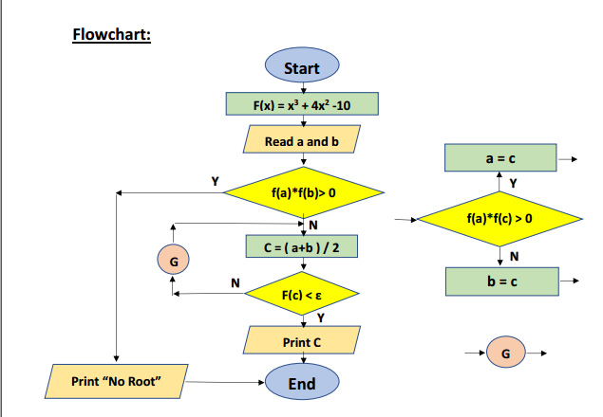
Source code:
#include<stdio.h>
#include<string.h>
#include<stdlib.h>
#include<math.h>
#define EPS 10.0e-6
#define f(x) (x*x*x+4*x*x-10)

int main(){
int n=100,i;
double a=1.25,b=1.5,c;
if(f(a)*f(b)>0)exit(0);
printf("------------------------------------------------------------------------------------------\n");
printf("ITER a b c f(a) f(b) f(c)\n"); printf("------------------------------------------------------------------------------------------\n");
for(int i=1;i<=n;i++){
c=(a+b)/2;
printf("%d %lf %lf %lf %lf %lf %lf\n",i,a,b,c,f(a),f(b),f(c));
if(fabs(f(c))<EPS){
printf("root-%lf",c);
break;
}
if(f(c)*f(a)<0){
b=c;
}
else a=c;
}
return 0;
}
Output:
