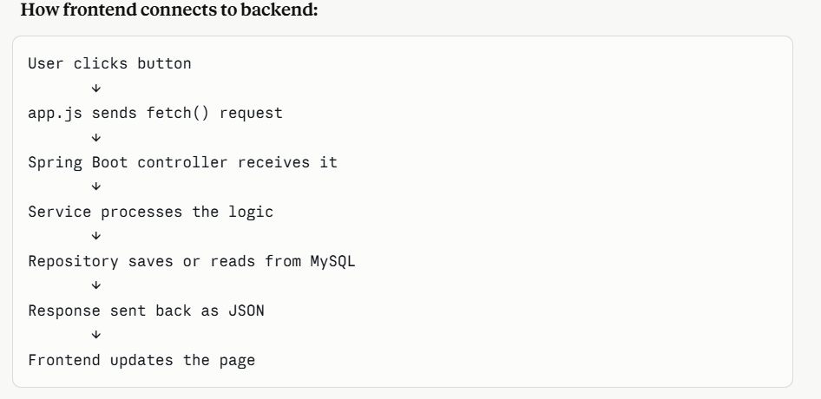

Here is the complete summary of everything we built from scratch!

QuickBite — Complete Project Journey

Phase 1 — Project Planning & Frontend Prototype
What we did: We started by understanding the project requirements. QuickBite is a full stack food delivery platform with 12 functionalities including user registration, restaurant browsing, cart, order tracking, payments, email and SMS notifications, reviews and admin dashboard.
We built: A complete interactive frontend prototype with all pages working — Home, Restaurant browsing, Menu, Cart, Payment modal, Order Tracking, Order History, Restaurant Dashboard and Admin Dashboard. All pages were clickable with real interactions.

Phase 2 — Spring Boot Project Setup
What we did: We went to start.spring.io and created a new Spring Boot project with these settings:
Project: Maven
Language: Java
Spring Boot: 3.5.1
Group: com.quickbite
Artifact: quickbite-backend
Packaging: Jar
Java: 21
Dependencies added on start.spring.io:
- Spring Web
- Spring Data JPA
- Spring Security
- MySQL Driver
- Spring Boot DevTools
- Lombok
- Validation
- Java Mail Sender
Extra dependencies added manually to pom.xml:
- JWT (jjwt-api, jjwt-impl, jjwt-jackson) version 0.12.6
- Twilio version 10.1.0
Errors we fixed:
- Twilio 9.14.0 not found → updated to 10.1.0
- JWT 0.11.5 not found → updated to 0.12.6
- Wrong directory for mvn command → navigated to correct inner folder

Phase 3 — Project Structure
We created these packages:
com.quickbite.quickbite_backend
├── model
├── repository
├── service
├── controller
├── config
├── dto
└── notification
We configured application.properties:
spring.application.name=quickbite-backend
server.port=8080
spring.datasource.url=jdbc:mysql://localhost:3306/quickbite_db
spring.datasource.username=root
spring.datasource.password=yourpassword
spring.jpa.hibernate.ddl-auto=update
jwt.secret=quickbite_super_secret_key
jwt.expiration=86400000

Phase 4 — Database Models
What we did: We created 6 Java entity classes. Spring Boot automatically creates database tables from these classes.
Files created in model package:
User.java — stores customers, restaurant owners and admins
Fields: id, name, email, password, role, phone, createdAt
Role options: CUSTOMER, RESTAURANT_OWNER, ADMIN
Restaurant.java — stores restaurant details
Fields: id, name, cuisine, address, phone, rating, imageUrl, isOpen, owner
MenuItem.java — stores food items
Fields: id, name, description, price, category, imageUrl, available, restaurant
Order.java — stores placed orders
Fields: id, user, restaurant, orderItems, status, totalAmount, deliveryAddress, createdAt
OrderItem.java — stores each item inside an order
Fields: id, order, menuItem, quantity, price
Review.java — stores ratings and comments
Fields: id, user, restaurant, rating, comment, createdAt
OrderStatus.java — enum for order stages
Values: PENDING, CONFIRMED, PREPARING, OUT_FOR_DELIVERY, DELIVERED, CANCELLED
Errors we fixed:
- Cannot resolve MenuItem → created file in correct order
- Files created in wrong package → deleted and recreated in model package
- Lombok not working → installed Lombok plugin and enabled annotation processing
- setPassword error → added @NoArgsConstructor and @AllArgsConstructor annotations

Phase 5 — Repositories
What we did: We created 6 repository interfaces. These are like filing cabinets that handle all database operations automatically.
Files created in repository package:
UserRepository — finds users by email, checks if email exists
RestaurantRepository — finds by cuisine, searches by name, finds by owner
MenuItemRepository — gets menu by restaurant, searches by name, filters by category
OrderRepository — gets orders by user, by restaurant, by status, sorted by newest
OrderItemRepository — gets all items inside a specific order
ReviewRepository — gets reviews by restaurant, by user, checks for duplicates
Important note: These are Interfaces not Classes! Created using New → Java Class → change dropdown to Interface.
Error we fixed: OrderRepository using Order.OrderStatus → moved OrderStatus to separate file and updated import

Phase 6 — Services
What we did: We created 6 service classes. These are the brain of the application containing all business logic.
Files created in service package:
UserService — registers users with encrypted passwords, finds by email, manages profiles
RestaurantService — gets all restaurants, searches, filters by cuisine, CRUD operations
MenuItemService — manages menu items, searches food, adds and updates items
OrderService — places orders, calculates totals, updates status, triggers notifications
ReviewService — adds reviews, prevents duplicates, gets reviews by restaurant or user
NotificationService (in notification package) — sends order confirmation emails and status update emails using JavaMail
Errors we fixed:
- Cannot resolve sendStatusUpdate → NotificationService was in wrong package
- Needed correct import for NotificationService in OrderService

Phase 7 — Controllers
What we did: We created 6 controller classes. These are the doors of the application — they receive HTTP requests from the browser and return responses.
Files created in controller package:
AuthController — handles register and login, returns JWT token on login
RestaurantController — GET all, GET one, search, filter by cuisine, POST, PUT, DELETE
MenuItemController — GET menu by restaurant, search items, POST, PUT, DELETE
OrderController — place order, get order, get user orders, get restaurant orders, update status
ReviewController — add review, get restaurant reviews, get user reviews, delete
UserController — get all users, get one, update, delete (admin only)
All API endpoints:
POST /api/auth/register
POST /api/auth/login
GET /api/restaurants
GET /api/restaurants/{id}
GET /api/restaurants/search?name=pizza
GET /api/restaurants/cuisine/Italian
POST /api/restaurants
PUT /api/restaurants/{id}
DELETE /api/restaurants/{id}
GET /api/menu/restaurant/{id}
POST /api/menu/restaurant/{id}
PUT /api/menu/{id}
DELETE /api/menu/{id}
POST /api/orders
GET /api/orders/{id}
GET /api/orders/user/{userId}
GET /api/orders/restaurant/{restaurantId}
PUT /api/orders/{id}/status
GET /api/reviews/restaurant/{id}
POST /api/reviews
DELETE /api/reviews/{id}

Phase 8 — Security & JWT
What we did: We created 4 security files that protect the application. Only logged in users can place orders. Only admins can delete users.
Files created in config package:
JwtUtil — generates JWT tokens after login, extracts email from token, validates tokens
JwtFilter — checks every request for a valid JWT token in the Authorization header
CustomUserDetailsService — loads user from database by email for Spring Security
SecurityConfig — defines which URLs are public and which require login, configures BCrypt password encryption
How JWT works:
1. User logs in with email and password
2. Backend verifies credentials
3. Backend generates JWT token
4. Frontend stores token in browser
5. Every request includes token in header
6. Backend validates token and allows access
Error we fixed:
- parserBuilder() error → JWT 0.12.6 changed the API, updated to new syntax using Jwts.parser() instead of Jwts.parserBuilder()

Phase 9 — MySQL Connection
What we did: We connected the Spring Boot app to a real MySQL database.
Steps taken:
- Tried to reset MySQL password using skip-grant-tables
- Found that data directory was in different location
- Used MySQL Installer Reconfigure option to reset password
- Updated application.properties with real MySQL credentials
- Added createDatabaseIfNotExist=true to URL so database creates automatically
Result: Spring Boot automatically created all 6 tables in MySQL:
✅ users
✅ restaurants
✅ menu_items
✅ orders
✅ order_items
✅ reviews
Errors we fixed:
- Could not resolve placeholder jwt.secret → application.properties had wrong content
- Port 8080 already in use → killed the existing process
- Access denied for root → reconfigured MySQL password

Phase 10 — API Testing with Postman
What we did: We downloaded Postman and tested all APIs to make sure they work correctly.
Tests we ran:
✅ POST /api/auth/register → user created successfully
✅ POST /api/auth/login → JWT token returned
✅ POST /api/restaurants → restaurant saved to MySQL
✅ GET /api/restaurants → list of restaurants returned
Results:
Login response:
{
"userId": 1,
"token": "eyJhbGciOiJIUzM4NCJ9...",
"role": "CUSTOMER",
"name": "Alex Johnson",
"email": "alex@gmail.com"
}
Errors we fixed:
- GET restaurants returning empty → added @JsonIgnore to prevent infinite loop between Restaurant and MenuItem
- Cannot access OrderStatus → moved from inner enum to separate file
- Incompatible types Restaurant → deleted duplicate Restaurant class from root package

Phase 11 — Frontend Connected to Backend
What we did: We created a complete professional frontend inside Spring Boot static folder so everything runs from one place.
Files created:
src/main/resources/static/
├── index.html ← all pages and structure
├── style.css ← complete styling
└── app.js ← connects to backend APIs
Key connection in app.js:
const API = 'http://localhost:8080/api';
Pages built:
- Home with hero section and restaurant grid
- Menu page with food items
- Cart with quantity controls and order summary
- Login and Register forms
- Order tracking with live stages
- Profile with order history
How frontend connects to backend:
User clicks button
↓
app.js sends fetch() request
↓
Spring Boot controller receives it
↓
Service processes the logic
↓
Repository saves or reads from MySQL
↓
Response sent back as JSON
↓
Frontend updates the page

Phase 12 — GitHub Upload
What we did: We uploaded the entire project to GitHub for version control and sharing.
Steps taken:
- Configured git identity with name and email
- Created .gitignore to exclude sensitive files and compiled code
- Ran git init to initialize repository
- Ran git add . to stage all files
- Ran git commit to save snapshot with 41 files
- Created GitHub repository
- Generated Personal Access Token
- Connected local project to GitHub with git remote add
- Pushed code with git push

Complete Technology Stack Used
Frontend:
HTML5, CSS3, JavaScript (Vanilla)
Google Fonts (Inter)
Fetch API for backend calls

Backend:
Java 21
Spring Boot 3.5.1
Spring MVC (REST Controllers)
Spring Security (JWT Authentication)
Spring Data JPA (Database ORM)
Spring Mail (Email notifications)

Security:
JWT (JSON Web Tokens) v0.12.6
BCrypt Password Encryption

Database:
MySQL 8.0
Hibernate (auto table creation)

Notifications:
JavaMail API (Email)
Twilio SDK v10.1.0 (SMS)

Build Tool:
Maven 3.9.9

Version Control:
Git
GitHub

Testing:
Postman (API testing)

IDE:
IntelliJ IDEA

