1. **Given an array and a number K where K is smaller than the size of the array. Find the K’th largest element in the given array. Given that all array elements are distinct.**

Sample Input: arr[] = { 5, 2, 7, 1, 3}, k = 2

Sample Output: 5

Explanation: The 2nd largest element is 5.

**Code:**

*//21161 Shaik Nazeer CSE-B*

*#include<bits/stdc++.h>*

*#define ll long long*

*#define loop(i,n) for(int i = 0; i < n; i++)*

*#define loop1(i,n) for(int i = 1; i <= n; i++)*

*using namespace std;*

*int main()*

*{*

*int n,k;*

*cin>>n>>k;*

*int a[n];*

*loop(i,n) cin>>a[i];*

*sort(a,a+n);*

*cout<<a[n-k]<<endl;*

*return 0;*

*}*

**Screenshot:**

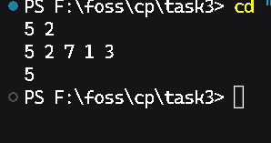

1. **Given a sorted array arr[] and a number x, write a function that counts the occurrences of x in arr[]. Expected time complexity is O(Logn).**

Sample Input: x = 2

A[] = {1,2,2,2,3,4,5,7,9}

Sample Output: 3

Explanation: The number 2 occurs 3 times in the array.

**Code:**

*// 21161 Shaik Nazeer CSE-B*

*#include <bits/stdc++.h>*

*#define ll long long*

*#define loop(i, n) for (int i = 0; i < n; i++)*

*#define loop1(i, n) for (int i = 1; i <= n; i++)*

*using namespace std;*

*int main()*

*{*

*int n,x;*

*cin>>n>>x;*

*int a[n];*

*loop(i,n) cin>>a[i];*

*int start = 0, end = n - 1, mid = (start + (end - start) / 2);*

*while (start <= end)*

*{*

*mid = (start + (end - start) / 2);*

*if (a[mid] < x)*

*{*

*start = mid + 1;*

*}*

*else if (a[mid] > x)*

*{*

*end = mid - 1;*

*}*

*else*

*{*

*break;*

*}*

*}*

*if (start > end && a[mid] != x)*

*return 0;*

*int cnt = 0, i = mid + 1;*

*while (mid >= 0 && a[mid] == x)*

*{*

*cnt++;*

*mid--;*

*}*

*while (i < n && a[i] == x)*

*{*

*i++;*

*cnt++;*

*}*

*cout<<cnt<<endl;*

*return 0;*

*}*

**Screenshot:**

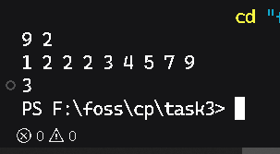

1. **Write a program to reverse an array.**

Sample Input: arr[] = {4, 5, 1, 2}

Sample Output: arr[] = {2, 1, 5, 4}.

Explanation: 1100 is the binary representation of the given number 12. Set bit is nothing but the ‘1’ bits that are present in a binary number. In 1100 the first set bit from the right occurs in third position. Thus, the output is 3.

**Code:**

*//21161 Shaik Nazeer CSE-B*

*#include<bits/stdc++.h>*

*#define ll long long*

*#define loop(i,n) for(int i = 0; i < n; i++)*

*#define loop1(i,n) for(int i = 1; i <= n; i++)*

*using namespace std;*

*int main()*

*{*

*int n;*

*cin>>n;*

*int a[n];*

*loop(i,n) cin>>a[i];*

*reverse(a,a+n);*

*loop(i,n) cout<<a[i]<<" ";*

*return 0;*

*}*

**Screenshot:**

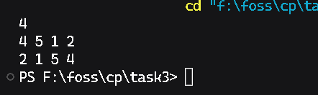

1. **Given an array Arr[] of N integers. Find the contiguous sub-array (containing at least one number) which has the maximum sum and return its sum. (Kadane’s Algorithm)** Sample Input: a[] = { -2, -3, 4, -1, -2, 1, 5, -3 }

Output: 7

Explanation: The Max subarray sum is 7 of elements (4, -1, -2, 1, 5) which is a contiguous subarray.

**Code:**

//21161 Shaik Nazeer CSE-B

#include<bits/stdc++.h>

#define ll long long

#define loop(i,n) for(int i = 0; i < n; i++)

#define loop1(i,n) for(int i = 1; i <= n; i++)

using namespace std;

int main()

{

    int n;

    cin>>n;

    int a[n];

    loop(i,n) cin>>a[i];

    int sum = a[0],maxSum = sum;

    loop1(i,n-1){

        if(sum<0){

            sum=0;

        }

        sum+=a[i];

        maxSum=max(sum,maxSum);

    }

    cout<<maxSum<<endl;

    return 0;

}

**Screenshot:**

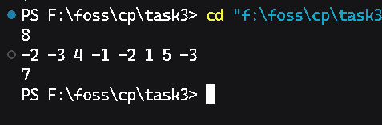

1. **Given an array and a value, find if there is a triplet in array whose sum is equal to the given value. If there is such a triplet present in array, then print the triplet and return true. Else return false.**

Sample Input: arr = {12, 3, 4, 1, 6, 9}, sum = 24;

Sample Output: 12, 3, 9

Explanation: There is a triplet (12, 3 and 9) present in the array whose sum is 24.

Constraints: Expected Time Complexity is O(n^2).

**Code:**

// 21161 Shaik Nazeer CSE-B

#include <bits/stdc++.h>

#define ll long long

#define loop(i, n) for (int i = 0; i < n; i++)

#define loop1(i, n) for (int i = 1; i <= n; i++)

using namespace std;

int main()

{

    int n, sum, j, k, tempSum = 0;

    cin >> n >> sum;

    int a[n];

    loop(i, n) cin >> a[i];

    sort(a, a + n);

    loop(i, n)

    {

        tempSum = sum-a[i];

        if(tempSum<0) {

            cout<<"False\n";

            return 0;

        }

        j = i + 1, k = n - 1;

        while (j < k)

        {

            if(tempSum==a[j]+a[k]){

                cout<<a[i]<<" "<<a[j]<<" "<<a[k]<<endl;

                return 0;

            }

            else if(a[j]+a[k]<tempSum){

                j++;

            }else{

                k--;

            }

        }

    }

    return 0;

}

**Screenshot:**

