**Business Insights**

1. **Customer Sign-Up Trends :**

Customer sign-ups have shown a noticeable decline between the 4th and 7th months, which could be attributed to various factors such as reduced marketing efforts, seasonal demand fluctuations, or external influences. To address this decline, it would be beneficial to focus on targeted marketing campaigns, promotions, or special offers during these months. Additionally, introducing seasonal products, conducting customer surveys to understand their preferences, and analysing market trends can help identify the root causes of this dip.

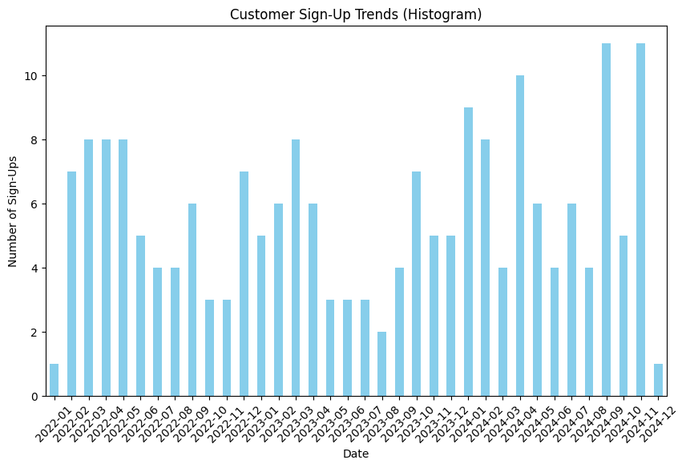

1. **Top Performing Regions by Revenue**  
   Revenue by region shows that South America leads with $219,352.56, followed by Europe at $166,254.63, North America with $152,313.40, and Asia with $152,074.97. This distribution suggests that South America has the highest revenue contribution, while Asia and North America are closely aligned. Europe, while significant, lags behind South America. To increase revenue, focus on targeted marketing campaigns and introduce region-specific promotions. Diversify products to cater to local needs, enhance customer retention with loyalty programs, and explore untapped markets.

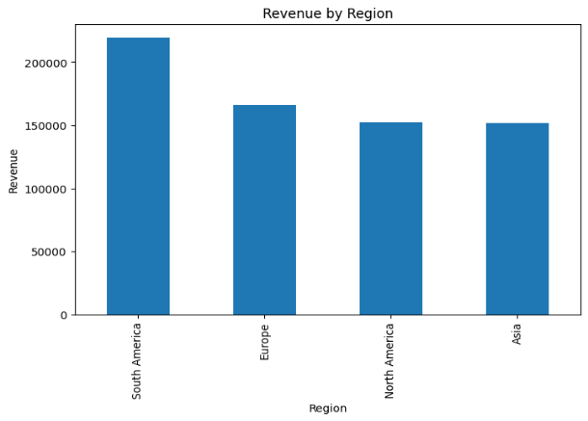

1. **Optimizing Inventory and Pricing Strategy Based on Top-Selling Products**  
   Observing the top products by revenue, we can manage inventory more effectively by ensuring that high-demand items are consistently stocked, minimizing stockouts and lost sales. Additionally, this insight allows us to strategically hike prices on the most sold products, capitalizing on their popularity to increase revenue while maintaining customer interest. By closely monitoring sales trends, we can adjust pricing dynamically and optimize inventory levels, ensuring maximum profitability and minimizing excess stock of lower-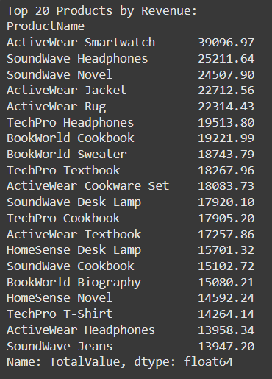performing items.
2. **Leveraging Monthly Sales Trends to Boost Revenue**  
   By analysing monthly sales trends, we can identify periods of lower sales and implement targeted strategies to increase revenue. For months with slower sales, we can introduce promotional offers, seasonal discounts, or limited-time deals to encourage purchases. Additionally, launching marketing campaigns, engaging with customers through loyalty programs, or offering exclusive products during these off-peak times can help boost customer interest and drive sales. By aligning marketing and sales strategies with the monthly trends, businesses can maintain steady revenue growth throughout the year, even during traditionally slower periods.

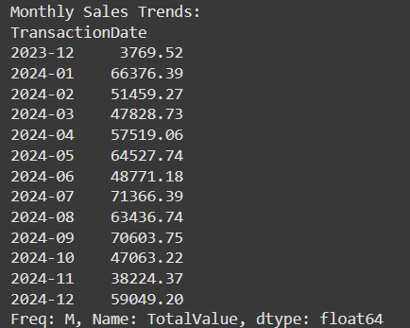

1. **Average Order Value (AOV) Insights**  
   Analysing the Average Order Value (AOV) provides valuable insights into customer spending habits. A higher AOV indicates that customers are purchasing more items per order, which can be further leveraged through cross-selling and upselling strategies. By analysing AOV trends, businesses can identify opportunities to bundle products or offer discounts on higher-value orders, encouraging customers to spend more. If AOV is lower than expected, introducing promotions like free shipping thresholds or loyalty rewards for larger purchases can drive customers to increase their order value. Optimizing AOV helps in maximizing revenue per transaction, improving profitability, and enhancing customer experience.

