|  |  |
| --- | --- |
| **Name** | **NAZEER AHMED** |
| **CMS ID** | **023-18-0062** |
| **Marks** |  |
| **Date** |  |

**Objective:** To become familiar selection/control structures (if else) in C/C++

#### **Operators in C++**

Operators are special type of functions that takes one or more arguments and produces a new value.

For example : addition (+), subtraction (-), multiplication (*) etc, are all operators. Operators are used to perform various operations on variables and constants.

#### **Types of operators**

We have studied few types of operators in our class. They are listed below

1. Assignment Operator
2. Arithmetic Operators
3. Relational Operators
4. Logical Operators

**Assignment (=) operator** is used to assign value to a certain variable. For example

int num1 = 3, num2;

num2 = num1*5+83;

char ch = ‘B’;

**Arithmetic Operators** consists of +, -, *, / and %. Try examples below

int num1, num2;

cin>>num1>>num2;

cout<<num1+num2<<endl;

cout<<num1-num2<<endl;

cout<<num1*num2<<endl;

cout<<num1/num2<<endl;

cout<<num1%num2<<endl;

**Relational Operators**

These operators establish a relationship between operands. The relational operators are : less than (<) , grater thatn (>) , less than or equal to (<=), greater than equal to (>=), equivalent (==) and not equivalent (!=).

Example of comparison of two operands using relational operators is

float num1, num2;

cin>>num1>>num2;

cout<<”Result of == relation is ”<<(num1 == num2)<<endl;

cout<<”Result of != relation is ”<<(num1 != num2)<<endl;

cout<<”Result of < relation is ”<<(num1 < num2)<<endl;

cout<<”Result of <= relation is ”<<(num1 <= num2)<<endl;

cout<<”Result of > relation is ”<<(num1 > num2)<<endl;

cout<<”Result of >= relation is ”<<(num1 >= num2)<<endl;

You must notice that assignment operator is (=) and there is a relational operator, for equivalent (==). These two are different from each other, the assignment operator assigns the value to any variable, whereas equivalent operator is used to compare values, like in if-else conditions.

# **Logical Operators**

These operators consists of &&(and), ||(or) and !(not). && and || operators are used when combining two or more than two relations. For example, I want to see whether a student got score above 5 and below or equal to 10, I have to use && operator as

float score;

cin>>score;

cout<<((score>5)&&(score<=10));

What if I want to see whether a person enters ‘M’ as gender or have score greater than 5

char gender;

float score;

cin>>gender>>score;

cout<<(score>5||gender == ‘M’);

There is another type of logical operator that is ! (not). It is used to invert the result. For example, if a Boolean expression is having result as true, placing ! at the start of it will make the result false and vice versa. For example,

int score = 6;

cout<<!(score>5)<<endl;

Although score is greater than 5, however, due to usage of logical operator !, result will be false.

# **if...else statement**

An **if** statement can be followed by an optional **else** statement, which executes when the boolean expression is false.

# **Syntax:**

if (boolean_expression) {

// statement(s) will execute if the boolean expression is true

} else {

// statement(s) will execute if the boolean expression is false

}

If the boolean expression evaluates to **true**, then the **if block** of code will be executed, otherwise **else block** of code will be executed.

# **How if statement works?**

# 

# **Flow Diagram**

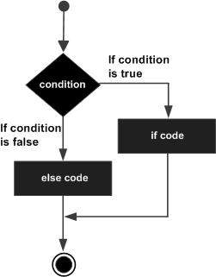

# **Example**

#include <iostream>

using namespace std;

void main () {

// local variable declaration:

int a = 100;

// check the boolean condition

if( a < 20 ) {

// if condition is true then print the following

cout << "a is less than 20;" << endl;

} else {

// if condition is false then print the following

cout << "a is not less than 20;" << endl;

}

cout << "value of a is : " << a << endl;

getch();

}

|  |
| --- |
| **Output:** |

# **if...else if...else Statement**

An **if** statement can be followed by an optional **else if...else** statement, which is very usefull to test various conditions using single if...else if statement.

When using if, else if, else statements there are few points to keep in mind.

* An if can have zero or one else's and it must come after any else if's.
* An if can have zero to many else if's and they must come before the else.
* Once an else if succeeds, none of the remaining else if's or else's will be tested.

# **Syntax**

* The syntax of an if...else if...else statement in C++ is –

if (boolean_expression 1) {

// Executes when the boolean expression 1 is true

} else if (boolean_expression 2) {

// Executes when the boolean expression 2 is true

} else if ( boolean_expression 3) {

// Executes when the boolean expression 3 is true

} else {

// executes when the none of the above condition is true.

}

# **Example**

#include <iostream>

using namespace std;

int main () {

// local variable declaration:

int a = 100;

// check the boolean condition

if( a == 10 ) {

// if condition is true then print the following

cout << "Value of a is 10" << endl;

} else if( a == 20 ) {

// if else if condition is true

cout << "Value of a is 20" << endl;

} else if( a == 30 ) {

// if else if condition is true

cout << "Value of a is 30" << endl;

} else {

// if none of the conditions is true

cout << "Value of a is not matching" << endl;

}

cout << "Exact value of a is : " << a << endl;

return 0;

}

**Programming Exercise.**

* Write a program which prompts the user to enter his percentage in decimal number, the program decides grade on following criteria using multi way selection.

80 or above grade A

70 or above grade B

60 or above grade C

50 or above grade D

Less than 50 fail

Source code

#include<iostream>

#include<conio.h>

using namespace std;

int main()

{

float percentage;

cout<<"Enter the percentage "<<endl;

cin>>percentage;

if(percentage>80)

cout<<"A GRADE"<<endl;

else if(percentage>70)

cout<<"B GRADE"<<endl;

else if(percentage>60)

cout<<"C GRADE"<<endl;

else if(percentage>50)

cout<<"D GRADE"<<endl;

else

cout<<"Fail"<<endl;

getch();

}

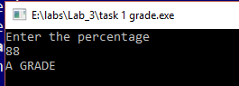

* Write a program which prompts the user to enter two decimal numbers, and displays the largest number on the screen using if else statement.

Source code

#include<iostream>

#include<conio.h>

using namespace std;

int main()

{

float num1,num2;

cout<<"Enter the number "<<endl;

cin>>num1>>num2;

if(num1>num2)

cout<<"Your large number is : "<<num1<<endl;

else

cout<<"your large number is : "<<num2<<endl;

}

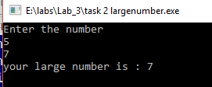

* Write a program that prompts the user to input a number. The program should then output the number and a message saying whether the number is positive, negative, or zero.

Source code

#include<iostream>

#include<conio.h>

using namespace std;

int main()

{

int num;

cout<<"Enter the number "<<endl;

cin>>num;

if(num>0)

cout<<"Number is postive"<<endl;

else if(num<0)

cout<<"Number is Negative"<<endl;

else

cout<<"Equall to zero"<<endl;

}

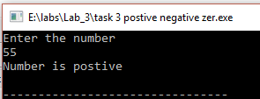

* Write a program that mimics a calculator. The program should take as input two integers and the operation to be performed. It should then output the numbers, the operator, and the result. (For division, if the denominator is zero, output an appropriate message.) Some sample outputs follow:

3 + 4 = 7

13 * 5 = 65

Source code

#include<iostream>

#include<conio.h>

using namespace std;

int main()

{

float num1,num2;

cout<<"Enter the 1st number"<<endl;

cin>>num1;

cout<<"Enter the 2nd number"<<endl;

cin>>num2;

char op;

cout<<"Enter the operation '+' for Addition ,'-' for Subraction , '*' for multiplication , '/' for Division and '%' for mod "<<endl;

cin>>op;

if(op=='+')

cout<<"your Addition is : "<<num1+num2<<endl;

else if(op=='-')

cout<<"Your Subraction is : "<<num1-num2<<endl;

else if(op=='*')

cout<<"your Multiplication is : "<<num1*num2<<endl;

else if(op=='/')

cout<<"your Divsion is : "<<num1/num2<<endl;

else

cout<<"you mod is : "<<int(num1)%int(num2)<<endl;

}

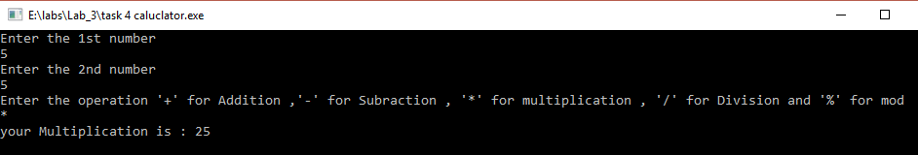

* Write a C++ program that prompts the user to input three integer values and find the greatest value of the three values.

Source code

#include<iostream>

#include<conio.h>

using namespace std;

int main()

{

float num1,num2,num3;

cout<<"Enter the 1st number "<<endl;

cin>>num1;

cout<<"Enter the 2nd number "<<endl;

cin>>num2;

cout<<"Enter the 3rd number "<<endl;

cin>>num3;

if(num1>num2 && num1>num3)

cout<<"Greater number is : "<<num1;

else if(num2>num1 && num2>num3)

cout<<"Greater number is : "<<num2;

else if(num3>num1 && num3>num2)

cout<<"Greater number is : "<<num3<<endl;

else

cout<<"Egual to each other "<<endl;

getch();

}

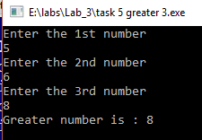

* Write a C++ program to check whether a number is divisible by 5 and 11 or not.

Source code

#include<iostream>

#include<conio.h>

using namespace std;

int main()

{

int num1;

cout<<"Enter the number "<<endl;

cin>>num1;

if((num1%5 && num1%11)==0)

cout<<"Divisabe "<<endl;

else

cout<<"Not Divisable"<<endl;

}

