|  |  |
| --- | --- |
| **Name** | **NAZEER AHMED** |
| **CMS ID** | **023-18-0062** |
| **Marks** |  |
| **Date** |  |

**Objective:** To become familiar with loops in C/C++

The ladder **if..else..if** statement allows you to execute a block code among many alternatives. If you are checking on the value of a single variable in ladder **if..else..if,** it is better to use **switch** statement.

The switch statement is often faster than if...else (not always). Also, the syntax of switch statement is cleaner and easier to understand.

**C++ switch...case syntax**

switch (n)

​{

case constant1:

// code to be executed if n is equal to constant1;

break;

case constant2:

// code to be executed if n is equal to constant2;

break;

.

.

.

default:

// code to be executed if n doesn't match any constant

}

When a case constant is found that matches the switch expression, control of the program passes to the block of code associated with that case.

In the above pseudocode, suppose the value of n is equal to constant2. The compiler will execute the block of code associated with the case statement until the end of switch block, or until the [break statement](https://www.programiz.com/cpp-programming/break-continue) is encountered.

The break statement is used to prevent the code running into the next case.

**Flowchart of switch Statement**

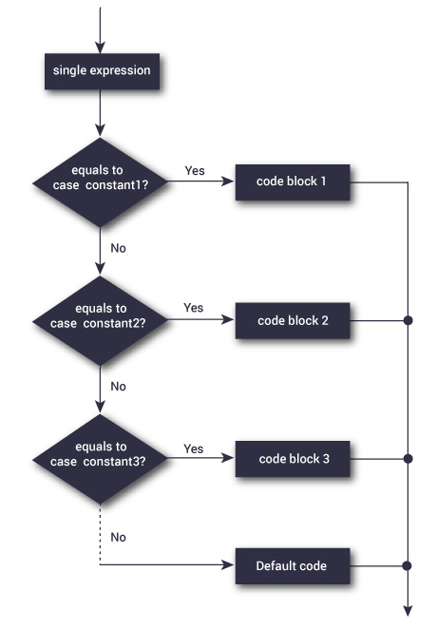

The above figure shows how a switch statement works and conditions are checked with in the switch case clause.

**Example: C++ switch Statement**

// Program to built a simple calculator using switch Statement

#include <iostream>

using namespace std;

int main()

{

char o;

float num1, num2;

cout << "Enter an operator (+, -, *, /): ";

cin >> o;

cout << "Enter two operands: ";

cin >> num1 >> num2;

switch (o)

{

case '+':

cout << num1 << " + " << num2 << " = " << num1+num2;

break;

case '-':

cout << num1 << " - " << num2 << " = " << num1-num2;

break;

case '*':

cout << num1 << " * " << num2 << " = " << num1*num2;

break;

case '/':

cout << num1 << " / " << num2 << " = " << num1/num2;

break;

default:

// operator is doesn't match any case constant (+, -, *, /)

cout << "Error! operator is not correct";

break;

}

return 0;

}

**Tasks of Switches:**

Solve the following problems using switches only.

1. **Currency conversion**

**Design a program that takes amount in Pakistani rupees and convert to one of these currencies**

1. To US Dollars(1 Rs = 0.0095$)
2. To Pound(1Rs = 0.0074 pound)
3. Euro(1Rs = 0.008 euro)
4. Korean won (1Rs = 10.8 KRW)
5. Japanes yen (1Rs = 1.04 JP Yen)
6. Chinese yuan (1Rs = 0.064 chinese yuan)

First you need to ask user to enter the amount in Pakistani rupees that he have. Then you need to display message

Please enter 1 for converting to Dollar

2 for converting into Pound

3 for converting into Euro

4 for converting into Korean won

5 for converting into Japanese yen

6 for converting into chinese yuan

CODE

#include<iostream>

#include<conio.h>

using namespace std;

int main()

{

float amount,bill;

cout<<"Enter the pakistani rupees "<<endl;

cin>>amount;

char op;

cout<<"Enter 1 for conversing to Dollar"<<endl;

cout<<"Enter 2 for conversing to Pound"<<endl;

cout<<"Enter 3 for conversing to Euro"<<endl;

cout<<"Enter 4 for conversing to Korean won"<<endl;

cout<<"Enter 5 for conversing to Japanese yen"<<endl;

cout<<"Enter 6 for conversing to chinese yuan"<<endl;

cin>>op;

switch(op)

{

case '1':

bill=amount*0.0095;

cout<<"convert amount in dollar is "<<bill<<endl;

break;

case '2':

bill=amount*0.0074;

cout<<"convert amount in Pound is : "<<bill<<endl;

break;

case '3':

bill=amount*0.008;

cout<<"convert amount in Euro is : "<<bill<<endl;

break;

case '4':

bill=amount*10.8;

cout<<"convert amount in Korean won is : "<<bill<<endl;

break;

case '5':

bill=amount*1.04;

cout<<"convert amount in Japanese yen is : "<<bill<<endl;

break;

case '6':

bill=amount*0.064;

cout<<"convert amount in chinese yuan is : "<<bill<<endl;

break;

getch();

}

}

OUTPUT

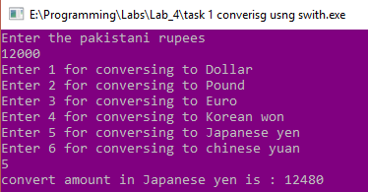

1. **Use switched wherever you can and if else wherever you can’t**

Ask user to enter age, gender ( M or F ), marital status ( Y or N ) and then using following rules print their place of service.  
if employee is female, then she will work only in urban areas.  
  
if employee is a male, marital status is N, and age is in between 20 to 40 then he may work in urban area only

if employee is a male, marital status is Y, and age is in between 20 to 40 then he may work in anywhere  
if employee is male and age is in between 40 t0 60 then he will work in urban areas only.  
And any other input of age should print "ERROR"

CODE

#include<iostream>

#include<conio.h>

using namespace std;

int main()

{

int age;

cout<<"Enter the age "<<endl;

cin>>age;

char gender,ms;

cout<<"Enter the Gender "<<endl;

cin>>gender;

switch(gender)

{

case 'f':

case 'F':

cout<<"Work onlu in urban area"<<endl;

break;

case 'm':

case 'M':

{

if(age>40 && age<60)

cout<<"work in urban area"<<endl;

cout<<"Enter the martical status y for yes N for NO"<<endl;

cin>>ms;

if(ms=='n' || ms=='N')

{

if(age>=20 && age<40)

cout<<"may work only uran area"<<endl;}

else if(ms=='y'|| ms=='Y')

{

if(age>=20 && age<=40)

cout<<"may work anywhere"<<endl;}

else

cout<<"ERROR"<<endl;

break;

}

}

}

OUTPUT

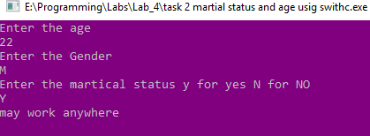

**Loops**

Loops are used in programming to repeat a specific block until some end condition is met. There are three type of loops in C++ programming:

1. for loop
2. [while loop](https://www.programiz.com/cpp-programming/do-while-loop)
3. [do...while loop](https://www.programiz.com/cpp-programming/do-while-loop)

**C++ for Loop Syntax**

for(initializationStatement; testExpression; updateStatement) {

// codes

}

where, only **testExpression** is mandatory.

**How for loop works?**

1. The initialization statement is executed only once at the beginning.
2. Then, the test expression is evaluated.
3. If the test expression is false, for loop is terminated. But if the test expression is true, codes inside body of for loop is executed and update expression is updated.
4. Again, the test expression is evaluated and this process repeats until the test expression is false.

**Flowchart of for Loop in C++**

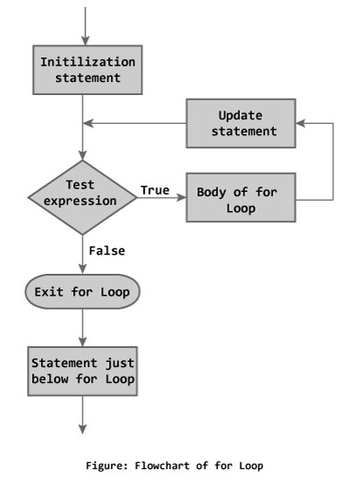

**Example 1: C++ for Loop**

#include <iostream>

using namespace std;

int main()

{

int i, n, factorial = 1;

cout << "Enter a positive integer: ";

cin >> n;

for (i = 1; i <= n; ++i) {

factorial *= i; // factorial = factorial * i;

}

cout<< "Factorial of "<<n<<" = "<<factorial;

return 0;

}

**Output:**

**C++ while Loop**

The syntax of a while loop is:

while (testExpression)

{

// codes

}

where, **testExpression** is checked on each entry of the while loop.

**How while loop works?**

* The while loop evaluates the test expression.
* If the test expression is true, codes inside the body of while loop is evaluated.
* Then, the test expression is evaluated again. This process goes on until the test expression is false.
* When the test expression is false, while loop is terminated.

**Flowchart of while Loop**

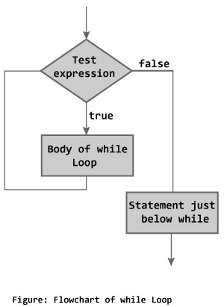

**Example 1: C++ while Loop**

#include <iostream>

using namespace std;

int main()

{

int number, i = 1, factorial = 1;

cout << "Enter a positive integer: ";

cin >> number;

while ( i <= number) {

factorial *= i; //factorial = factorial * i;

++i;

}

cout<<"Factorial of "<< number <<" = "<< factorial;

return 0;

}

**Output**

**C++ do...while Loop**

The do...while loop is a variant of the while loop with one important difference. The body of do...while loop is executed once before the test expression is checked.

**The syntax of do..while loop is:**

do {

// codes;

}

while (testExpression);

**How do...while loop works?**

* The codes inside the body of loop is executed at least once. Then, only the test expression is checked.
* If the test expression is true, the body of loop is executed. This process continues until the test expression becomes false.
* When the test expression is false, do...while loop is terminated

**Flowchart of do...while Loop**

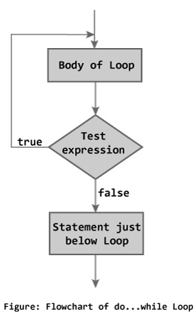

**Example 2: C++ do...while Loop**

#include <iostream>

using namespace std;

int main()

{

float number, sum = 0.0;

do {

cout<<"Enter a number: ";

cin>>number;

sum += number;

}

while(number != 0.0);

cout<<"Total sum = "<<sum;

return 0;

}

**Output**

**Programming Exercise.**

1. Write a program which prompts the user to enter the password, until the user enters 66666; the program asks the user for 10 times for password and then terminates

SOURCE CODE

#include<iostream>

#include<conio.h>

using namespace std;

int main()

{

int pw;

for(int i=1;i<=10;i++)

{

cout<<"Enter the passowrd"<<endl;

cin>>pw;

if(pw==6666)

{

cout<<"correct"<<endl;

break;

}

else

cout<<"wrong password"<<endl;

}

}

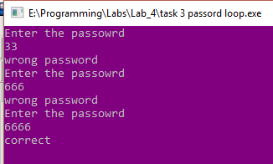

1. [Write a C++ program that prompt user to enter an alphabet and print ASCII values](http://www.codeforwin.in/2015/06/c-program-to-print-ascii-values-of-all-characters.html) using while loop.

SOURCE CODE

#include<iostream>

#include<conio.h>

using namespace std;

int main()

{

char alpha,ch;

bool nazeer=true;

while(nazeer)

{

cout<<"Enter the charcter"<<endl;

cin>>alpha;

cout<<"YOu ASCII value : "<<int(alpha)<<endl;

cout<<"Enter the y for continue and N for break"<<endl;

cin>>ch;

if(ch=='N' || ch=='n')

nazeer=false;

}

}

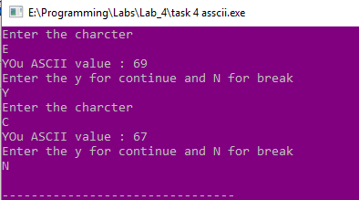

1. [Write a C program to display all even numbers between 1 to](http://www.codeforwin.in/2015/06/c-program-to-print-sum-of-all-even-numbers-between-1-to-n.html) 20 using for loop.

SOURCE CODE

#include<iostream>

#include<conio.h>

using namespace std;

int main()

{

for(int i=0;i<=20;i+=2)

cout<<i<<" ";

}



1. Write a C program to sum of Natural Numbers up to 25.

SOURCE CODE

#include<iostream>

#include<conio.h>

using namespace std;

int main()

{

int sum=0;

for(int i=1;i<=25;i++)

{

sum+=i;

}

cout<<"sum is : "<<sum<<endl;

}



1. [Write a C program to find sum of all even numbers between 1 to n](http://www.codeforwin.in/2015/06/c-program-to-print-sum-of-all-even-numbers-between-1-to-n.html) using for loop.
2. Take 10 integers from keyboard using for loop and print their average value on the screen.

SOURCE CODE

#include<iostream>

#include<conio.h>

using namespace std;

int main()

{

int num,sum=0,average;

for(int i=1;i<=10;i++)

{

cout<<"Ente the "<<i<<" number"<<endl;

cin>>num;

sum=sum+num;

}

cout<<"your average is : "<<sum/10<<endl;

}

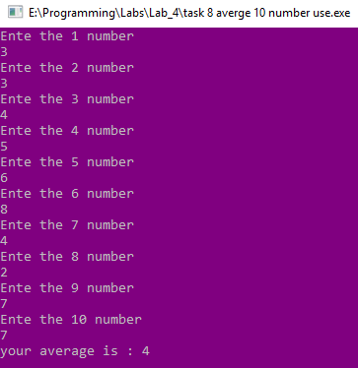

1. Design a program that prompt user to enter a number n, and display sum of all odd numbers from 1 to n. For example, if user enter 9, your program should display  
   1+3+5+7+9 = 25. You should use while loop for this task only.

SOURCE CODE

#include<iostream>

#include<conio.h>

using namespace std;

int main()

{

int i,num,sum=0;

cout<<"Enter the nth term"<<endl;

cin>>num;

for(i=1;i<=num;i+=2)

{

cout<<i<<" ";

sum+=i;

}

cout<<" = "<<sum<<endl;

}

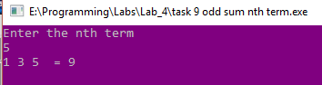

1. Write a program to display the cube of the number up to a given integer. For example, if user provide n=5, output should be :   
   Number is : 1 and cube of the 1 is :1   
   Number is : 2 and cube of the 2 is :8   
   Number is : 3 and cube of the 3 is :27   
   Number is : 4 and cube of the 4 is :64   
   Number is : 5 and cube of the 5 is :125

SOURCE CODE

#include<iostream>

#include<conio.h>

using namespace std;

int main()

{

int num,cube;

cout<<"Enter the number "<<endl;

cin>>num;

for(int i=1;i<=num;i++)

{

cube=i*i*i;

cout<<i<<"*"<<i<<"*"<<i<<"="<<cube<<endl;

}

}

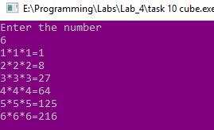

1. Write a program that will ask the user to input n positive numbers. The program will terminate if one of those number is not positive.

SOURCE CODE

#include<iostream>

#include<conio.h>

using namespace std;

int main()

{

int num;

bool flag=true;

while(flag)

{

cout<<"Enter the number "<<endl;

cin>>num;

if(num<0)

flag=false;

}

}

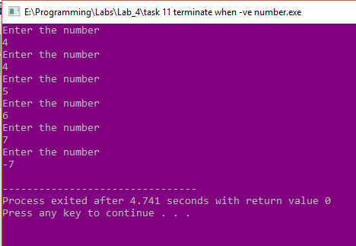

1. Write a c++ program that prints all the numbers from 0 to 6 except 3 and 6.

SOURCE CODE

#include<iostream>

#include<conio.h>

using namespace std;

int main()

{

for(int i=0;i<=6;i++)

{

if(i==3 && i==6)

continue;

else

cout<<i;

}

}

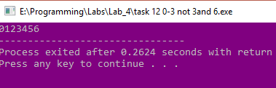

1. Write a c++program to print alphabet pattern 'L'.

*

*

*

*

*

*

*****

SOURCE CODE

#include<iostream>

#include<conio.h>

using namespace std;

int main()

{

for(int i=0;i<=7;i++)

{

cout<<"*"<<endl;

if(i==7)

cout<<"********";

}

}

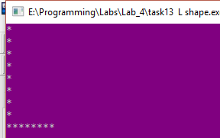

1. Write a program that will print the following pattern:

1******

 12*****

  123****

  1234***

  12345**

  123456*

  1234567

SOURCE CODE

#include<iostream>

#include<conio.h>

using namespace std;

int main()

{

for (int i=1;i<=7;i++)

{

for(int j=1;j<=i;j++)

{

cout<<j;

}

for(int k=6;k>=i;k--)

cout<<"*";

cout<<endl;

}

}

