

Foundations of Programming

Assignment No. : 10

PROBLEM STATEMENT:
Write a program in C to simulate a simple calculator that performs basic arithmetic operations such as addition, subtraction, multiplication, and division. The calculator should also perform special operations like computing xʸ (power) and x! (factorial).

OBJECTIVE:
• To understand the use of switch-case statements in C.
• To perform basic arithmetic and special mathematical operations.
• To enhance problem-solving skills using menu-driven programs.

THEORY:
A calculator is a basic computing device used to perform arithmetic operations. In C programming, a simple calculator can be implemented using conditional or switch-case statements. Arithmetic operations like addition, subtraction, multiplication, and division are fundamental operations. Special operations such as power (xʸ) and factorial (x!) require loops for repeated calculations.

ALGORITHM:
- Start
- Display a menu with the following options:
  - Addition
  - Subtraction
  - Multiplication
  - Division
  - Power (xʸ)
  - Factorial (x!)
- Read the user’s choice.
- If choice is 1–5:
  - Read two numbers x and y.
- If choice is 6:
  - Read one integer n.
- Use a switch statement to perform the selected operation:
  - Addition → x + y
  - Subtraction → x - y
  - Multiplication → x * y
  - Division →
    - If y = 0, display error
    - Else, compute x / y
  - Power → compute xʸ
  - Factorial → compute n! using a loop
- Display the result.
- Stop

CODE:
#include <stdio.h>
#include <math.h>

// Function to calculate factorial
long long factorial(int n) {
long long fact = 1;
for (int i = 1; i <= n; i++) {
fact = fact * i;
}
return fact;
}

int main() {
int choice;
double x, y;
int n;

printf("Simple Calculator\n");
printf("1. Addition\n");
printf("2. Subtraction\n");
printf("3. Multiplication\n");
printf("4. Division\n");
printf("5. Power (x^y)\n");
printf("6. Factorial (x!)\n");
printf("Enter your choice: ");
scanf("%d", &choice);

switch (choice) {
case 1:
printf("Enter two numbers: ");
scanf("%lf %lf", &x, &y);
printf("Result = %.2lf\n", x + y);
break;

case 2:
printf("Enter two numbers: ");
scanf("%lf %lf", &x, &y);
printf("Result = %.2lf\n", x - y);
break;

case 3:
printf("Enter two numbers: ");
scanf("%lf %lf", &x, &y);
printf("Result = %.2lf\n", x * y);
break;

case 4:
printf("Enter two numbers: ");
scanf("%lf %lf", &x, &y);
if (y == 0)
printf("Error: Division by zero!\n");
else
printf("Result = %.2lf\n", x / y);
break;

case 5:
printf("Enter base and exponent: ");
scanf("%lf %lf", &x, &y);
printf("Result = %.2lf\n", pow(x, y));
break;

case 6:
printf("Enter an integer: ");
scanf("%d", &n);
if (n < 0)
printf("Error: Factorial of negative number not defined!\n");
else
printf("Result = %lld\n", factorial(n));
break;

default:
printf("Invalid choice!\n");
}

return 0;
}

FLOWCHART:
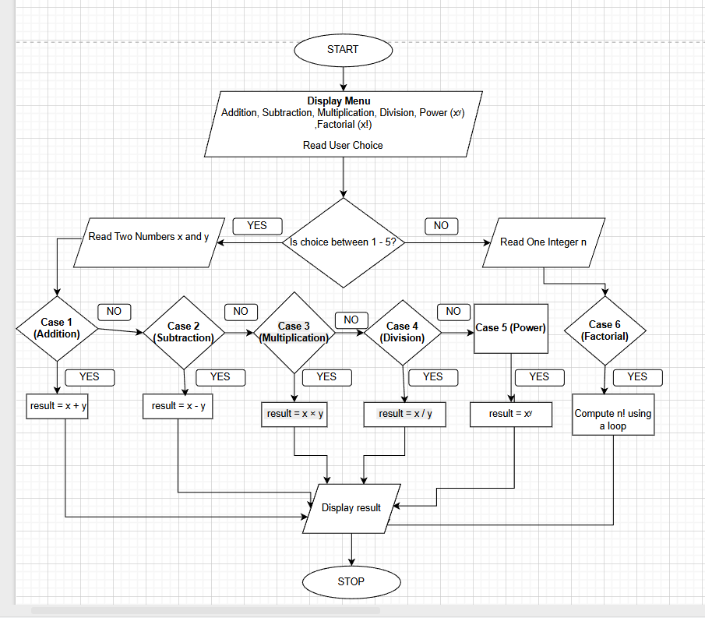

INPUT:
User selects an operation from the menu and enters required values.
Example Input:
Choice: 1
Numbers: 10 20
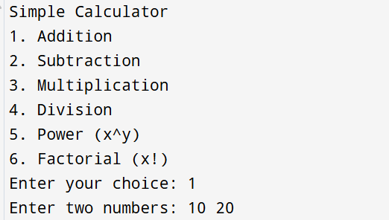

OUTPUT:
Example Output:
Result = 30.00
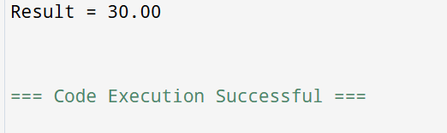

CONCLUSION:
Thus, a simple calculator program was successfully implemented using C programming. The program demonstrates the use of switch-case statements, loops, and arithmetic operations.

