

Foundations of Programming

Assignment No. : 4

PROBLEM STATEMENT: Write a C Program to calculate the salary of an employee given his basic pay (taken as input from the user). Calculate gross salary of employee. Let HRA be 10 % of basic pay and TA be 5% of basic pay. Let employees pay professional tax as 2% of total salary. Calculate net salary payable after deductions.

OBJECTIVE:

- To understand the importance of flowchart for any programming model.
- To learn simple flowchart symbols and arrows to define relationships.To understand and develop visual representations of flow of data.

THEORY:
- Define Algorithm.
- What are the different characteristics of an algorithm.

Algorithm:
- START
- Read value of Basic pay
- Calculate HRA = 10% of Basic pay
- Calculate TA = 5% of Basic pay
- Calculate Gross Salary = Basic pay + HRA + TA
- Calculate Professional tax = 2% of Gross Salary
- Calculate Net Salary = Gross Salary – Professional tax
- Display Gross Salary and Net Salary
- STOP

Flowchart:
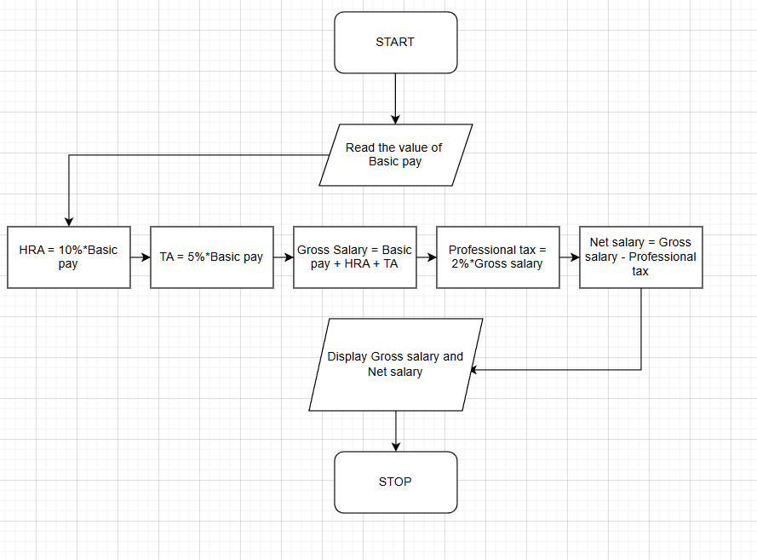

Code:
#include <stdio.h>

int main() {
float Basic,HRA,TA,Gross,Tax,Net;

printf("Enter Basic Pay:");
scanf("%f",&Basic);

HRA = 0.10*Basic;
TA = 0.05*Basic;
Gross = Basic + HRA + TA;
Tax = 0.02*Gross;
Net = Gross - Tax;

printf("Gross Salary = %.2f\n",Gross);
printf("Net salary Payable = %.2f\n",Net);

return 0;
}

INPUT:


OUTPUT:
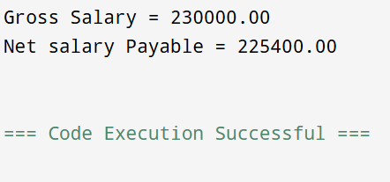

CONCLUSION: Thus, we have learned to write algorithms and to draw its representation in terms of flowchart.

