HTML DAY 1 TOPICS (REF URL : https://www.w3schools.com/html/)

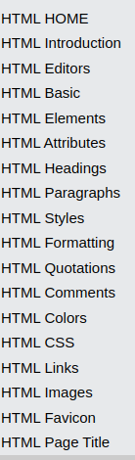

HTML DAY 2 TOPICS (REF URL : https://www.w3schools.com/html/)

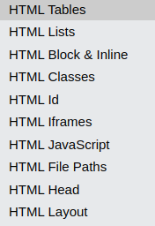

HTML DAY 3 PRACTICE

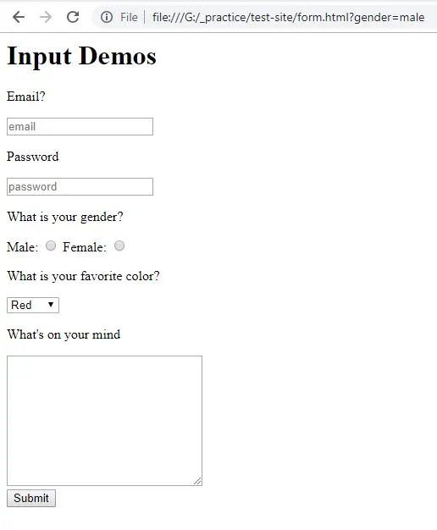

Java Script Day1
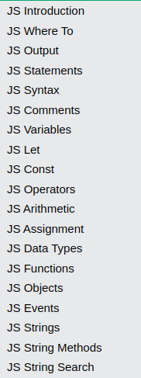

Java Script Day2
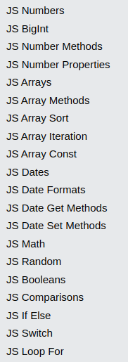

Java Script Day3

JavaScript Form Validation
https://www.w3schools.com/js/js_validation.asp

Add validation to your html registration form (HTML DAY3 )

Jquery Day1
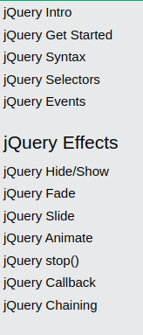

Jquery Day2
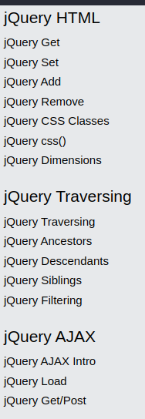

Jquery Day3

Add validation and animations to HTML registration page

