Bayesian Logistic Regression Analysis of Heart Disease

1st SAMUEL CHRISTOPHER
dept. name of organization
(of Affiliation)
name of organization
(of Affiliation)
Jakarta, Indonesia
samuel.christopher@binus.ac.id
4th
VALENTINO KURNIAWAN
dept. name of organization
(of Affiliation)
name of organization
(of Affiliation)
Jakarta, Indonesia
valentino.kurniawan@binus.ac.id
2nd MICHAEL YEREMIA
dept. name of organization
(of Affiliation)
name of organization
(of Affiliation)
Jakarta, Indonesia
michael.yeremia@binus.ac.id
3rd NAZHIFA KIRANA MULIA NUGRAHA
dept. name of organization
(of Affiliation)
name of organization
(of Affiliation)
Jakarta, Indonesia
nazhifa.kirana@binus.ac.id

Abstract—Heart disease remains one of the leading causes of mortality worldwide, highlighting the importance of reliable risk prediction models. While classical statistical and machine learning methods are commonly used for heart disease classification, they often lack explicit uncertainty quantification. This study applies Bayesian Logistic Regression to model the probability of heart disease using clinical predictors, providing probabilistic inference and interpretable uncertainty estimates.
The analysis utilizes a heart disease dataset with a binary outcome indicating disease presence. Weakly informative normal prior distributions are specified for the regression coefficients, and posterior inference is performed using Markov Chain Monte Carlo (MCMC) sampling via the JAGS framework. Model performance and adequacy are evaluated using posterior predictive checks, Deviance Information Criterion (DIC), and Watanabe–Akaike Information Criterion (WAIC), which approximates leave-one-out cross-validation.
Results indicate that age and cholesterol levels are positively associated with heart disease risk, while higher maximum heart rate is associated with lower risk. The model achieves a classification accuracy of approximately 69%, reflecting moderate predictive performance given the limited number of predictors. Overall, the Bayesian approach provides a transparent framework for heart disease modeling, emphasizing uncertainty quantification and interpretability over purely predictive accuracy.
Keywords—Bayesian Logistic Regression, Heart Disease, MCMC, WAIC, Posterior Inference

Introduction

Background and Motivation
Cardiovascular diseases, particularly heart disease, represent a major global health burden. Early detection and accurate risk assessment are crucial for preventive strategies and clinical decision-making. Logistic regression is widely used to model binary health outcomes; however, classical approaches rely on point estimates and asymptotic assumptions that may not fully capture uncertainty.
Bayesian methods offer an alternative framework that allows uncertainty to be quantified directly through posterior distributions. By incorporating prior information and producing probabilistic interpretations of model parameters, Bayesian Logistic Regression provides a robust and interpretable approach for medical data analysis. This study applies Bayesian logistic regression to analyze heart disease risk factors using clinical data.

Literature review

Existing Studies on Heart Disease Prediction
Previous research on heart disease prediction has employed various methods, including classical logistic regression, decision trees, support vector machines, and neural networks. These approaches often focus on maximizing predictive accuracy, sometimes at the expense of interpretability and uncertainty assessment.

Bayesian Analysis in Medical Research
Bayesian methods have been increasingly applied in medical statistics due to their flexibility and ability to model uncertainty explicitly. Bayesian logistic regression has been used in clinical risk modeling to provide posterior distributions of parameters rather than single-point estimates.

Justification for the Bayesian Approach
The Bayesian framework is particularly suitable for medical applications because it allows uncertainty quantification, incorporation of prior knowledge, and transparent interpretation of results. In this study, Bayesian logistic regression is chosen to balance predictive performance with interpretability and uncertainty awareness.

Methodology

Dataset Description
The dataset used in this study is a publicly available heart disease dataset containing patient-level clinical variables. The response variable indicates the presence or absence of heart disease, making it a binary outcome. Predictor variables include age, serum cholesterol level, and maximum heart rate achieved. All predictors were standardized prior to analysis to improve numerical stability and interpretability.

Model Specification
A Bayesian Logistic Regression model is employed. For each observation $i$, the outcome $y_{i}$follows a Bernoulli distribution with success probability $π_{i}$:

$$y_{i}∼\text{Bernoulli}(π_{i})$$

The log-odds of disease presence are modelled as:

$$\text{logit}(π_{i})=β_{0}+β_{1}{\text{x}}_{1i}+β_{2}{\text{x}}_{2i}+β_{3}{\text{x}}_{3i}$$

Prior Distribution, Likelihood, and Posterior
Weakly informative normal priors are assigned to all regression coefficients:

$$β_{j}∼N(0,1)$$

The likelihood is derived from the Bernoulli distribution, and the posterior distribution is obtained via Bayes’ theorem:

$$p(β∣y)∝p(y∣β) p(β)$$

Because the posterior distribution does not have a closed-form solution, numerical approximation is required.

Model Inference
Posterior inference is conducted using Markov Chain Monte Carlo (MCMC) sampling implemented through the JAGS framework. Two parallel chains are run, with an initial burn-in period to ensure convergence, followed by sampling used for posterior analysis.

Results and Discussion

Model Diagnostics and Convergence
Convergence of the Markov Chain Monte Carlo samples was assessed using trace plots.
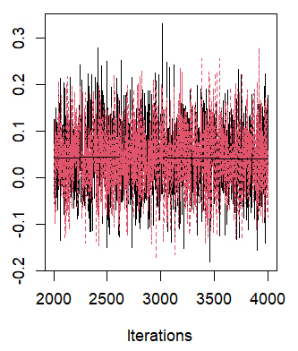
As shown in Figure 1, the chains exhibit good mixing and stable behavior with no apparent trends, indicating convergence to the target posterior distribution. These visual diagnostics are supported by numerical convergence measures such as the Geweke diagnostic, Gelman–Rubin statistic, and effective sample size.

Posterior Distributions and Credible Intervals
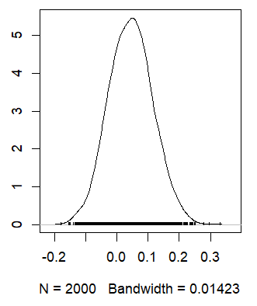
The posterior distributions of the regression coefficients are illustrated in Figure 2. The density plots are unimodal and well-behaved, suggesting stable parameter estimation. Credible intervals provide direct probabilistic interpretations, indicating the range within which each parameter lies with high posterior probability.

Model Evaluation
Model adequacy was further evaluated using posterior predictive checks.
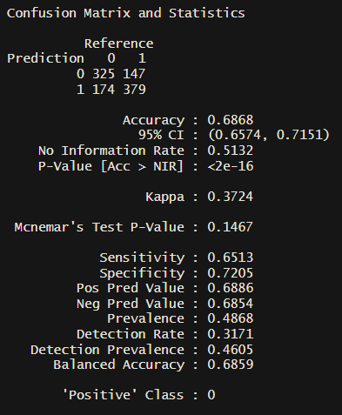
As shown in Figure 3, the observed summary statistic lies within the distribution of replicated statistics generated from the posterior, indicating that the model provides an adequate fit to the observed data.
Predictive performance was also assessed using information criteria and classification accuracy. The model achieves an overall accuracy of approximately 69%, reflecting moderate predictive capability given the limited number of predictors. DIC and WAIC values further support the adequacy of the model, with WAIC serving as an approximation to leave-one-out cross-validation.

Comparison with Classical Methods
Compared to classical logistic regression, the Bayesian approach yields comparable predictive performance while providing richer information through uncertainty quantification and probabilistic interpretation of parameters.

Conclusion and Future Work

Summary of Findings
This study demonstrates the application of Bayesian Logistic Regression for modeling heart disease risk using clinical predictors. The Bayesian framework provides interpretable parameter estimates and explicit uncertainty quantification, which are valuable for medical decision-making.

Limitations
The analysis is limited by the number of predictors and the moderate sample size. Additionally, the model assumes linear relationships between predictors and the log-odds of disease.

Future Research
Future work may incorporate additional clinical variables, hierarchical modeling structures, or non-linear effects. Further comparisons with advanced machine learning methods may also provide insights into improving predictive performance.

References
- Gelman, A., Carlin, J. B., Stern, H. S., Dunson, D. B., Vehtari, A., & Rubin, D. B. (2013). Bayesian data analysis (3rd ed.). Chapman & Hall/CRC.
- McElreath, R. (2020). Statistical rethinking: A Bayesian course with examples in R and Stan (2nd ed.). Chapman & Hall/CRC.
- Vehtari, A., Gelman, A., & Gabry, J. (2017). Practical Bayesian model evaluation using leave-one-out cross-validation and WAIC. Statistics and Computing, 27(5), 1413–1432.

