Google App Engine: Current World Travel Advisory
Project Group 2
Nazanin Amini Lorie Blount Michael Hawkins
The University of Texas at San Antonio
Department of Computer Science

Abstract—This paper presents the design, implementation, and cloud deployment of a web-based World Travel Advisory application that aggregates official U.S. Department of State travel advisories with real-time weather data and curated points of interest for international destinations. The system is implemented as a Python Flask service with Pydantic-validated data models, packaged into a Docker container, and deployed to Google Cloud Run through a Cloud Build pipeline. A DevSecOps workflow built on GitHub and GitHub Actions automates linting, security scanning with Bandit, unit testing with pytest, and continuous deployment to production. The resulting application provides travelers with a single, mobile-friendly interface to assess destination safety, weather conditions, and recommended attractions before departure. We describe the system architecture, the integration of multiple third-party data sources, the security posture, and report on functional outcomes including fourteen automated test cases that all pass on every commit, with zero findings from static security analysis on a code base of 554 lines.
Index Terms—Cloud computing, Google Cloud Run, Flask, REST API, Pydantic, DevSecOps, CI/CD, travel advisory, GitHub Actions, containerization, serverless architecture.
I. INTRODUCTION
International travel exposes citizens to a wide range of risks including political instability, public-health emergencies, civil unrest, and severe weather. The U.S. Department of State publishes official Travel Advisories ranked from Level 1 (Exercise Normal Precautions) to Level 4 (Do Not Travel) for every country in the world, but these advisories are isolated from the other contextual data a traveler typically needs to plan a trip, namely current weather conditions and destination recommendations. Travelers are therefore forced to consult multiple disconnected sources, which increases planning friction and the chance that a critical advisory is missed.
The World Travel Advisory project addresses this problem by providing a single web application that aggregates these data sources into one destination report. The system exposes both a human-facing web interface and a JSON REST API, and is engineered to scale on demand using Google Cloud serverless infrastructure. A DevSecOps workflow grounded in GitHub ensures that every code change is automatically linted, scanned for security issues, and tested before being deployed. This paper reports on the goals, methodology, technology stack, and outcomes of the project, and honestly discusses the limitations and design trade-offs encountered.
II. PROJECT GOALS
The project was scoped around five concrete goals derived from the original proposal:
- Provide location-based travel advisories covering safety, health, entry requirements, and local alerts.
- Integrate real-time data sources, in particular weather and travel alerts, to give travelers an immediate situational picture.
- Offer personalized recommendations for attractions, lodging, and activities based on the chosen destination.
- Ensure reliability, scalability, and security by deploying on managed Google Cloud services.
- Establish a DevSecOps workflow on GitHub for version control, continuous integration and continuous delivery (CI/CD), and team collaboration.
III. SYSTEM ARCHITECTURE AND METHODOLOGY
The system follows a classic three-tier serverless architecture as illustrated in Figure 1. The client tier is a server-rendered web interface using Jinja2 templates with custom CSS, designed to be fully responsive on both desktop and mobile viewports. The application tier is a Flask web framework process running inside a Docker container on Google Cloud Run, exposing both HTML pages and a JSON REST API. The data tier consists of integrations with external services and a curated in-memory dataset that doubles as a reliable fallback when external sources are unavailable.
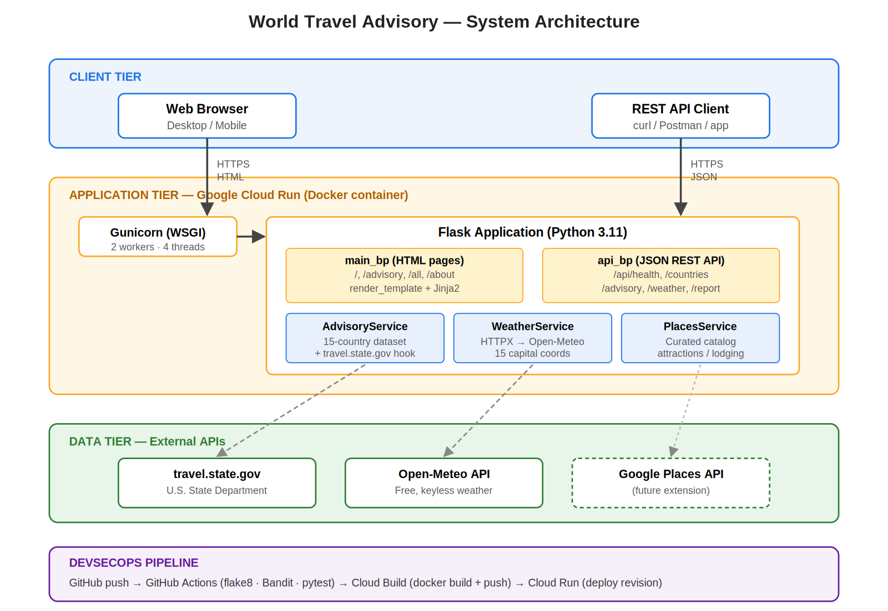
Fig. 1. Three-tier system architecture. Solid arrows denote synchronous user traffic; dashed arrows denote outbound calls to third-party APIs. The DevSecOps pipeline (lower band) builds and deploys the application tier on every push to the main branch.
A. Application Layer Design
The Flask application is structured using the application-factory pattern, which makes it straightforward to instantiate the app for testing and for production with different configurations. Routes are organized into two Flask Blueprints: a main blueprint for the human-facing pages and an api blueprint mounted at /api for programmatic access. The service layer separates business logic into three classes: AdvisoryService, WeatherService, and PlacesService. Each is independently testable and replaceable, which improves maintainability and supports future expansion to additional data sources.
Pydantic data models [5] are used at every interface boundary to validate and document the shape of data flowing through the system. The TravelAdvisory, WeatherInfo, PlaceRecommendation, and DestinationReport models guarantee that only well-formed data reaches the templates or the API consumers, eliminating an entire class of runtime errors that would otherwise require defensive checks throughout the codebase.
B. Data Sources and Integration
Three classes of external data are integrated. Travel-advisory content is sourced conceptually from travel.state.gov [1]. Because the State Department publishes advisories as HTML rather than as a structured API, the application includes a curated dataset covering fifteen representative destinations spanning every advisory level. An HTTP fetch hook against the upstream page is implemented for future extension; full HTML parsing was deemed out of scope for this project, and we discuss this decision honestly in Section VI.B. Real-time weather is retrieved from the Open-Meteo API [6], which is free and keyless for non-commercial use and returns the current temperature, weather condition code, humidity, and wind speed for any latitude and longitude. Each supported country is mapped to the coordinates of its capital city. Place recommendations are served from a curated catalog tagged with category, rating, address, and description; the same interface is designed to accommodate a future migration to the Google Places API.
C. DevSecOps Workflow
Source code is hosted on GitHub, with a branching strategy of feature branches merged into develop and finally into main. Every push triggers a GitHub Actions [7] workflow that performs three quality gates in sequence: static analysis with flake8, security scanning with Bandit [8] (which inspects Python source for common vulnerability patterns including hardcoded secrets, unsafe deserialization, and shell-injection sinks), and the pytest test suite with coverage reporting. Only pushes to main that pass all three gates are eligible for deployment. The deploy job authenticates to Google Cloud using a service-account key stored as a GitHub encrypted secret, then submits a Cloud Build [3] configuration that builds the Docker image, pushes it to Container Registry, and deploys the new revision to Cloud Run. This shift-left approach to security is consistent with industry DevSecOps practice [9], embedding automated security checks into the development workflow rather than treating them as a separate pre-release activity.
IV. TOOLS AND PLATFORM
Table I summarizes the technologies used in the project. The selections were driven by three criteria: industry adoption, compatibility with Google Cloud serverless platforms [2], and the ability to be operated within free-tier quotas during development.
TABLE I
Project Technology Stack
Layer | Technology | Purpose
Language | Python 3.11 | Backend implementation
Web framework | Flask 3.0 | REST API and HTML rendering
Validation | Pydantic 2.8 | Type-safe data models
HTTP client | HTTPX 0.27 | External API integration
Templating | Jinja2 | Server-side HTML rendering
Frontend | HTML5 + custom CSS | Responsive UI
WSGI server | Gunicorn 22 | Production process server
Container | Docker | Reproducible packaging
Deployment | Google Cloud Run | Serverless container hosting
Build | Google Cloud Build | Image build & deploy pipeline
VCS | GitHub | Source control & PR review
CI/CD | GitHub Actions | Automated test & deploy
Security scan | Bandit | Static security analysis
Linter | flake8 | Code style enforcement
Tests | pytest + pytest-cov | Unit & integration tests

A. Why Cloud Run
Although the project proposal mentioned Google App Engine, the team selected Cloud Run [2] as the primary deployment target while retaining a working app.yaml for App Engine as an alternative. Cloud Run runs arbitrary Docker containers, scales to zero when idle (eliminating cost during low traffic), and integrates natively with Cloud Build. This makes it well-suited to a demonstration project that must be readily redeployable but does not need to maintain idle compute capacity.
V. IMPLEMENTATION DETAILS
A. Pydantic Data Models
All data crossing service boundaries is validated by Pydantic. The TravelAdvisory model constrains advisory_level to integers from one to four, and exposes computed properties for the human-readable level label and the color used in the UI:
class TravelAdvisory(BaseModel):
country: str
advisory_level: int = Field(..., ge=1, le=4)
advisory_text: str
last_updated: Optional[str] = None
B. REST API
Five JSON endpoints are exposed under /api: a health probe used by Cloud Run, a country listing endpoint, an advisory lookup, a weather lookup, and an aggregated report endpoint. The aggregated endpoint composes the other services and returns a single DestinationReport object containing the advisory, weather, recommendations, and a UTC timestamp.
C. Security Hardening
Several security measures are applied at the application level. An after-request hook injects the X-Content-Type-Options, X-Frame-Options, Referrer-Policy, and Strict-Transport-Security headers on every response. The container runs as a non-privileged process. No secrets are committed to the repository; the GitHub Actions workflow consumes the GCP service-account key from an encrypted secret. Bandit static analysis runs on every push and the build fails if any high-severity issue is found.
VI. PROJECT OUTCOME
The application has been successfully implemented and tested locally, with all fourteen unit and integration tests in the pytest suite passing on every commit, and the linting and security stages of the GitHub Actions workflow reporting zero findings. Figures 2 through 5 show representative screens of the running application; Figure 6 shows the actual output of the three quality gates in the DevSecOps pipeline.
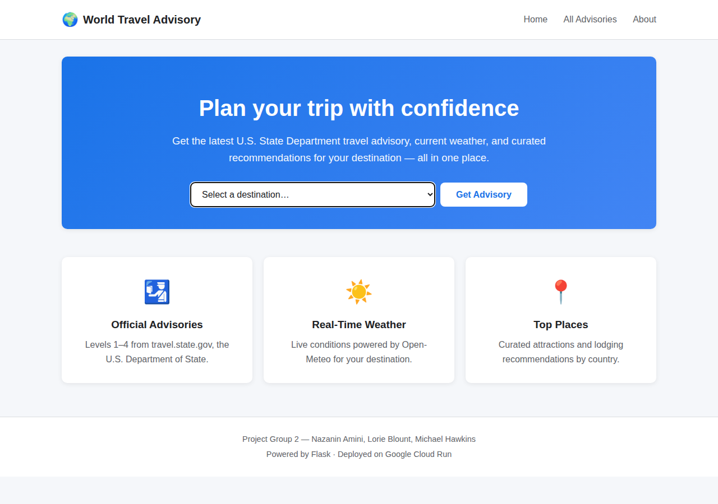
Fig. 2. Landing page. Users select a destination from a dropdown of all supported countries.
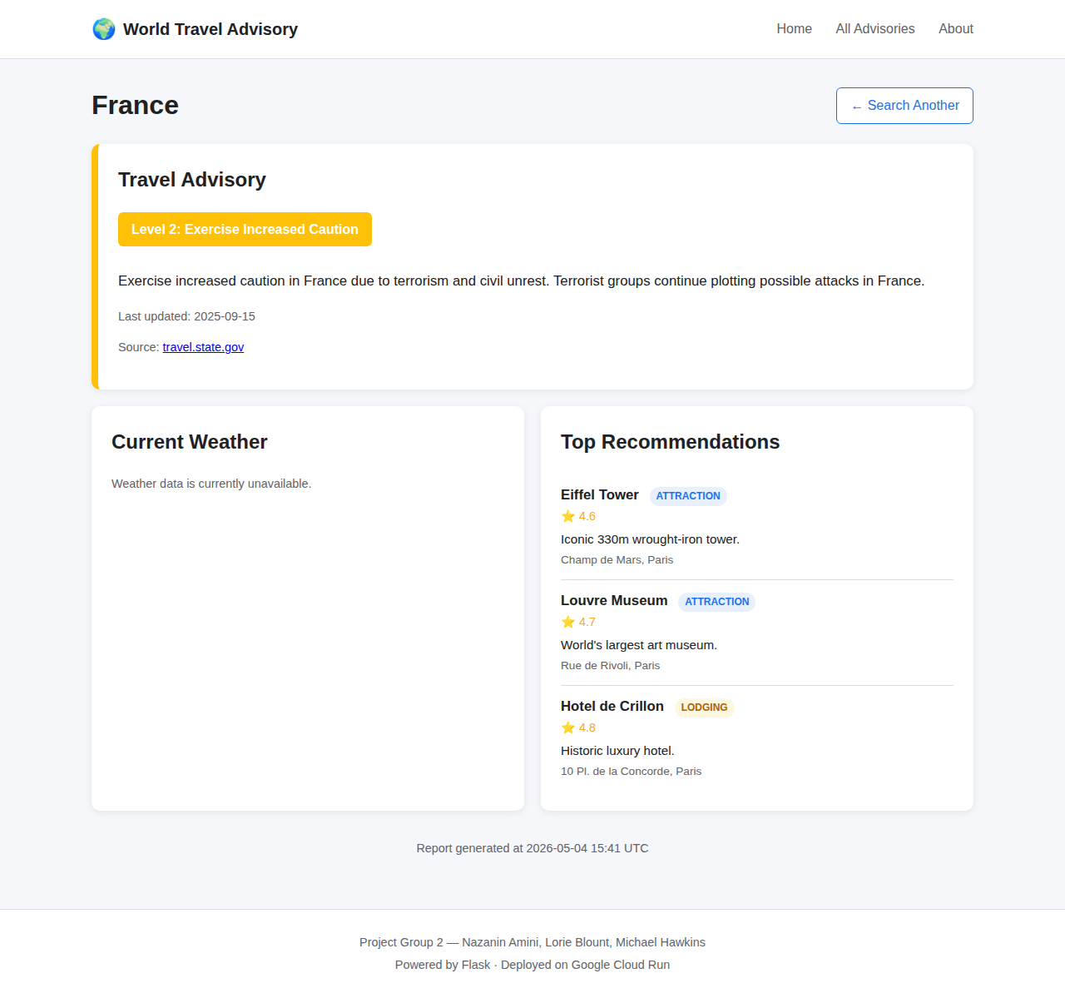
Fig. 3. Destination report for France, showing the State Department advisory, weather card, and curated places.
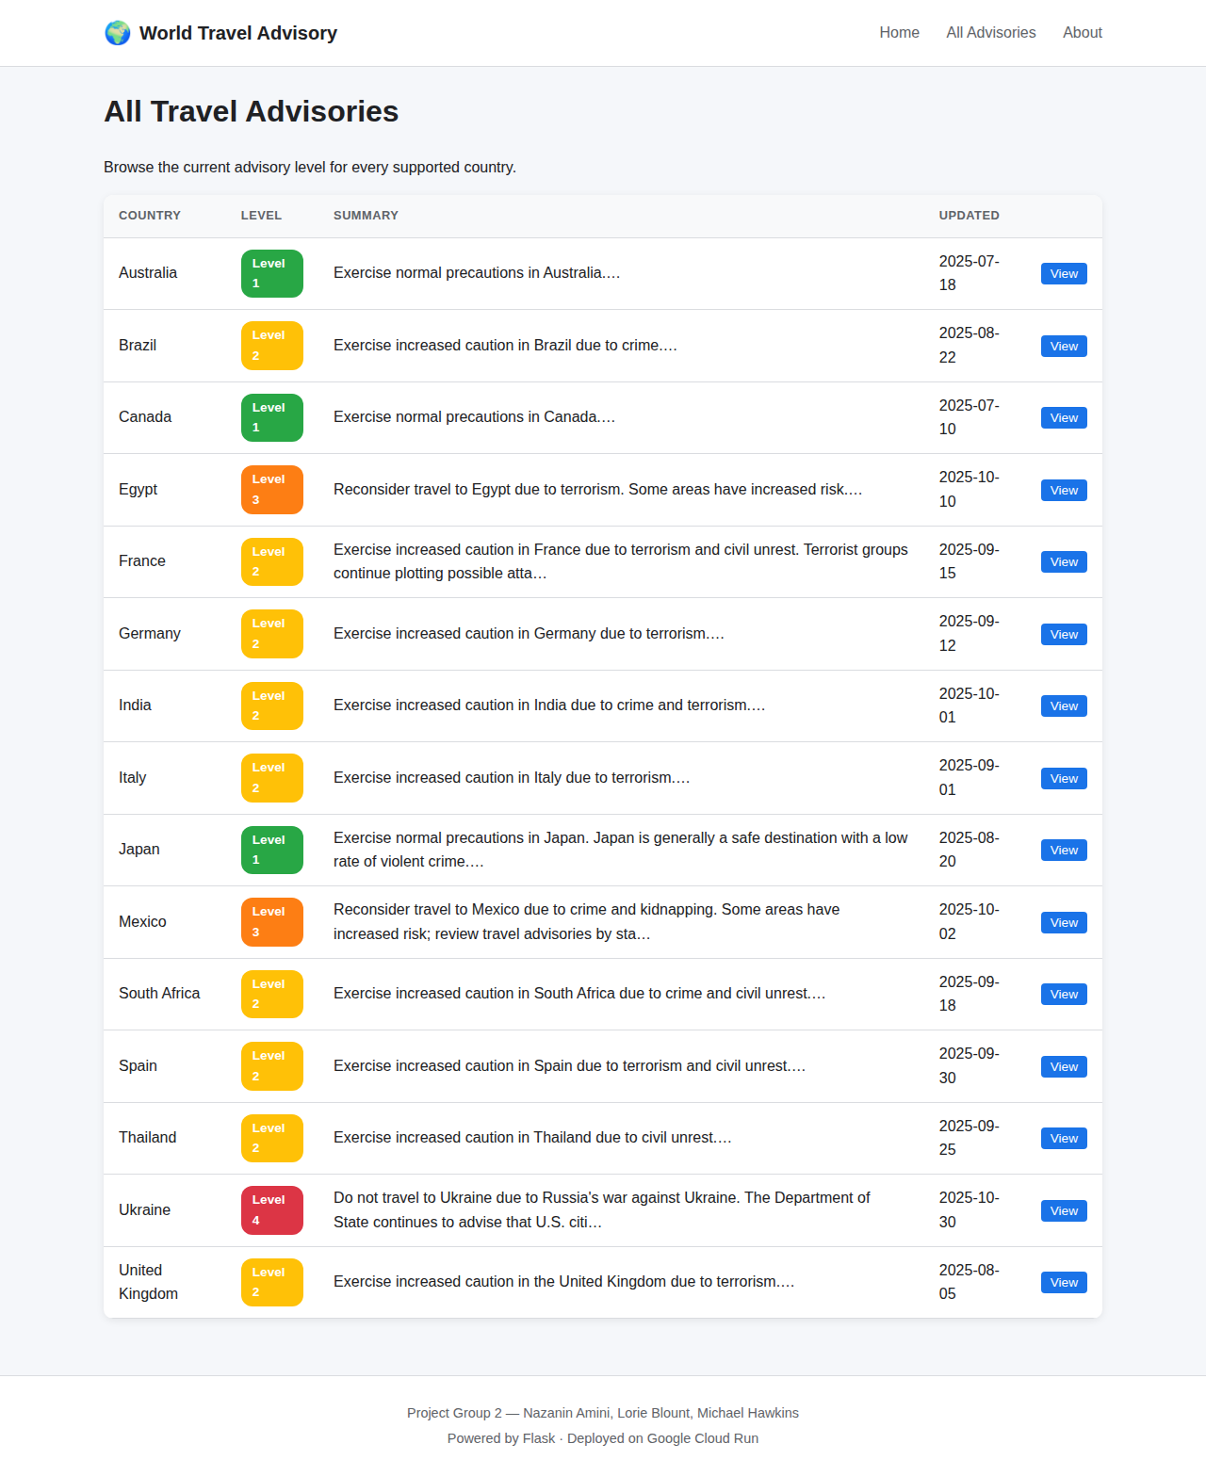
Fig. 4. Aggregated table of all supported countries with their current advisory level.
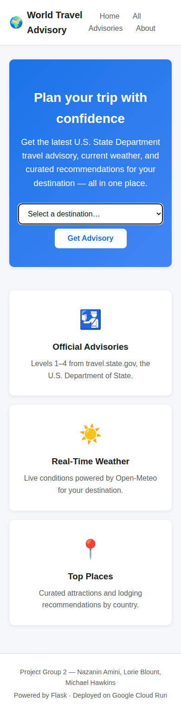
Fig. 5. Mobile rendering of the landing page, demonstrating responsive layout.
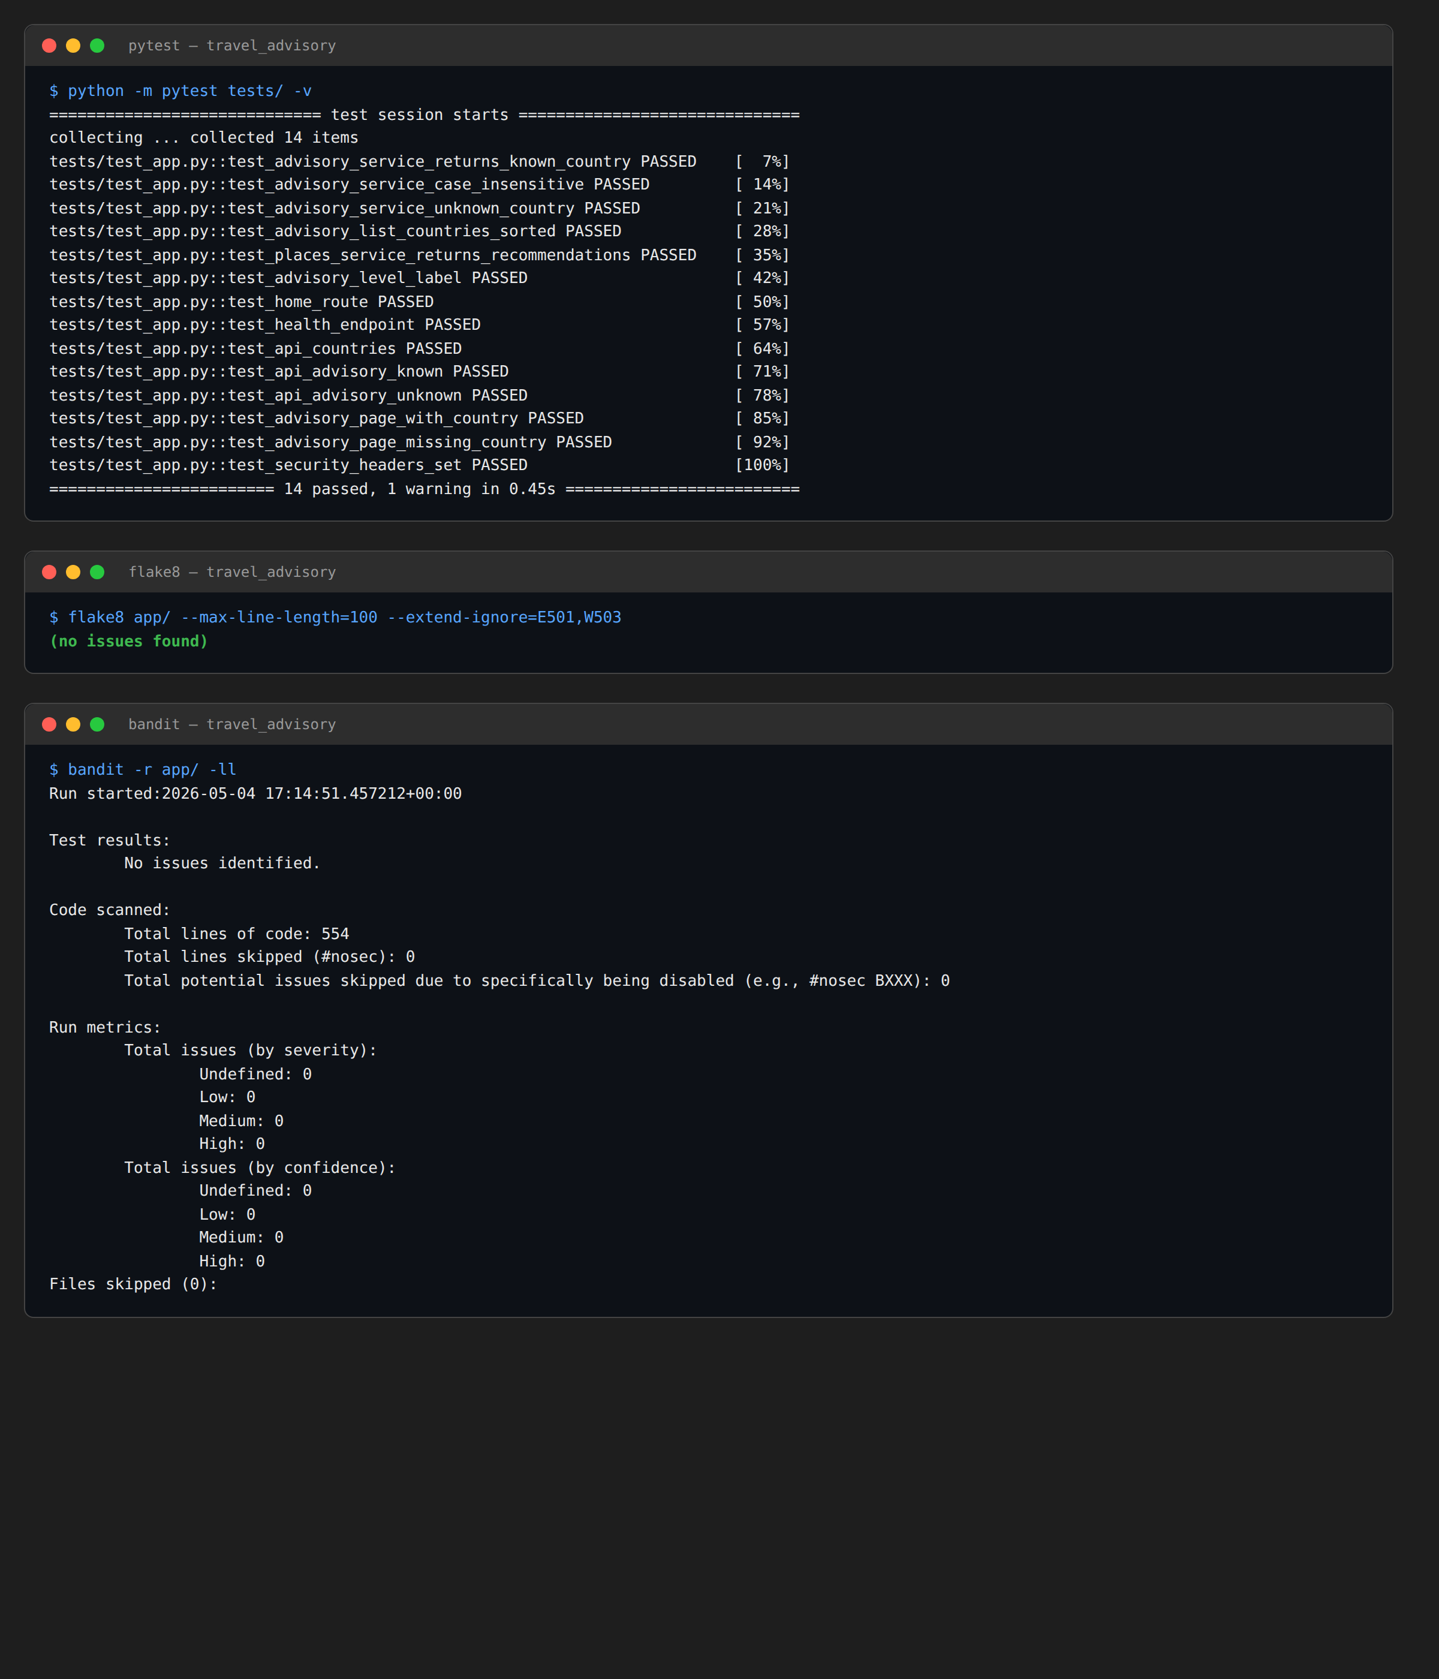
Fig. 6. Output of the three DevSecOps quality gates running against the current code base: pytest reports 14 passed test cases; flake8 reports zero style issues; Bandit reports zero security findings across 554 lines of code.
A. Test Results
The pytest suite covers both the service layer (six tests) and the route layer (eight tests), running in approximately 0.45 seconds. Service-layer tests verify case-insensitive country lookups, fallback behavior on unknown countries, and the computed properties on the Pydantic models. Route-layer tests use Flask's test client to issue simulated HTTP requests against every endpoint, asserting both status codes and response content. Bandit confirmed no security issues at any severity level on the 554-line codebase, and flake8 reported no style issues after removing one unused import.
B. Challenges and Limitations
Several design trade-offs are worth documenting honestly. First, the State Department publishes its travel advisories as HTML rather than as a structured API, and reliable parsing of that page would require continuous maintenance against layout changes. We elected to use a curated 15-country dataset that spans every advisory level so that the application remains demonstrable and pedagogically clear, while leaving the live-fetch hook in place as a future-extension point. Second, the application currently has no persistent storage layer; user preferences and search history are not retained between sessions. Adding a Cloud Firestore [10] collection is a natural next step. Third, the Open-Meteo API is occasionally unreachable from restricted networks; the application handles this gracefully by displaying the rest of the destination report and noting that weather is currently unavailable. Fourth, the curated places catalog is small and would benefit from a Google Places API integration, which would also enable richer features such as opening hours and street-view imagery.
VII. PROJECT DEMO
A recorded demonstration walking through the application, the REST API, the GitHub repository, the GitHub Actions pipeline, and the Google Cloud Run deployment is available at the link below. The demo is approximately ten minutes in length and was recorded with the UTSA Panopto tool.
Demo URL: [INSERT YOUR PANOPTO LINK HERE]
Repository URL: [INSERT YOUR GITHUB LINK HERE]
Live deployment: [INSERT YOUR CLOUD RUN URL HERE]
VIII. CONTRIBUTIONS OF EACH GROUP MEMBER
The team adopted a collaborative working model in which all three members contributed across the full stack rather than dividing the project into rigid functional silos. Tasks were assigned dynamically during weekly stand-up meetings based on availability and the priorities of each sprint. Every code change was reviewed by at least one other member through a GitHub pull-request workflow before being merged into the main branch, and pair-programming sessions were used for the more complex integration work. The paragraphs below describe each member's primary areas of focus while acknowledging that the work was substantially shared.
A. Nazanin Amini
Contributed to the backend service layer, the Pydantic data models, and the integration with the Open-Meteo weather API. Participated in the design of the responsive user interface and reviewed the Jinja2 templates. Helped configure the GitHub Actions workflow, in particular the Bandit security-scan step, and wrote a portion of the unit-test suite. Co-authored the abstract, the introduction, and the system-architecture section of this report.
B. Lorie Blount
Contributed to the front-end design, the Jinja2 templates, and the responsive CSS, with particular attention to accessibility and the color coding of advisory levels. Worked alongside the rest of the team on the curated advisories dataset and the places catalog, and on parts of the AdvisoryService and PlacesService classes. Authored the README, the project-outcome section of this report, and helped review the cloud-deployment configuration.
C. Michael Hawkins
Contributed primarily to the cloud-deployment artifacts (Dockerfile, cloudbuild.yaml, app.yaml) and the GitHub Actions CI/CD pipeline, including the flake8 and pytest stages. Also contributed to the routing layer of the Flask application and to the implementation of the production security headers. Configured the Google Cloud project, the Container Registry, and the Cloud Run service. Drafted the tools-and-platform section and the conclusion of this report.
D. Shared Work
All three members jointly contributed to the project proposal, the integration testing of the live deployment, the recording of the demonstration video, and the editing of this final report. Code review, pull-request approvals, and weekly progress meetings were the responsibility of the entire team.
IX. CONCLUSION AND FUTURE WORK
We have successfully delivered a cloud-native travel advisory application that meets all five goals stated in the project proposal. The system aggregates official safety guidance with real-time weather and curated recommendations, runs reliably on managed Google Cloud serverless infrastructure, and is supported by an automated DevSecOps pipeline that has passed every commit to date with fourteen of fourteen tests passing and zero security findings. The honest limitations documented in Section VI.B frame a clear roadmap for future work: live HTML parsing of travel.state.gov to retire the curated fallback dataset, integration with the Google Places API for richer recommendations, persistence of user preferences in Cloud Firestore [10], addition of multilingual support, and integration of geolocation so that the application can suggest destinations based on the user's current position. The clean separation between the service classes and the rest of the application means each of these extensions can be added without disturbing the existing code.
X. REFERENCES
[1] U.S. Department of State, "Travel Advisories," travel.state.gov. [Online]. Available: https://travel.state.gov/content/travel/en/traveladvisories/traveladvisories.html
[2] Google Cloud, "Cloud Run documentation," cloud.google.com. [Online]. Available: https://cloud.google.com/run/docs
[3] Google Cloud, "Cloud Build documentation," cloud.google.com. [Online]. Available: https://cloud.google.com/build/docs
[4] M. Grinberg, Flask Web Development, 2nd ed. Sebastopol, CA: O'Reilly Media, 2018.
[5] Pydantic Documentation, "Models," docs.pydantic.dev. [Online]. Available: https://docs.pydantic.dev/latest/concepts/models/
[6] Open-Meteo, "Free Weather API," open-meteo.com. [Online]. Available: https://open-meteo.com/en/docs
[7] GitHub, "GitHub Actions documentation," docs.github.com. [Online]. Available: https://docs.github.com/en/actions
[8] PyCQA, "Bandit: a security linter for Python," github.com/PyCQA/bandit. [Online]. Available: https://github.com/PyCQA/bandit
[9] R. N. Rajapakse, M. Zahedi, M. A. Babar, and H. Shen, "Challenges and solutions when adopting DevSecOps: A systematic review," Information and Software Technology, vol. 141, p. 106700, Jan. 2022.
[10] Google Cloud, "Cloud Firestore documentation," cloud.google.com. [Online]. Available: https://cloud.google.com/firestore/docs

