**IMAGES:**

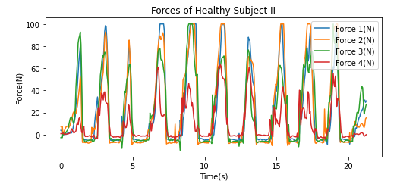

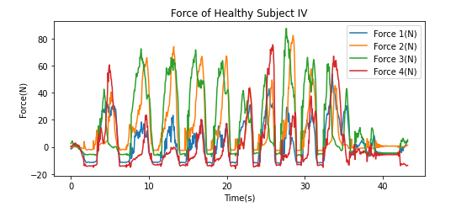

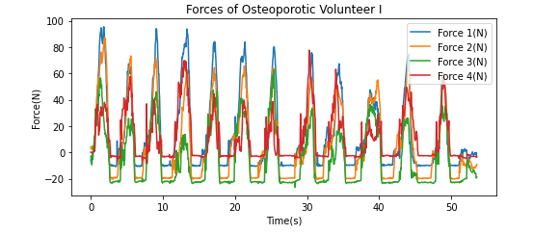

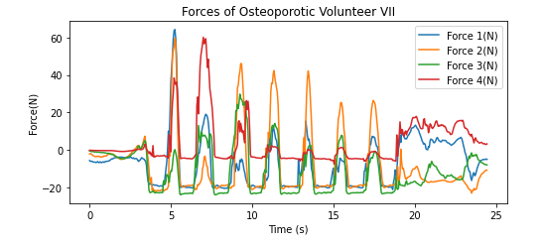

**Sensor:**

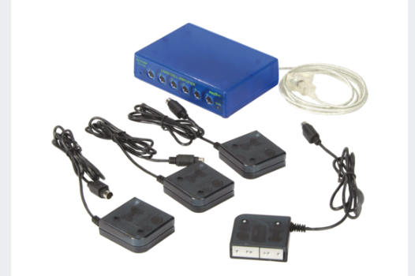

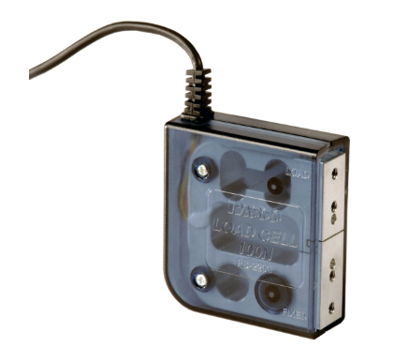

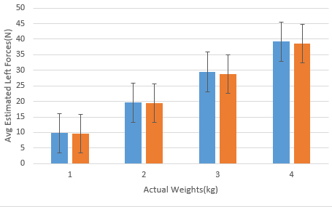

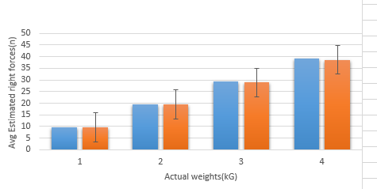

# **60**

# **Total Number of Participants**

**20 group of participants with healthy individuals**

**20 group of participants with osteoporosis individuals**

**40**

**Total Number of Included Participants**

**20**

**Total Number of Excluded Participants**

Dear Dr. Joaquin Ballesteros,

Hope you are fine and doing well.

I apologize for the late reply but I was hospitalized for a week after next day to my presentation due to sudden pain in my gall bladder and was gone through surgery so, I resume my work from today.

Sir as Dr. Saad knows I applied all your suggestions to my presentation and one day before the presentation it was checked by Dr. Saad as well but on the day of the presentation when I was going to start my presentation my laptop got off due to some unknown problem related to windows and I don’t have a backup of updated PPT so at that time we played our last PPT by using Dr. Saad laptop.

Yes the data set was taken too long I asked you, and Dr. Saad knows as well but I don’t want to tell this to my postgraduate incharge that’s why at that time I said that. I send some of my students with the device to the physical therapy department and old age home for data collection but I come to know that they didn’t follow the walk test protocols properly I am trying to overcome this problem maybe we will go for another data collection with the wireless device. And last year I had some health issues and other personal matters due to which I was unable to focus on my research.

I collected all the papers related to rollator and osteoporosis for the literature review but did not upload that folder on Github. I start work on Google Colab and extract some of the features but due to our new proposal, I postponed work on Colab and focus on device designing and testing and my progress PPT after this work I have a plan to work on Colab for classification.

Thank you for letting me know about your decision. While I am disappointed to hear that you won’t be supervising further me. I am grateful for the time you took to supervise me and I learned a lot of things from you regarding my research.

I attached the document for change of co supervisor.

Best Regards

Nazia Ejaz