PROJECT 1
SSH Log Analysis using Splunk
Detecting brute-force login attempts through real-time SIEM monitoring

Project Overview
This project focuses on monitoring and identifying suspicious SSH login activity on a Linux server using Splunk. It simulates a real-world SOC task: turning raw authentication logs into actionable, real-time threat detection.
TOOLS & TECHNOLOGIES Splunk • Linux • SSH • SPL (Search Processing Language)
Objective
- Collect and centralize Linux SSH authentication logs in Splunk
- Detect failed login attempts, unusual login times, and repeated access attempts
- Build dashboards and alerts to speed up threat detection
Architecture / Workflow Diagram
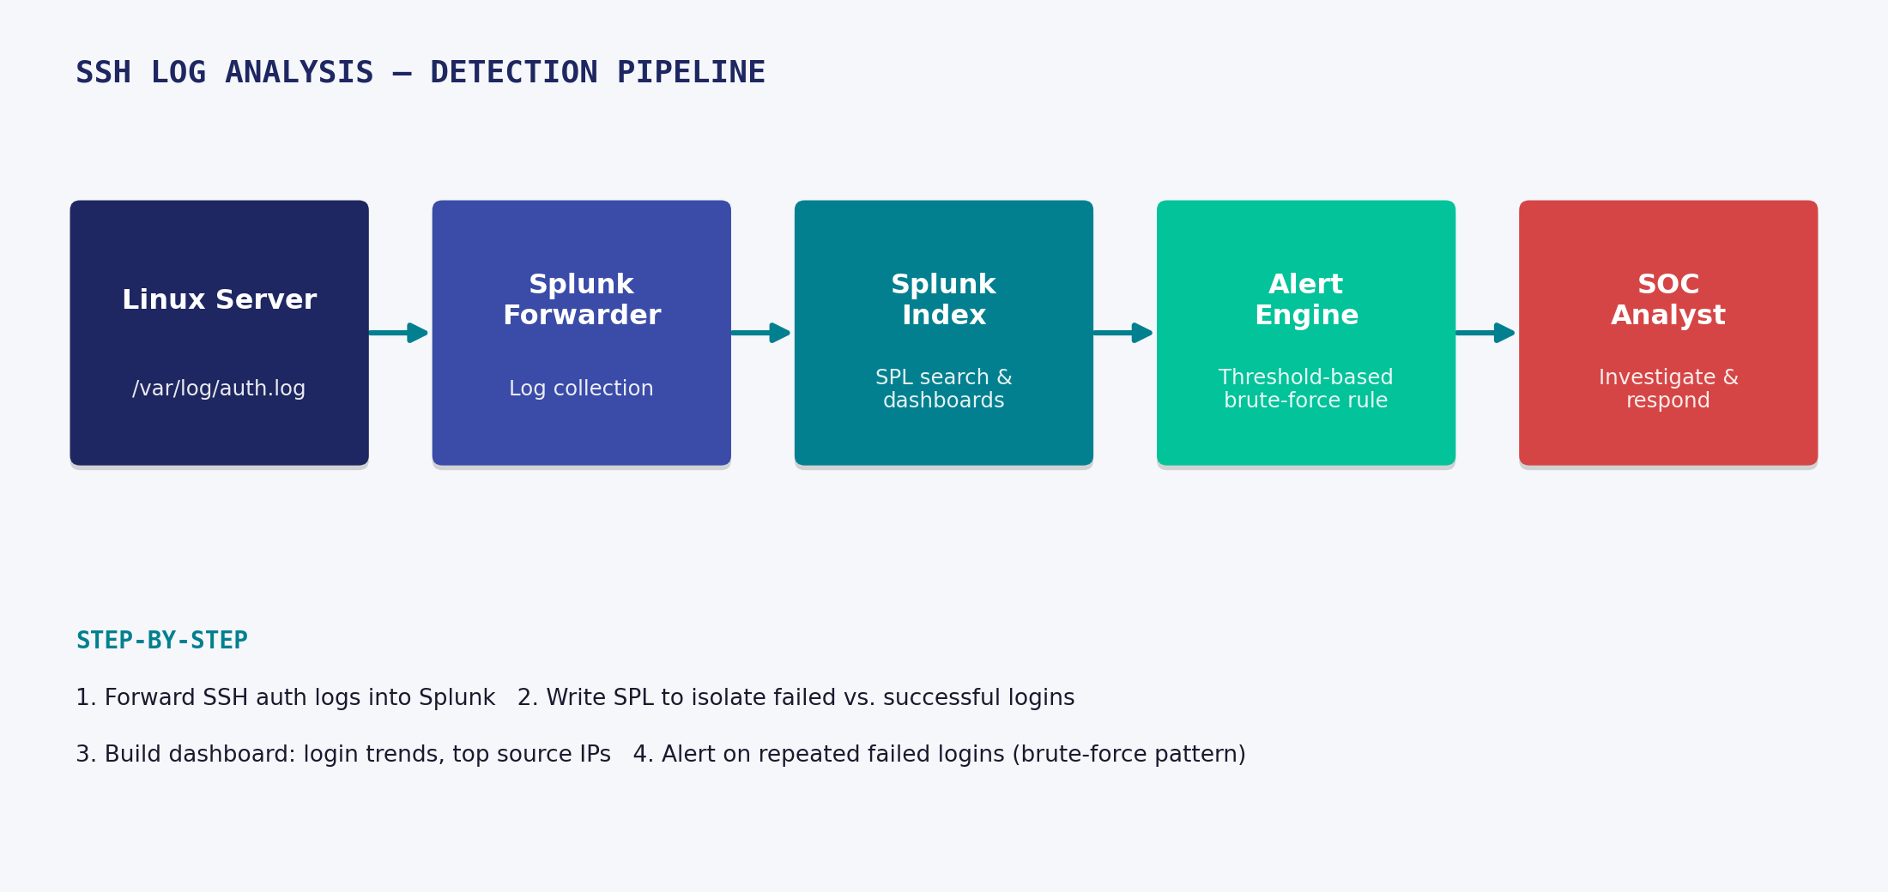
Detection pipeline: log source → Splunk forwarder → index/search → alerting → analyst response
Step-by-Step Process
- Configured a Linux server to generate SSH authentication logs (/var/log/auth.log)
- Forwarded logs into Splunk using a universal forwarder / file monitoring input
- Wrote SPL queries to filter failed vs. successful login events
- Built a dashboard showing login trends, top source IPs, and failed login counts over time
- Created an alert that triggers when failed login attempts from a single IP exceed a threshold in a short window (brute-force pattern)
- Validated the alert by simulating repeated failed logins
Key Skills Demonstrated
- Log source onboarding and field extraction in Splunk
- SPL query writing for security use cases
- Dashboard and alert creation for SOC monitoring
- Recognizing brute-force / credential-stuffing attack patterns
Outcome
OUTCOME
Replaced manual log review with automated, real-time Splunk alerting for suspicious SSH activity.

Nazia Begum | SOC Analyst | linkedin.com/in/nazia-begum-securityanalyst

