

School of Computing and Informatics

PRACTICAL LOGBOOK
BIT3208: Advanced Web Design and Development

Student Name | Abdinasir Adow
Admission Number | BSCCS/2024/74116
Course/Class | BSc Computer Science
Unit Code | BIT3208
Unit Name | Advanced Web Design and Development
Lecturer | Mr. Michael Nyoro
Academic Year | Year 3.2
Project Title | ShopEase– Smart E-Commerce Web Application
Selected Technologies | PHP + MySQL (MySQLi API) + HTML5 + CSS3 + JavaScript
Logbook Coverage | Weeks 6

GitHub Repository: https://github.com/nazianz1

WEEK 6: DATABASE INTEGRATION AND CRUD OPERATIONS

Title: Implementing CRUD Operations on the Shopora E-Commerce Database

Required Evidence – Screenshots:

Fig 1: Admin product form (admin.php) filled in with new product details before submission – CREATE operation
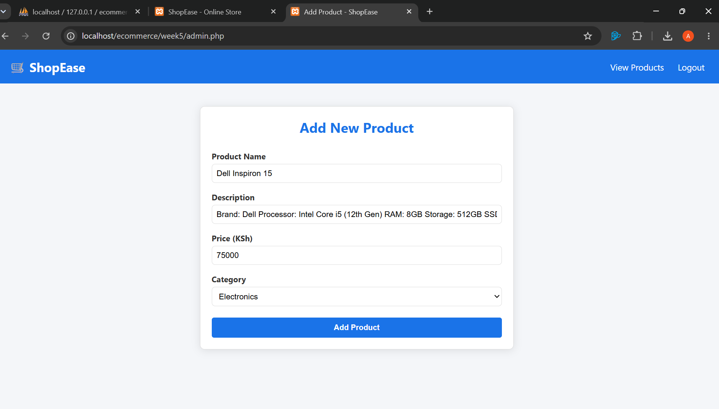
Fig 2: Success message confirming a new product was added to the MySQL products table
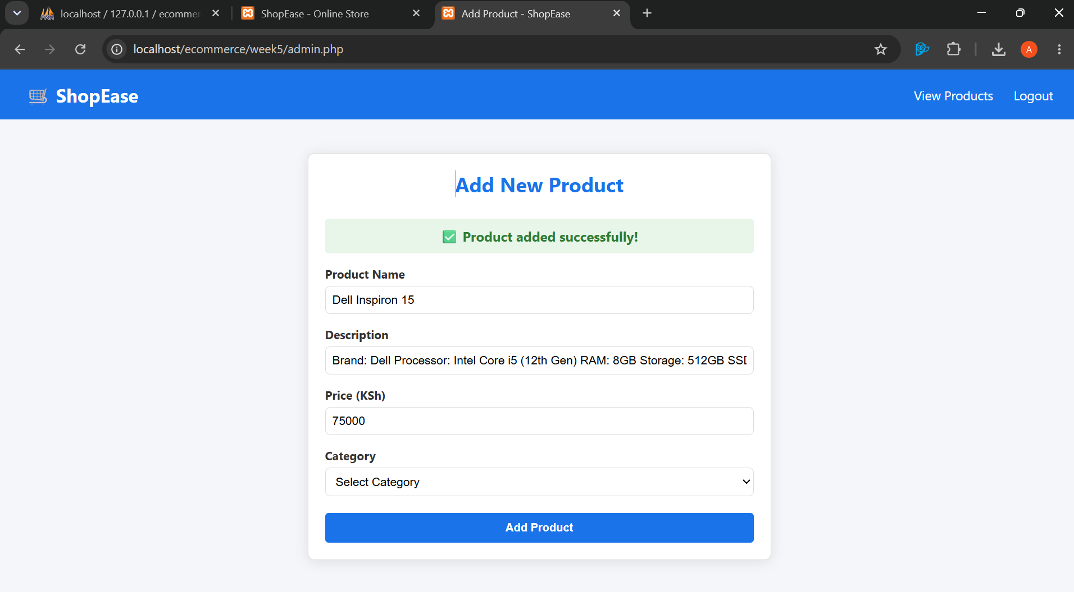
Fig 3: Product listing page (products.php) dynamically displaying all records fetched from the database – READ operation
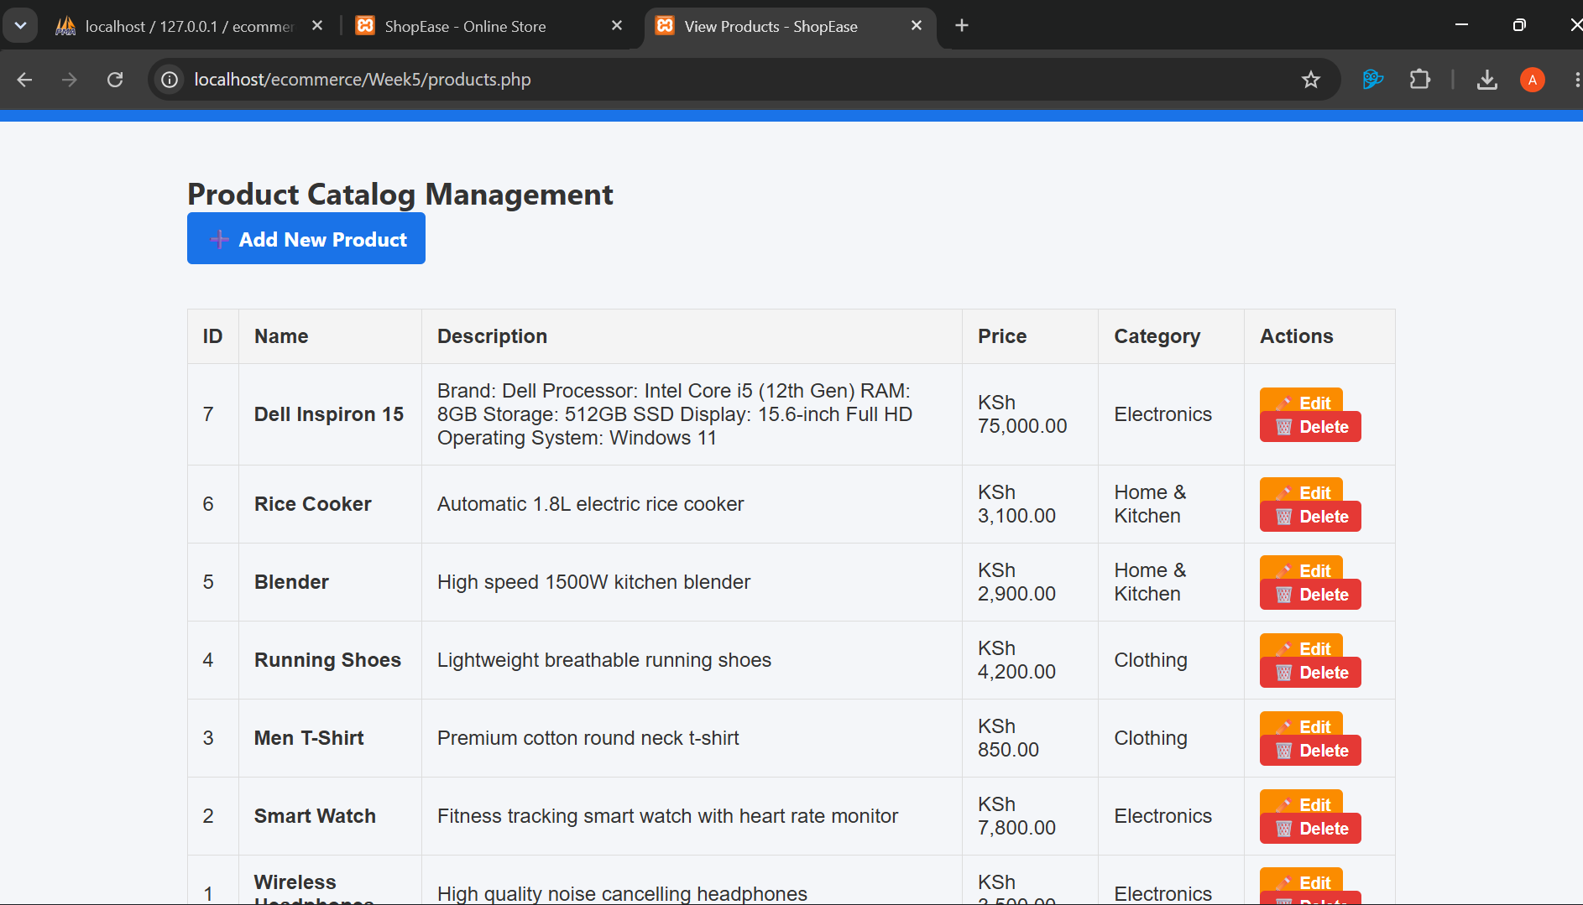
Fig 4: Edit product form pre-filled with existing data, showing updated price/details being saved – UPDATE operation
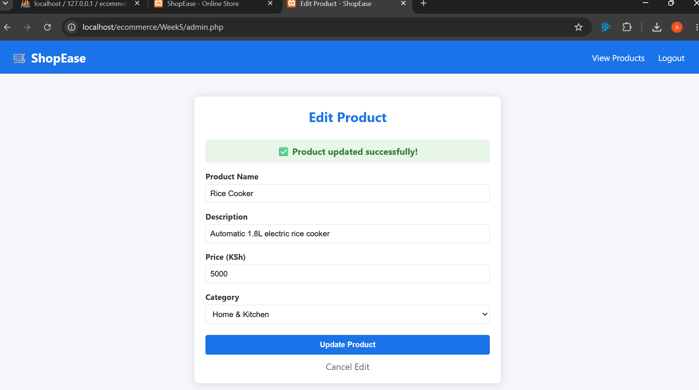

Fig 5: Delete confirmation prompt and resulting product list after a record was removed – DELETE operation
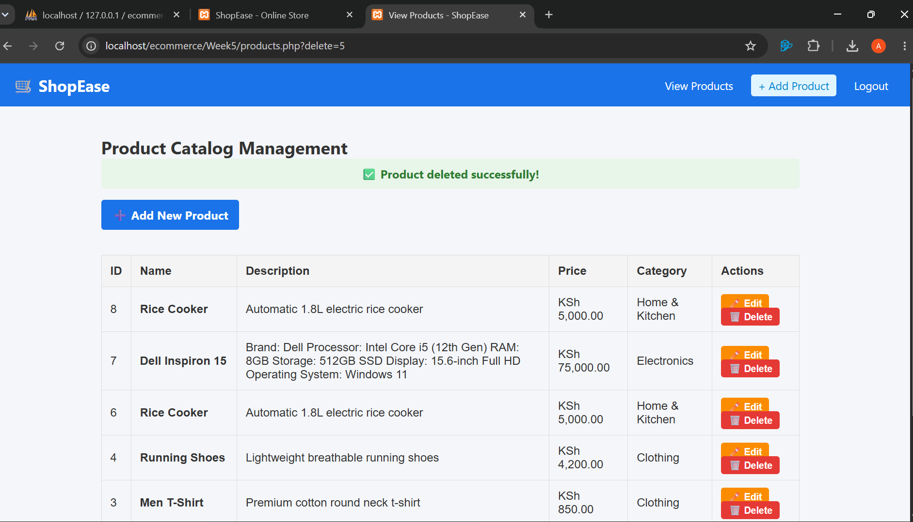

Student Reflection

This week I implemented full CRUD operations on my ShopEase e-commerce project using PHP and MySQL. I used the admin panel to add a new product, confirming the INSERT query worked correctly. The products page reads and displays all records dynamically using a SELECT query joined with categories. I tested the UPDATE operation by editing a product's price and description, and confirmed changes were saved. Finally, I tested DELETE by removing a product and confirming it no longer appeared in the listing. I learned that prepared statements are essential for preventing SQL injection during these operations, and that giving clear success/error feedback greatly improves user experience.

