

BIT3208: Advanced Web Design and Development
PROJECT DOCUMENTATION AND PRACTICAL LOGBOOK
ShopEase Smart E-Commerce Web Application

Student Name | Abdinasir Adow
Admission Number | BSCCS/2024/74116
Course | BSc Computer Science
Unit Code | BIT3208
Unit Name | Advanced Web Design and Development
Lecturer | Mr. Michael Nyoro
Academic Year | Year 3, Semester 2
Project Title | ShopEase Smart E-Commerce Web Application
Technologies | PHP + MySQL + HTML + CSS + JavaScript + Bootstrap
GitHub Repository | https://github.com/nazianz1/ShopEase.git

PART 1: PROJECT DOCUMENTATION

1. Project Overview
ShopEase is a full-featured smart e-commerce web application developed as part of the BIT3208 Advanced Web Design and Development unit. The application enables online product management and user authentication through a dynamic, database-driven web interface.
The system is built on a LAMP-style local stack using XAMPP, with PHP handling server-side logic, MySQL managing persistent data, and a combination of HTML, CSS, JavaScript, and Bootstrap driving the responsive frontend. ShopEase simulates a real-world online shopping platform with an admin panel for managing products and a user-facing storefront for browsing and interacting with listed items.

2. Project Objectives
The following objectives guided the development of ShopEase:
- Set up and configure a local web development environment using XAMPP (Apache + MySQL + PHP).
- Design and implement a responsive user interface using HTML, CSS, Bootstrap, and JavaScript.
- Develop a secure user authentication system using PHP sessions, password hashing, and prepared statements.
- Design a normalized relational database schema to support users, products, and application data.
- Implement full CRUD (Create, Read, Update, Delete) operations for product management.
- Apply client-side form validation using JavaScript to improve usability and reduce invalid submissions.
- Demonstrate understanding of web security principles including SQL injection prevention and secure password storage.
- Deploy and test the application in a local environment and document all development stages.

3. System Requirements

3.1 Functional Requirements
- Users must be able to register with a name, email address, and password.
- Users must be able to log in and log out securely using session-based authentication.
- Authenticated admin users must be able to add, edit, view, and delete products.
- The system must display all available products in a structured listing.
- Forms must be validated on the client side before submission.
- Passwords must be hashed before storage and verified securely during login.
- The system must display appropriate feedback messages for errors and successful actions.

3.2 Non-Functional Requirements
- Security: All database queries must use prepared statements to prevent SQL injection. Passwords must be stored using bcrypt hashing via PHP password_hash().
- Usability: The interface must be intuitive and responsive across desktop and mobile screen sizes.
- Performance: Pages must load within acceptable time on a local development server.
- Maintainability: Code must be organised into logical files and folders (config, auth, admin, etc.) for easy maintenance.
- Compatibility: The application must run correctly on modern browsers including Chrome and Firefox.

4. Technologies Used
Technology | Version/Tool | Purpose
PHP | PHP 8.x (XAMPP) | Server-side scripting, session management, form processing
MySQL | MySQL 8.x (XAMPP) | Relational database for users, products, and application data
HTML5 | HTML5 | Page structure and semantic markup
CSS3 | CSS3 | Styling, layout, and visual presentation
JavaScript | Vanilla JS (ES6) | Client-side form validation and dynamic UI feedback
Bootstrap | Bootstrap 5 | Responsive grid system, UI components, and mobile-first design
XAMPP | XAMPP 8.x | Local development stack bundling Apache, MySQL, and PHP
phpMyAdmin | Bundled with XAMPP | Visual database management and query testing
Figma | Web-based | UI wireframing and prototype design
Git / GitHub | Git 2.x | Version control and source code hosting

5. System Architecture
ShopEase follows a three-tier architecture pattern, separating the presentation layer, application logic layer, and data layer as described below.

5.1 Presentation Layer (Frontend)
The frontend is built using HTML5, CSS3, Bootstrap 5, and JavaScript. It handles all user-facing pages including the homepage, login and registration forms, product listings, and the admin dashboard. JavaScript is used to validate forms on the client side before data is sent to the server, improving responsiveness and reducing unnecessary server requests.

5.2 Application Logic Layer (Backend)
PHP handles all server-side processing. This includes receiving form data, validating input, querying the database, managing user sessions, and returning appropriate responses. A central configuration file (config.php) manages the database connection and is included across all pages that require data access. Prepared statements are used throughout to protect against SQL injection.

5.3 Data Layer (Database)
MySQL manages all persistent data through the ecommerce_db database. The database contains two primary tables: users (storing registered account information) and products (storing inventory data). phpMyAdmin is used during development for direct database inspection and management.

5.4 Request Flow
A typical user interaction follows this flow: (1) The browser sends an HTTP request to the Apache server. (2) PHP processes the request, reads session data, and queries MySQL as needed. (3) PHP builds the HTML response and sends it back to the browser. (4) The browser renders the page, and JavaScript handles any client-side interactions without a page reload.

6. Database Design

6.1 Database Name: ecommerce_db
The database consists of two core tables designed to support user authentication and product management functionality.

Table 1: users
Column Name | Data Type | Constraints | Description
id | INT | PRIMARY KEY, AUTO_INCREMENT, NOT NULL | Unique identifier for each user
name | VARCHAR(100) | NOT NULL | Full name of the registered user
email | VARCHAR(150) | UNIQUE, NOT NULL | Email address used for login
password | VARCHAR(255) | NOT NULL | Bcrypt-hashed password string
created_at | TIMESTAMP | DEFAULT CURRENT_TIMESTAMP | Date and time the account was created

Table 2: products
Column Name | Data Type | Constraints | Description
id | INT | PRIMARY KEY, AUTO_INCREMENT, NOT NULL | Unique identifier for each product
name | VARCHAR(150) | NOT NULL | Name of the product
description | TEXT | NULL | Detailed product description
price | DECIMAL(10,2) | NOT NULL | Product price in KES
quantity | INT | NOT NULL, DEFAULT 0 | Available stock quantity
created_at | TIMESTAMP | DEFAULT CURRENT_TIMESTAMP | Date the product was added

6.2 Relationships
In the current implementation the users and products tables are independent. The users table manages authentication while the products table manages the shop inventory. Future versions would introduce a foreign key from an orders table referencing both users(id) and products(id) to support transactional functionality.

7. Features and Modules

7.1 User Authentication Module
This module covers registration, login, session management, and logout functionality. New users submit their details through register.php, where the password is hashed using PHP's password_hash() function before being stored. On login, password_verify() checks the submitted password against the stored hash. Upon successful authentication a PHP session is created, storing the user's ID and name to maintain state across pages. All protected pages check for an active session and redirect unauthenticated users back to the login page.

7.2 Product Management Module (Admin CRUD)
Authenticated admin users access the product management dashboard to perform full CRUD operations. New products are added via an HTML form that submits to a PHP handler executing a prepared INSERT statement. The product listing page fetches all records with a SELECT query and renders them in a Bootstrap table. Each row includes Edit and Delete action buttons. Editing loads the existing product data into a pre-filled form and executes an UPDATE query on submission. Deletion executes a DELETE query after a confirmation prompt, then refreshes the listing.

7.3 Client-Side Validation Module
JavaScript handles form validation before any data reaches the server. The login and registration forms check that all required fields are filled in, that email addresses match a valid format, and that passwords meet a minimum length requirement. A password strength indicator provides real-time visual feedback (Weak / Medium / Strong) as the user types, driven by string length checks and character-type detection.

7.4 Responsive UI Module
Bootstrap 5's grid system and utility classes ensure the application is fully responsive across desktop, tablet, and mobile screen sizes. The navigation bar collapses into a hamburger menu on smaller screens, and product tables reflow to remain readable. The colour scheme uses blue and white tones defined consistently across all pages for a professional, coherent look.

8. Installation and Setup Guide
Follow the steps below to run ShopEase on a local machine:

Step 1: Install XAMPP
Download XAMPP from https://www.apachefriends.org and run the installer. Ensure Apache and MySQL modules are selected during installation. Launch the XAMPP Control Panel and start both the Apache and MySQL services.

Step 2: Clone the Repository
Open a terminal or Git Bash and run the following command to clone the project into the XAMPP web root:
git clone https://github.com/nazianz1/ShopEase.git C:/xampp/htdocs/ShopEase

Step 3: Create the Database
Open your browser and navigate to http://localhost/phpmyadmin. Create a new database named ecommerce_db. Import the provided SQL file (ecommerce_db.sql) from the project root to create the required tables and any seed data.

Step 4: Configure the Database Connection
Open the file config.php in the project root and confirm the following connection settings match your local XAMPP installation:
$host = 'localhost'; $user = 'root'; $password = ''; $database = 'ecommerce_db';

Step 5: Launch the Application
Open a browser and navigate to http://localhost/ShopEase. The homepage should load. Register a new account, log in, and navigate to the admin panel to begin managing products.

9. Testing Summary
The following test cases were executed against the ShopEase application to verify correct functionality, security, and edge-case handling.

Test Case | Input | Expected Result | Actual Result | Status
User Registration | Valid name, email, password | User added to DB, redirected to login | User inserted, redirect works | PASS
User Login – Valid | Correct email & password | Session created, welcome page loads | Session set, welcome page displayed | PASS
User Login – Invalid | Wrong password | Error message displayed | Error message shown | PASS
Add Product (Admin) | Product name, price, quantity | Product saved to products table | Product appears in DB and listing | PASS
Edit Product | Updated product price | Record updated in DB | Updated value reflected in table | PASS
Delete Product | Click delete on product | Product removed from DB | Product removed successfully | PASS
Form Validation (JS) | Submit empty login form | JS prevents submission, shows error | Alert shown, form not submitted | PASS
Password Hashing | Register new user | Password stored as bcrypt hash | Hash visible in phpMyAdmin | PASS
SQL Injection Test | ' OR '1'='1 in login | Login fails, no DB error exposed | Login rejected safely | PASS
Session Persistence | Navigate between pages | User stays logged in | Session maintained across pages | PASS

All test cases passed. The application correctly handles both valid and invalid inputs, maintains secure authentication, and protects against common web vulnerabilities including SQL injection.

10. Conclusion and Future Work

10.1 Conclusion
The ShopEase project successfully demonstrates the application of full-stack web development skills using PHP, MySQL, HTML, CSS, JavaScript, and Bootstrap. Over the five-week development period, a functional e-commerce application was built from the ground up, covering environment setup, UI design, authentication, database design, and CRUD operations. The project reinforced key concepts in web security, responsive design, and structured backend development.

10.2 Future Work
Several enhancements could be made to extend ShopEase into a more complete production-ready platform:
- Shopping cart and order management system with a dedicated orders table and checkout flow.
- Role-based access control distinguishing between regular customers and administrators.
- Product image upload functionality using PHP file handling and stored image paths.
- Search and filter capabilities on the product listing page.
- Integration with a payment gateway such as M-Pesa Daraja API for local Kenyan transactions.
- Deployment to a live hosting environment using cPanel or a cloud provider such as AWS or DigitalOcean.
- Pagination for large product datasets to improve performance and usability.

PRACTICAL LOGBOOK
BIT3208: Advanced Web Design and Development
Student Name | Abdinasir Adow
Admission Number | BSCCS/2024/74116
Course/Class | Computer Science
Unit Code | BIT3208
Unit Name | Advanced Web Design and Development
Lecturer | Mr. Michael Nyoro
Academic Year | Year 3.2
Project Title | Smart E-Commerce Web Application
Selected Technologies | PHP + MySQL + HTML + CSS + JavaScript

GitHub Repository: https://github.com/nazianz1/ShopEase.git

Week 1: Local Environment Setup

Title: Installation and Testing of Local Development Environment

Required Evidence – Screenshots:

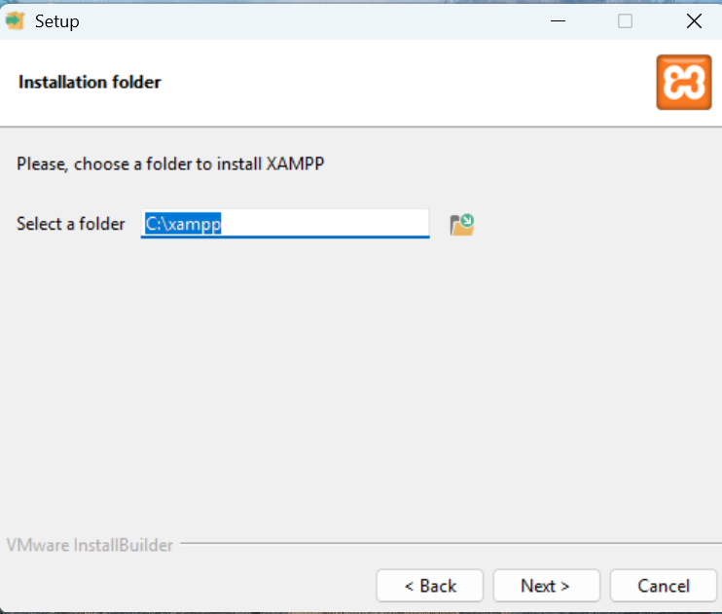
Figure 1 : Installation of XAMPP showing the setup wizard
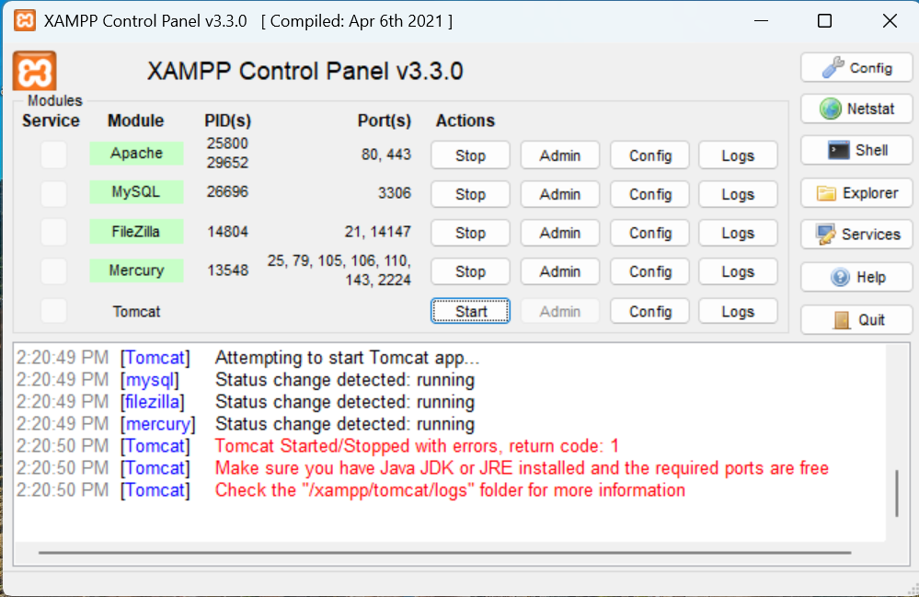
Figure 2 : XAMPP Control Panel showing Apache and MySQL services running

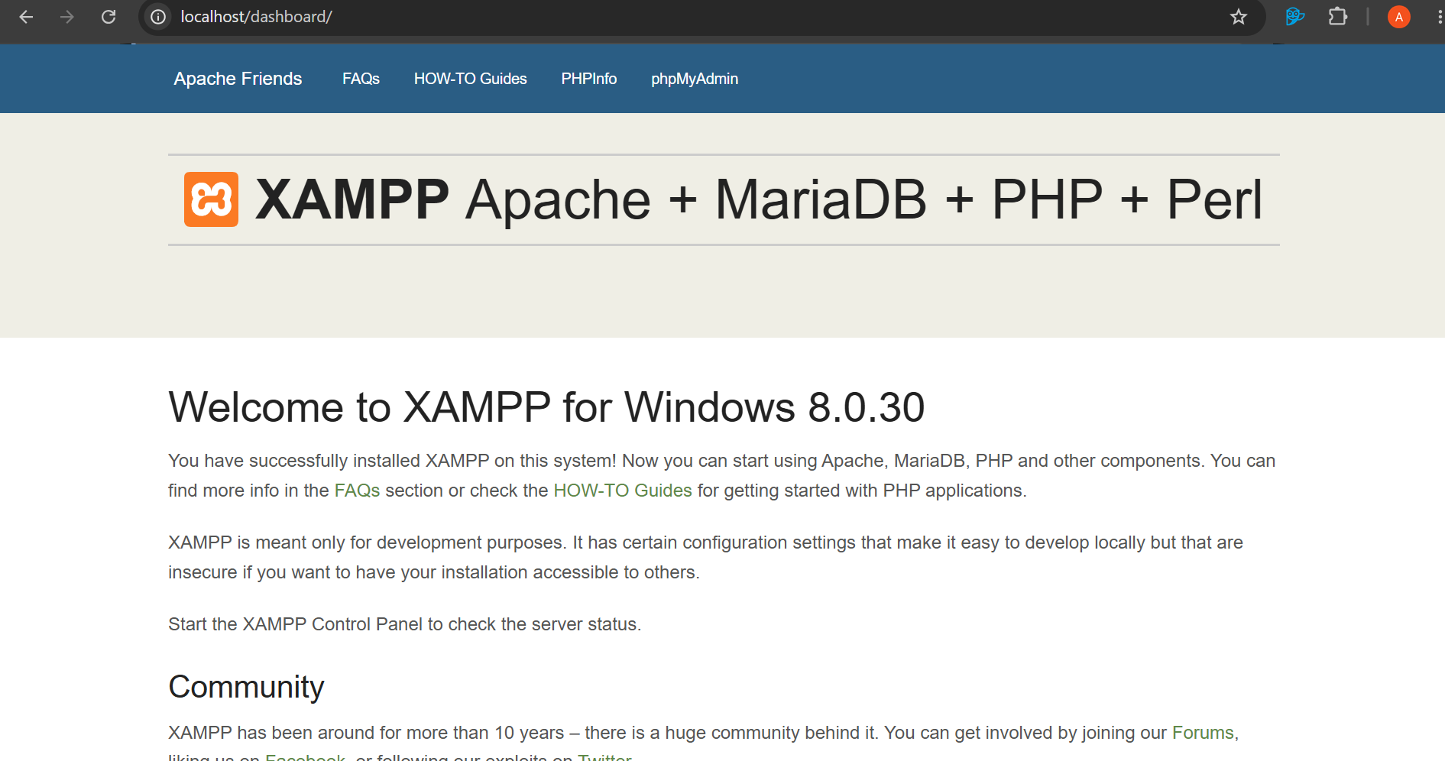
Figure 3 : Browser displaying the XAMPP localhost test page at http://localhost
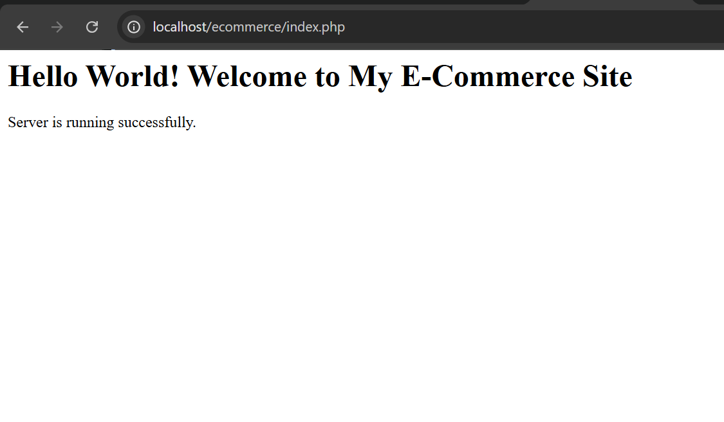
Figure 4 : First PHP 'Hello World' page rendered in the browser
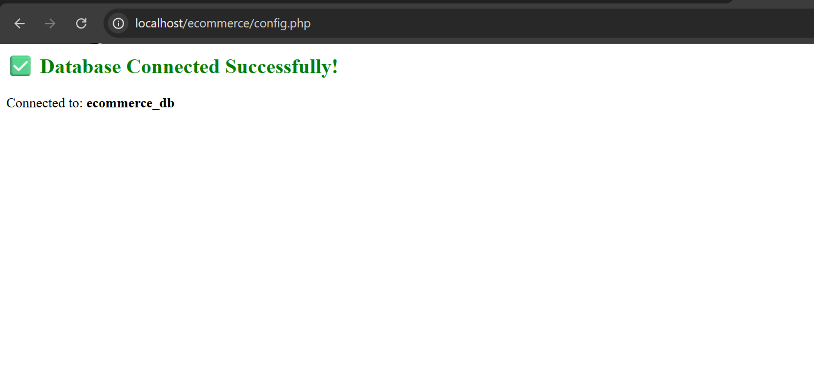
Figure 5 : Successful database connection test using mysqli_connect() function in PHP – connection confirmed message displayed

Student Reflection
This week I set up XAMPP to get a working local development environment on my machine. Getting Apache and MySQL running through the control panel was fairly straightforward once I understood what each service does. I created a PHP test file in the htdocs folder to confirm the server was picking it up, then tested the database connection using mysqli_connect(). It took a bit of back and forth getting the file paths right but once it clicked everything made sense. This is the setup I’ll be building the project on for the rest of the weeks.

Week 2: UI Planning and System Design
Title: User Interface Planning and System Design

Required Evidence – Screenshots:

Fig 1: Hand-drawn wireframe sketch of the homepage and login page showing layout zones and navigation structure
[ Insert Screenshot – Fig 1 Here ]

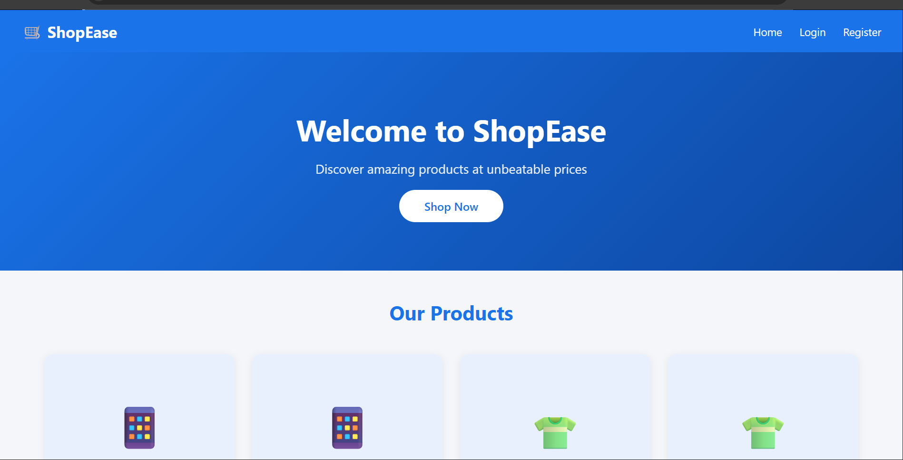
Figure 6 : Dashboard layout design showing the main navigation panel, product listing area, and header sections

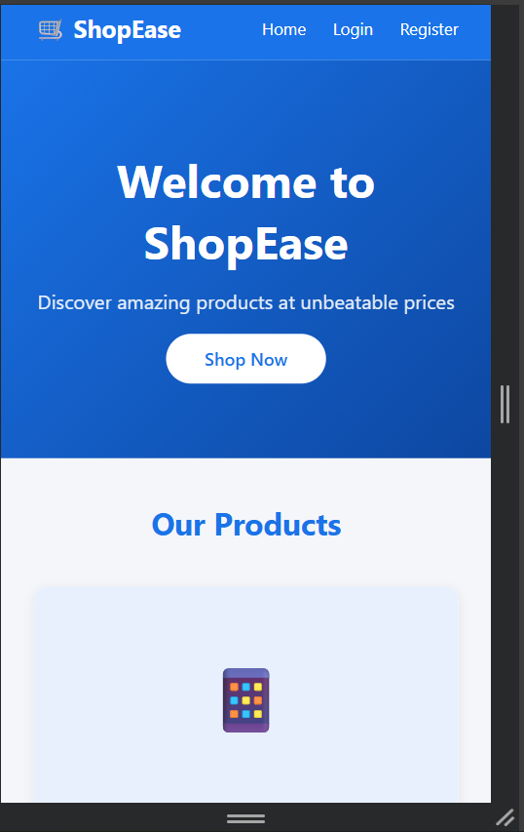
Figure 7 : Mobile view mockup for the e-commerce homepage demonstrating responsive layout adjustments

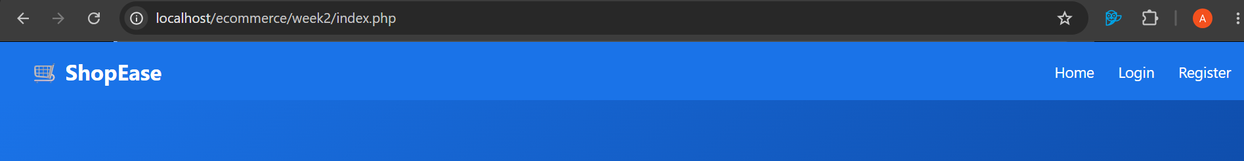
Figure 8 :Color theme palette and navigation structure defined in Figma showing chosen colors and font styles

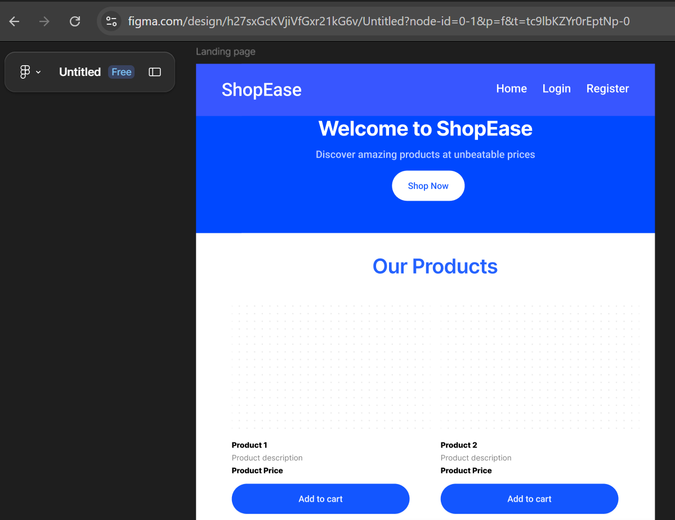
Figure 9 : Complete GUI prototype created in Figma

Student Reflection
I spent this week planning the interface before writing any code. I started with rough sketches of the homepage and login page to get a feel for the layout, then moved into Figma to tighten things up. Blue and white felt like the right colour scheme — clean and professional without being too generic. Working through the mobile layout early was useful because it’s much easier to plan for different screen sizes at the design stage than to fix it later in code. Having these mockups gives me a clear reference point going into the HTML and CSS work.

Week 3: JavaScript and PHP Basics

Title: Frontend Interaction and Backend Foundations

Required Evidence – Screenshots:

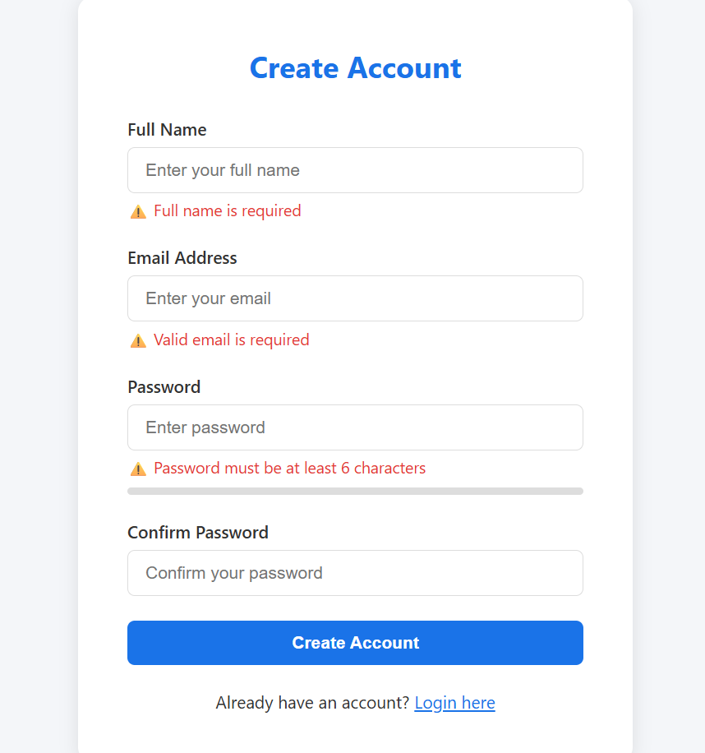
Figure 10 : JavaScript form validation preventing empty field submission on the login

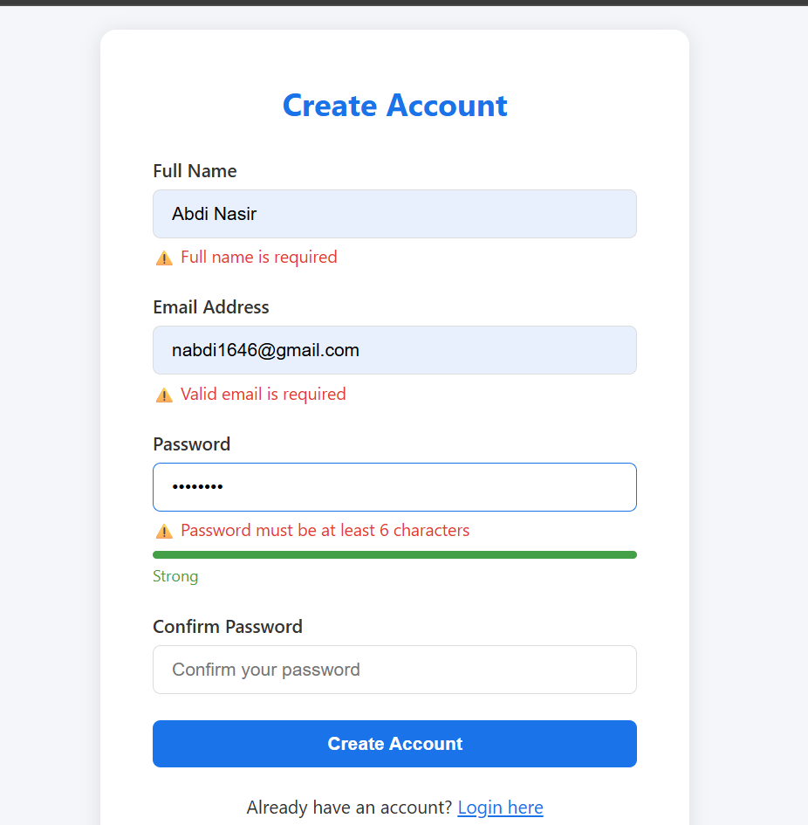
Figure 11 : Password strength checker dynamically displaying weak/medium/strong feedback as the user types

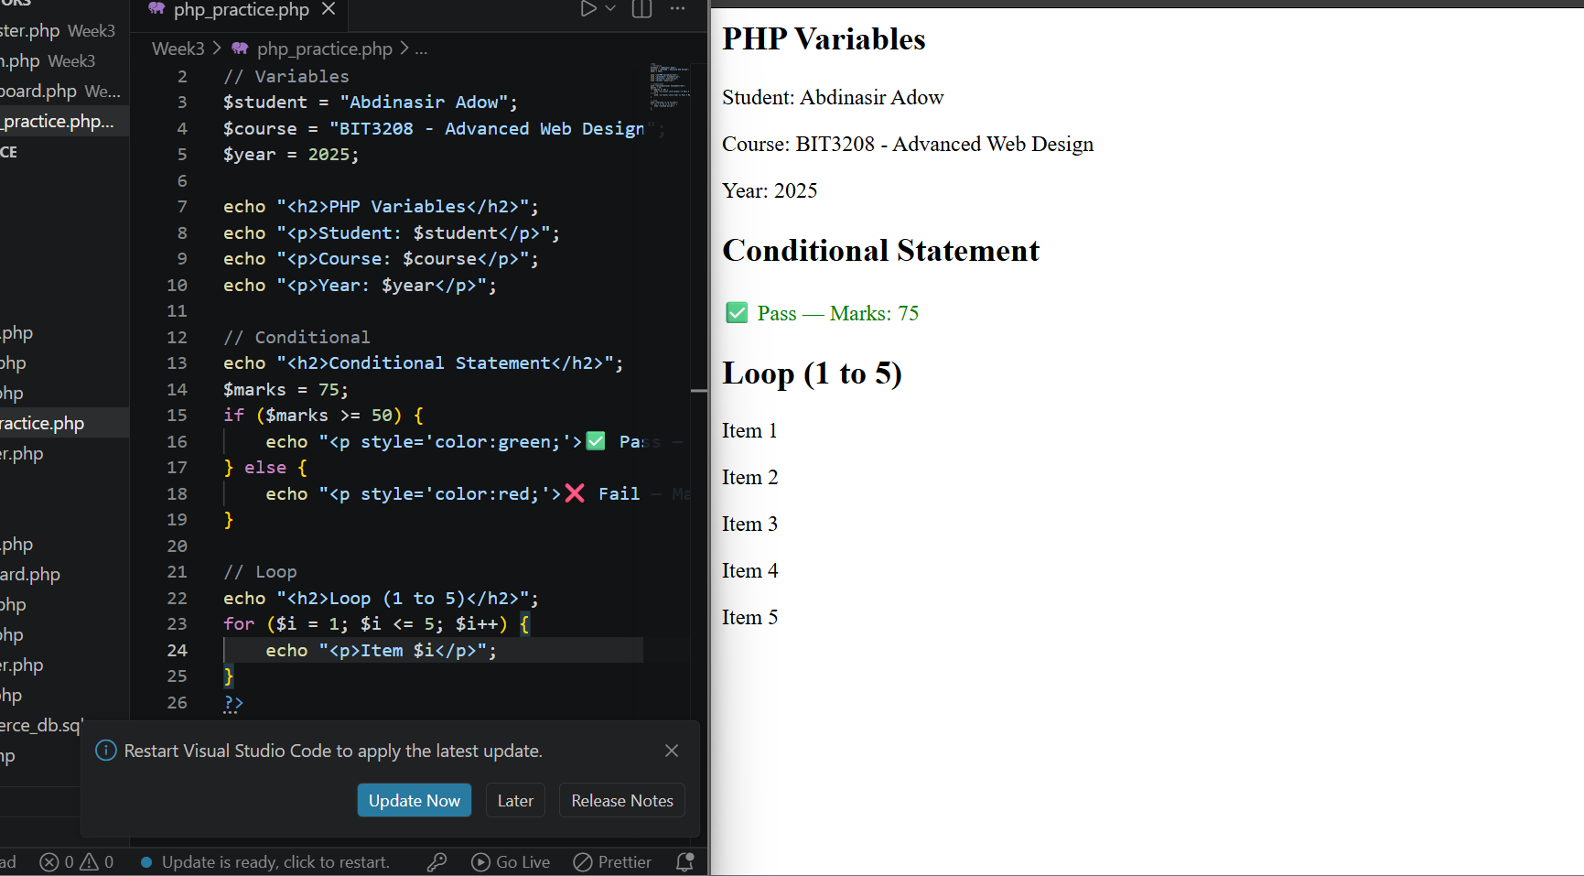
Figure 12 : PHP syntax practice file showing variables, conditional statements, and loops rendered in the browser

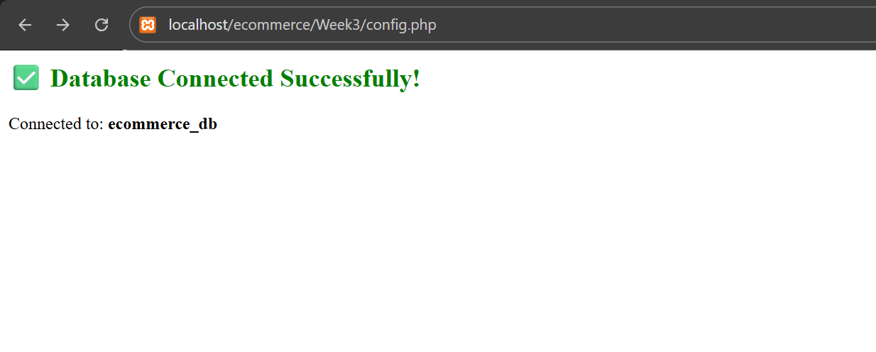
Figure 13 : PHP database connection script (config.php) successfully connecting to MySQL
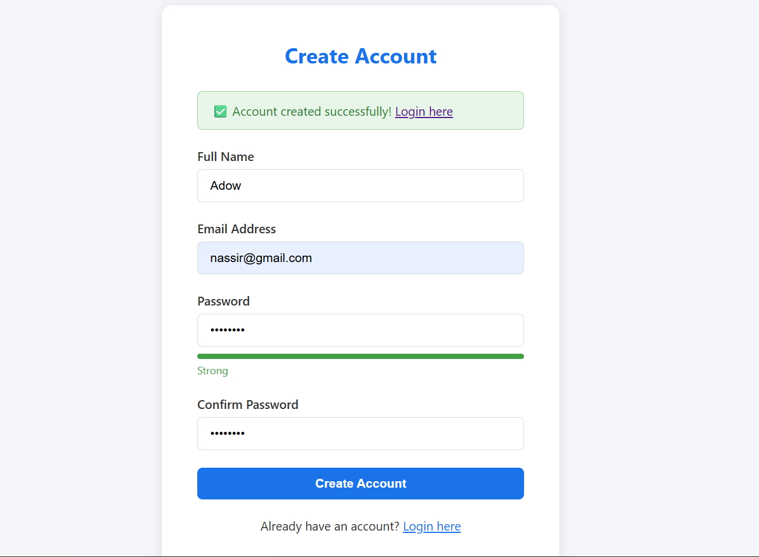
Figure 14 : Dynamic User Input handling where page displays user submitted form back to them

Student Reflection
This week I worked on both client-side and server-side scripting. The JavaScript form validation was useful to build because it stops empty submissions before anything even hits the server, which makes the whole experience smoother for the user. The password strength checker was a good exercise — using string length to drive real-time visual feedback is simple but effective. On the PHP side I practised the basics and then wrote a config file to connect to MySQL. Putting the two together started showing me how the front and back ends work as one system rather than separately.

Week 4: Login System and Server-Side Components

Title: PHP Login System with Secure Authentication

Required Evidence – Screenshots:

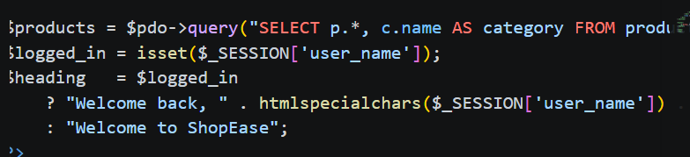
Figure 15 : Dynamic welcome page php code to fetch user data


Figure 16 : PHP registration script output confirming a new user was inserted into the MySQL users table
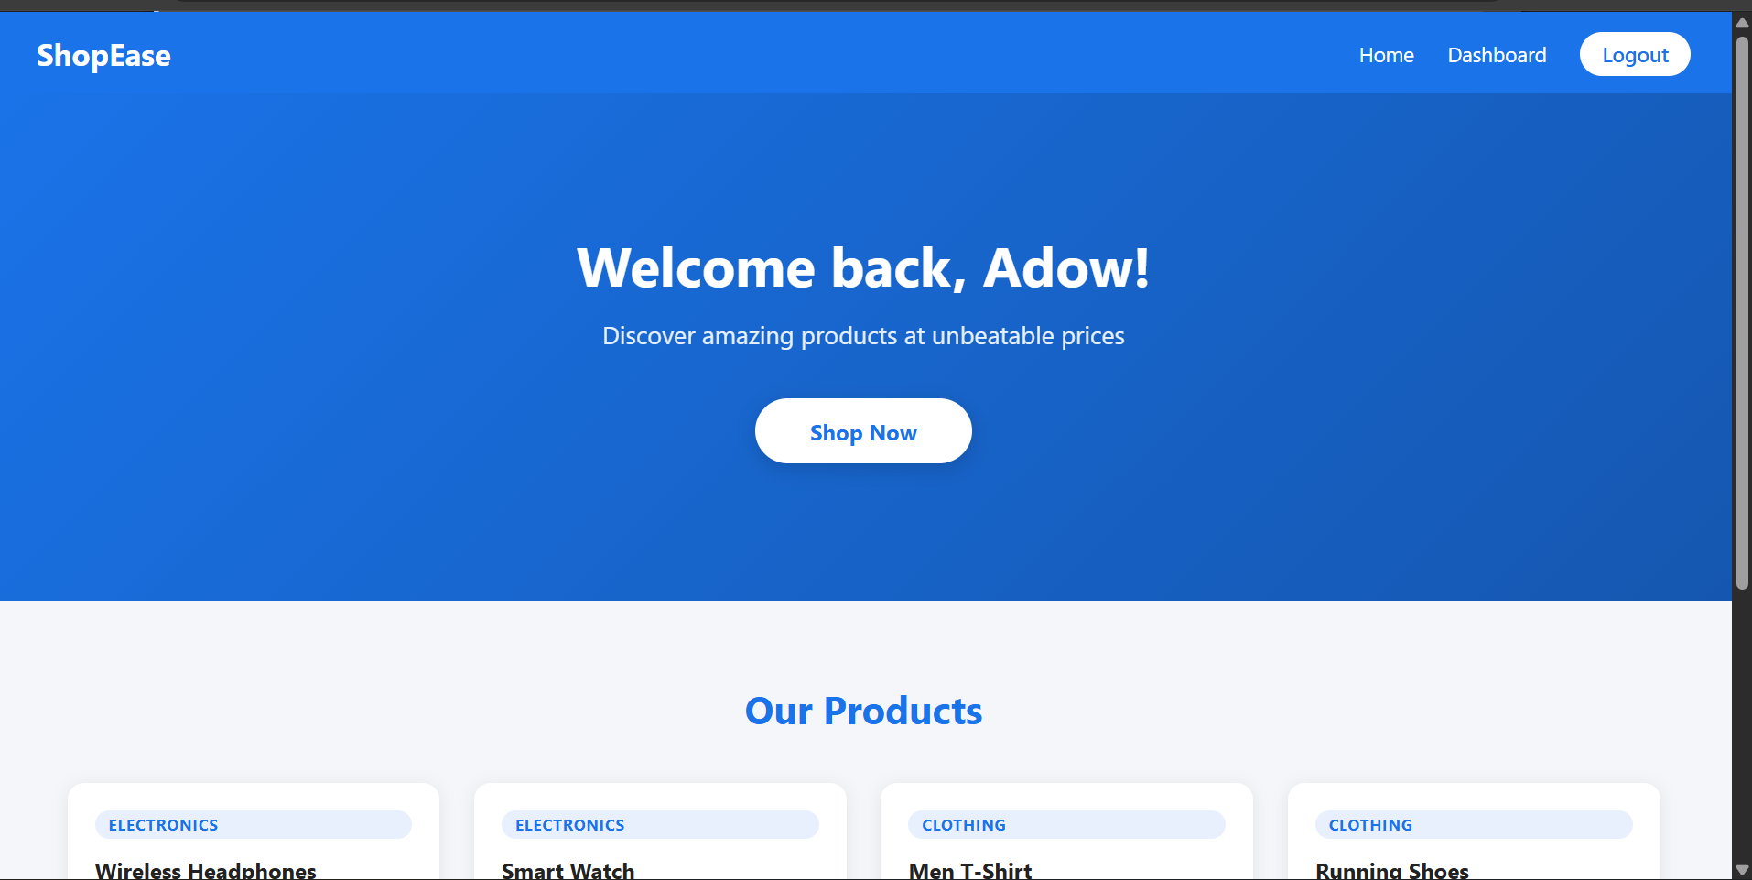
Figure 17 : Session-based welcome page
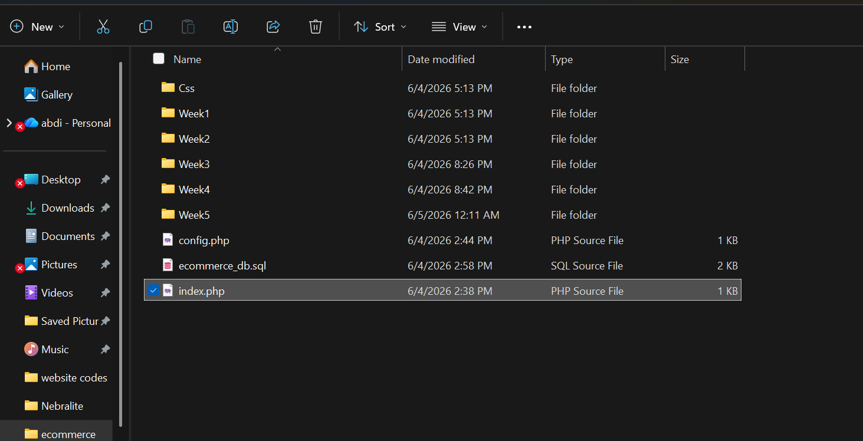
Figure 18 : Folder Organization
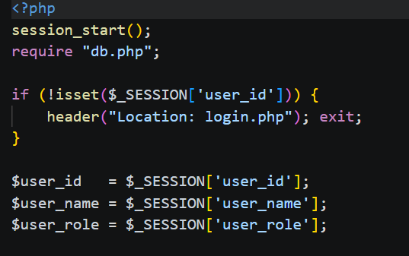
Figure 19 : PHP sessions introduction

Student Reflection
Building the login and registration system this week was where the project started feeling more real. Using password_hash() to store credentials properly and prepared statements to protect against SQL injection were the two things I focused on getting right. Sessions handle the authentication state across pages so users don’t have to keep logging in. Testing with both valid and invalid credentials helped me catch a few edge cases I hadn’t planned for, like what happens when a form is submitted twice. Getting this part working correctly was important because everything else in the app depends on it.

Week 5: Database Design and CRUD Operations

Title: MySQL Database Design and CRUD Operations

Required Evidence – Screenshots:

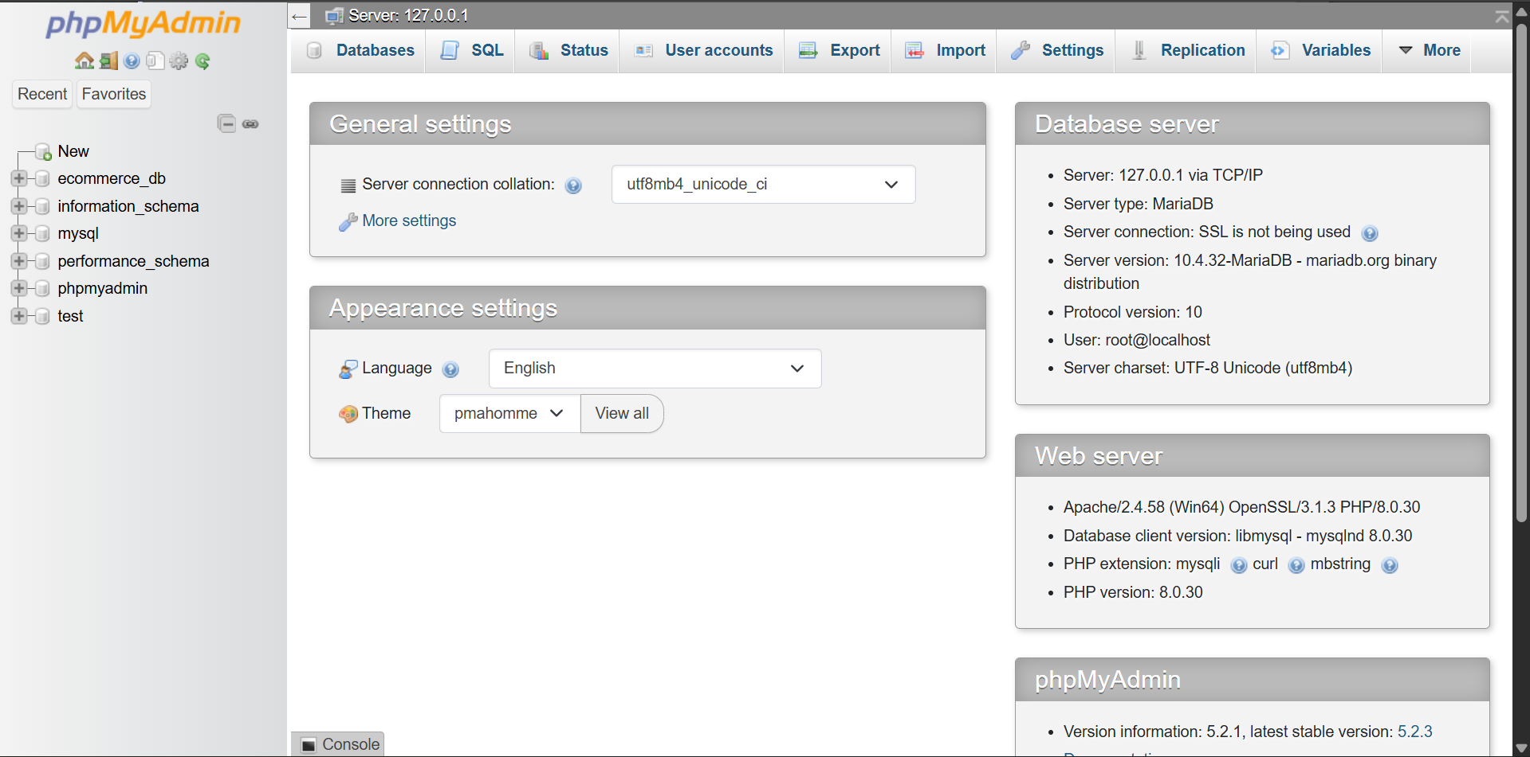
Figure 20 : Introduction to databases and MySQL

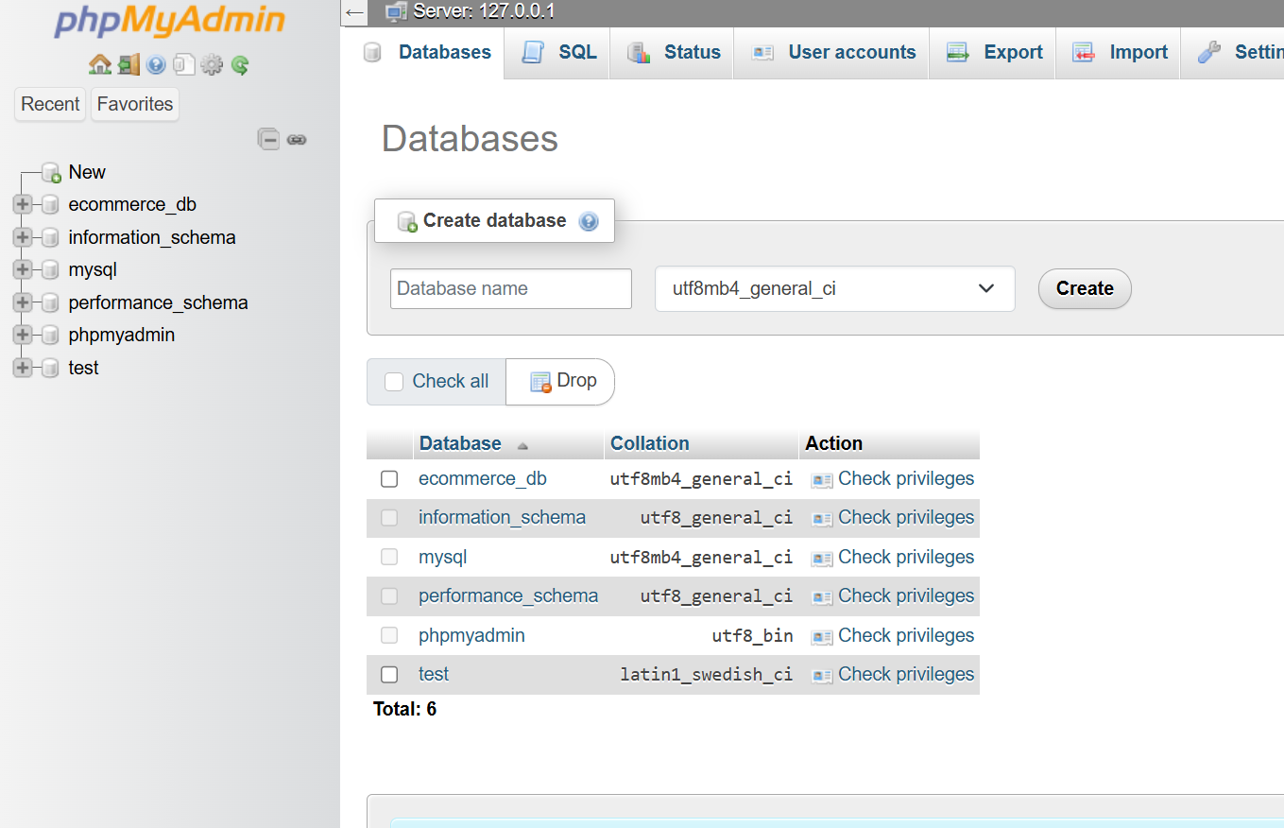
Figure 21 : phpMyAdmin showing the databases list
Fig 3: SQL INSERT statement successfully adding a new product record – confirmation shown in phpMyAdmin query result
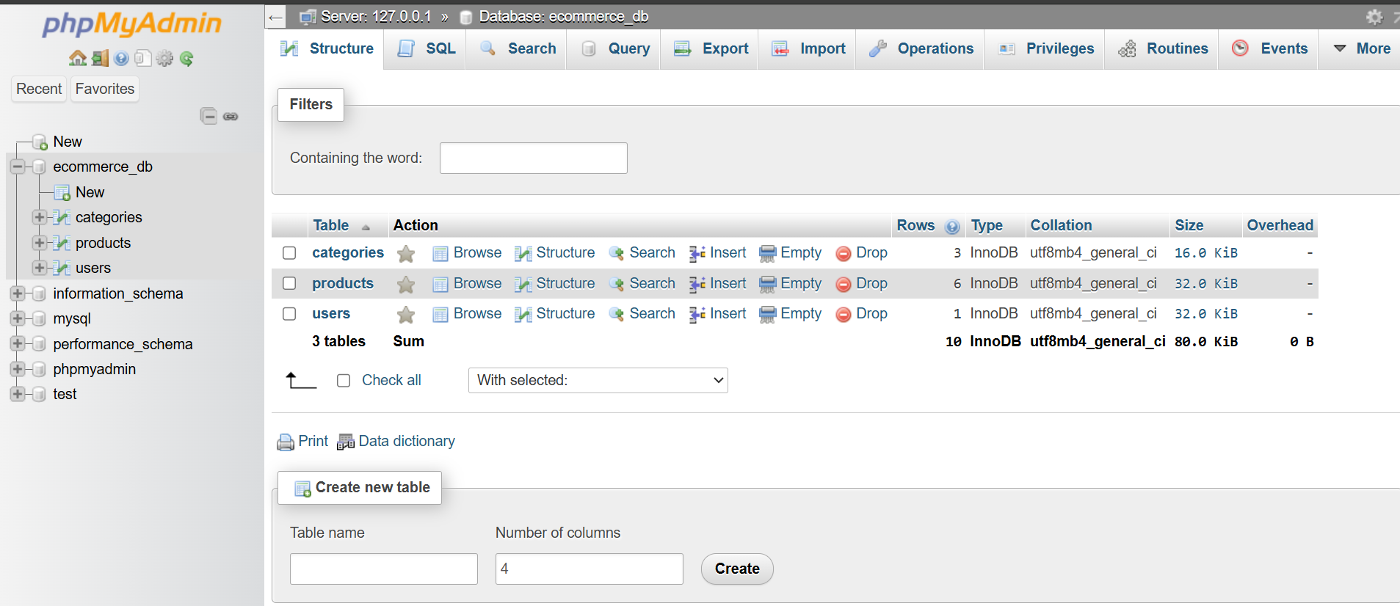
Figure 22 : phpMyAdmin showing the products table structure with column names, data types, and primary key defined
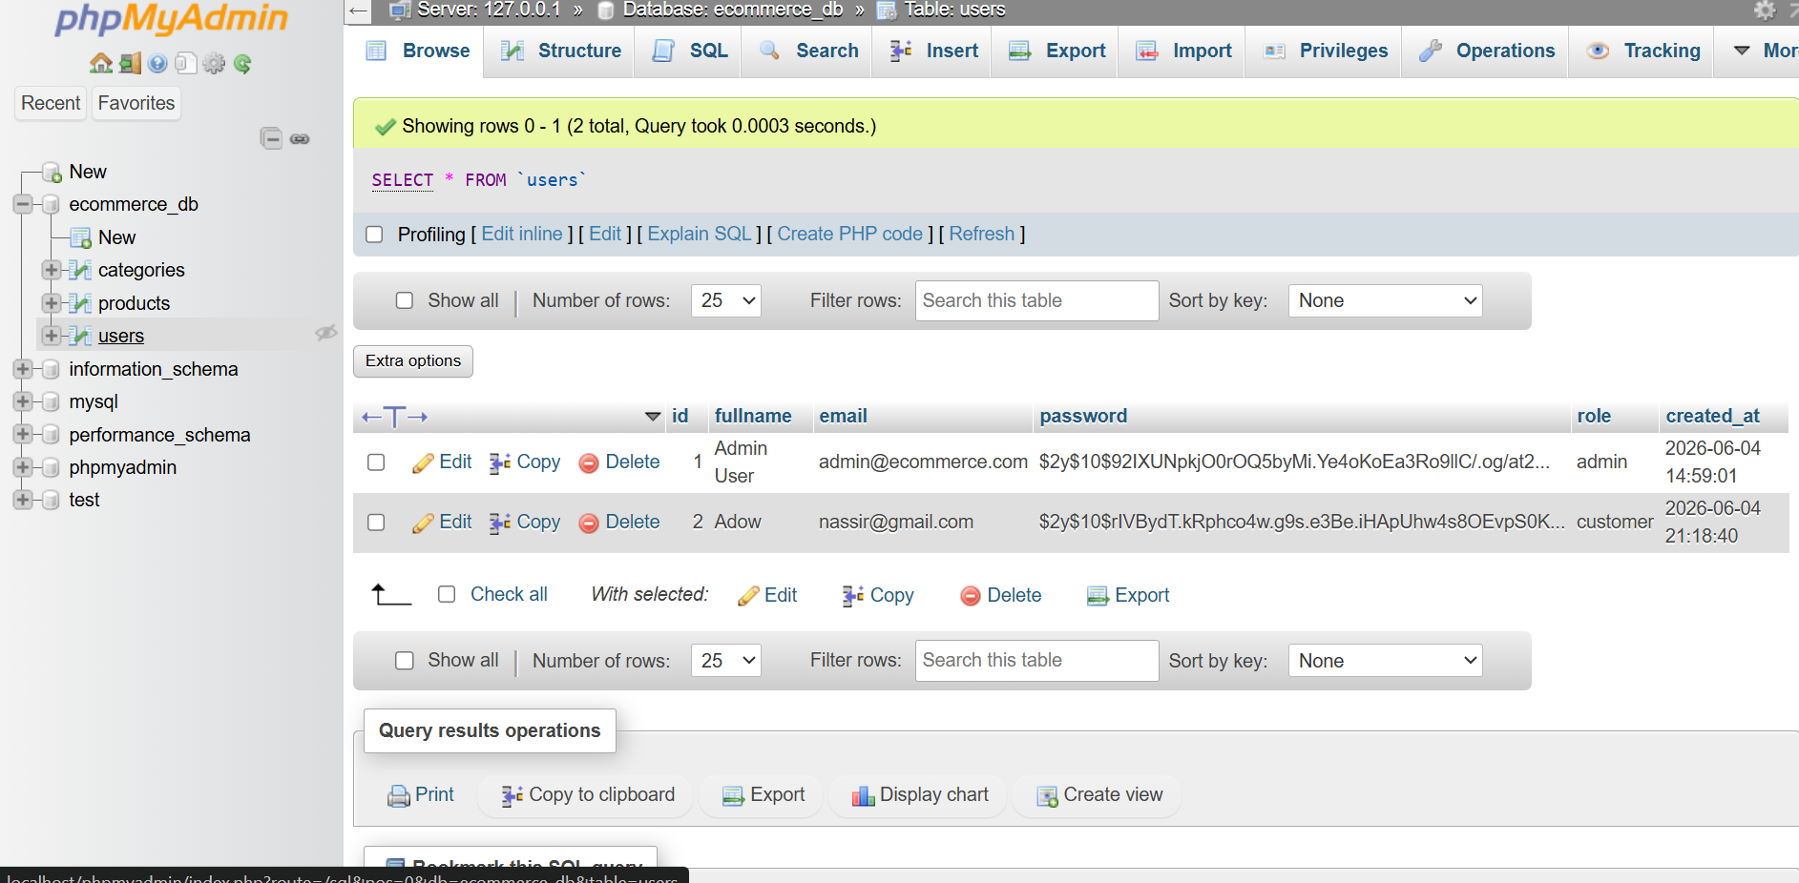
Figure 23 : Data in a table hashed by the register.php password manager
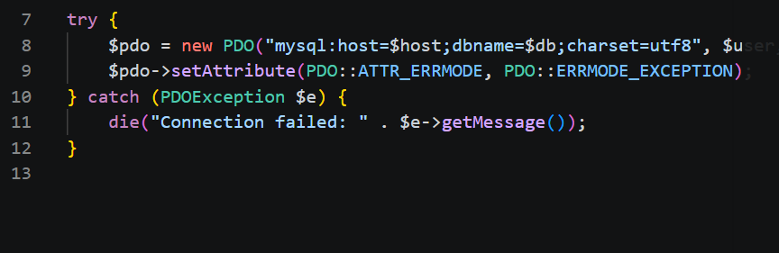
Figure 24 : Connecting PHP to Database
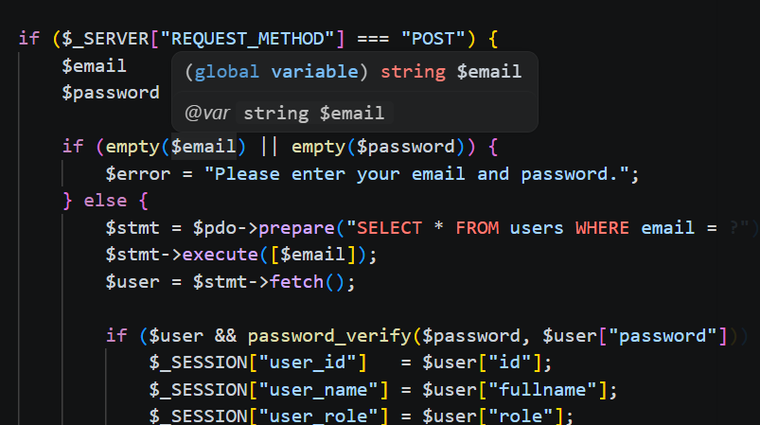
Figure 25 : Fetching Database records
Student Reflection
Database design was the main focus this week. Drawing out the ER diagram before touching phpMyAdmin made the actual table setup much quicker because the relationships were already figured out. Creating the tables with the right data types and setting primary and foreign keys correctly took some care but it’s worth getting right early. The CRUD operations in PHP all tested fine — INSERT, SELECT, UPDATE, and DELETE each working against the products and users tables. Seeing the hashed passwords sitting in the database confirmed that the registration system from last week is doing its job properly.

