Query:
Create Table Director
(Person_ID int Primary key,
Director_Name varchar(50),
Birth_Year int,
No_Of_Films int,
No_Of_Awards int);

(1,'Zahir Raihan',1935,5,5),
(2,'Rajkumar Hirani',1962,5,9),
(3,'Satyajit Ray',1921,45,55),
(4,'Anjan Dutt',1953,23,17),
(5,'Rituparno Ghosh',1963,20,15),
(6,'Goutam Ghose',1950,12,8),
(7,'Aparna Sen',1945,12,7),
(8,'Kaushik Ganguly',1968,23,30);

Create Table Movie
(Movie_ID int Primary key,
Movie_Name varchar (50),
Genre varchar (20),
Year int,
IMDb_Rating numeric (3,1),
Person_ID int,
foreign key (Person_ID) references Director(Person_ID)
);

Insert into Movie
Values (1,'Pather Panchali','Drama',1955,8.5,3),
(2,'Noukadubi','Drama',2011,7.6,5),
(3,'Abohomaan','Drama',2009,7.3,5),
(4,'Joi Baba Felunath','Thriller',1979,8.0,3),
(5,'Jibon Theke Neya','Drama',1970,9.4,1),
(6,'Moner Manush','Biography',2010,8.0,6),
(7,'Apur Panchali','Biography',2013,8.2,8),
(8,'Goynar Baksho','Comedy',2013,7.1,7),
(9,'Byomkesh O Agnibaan','Thriller',2017,7.4,4),
(10,'Byomkesh Bakshi','Thriller',2010,7.4,4),
(11,'PK','Fiction',2014,8.2,2);

Create Table Actor
(Person_ID int Primary key,
Actor_Name varchar(50),
Birth_Year int,
No_Of_Films int,
No_Of_Awards int);

Insert into Actor
Values (11, 'Uttam Kumar', 1926, 190, 150),
(12, 'Razzak', 1942, 120, 100),
(7, 'Aparna Sen', 1945, 73, 43),
(6, 'Goutam Ghose', 1950, 3, 1),
(8, 'Kaushik Ganguly', 1968, 22, 7),
(10, 'Soumitra Chatterjee', 1935, 250, 220),
(4, 'Anjan Dutt', 1953, 39, 10);

Task 1:
Find the name ,genre and IMDB rating of all the movies
SQL CODE :
SELECT Movie_Name,Genre,IMDB_Rating
FROM Movie
Output:
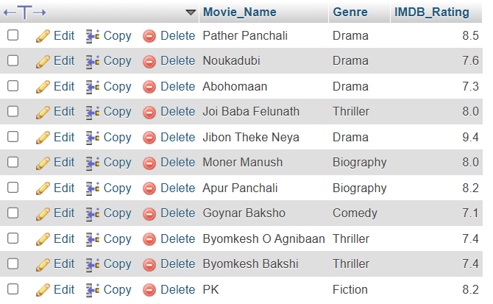
Task 2:
Display all the distinct movie genres
SQL Code:
SELECT Distinct Genre
FROM Movie
Output:

Task 3:
Find the names and current age of all the actors
SQL Code:
SELECT Actor_Name,year(CURRENT_DATE)-Birth_Year as Current_Age
FROM Actor
Output:
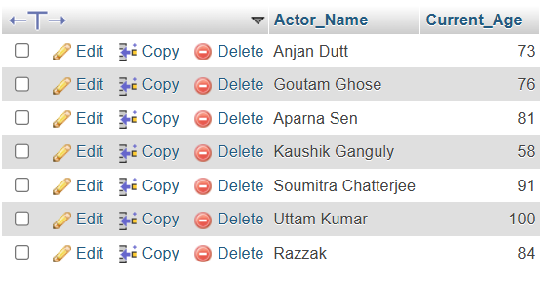
Task 4:
Find all the movies of the thriller genre with an IMDB rating greater then or equal to 8.0
SQL Code:
SELECT Movie_Name
FROM Movie
where Genre='Thriller'
and IMDB_Rating >= 8.0
Output:

Task 5:
Find the name,release year,IMDB rating and the name of the all the director of all the movies
SQL Code:
SELECT Movie_Name,Year,IMDB_Rating,Director_Name
FROM Movie,Director
Where Movie.Person_ID=Director.Person_ID
Output:
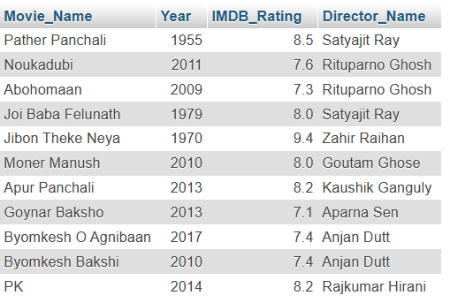

Lab-2:
Level #1:
Query 1.1:Find the name and number of awards of those directors whose
name starts with a ‘R’ or a ‘A’.

SQL Code:
SELECT Director_Name, No_Of_Awards
from Director
where Director_name LIKE 'R%' or Director_name LIKE 'A%'

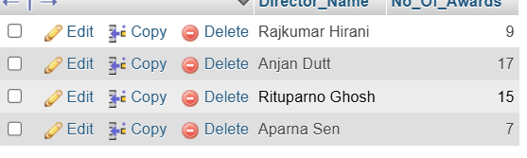
Query 1.2: Find the name and birth year of those directors whose name
contains an ‘a’ as its 2nd last character.

SQL Code:
SELECT Director_Name, Birth_Year
from Director
where Director_Name LIKE '%a_'
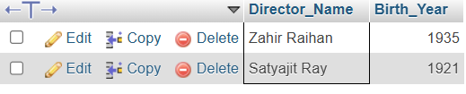
Query 1.3: Find the name, release year, and genre of all the movies which
contain the word ‘Byomkesh’ anywhere in their name.

SQL Code:
SELECT Movie_Name, Year, Genre
from Movie
where Movie_Name LIKE '%Byomkesh%'

Query 1.4: Find the name and IMDB rating of all the movies whose name
consists of only 2 characters.

SQL Code:
SELECT Movie_Name, IMDB_Rating
from Movie
where Movie_Name LIKE '__'

Query 1.5: Find the name and genre of all the movies whose name consists
of at least 3 characters.

SQL Code:
SELECT Movie_Name, Genre
from Movie
where Movie_Name LIKE '__%'

SELECT Movie_Name, Genre
from Movie
where length(Movie_Name)>=3

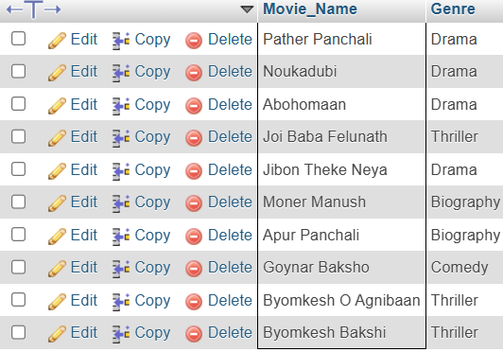
Query 1.6: Find the name and IMDB rating of all the movies which contain
at most 9 characters in their name.

SQL Code:
SELECT Movie_Name, IMDB_Rating
from Movie
where length(Movie_Name)<=9

SELECT Movie_Name, IMDB_Rating
from Movie
where Movie_Name NOT LIKE '__________%'

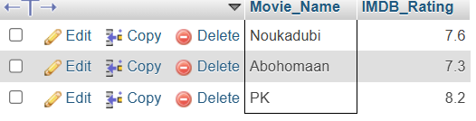

Level #2:
Query 2.1:Display the name and IMBb rating of all the movies according to
their IMDB rating (in descending order); if multiple movies have the same
IMDB rating then rearrange those movies alphabetically according to their
names.

SQL Code:
SELECT Movie_Name, IMDB_Rating
from Movie
ORDER BY IMDB_Rating DESC, Movie_Name
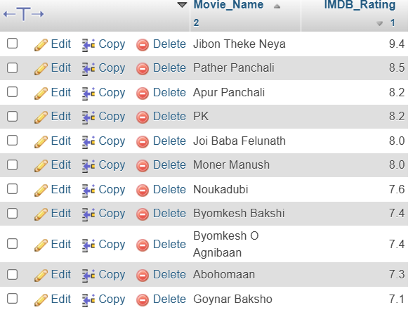
Query 2.2:Find the total number of movies in the database.
SQL Code:
SELECT COUNT(Movie_ID) AS Total_Movies
from Movie
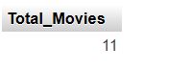
Query 2.3:Find how many movie-genres are there in the database.
SQL Code:
SELECT COUNT(DISTINCT Genre) AS Total_Genres
from Movie

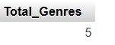
Query 2.4:Find the total number of movies in each genre.
SQL Code:
SELECT Genre,COUNT(Movie_ID) AS Total_Movies
from Movie
GROUP BY Genre

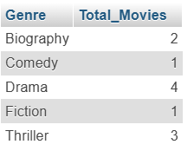
Query 2.5:Find the average IMDB rating of all the movies of the drama
genre.

SQL Code:
SELECT AVG(IMDB_Rating) AS Average_Rating
from Movie
where Genre='Drama'

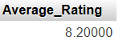

Lab 3:
CREATE TABLE Movie_Characters2(
Character_ID int,
Character_Name varchar(50) NOT NULL,
Age int,
PRIMARY KEY(Character_ID)
);
Create table Movie_Character_Relationship2(
Character_ID int,
Movie_ID int,
PRIMARY KEY(Character_ID,Movie_ID),
FOREIGN KEY Character_ID REFERENCES Movie_Characters2(Character_ID),
FOREIGN KEY Movie_ID REFERENCES Movie(Movie_ID)
);

Level # 1
Query 1.1:Find the name and age of all the movie-characters who are not
teenagers.

SQL Code:
SELECT Character_Name, age
from movie_characters
WHERE age not BETWEEN 13 AND 19
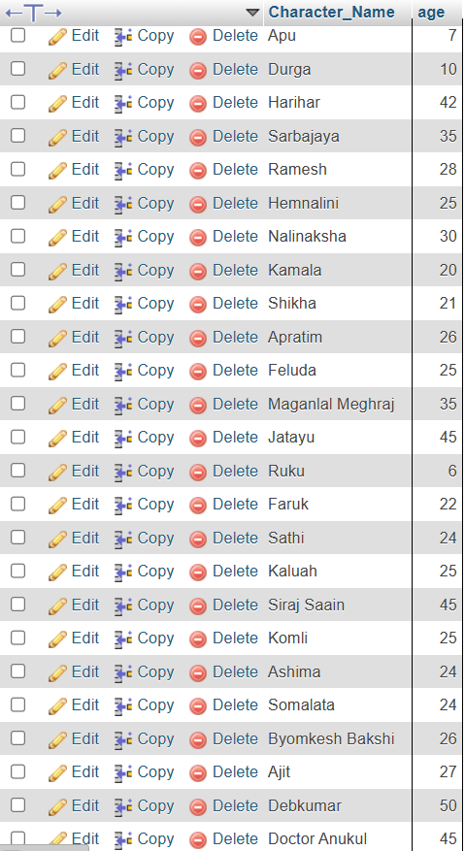
Query 1.2: Find the movie ID of all the movies and the number of
movie-characters in each movie.
SQL Code:

SELECT Movie_ID, COUNT(character_ID)
FROM movie_character_relationship
GROUP BY Movie_ID

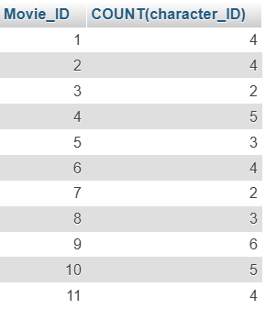
Query 1.3: Find the movie name of all the movies and the number of
movie-characters in each movie.
SQL Code:
SELECT Movie_Name, COUNT(character_ID)
FROM movie_character_relationship NATURAL JOIN movie
GROUP BY Movie_ID
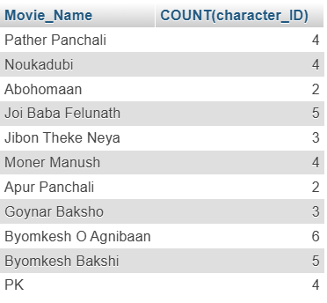
Query 1.4: Find the name, year of release, IMDB rating and the name of the
director of all the movies that contain at most 12 characters (including
spaces) in their name.
SQL Code:
SELECT Movie_Name, Year, IMDB_Rating, Director_Name
FROM movie NATURAL JOIN director
WHERE length(Movie_Name)<=12
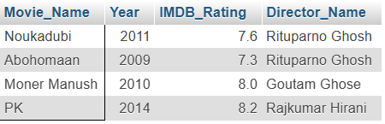
Query 1.5: Display the name and the IMDb rating of the movie with the
highest IMDb rating in each genre.
SQL Code:
SELECT Movie_Name, Genre, IMDB_Rating
FROM movie
WHERE (Genre, IMDB_Rating) IN (SELECT Genre,MAX(IMDB_Rating)
FROM movie
GROUP BY genre)
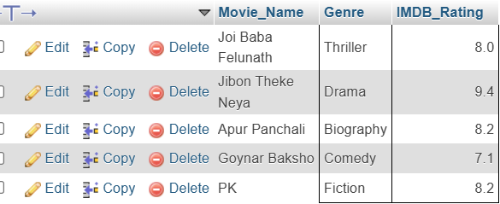

Level # 2
Query 2.1: Find the name, year of release, IMDB rating of all the movies of
Byomkesh (N.B.: A movie of Byomkesh may not contain the term
‘Byomkesh’ in its name).
SQL Code:
SELECT Movie_Name, Year, IMDB_Rating
FROM movie NATURAL JOIN movie_character_relationship NATURAL JOIN movie_characters
WHERE character_name LIKE '%Byomkesh%'
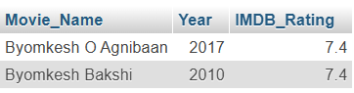
Query 2.2: Find the name of all the movies and, the name & the age of the
youngest movie-character in each movie.
SQL Code:
SELECT Movie_Name, character_name, age
FROM movie NATURAL JOIN movie_character_relationship NATURAL JOIN movie_characters
WHERE (Movie_ID, age) IN (SELECT Movie_ID, MIN(age)
FROM movie_characters NATURAL JOIN movie_character_relationship
GROUP BY Movie_ID)

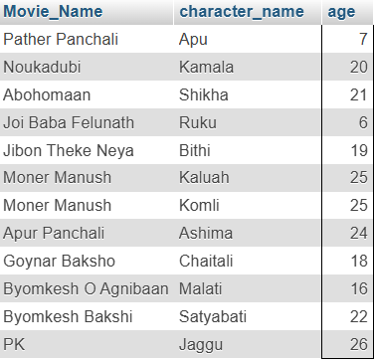
Query 2.3: Find the name and age of all the characters from the movies of
Feluda (N.B.: A movie of Feluda may not contain the term ‘Feluda’ in its
name).
SQL Code:
SELECT character_name, age
FROM movie_characters NATURAL JOIN movie_character_relationship
WHERE Movie_ID IN (SELECT Movie_ID
FROM movie_characters NATURAL JOIN movie_character_relationship
WHERE character_name LIKE '%Feluda%')

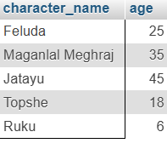

Lab4:
Level # 1
Query 1.1: Determine the number of movies in each genre whose IMDb
rating is less than or equal to 7.5.
SQL Code:
SELECT Genre, COUNT(*)
FROM movie
WHERE IMDB_Rating<=7.5
GROUP BY Genre
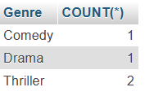
Query 1.2: Retrieve the names of the genres along with their average IMDb
ratings, considering only those genres whose average IMDb rating is less
than or equal to 7.5.
SQL Code:
SELECT Genre, AVG(IMDB_Rating) as AVG_Rating
FROM movie
GROUP BY Genre
HAVING AVG(IMDB_Rating)<=7.5
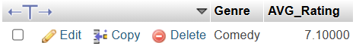
Query 1.3: Find the name, current age, number of films and number of
awards of the youngest actor.
SQL Code:
SELECT Actor_Name, year(CURRENT_DATE)-Birth_Year as Age, No_of_Films, No_Of_Awards
FROM actor
WHERE year(CURRENT_DATE)-Birth_Year=(SELECT MIN(year(CURRENT_DATE)-Birth_Year)
FROM actor)

Query 1.4: Retrieve the names and current ages of all directors and actors.
SQL Code:
SELECT Director_Name AS Name, year(CURRENT_DATE)-Birth_Year as Age
FROM director
UNION
SELECT Actor_Name, year(CURRENT_DATE)-Birth_Year as Age
FROM actor
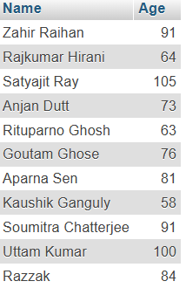
Query 1.5: Retrieve the names, current ages, number of films acted in, and
number of films directed for those actors who have directed at least one film.
SQL Code:
SELECT Actor_Name, year(CURRENT_DATE)-actor.Birth_Year as Age, actor.No_Of_Films as Films_As_Actor, director.No_Of_Films as Films_As_Director
FROM actor JOIN director
ON actor.Person_ID=director.Person_ID
WHERE director.No_Of_Films>=1
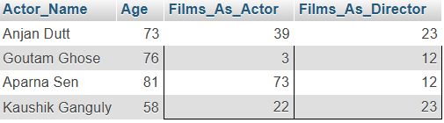

Level # 2
Query 2.1: Find the names of all directors along with the number of films
they have directed, the number of films they have acted in, the number of
awards they have received as directors, and the number of awards they have
received as actors. (If a director has never acted in any film, then the
corresponding counts for films and awards as an actor should be reported as
null.)
SQL Code:
SELECT Director_Name, director.No_Of_Films as Films_As_Director, actor.No_Of_Films as Films_As_Actor, director.No_Of_Awards as Awards_As_Director, actor.No_Of_Awards as Awards_As_Actor
FROM director LEFT JOIN actor
ON director.Person_ID=actor.Person_ID
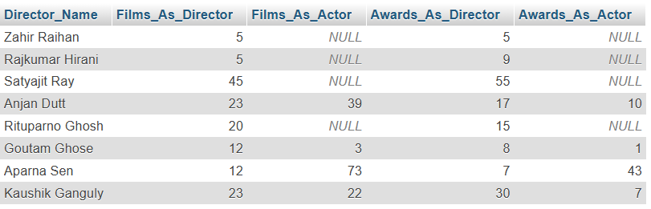
Query 2.2: Retrieve the names, number of films acted in, and number of
awards received for those actors who have never directed any film.
SQL Code:
SELECT Actor_Name, actor.No_Of_Films as Films_As_Actor, actor.No_Of_Awards as Awards_As_Actor
FROM actor LEFT JOIN director
ON actor.Person_ID=director.Person_ID
WHERE director.Person_ID IS null

SELECT Actor_Name, actor.No_Of_Films as Films_As_Actor, actor.No_Of_Awards as Awards_As_Actor
FROM actor
WHERE Person_ID NOT IN (SELECT Person_ID
FROM director)

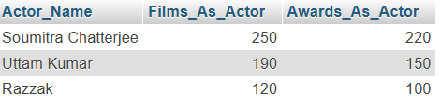
Query 2.3: Retrieve the names of all actors and directors along with the
number of films they have directed, the number of films they have acted in,
the number of awards they have received as directors, and the number of
awards they have received as actors.
SQL Code:
SELECT Actor_Name as Name, actor.No_Of_Films as Films_As_Actor, actor.No_Of_Awards as Awards_As_Actor
FROM actor LEFT JOIN director
ON actor.Person_ID=director.Person_ID
UNION
SELECT Director_Name as Name, director.No_Of_Films as Films_As_Director, director.No_Of_Awards as Awards_As_Director
FROM actor RIGHT JOIN director
ON actor.Person_ID=director.Person_ID

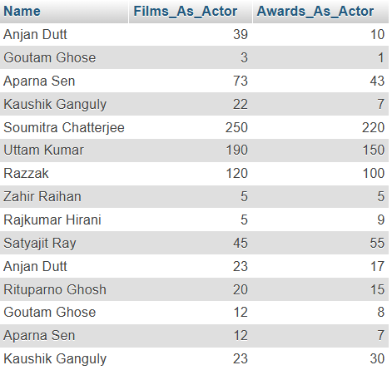

Query 2.4: Find the names and ages of all characters appearing in movies
directed by Satyajit Ray:
➵ 1.1.1: Without Join or Cartesian Product (using Subqueries only)
SQL Code:
SELECT Character_Name, Age
FROM movie_characters
WHERE Character_ID IN (SELECT Character_ID
FROM movie_character_relationship
WHERE Movie_ID IN (SELECT Movie_ID
FROM movie
WHERE Person_ID=(SELECT Person_ID
FROM director
WHERE Director_Name='Satyajit Ray')))
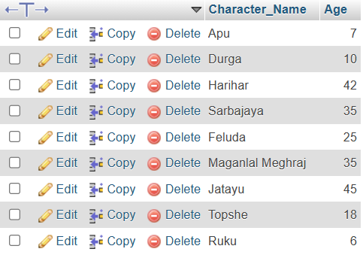
➵ 1.1.2: Using Join (Without using any Subqueries)
SQL Code:
SELECT Character_Name, Age
FROM movie_characters JOIN movie_character_relationship
ON movie_characters.character_ID=movie_character_relationship.character_ID
JOIN movie
ON movie_character_relationship.Movie_ID=movie.Movie_ID
JOIN director
ON movie.Person_ID=director.Person_ID
WHERE Director_Name='Satyajit Ray'
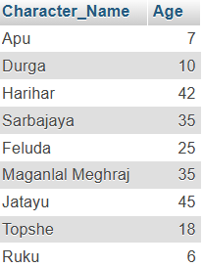
Query 2.5: Consider that there is no No_of_Films attribute in the Director
relation. Now find the names of all directors along with the total number of
movies directed by each director.
SQL Code:
SELECT Director_Name, COUNT(*) as No_Of_Films
FROM director JOIN movie
ON director.Person_ID=movie.Person_ID
GROUP BY Director_Name

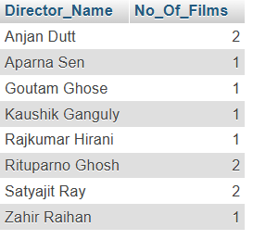

Lab 5:
Redesign Database:
Person(Person_ID Primary Key, Person_Name(not null), Date_Of_Birth)

Director(Person_ID Primary Key, No_Of_Films_As_Director, No_Of_Awards_As_Director
Foreign Key Person_ID references Person(Person_ID))

Actor(Person_ID Primary Key, No_Of_Films_As_Actor, No_Of_Awards_As_Actor
Foreign Key Person_ID references Person(Person_ID))

Movie(Movie_ID Primary Key, Movie_Name, Genre, Year, IMDB_Rating)

Movie_Director(Movie_ID,Person_ID,
Primary Key (Movie_ID,Person_ID),
Foreign Key (Movie_ID) references Movie(Movie_ID),
Foreign Key (Person_id) references Director(Person_ID)
)

Movie_Characters(Character_ID Primary Key, Character_Name, Age)

Movie_Character_Relationship(Character_ID, Movie_ID,
Primary Key(Character_ID, Movie_ID),
Foreign Key (Character_ID) references Movie_Characters(Character_ID),
Foreign Key (movie_ID) references Movie(Movie_ID))

Lab6:
Level # 1

Query 1.1: Find the names and phone numbers of all restaurants located in
Ranibazar.
SQL Code:
SELECT Restaurant_Name, Phone
FROM restaurants
WHERE Address LIKE '%Ranibazar%'
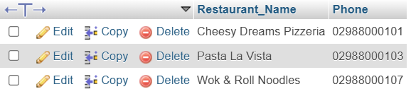
Query 1.2: Find the names, locations, and ratings of all restaurants currently
offering either ‘Pizza’ or ‘Burger’ on their menu.
SQL Code:
SELECT Restaurant_Name , Address, Rating from restaurants
where RestaurantID IN (select RestaurantID
from menuitems where
Category ='Pizza' or Category ='Burger');

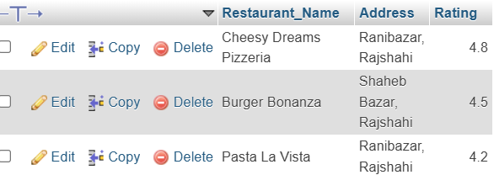
Query 1.3: Identify the name, location, and rating of the restaurant with the highest
rating.
SQL Code:
SELECT Restaurant_Name , Address, Rating from restaurants
where Rating IN (select MAX(Rating)
from restaurants)

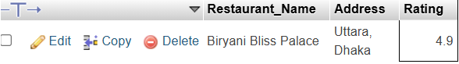
Query 1.4: Identify the names and email addresses of customers who, during the
current month, have placed orders that were not successfully delivered.
SQL Code:
SELECT Customer_Name, Email
FROM customers
WHERE CustomerID IN (SELECT CustomerID
FROM orders
WHERE Month(OrderDate)=CURRENT_DATE AND DeliveryStatus='Failed' or DeliveryStatus='Pending' or DeliveryStatus='Cancelled')

Query 1.5: Retrieve the IDs of all customers who have placed more than 13 orders
during the current month.
SQL Code:
SELECT CustomerID
FROM orders
WHERE Month(OrderDate)=Month(CURRENT_DATE)
GROUP BY CustomerID
HAVING COUNT(OrderId)>13
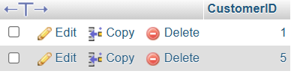
Query 1.6: Retrieve the name, price, and availability of items that have not been
ordered so far.
SQL Code:
SELECT Item_Name, Price, IsAvailable
FROM menuitems
WHERE ItemID NOT IN (SELECT ItemID
FROM orderitems)


Query 1.7: Determine the total revenue earned by each restaurant during the
current year.
SQL Code:
SELECT RestaurantID, SUM(TotalAmount) AS TotalRevenue
FROM Orders
where year(OrderDate)=year(CURRENT_DATE)
GROUP BY RestaurantID;
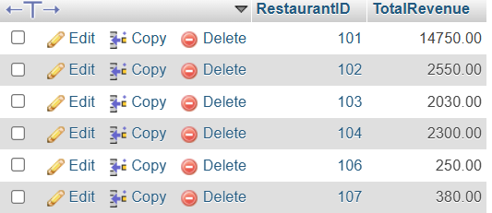

Without Using Total Amount:
SELECT menuitems.RestaurantID, SUM(Quantity*Price) AS TotalRevenue
FROM orderitems
join orders
on orders.OrderID=orderitems.OrderID
join menuitems
on orderitems.ItemID=menuitems.ItemID
where year(OrderDate)=year(CURRENT_DATE)
GROUP BY RestaurantID;
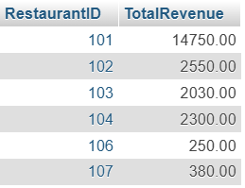

Problems in this Database:
- There is ownerID in restaurants table but no owner table
- Total amount is not needed.
- Price and unitprice are same thing. Unit price can be fetched for menuitems by MenuID.
- Not available items can be ordered

