**Index**

1. What is react?
2. Advantages of react.
3. How does react work?
4. Setup react project
5. Folder structure.
6. Create component.
7. Style component.
8. Component export import.
9. Props properties
10. Default properties
11. Handle events in react.
12. If else
13. Ternary operator
14. How to use if else inside jsx

**1. React**

JavaScript library which is used to make interactive user interfaces.

HTML for creating content

CSS for style content.

JavaScript for generating dynamic content/ generating live content/ for events also.

**2. Advantages of using react**

There are the following advantages

Increase performance.

Decrease the line of code.

Faster development.

**3. How does react work- react concept**

Component-based development library.

Component is a piece/ part of UI- theory wise.

Create components separately.

Every component has its own/separate HTML (JSX), CSS, and JS.

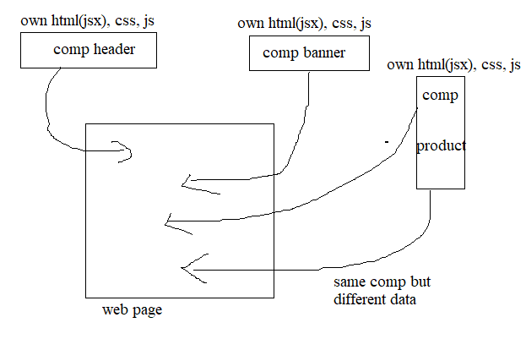

Component reusability.

Components can be used again on the same page and again but with different data.

Components are not dependent on each other

**4. Setup react project**

**Node:**

(Provides)It is a Java script environment/runtime.

Js runtime = running environment for JS.

**Note:** run JavaScript anywhere on PC without using any HTML.

Brower by default running environment for JavaScript.

Note: if we want to run JavaScript outside the browser, we need node JS.

Download and install node

>node –version

>node -v

**NPM (Node Package Manager):**

There are a lot of libraries, and react is one of them.

NPM is a tool that you get when you install node js to help you install, uninstall, and manage libraries in your project.

**NPX (ode Package eXecute):**

Sometimes don’t you want to download the tool and directly use the library, then use npx. Npx executes the package from the internet without even downloading to the pc

**Create React project**

>cd react project

>npm create-react-app myapp

>cd myapp

>npm start

>ctrl+c

>npm run build

**5. Folder structure**

**Package.json: -** just an overview of libraries

It is the heart of any JS project.

The configuration file of any js project.

Keep track of project information.

**Package-Lock _JSON:**

Extended version of pakage.json

Information about dependencies/libraries in details

**Node Module:** contains dependencies

All dependencies mentioned in package.js are present in the node module folder.

Libraries are also called modules.

Modules are simply nothing but collections of function.

The library is nothing but a collection of modules

>delete node module folder

>npm install

**Public (Index.htm):**

Note: The public folder keeps assets.

Two components have a single js file.

**SRC Folder:**

Contains components.

Component is nothing but a function returning some html that’s all – coding wise.

**Guideline for component**

1 - Comp file name should be started with capital & follow camel case.

2 - To create component use capital letter so that is can be identified as a component.

3 - The component name should be as component file name.

4 - To differentiate between component and element we start component name with capital letter.

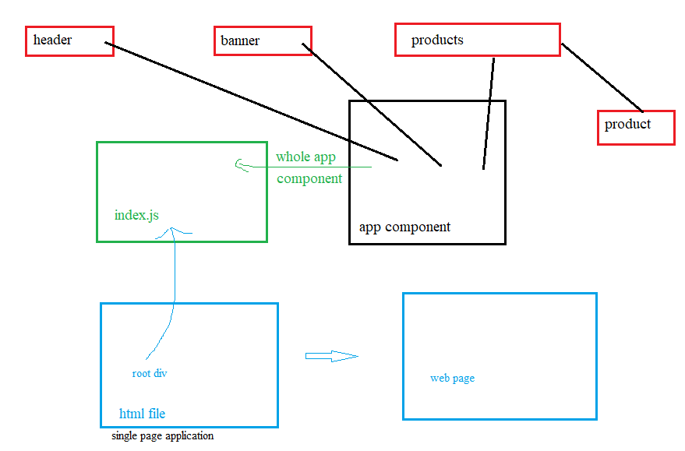

**6. Creating Component**

Component is nothing but a function returning some html that’s all – coding wise.

import './Header.css';

function Header() {

  return (

    <div className="header">

      <h1>this is header</h1>

    </div>

  );

}

export default Header;

Creating function by extension rafc

function return jsx (JavaScript XML) not html.

Should be one parent/wrapper element like div section main <> etc.

**JSX Guidelines-**

1. Attribute should be in camel case conventional

Like class= className

1. Tag should be closed
2. Self-closing tag like img and input should be closed.
3. To write java script inside jsx use {} brackets.
4. Comment in jsx.
5. function Product(props) {
6. return (
7. <div className="product">
8. {/* <h3>{props.name}</h3>
9. <p>Rs {props. Price}</p> */}
10. </div>
11. );
12. }
13. export default Product;

**Babel-**

This is a library & compiler which is responsible for compiling this jsx into java script.

Like <h1></h1>

Babel compile/transpiler this jsx into js

document. createElement(‘h1’)

**difference between js/jsx**

js is a programming language and jsx is way of writing java Script in terms of html.

**7. Styling Component**

1. **Separate CSS file**

**Header.css**

.header {

  border: 5px solid green;

}

**Import CSS file**

import './Header.css'; //importing

function Header() {

  return (

    <div className="header">

      <h1>this is header</h1>

    </div>

  );

}

export default Header;

1. **inline CSS**

import "./Header.css";

function Header() {

  return (

    <div className="header">

      <h1 style= {{ backgroundColor: "yellow", color: "white" }}>// inline css

        this is header

      </h1>

    </div>

  );

}

export default Header;

1. **Note**
2. we can apply class name to child component and style in App.css too
3. App.css is only work for App Component and its Childs components.

**Note index.css -global CSS**

We can write global CSS for whole application.

**Style Priority**

Inline-highest

Separate CSS file between App.js

Separate CSS file>App.js

**8. Component export and import**

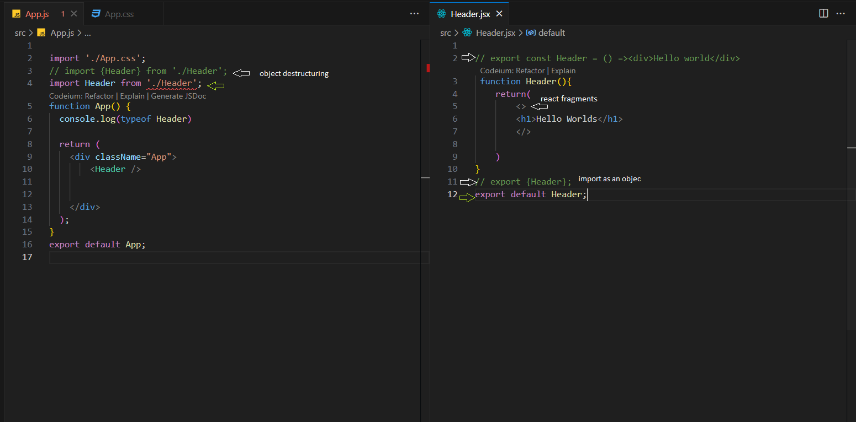

**9. Props - Properties**

Props stands for properties in react.

Props in react are nothing but properties of a component.

Properties of an individual component are called props.

Ex

<div class=” abs” id= ‘one>

Class and id are nothing but properties of that elements

Attributes of the element is called the property of that element.

In react we can give custom property to an element/component.

<Product name =” nike” price = ”2000”></Product>

Name = “nazim”- string

Age = {35}, age = ‘’2000’’ - number or string

Ismarried = {true} – Boolean

Icon ={<McCall>} - component

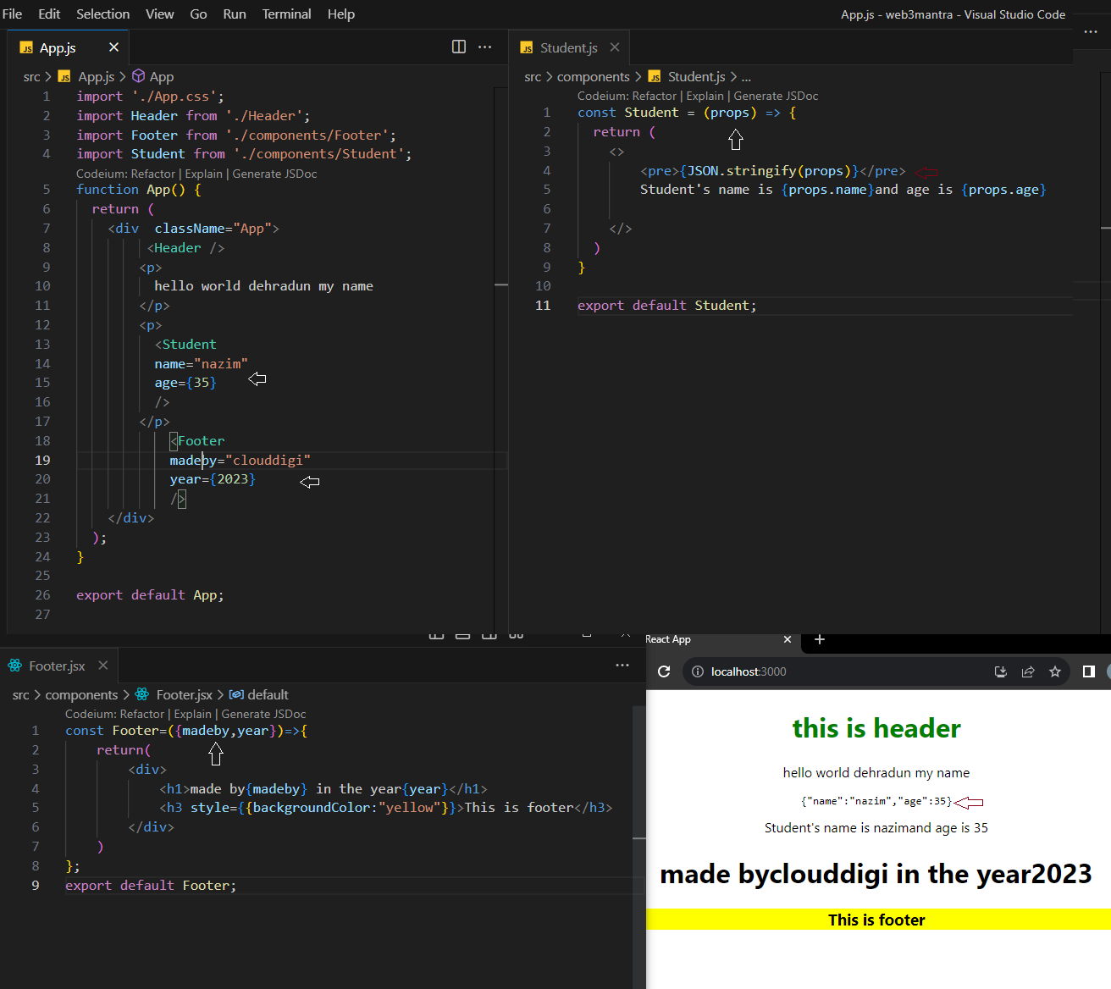

Note - Property pass to the component are the property of the props object.

Note- to verify props object we can use console log in js and pre tag in jsx.

Console.log(props)

<pre>{JSON.stringify(props)} </pre>

**10. Default Props & Props Type**

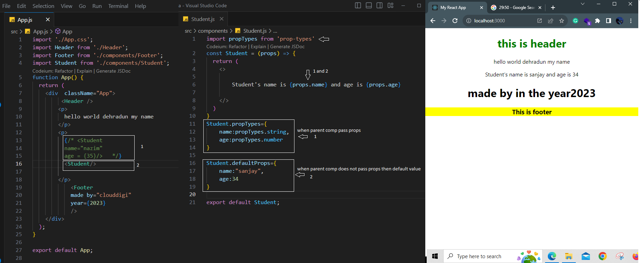

**11. Handle Events in React**

Function without parameter.

function App () {

  function myfun () {

    let num = prompt ("enter a number");

    alert (num * num);

  }

  return (

    <div className="App">

      <button onClick={myfun}>click</button>

    </div>

  );

}

If we use {myfun ()} instead of {myfun}, then function will be called automatically.

Event handler is like a button or image where I click, dbclick, mouseover, mouseout.

Event listener is a function which gets called wherever I perform the event.

Function with parameter

function App()

{

  function myfun(name) {

    alert ("hello " + name);

  }

  return (

<div className="App">

    <button onClick= {() =>{myfun("Nazim");}}>click</button>

</div>

  );

}

export default App;

Note – first calling this function () = {} this function doing nothing but calling another

Function myfun ().

Function with event object

function App() {

  function myfun(name) {

    alert("hello " + name);

  }

  return (

    <div className="App">

      <button onClick={(event) => {console.log(event); myfun("Nazim");}}>

        click

      </button>

    </div>

  );

}

export default App;

event object provides info about whole event.

**12. If else**

Return jsx with return keyword.

Cannot write directly if else condition inside Jsx return (no if else)

import "./App.css";

function App() {

  let login = true;

  if (login) {

    return (

      <div className="App">

        <h1>true</h1>

      </div>

    );

  } else {

    return (

      <div>

        <h1>false</h1>

      </div>

    );

  }

}

export default App;

Note –

If else login base condition

Let login =0 false

Let login =1 true (any number)

Let login false (only declared)

Let login =” nazim” true

Let login= true Boolean

Let login = false Boolean

**13. Ternary Operator**

We can apply condition inside jsx return (ternary operator) with the help of ternary of ternary operator.

Syntax- Condition (expression)? Expression if true: expression if false.

import "./App.css";

function App() {

  //let login;//false

  //let login = "nazim";//true

  //let login = 0; //false

  let login = 1; //true

  return (<div className="App">{login ? <h1>true</h1> : <h1>false</h1>}</div>)

}

export default App;

**14. How to use if else inside jsx**

Alternate of ternary operator and apply if else and else if.

We can apply condition inside jsx return (if-else).

Syntax

**{()()}**

**{**

**( () =>{if-else} ) ()**

**}**

import "./App.css";

function App() {

  let login = 0;

  return (

    <div className="App">

      {(() => {

        if (login) {

          return (

            <div>

              <h1>true</h1>

            </div>

          );

        } else {

          return (

            <div>

              <h1>False</h1>

            </div>

          );

        }

      })()}

    </div>

  );

}

export default App;

Random

React is all about component, props and state that is all