Platform Kya Hota Hai?
Platform = CPU Architecture + Chipset (PCH/SoC) + Power Sequence + Signal Design
Chapter-1: Laptop Motherboard Architecture
Intel & AMD Architecture Evolution
Generation | Year | Architecture | CPU | PCH | SoC | DDR | Examples
Northbridge + Southbridge | 2004–2009 | 3 Chip | Separate | Southbridge | ❌ | DDR2 | Intel Core2Duo
CPU + PCH (Nehalem/Sandy) | 2010–2011 | 2 Chip | Separate | Separate | ❌ | DDR3 | HM55, HM65
CPU + PCH (Ivy Bridge) | 2012 | 2 Chip | Separate | Separate | ❌ | DDR3 | HM76
CPU + PCH (Haswell) | 2013 | 2 Chip | Separate | Separate | ❌ | DDR3L | HM86
Intel BayTrail | 2014 | SoC | Integrated | Integrated | ✅ | DDR3L | Lenovo G40-30
Intel Braswell | 2015 | SoC | Integrated | Integrated | ✅ | DDR3L | HP Stream
Intel Skylake | 2015 | CPU + PCH | Separate | Separate | ❌ | DDR4 | HM170
Intel Kaby Lake | 2016 | CPU + PCH | Separate | Separate | ❌ | DDR4 | HM175
Intel Coffee Lake | 2017 | CPU + PCH | Separate | Separate | ❌ | DDR4 | HM370
Intel Comet Lake | 2019 | CPU + PCH | Separate | Separate | ❌ | DDR4 | U-Series
Intel Tiger Lake | 2020 | SoC | Integrated | Integrated | ✅ | DDR4/LPDDR4 | Modern Ultrabooks
Intel Alder Lake | 2021 | SoC | Integrated | Integrated | ✅ | DDR5/LPDDR5 | 12th Gen
Intel Raptor Lake | 2022 | SoC | Integrated | Integrated | ✅ | DDR5 | 13th Gen
AMD Ryzen | 2017–Present | SoC | Integrated | Integrated | ✅ | DDR4/DDR5 | Ryzen 3/5/7/9

Architecture | Difficulty | Repair Level
Northbridge + Southbridge | ⭐⭐ | Easy
CPU + PCH | ⭐⭐⭐ | Medium
Intel SoC | ⭐⭐⭐⭐ | Advanced
AMD Ryzen SoC | ⭐⭐⭐⭐⭐ | Expert

Aapke Learning ke Liye Roadmap
Main suggest karunga ki hum isi order me padhein:

Phase-1 (Architecture) ✅
- Motherboard Evolution
- Northbridge / Southbridge
- CPU + PCH
- SoC

Phase-2 (Hardware)
- Charger IC
- DC-DC Converter
- PWM Controller - Pulse Width Modulation Controller
- VRM Controller - Voltage Regulator Module Controller
- LDO
- MOSFET
- Coil
- PMIC

Phase-3 (Power Sequence)
- G3 → S5
- S5 → S0
- RSMRST#
- SUSCLK
- SLP Signals
- VR_ON

Phase-4 (Practical Repair)
- No Power
- Auto ON
- No Display
- No Charging
- No Boot

Aapne pichhle 2–3 din me jo questions puche hain, unse mujhe lag raha hai ki ab aap signal yaad nahi karna chahte, balki unka source samajhna chahte hain.

PMIC = Power Management Integrated Circuit
Simple definition:
PMIC ek aisa IC hai jo ek hi chip ke andar kai PWM Controllers, LDOs aur Power Sequence Logic ko integrate karta hai.
Matlab:
PMIC = Multiple Power Controllers in One IC

Pehle ka Design
Purane laptops me:
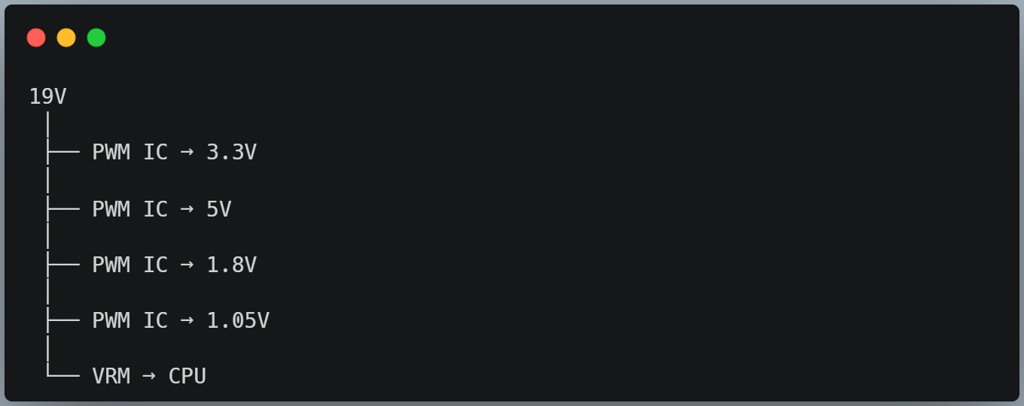
Yahan 5 alag IC lage hue hain.

PMIC Design
Naye boards me:
