Top Laptop Motherboard ODM Companies
ODM Company | Common Brands
Compal | HP, Dell, Lenovo, Acer, Toshiba
Quanta | HP, Dell, Apple, Lenovo
Wistron | Acer, Dell, Lenovo, HP
Inventec | HP, Toshiba, Lenovo, Acer
Pegatron | ASUS, Acer, HP
Foxconn (Hon Hai) | Apple, Dell, HP
LCFC (Lenovo) | Lenovo ThinkPad, IdeaPad
Clevo | Gaming Laptops (Sager, XMG, Eurocom, etc.)
MSI | MSI Laptops
Tongfang | XMG, Eluktronics, Mechrevo
Uniwill | Fujitsu, Schenker, Tuxedo
Mitac | Older Acer, Fujitsu

Important ODM

1. Compal
2. Quanta
3. Wistron
4. Inventec
5. LCFC (Lenovo)

Common ODM Prefix
ODM Company | Common Prefix | Example Board No. | Common Laptop Brands
Compal | LA- | LA-D071P, LA-K491P, LA-J891P, LA-E541P | HP, Dell, Lenovo, Acer
Quanta | DA0- | DA0R33MB6F0, DA0HK1MB6E0, DA0ZRWMB8G0 | HP, Dell, Lenovo
Wistron | 48.4xxxx, DA0- | 48.4PA01.021, DA0UM8MB6D0 | Acer, Dell, Lenovo
Inventec | 6050A- | 6050A2493101, 6050A2730001 | HP, Toshiba, Acer
LCFC (Lenovo) | NM- | NM-D031, NM-C821, NM-B701, NM-A311 | Lenovo IdeaPad, ThinkPad

Quick Memory Table

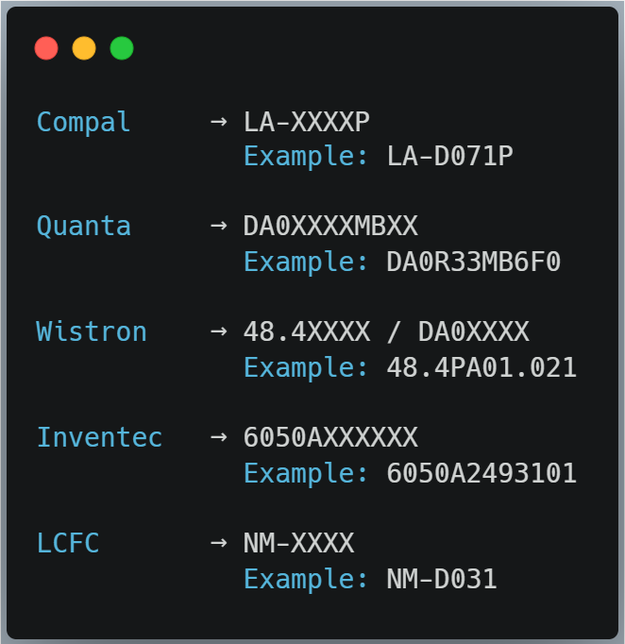

Examples

1. Lenovo IdeaPad 3

Brand : Lenovo

ODM : LCFC

Board No. : NM-D031

2. HP Pavilion

Brand : HP

ODM : Compal

Board No. : LA-D071P

3. Dell Inspiron

Brand : Dell

ODM : Quanta

Board No. : DA0R33MB6F0

4. Acer Aspire

Brand: Acer

ODM : Wistron

Board No. : 48.4PA01.021

5. HP EliteBook

Brand : HP

ODM : Inventec

Board No. : 6050A2493101

Important Note
DA0- prefix sirf Quanta ka exclusive nahi hai. Wistron aur kuch anya ODM bhi DA0XXXXMBXX format use karte hain. Isliye final confirmation ke liye hamesha schematic ka title page ya boardview dekhen, jahan manufacturer (Compal, Quanta, Wistron, Inventec, etc.) ka naam likha hota hai. Ye habit professional repair engineers follow karte hain.

