Transistor

Yeh ek chhota electronic component hota hai jo current ko control, amplify ya switch karta hai.

🟩 Short & Simple Definition
- Transistor: Ek semiconductor device jo ON/OFF switch ya signal amplifier ki tarah kaam karta hai.
- Types:

BJT (NPN / PNP)
- Current-controlled device
- Base par thoda current → Collector se zyada current flow.

MOSFET (N-Channel / P-Channel)
- Voltage-controlled device
- Gate par voltage → Source-Drain current flow.
- Switch ki tarah
Use Case: LED ON/OFF karna


- Amplifier ki tarah
Use Case: Weak mic signal ko boost karna

🟦 1. BJT (NPN / PNP) — Current Controlled Device

Concept (Kya hota hai?)
BJT me Base par thoda current dene se
Collector → Emitter me bada current flow hota hai.
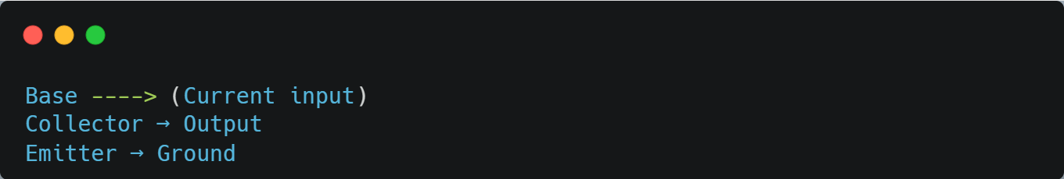

🟩 2. MOSFET (N-Channel / P-Channel) — Voltage Controlled Device

Concept (Kya hota hai?)
MOSFET me Gate me current nahi dalna hota,
sirf voltage touch karte hi switch ON/OFF ho jata hai.

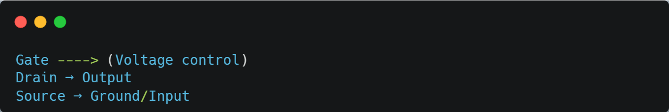
A transistor has at least three terminals: the base (or gate), collector (or drain), and emitter (or source).
Terminals:
- Base (or Gate): The control terminal.
- Collector (or Drain): The terminal where current enters.
- Emitter (or Source): The terminal where current exits.

