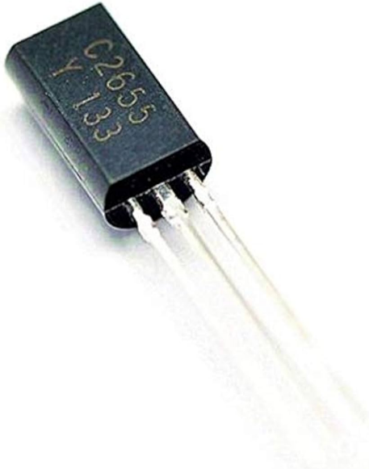
Power Transistor (2SC2655) NP(B )N ----PN(P)P-A1020

