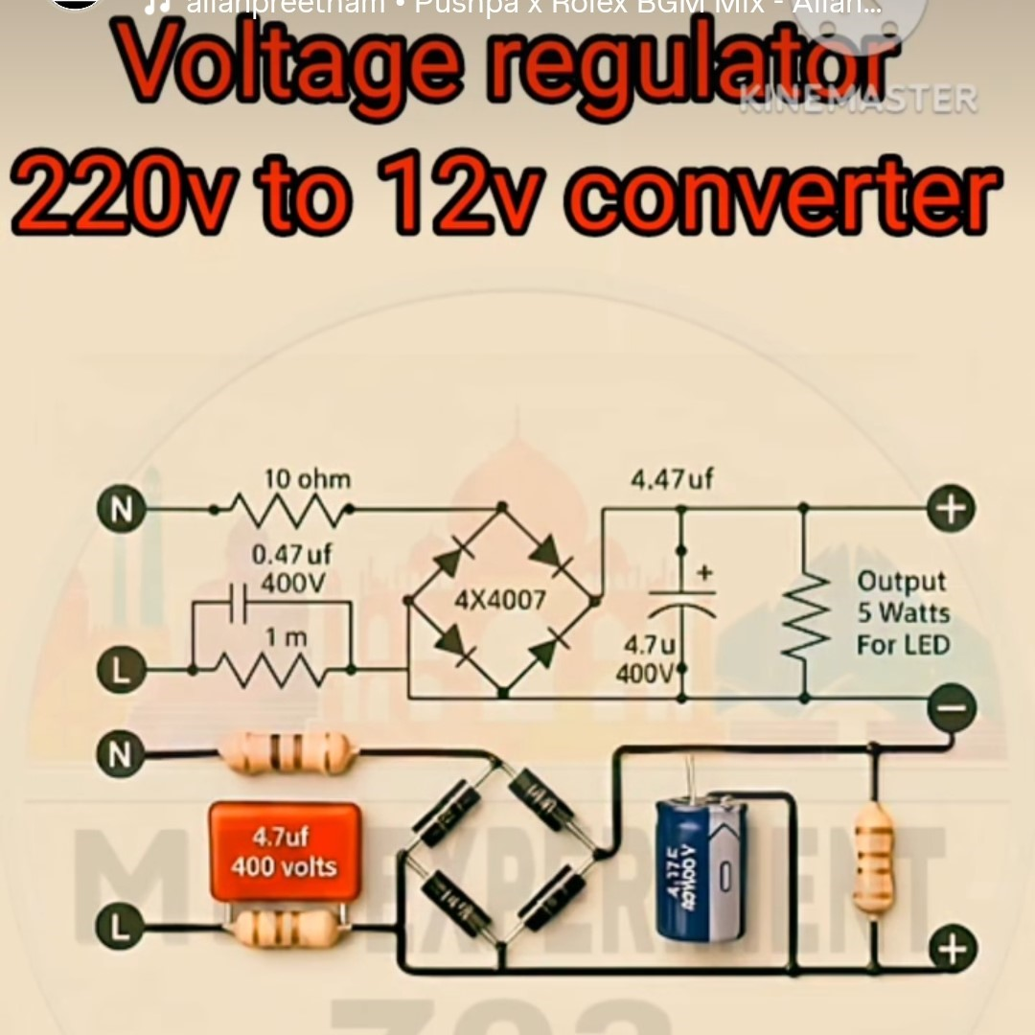
Capacitive Dropper Power Supply
(Transformerless Power Supply)
low-power load ke liye bana hai:
➡ LED: 3W–5W

Without a transformer kaise 220V → 12V banta hai?
Isme transformer ki jagah 4.7µF / 400V capacitor current ko limit karta hai.
Voltage drop nahi karta —
sirf current limit hota hai.
⚠ Is type ki supply mains se isolated nahi hoti
Matlab:
- Output ka +/– directly 220V se linked rehta hai
- Touch karne se shock lag sakta hai
Isliye:
❌ Mobile charger jaisa isolate output nahi hota
❌ Human-safe nahi
✔ LED bulbs, night lamps, indicators ke liye theek
Process
N & L me resistors isliye lagaye hain taaki
- ⚡ surge current control ho
- 🔥 capacitor safe charge ho
- 🛡️ spikes aur noise filter ho
- 🔌 circuit safe start ho
- 💥 blast risk na ho
N & L side ke resistors = Circuit ke “bodyguards”.
4.7µF capacitor (Capacitive Dropper)
Ye capacitor voltage ko drop nahi karta,
ye current ko limit karta hai — aur isi ko bolte hain:
👉 Capacitive Dropper
4.7µF capacitor AC supply ka current control karta hai,
taaki 220V ka current safe level me aaye aur bridge rectifier + load ko safe DC mile.

✔ Function 1: Current Limiting (Main purpose)

✔ Function 2: Heat-free Voltage Reduction
Normal resistor se voltage drop karne par heat banti hai.
Capacitor se voltage drop hone par heat almost zero hoti hai.

✔ Function 3: Safe Input for Rectifier Diodes
Direct 220V → bridge diodes mar jayenge.
Capacitor current ko limit karke diodes ko safe rakhta hai.
L line me jo 4.7µF / 400V capacitor laga hai,
wo 220V AC ka current limit karke safe amount me 12V output create karne ke liye use hota hai.
Ye hi pura capacitive dropper circuit ka main component hai.

Capacitor After Rectifier
Bridge rectifier AC ko pulsating DC banata hai.
Ye DC bilkul smooth nahi hota — upar-neeche, ripple, wave jaisa hota hai.
👉 Rectifier ke baad jo big capacitor lagate hain,
wo is pulsating DC ko smooth DC banata hai.

⭐ 2. Short Definition
Ye capacitor filter capacitor hota hai,
kaam = ripple remove karna + “DC ko stable banana”.

✔ Function 1: DC ko smooth banana (Ripple Removal)
Bridge rectifier AC sinewave ko half-rectified pulses me badalta hai
Capacitor in gaps ko charge–discharge karke smooth karta hai:

✔ Function 2: Load ke liye stable Voltage
Bulb / LED / IC / Load ko ekdum clean DC chahiye hota hai.
Agar capacitor na ho →
LED flicker karega, IC reset hoga, output unstable hoga.
Capacitor is a problem ko solve karta hai
Without a capacitor (rectifier output)

With capacitor


⭐ 6. Final Short Hinglish Answer
👉 Bridge rectifier ke baad wala capacitor “filter capacitor” hota hai.
Wo pulsating DC ko smooth & stable DC me convert karta hai,
ripple hatata hai, aur load ko clean supply deta hai.
Bleeder / Load Resistor

✔ Output voltage ko control rakhna

✔ Output current limit karna (LED ko protect karna)

✔ Capacitor ko discharge help karna

✔ Supply ko stable banana

⚡ Use Case 1: Output current limit
Capacitive dropper circuits me current high spike kar sakta hai.

⚡ Use Case 2: Output voltage stabilize karna
Rectifier + capacitor se voltage kabhi kabhi thoda high aa jata hai.
Resistor usko down karta hai.

⚡ Use Case 3: Capacitor discharge
Output smoothing capacitor (large blue capacitor)
power off hone ke baad dangerous voltage hold kar sakta hai.
Ye resistor usko dheere-dheere discharge karta hai → safe karta hai.

🔥 6. Final
Last me jo resistor + aur – ke beech dikh raha hai,
wo actually LED load ke saath SERIES me laga hota hai.
Uska kaam output current ko limit karna, voltage ko stable rakhna,
aur capacitor ko discharge help karna hai.
Resistor aur Capacitor dono AC aur DC dono circuits me use hote hain
Resistor:
AC–DC me koi farq nahi — hamesha same kaam: current limit & voltage drop.

✔ Resistor (AC + DC both)
- AC me bhi current limit karta hai
- DC me bhi current limit karta hai
- Frequency ka koi effect nahi
- Bilkul universal component

✔ Capacitor
- DC me: charge store karta hai → ek time ke baad open circuit ban jata hai
- AC me: continuously charge–discharge hota hai → current pass hota hai

A) AC me RESISTOR
Use cases:
- Surge control
- Current limiting
- Voltage divider
- Dropper circuit (220V me)


B) DC me RESISTOR
Use cases:
- LED current limit
- Transistor biasing
- Pull-up / Pull-down
Example:


C) AC me CAPACITOR
Use cases:
- Capacitive dropper (4.7µF / 400V)
- Fan capacitor
- Motor phase shift
- EMI filter
- AC coupling
Example:


D) DC me CAPACITOR
Use cases:
- Power supply filter
- Ripple remove
- Battery backup (small)
- Timing circuit (555 IC)


