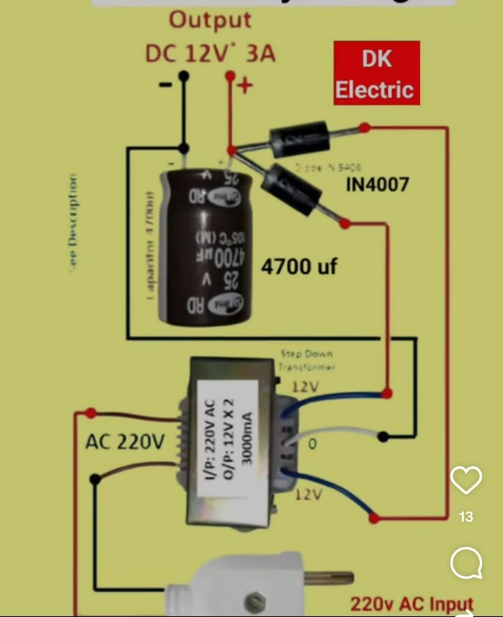

Transformer-based 12V DC Power Supply Circuit
• 220V AC ko transformer se 12V AC me convert karta hai
• Diodes se AC ko DC banata hai (rectifier)
• 4700µF capacitor se DC ko smooth karta hai
Ye circuit 220V ko safe 12V DC me convert karta hai:
- Transformer → voltage kam karta hai
- Diodes (1N4007) → AC ko DC banate hain
- 4700µF capacitor → DC ko clean/smooth banata hai
- Output = 12V DC, 3 Ampere

🔹 Transformerless 220V → 12V circuit
→ 4×1N4007 Bridge use hua
(kyunki transformer hi nahi hai → center tap possible nahi)

🔹 Transformer-based 12V DC supply
→ 2 diodes (1N4007) + 12-0-12 transformer
(kyunki transformer already center-tap diya hua hai)
Transformer ke markings:
✔ 12V – 0 – 12V
✔ 9V – 0 – 9V
✔ 15V – 0 – 15V
Iska matlab:
- Left side 12V
- Right side 12V
- Middle = 0V (Centre Tap)
Rectifier ke 2-diode method me center tap zaroori hota hai.

