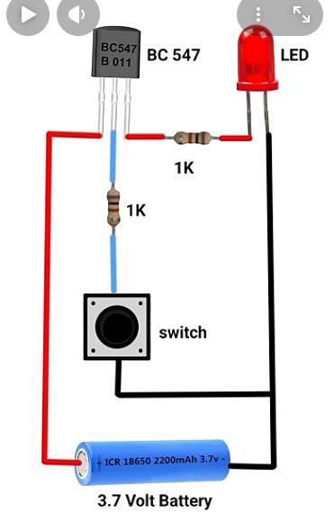
Short Definition
Transistor Switch Circuit = chhote signal se bade load (LED) ko control karna.
BC547 NPN transistor me legs ka order bahut important hota hai.
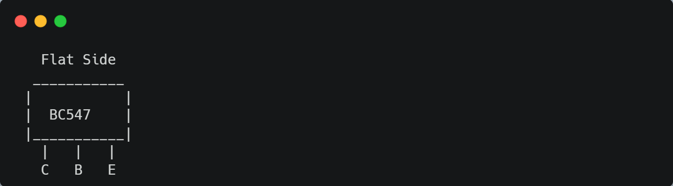
• Base = Handle
• Collector = Inlet
• Emitter = Outlet
Base par hamesha chhota signal (current / voltage) diya jata hai,
aur phir bada current Collector se Emitter flow karta hai.
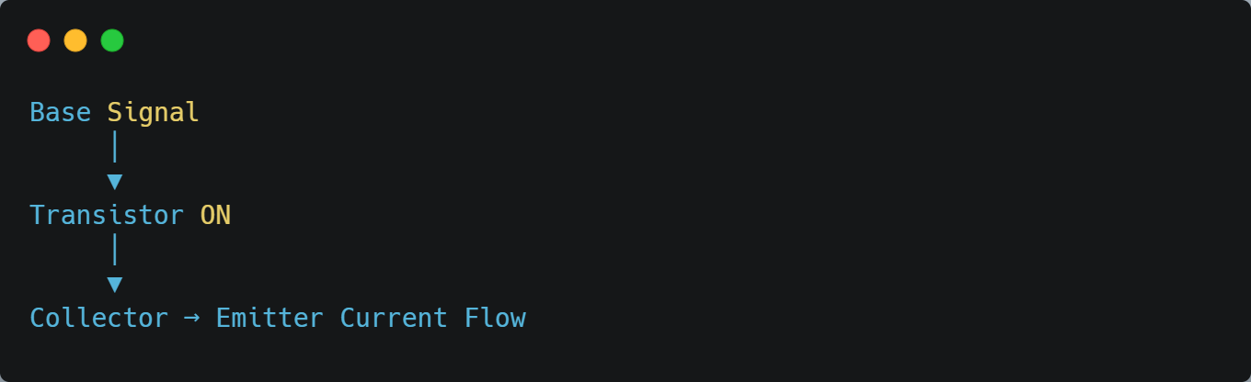

• Base = gate ka button
• Collector = upar se aane wali supply line
• Emitter = neeche drain

https://www.youtube.com/watch?v=uavMxwrgUQQ

