Student Score and Management System – Project Report

Name: Nazim Khandakar

Reg No: 25BCY10161

Faculty: Sivabalan KR

Course : CSE

( Introduction to problem solving and Programming)

Flipped Course: Vityarthi

Vityarthi Project:

( Student Score and Managment)
1. Introduction:
The Student Score and Management System is a Python-based console application designed to store student names, record marks, calculate averages, and identify the top performer. The project helps beginners understand Python concepts such as functions, loops, conditional statements, and dictionary data structures.

Problem Statement:
Manual student record handling is inefficient, error-prone, and time-consuming. A simple automated system is needed to manage marks, calculate averages, and find the top-scoring student.Problem Identificcation.

Functional Requirements
- Add student name and marks
- Store multiple student entries
- Display all
- student records
- Calculate class average
- Identify the top scoring student
- Exit the program safely

Non-functional Requirements
- Usability
- Performance
- Reliability
- Portability
- Maintainability

System Architecture
Flow:
User → Input Functions → Dictionary Storage → Processing Functions → Output Display

Design Diagrams

a) Use case Diagram
+------------------+
| User |
+------------------+
|
-----------------------------------
| | | |
Add Student View Records Calculate Avg Find Topper

B) Workflow diagram

Start
|
Show Menu
|
User Choice → (1–5)
|
Perform Operation
|
Return to Menu
|
Exit

c) Sequence Diagram:
User → System: Enter choice
System → User: Ask for input (name/marks)
System: Stores data in dictionary
System: Calculates results
System → User: Displays output

D) Class/ component Diagram
+---------------------------+
| Student Score Manager |
+---------------------------+
| - students: dictionary |
+---------------------------+
| + add_student() |
| + display_students() |
| + calculate_average() |
| + find_topper() |
+---------------------------+

E) ER Diagram ( Simple Dictionary Storage)
Student (Name, Marks)
Each Name → One Marks Entry

Design Decisions & Rationale

Dictionary was chosen because it stores data in key-value pairs (name → marks), making lookup fast.
Functions used for modularity and easy maintenance.
Menu-based loop gives user full control.
Console application chosen due to simplicity and course requirement.

Implementation Details
Language used: Python
Key concepts applied:
Functions
Dictionaries
Loops
Conditional statements
Input/Output handling
Project contains one main script that handles all operations via menu.

Python Code and Output:
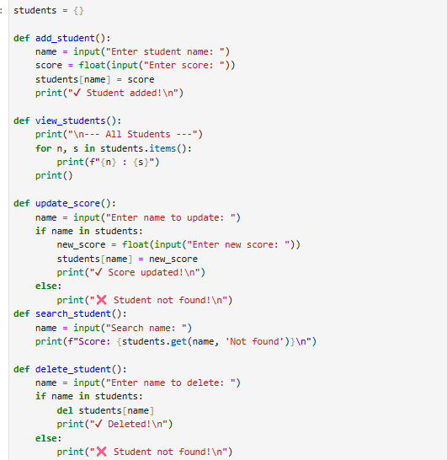
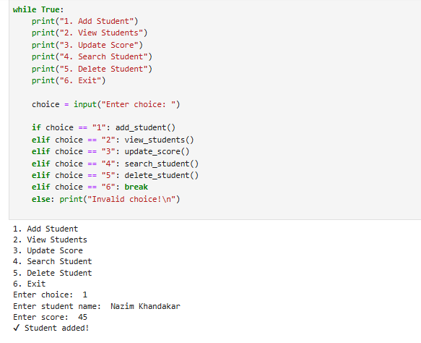
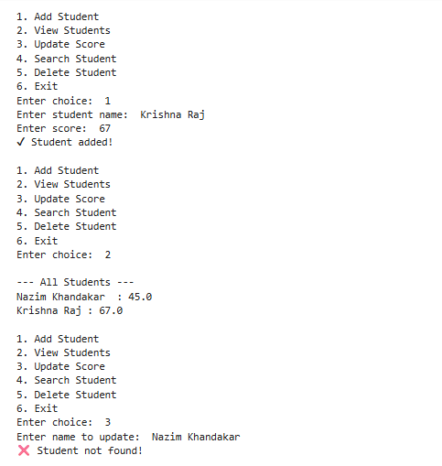
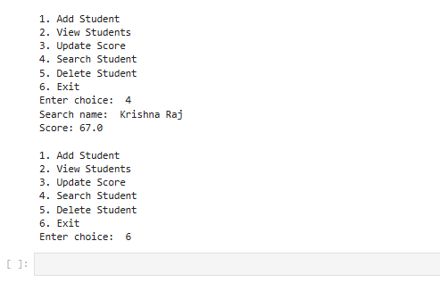

Testing Approach
Testing was done using:
Multiple student entries
Edge cases (empty list, invalid input)
Checking accuracy of average
Ensuring topper detection works correctly

Challenges Faced
Handling empty inputs
Avoiding errors when no data is present
Maintaining readable and structured code
Ensuring correct average and topper logic

Learnings & Key Takeaways
Python dictionary usage
Modular code using functions
Basic data management
Importance of testing and validation
Menu-driven system implementation

Future Enhancements
Store data permanently using files
Add grading system
Add update/delete student feature
Add GUI using Tkinter
Add multiple subjects marks
Export results to PDF or Excel

References
Python Official Documentation
Classroom Notes
Online Tutorials(Vityarthi)
Faculty Guidance

