**Stamford University Bangladesh**



Online Chocolate shop Management System

Presented By : Crazy Engineers

Department of Computer Science & Engineering

Final Report

Submitted By:

* Md Nazim Uddin CSE 063 07429
* Priyanka Rani Satu CSE 063 07380
* Md. Naeemul Hasan CSE 063 07438
* Janith Sultana Juthi CSE 063 07477

# **Introduction:**

The project online chocolate shop management system deals with the automation of online chocolate shop. It includes both sales and purchase of items. This project is developed with the objective of making the system reliable, easier, fast and informative. And an important part of this project is information gathering and project objectives. Data Flow Diagram is also another important part for this online chocolate shop management system which provides information about the outputs and inputs of each entity and the process itself.

## **Motivation for this Project:**

It is a system that allows users to check for various chocolate available at the online shop and purchase online. The project consists of list of Chocolate displayed in various categories. The user may browse through these items as per categories. If the user likes a brand of a chocolate he may add it to his shopping cart. He may even pay through a credit card or cash on delivery. Once the user makes a successful transaction he gets a copy of the shopping receipt on his email id. User has also option for ordering custom chocolate according to their requirements like chocolate flavor, size, shape and so on. Thus the online Chocolate shopping project brings an entire chocolate shop online and makes it easy for both buyer and seller.

## **Project Goals:**

**# Registration:** Firstly users can need to creating a account. Then need to login. Then if they can want to order or show all the product without any permission.

**# Updating:** Up-to-date information about data processing resources through the creation and archiving of records in a centralized repository.

**#** **Rating maintaining and reporting:** Reports can be generated from the Chocolate shop and Asset Systems that would protect the amount of revenue that can be generated through the sale of surplus equipment, or to define the number of components that have a criticality rating of ‘1’ so that you can project the costs associated with maintaining duplicates of critical equipment at recovery sites. Combining the two reports would allow you to reroute equipment being scheduled for termination to the Recovery Facility and eliminate the additional costs associated with

**# Financial records:** Financial records specific to a single component, or groups of components.

**# Purchasing:** Purchasing to original product of various chocolate.

**#** **Identify:** Component Status Indicators to identify a component as Active (A), Redeployed (R ), Donated (D), or Terminated (T).

**# Services:** service records for all components in the chocolate shop.

**# Data process:** Data used to support configuration diagrams of the hardware and software components contained within specific locations, or the entire data processing environment.

**# Ordering:** Online ordering system.

**# Recovery:** Equipment in support of recovery needs.

## **Project Feasibilities:**

* Programming Language: HTML5, C#
* Style: CSS3
* Operating System: Windows 10

1. Technical Feasibility

* Use a personal laptop or PC, as it costs less.
* Don't buy high speed. We use the internet all the time. I can use that.
* I will use open source software.
* We will use operating software windows 10. It costs less.

1. Economic Feasibility

* Server and hosting cost.
* For our foreign product, we have to communicate with a foreign company.
* Using open source software reduces our costs.
* It costs us to update the software.

1. Operational Feasibility

* We are able to deliver within a short time when customer order.
* Our website is designed in a very simple way, so use is easy.
* Customer will be very benefited by using our website.
* Our website is monitored 24 hours by skill employee.

## **Cost Benefit Analysis:**

**#** Cost benefit analysis compares the expected financial gain derived from a particular set of action with the expected cost of providing each action to determine the most profitable option. The project benefit of a plan or program are divided by its estimated total long term cost.

* Client Sided Cost
* Various cost appear during the project.
* If chocolate quality is not good will give selling cost return.
* Client Sided Benefit
* Branded chocolate.
* Best quality.
* Web based communicate with the users easily and efficiency.
* Developer Sided Cost
* Programmer give enough time to create system successfully. #Monetize cost.
* compare cost of chocolate.
* Internet and electricity bill will be provided.
* Developer Sided Benefit
* Project will be experience for us.
* Solving real life problems.
* payment is benefit for this project.

## **Project Scheduling**

|  |  |  |  |
| --- | --- | --- | --- |
| **Activity** | **Description** | **Precedence** | **Time (in week/s)** |
| Analysis | | | |
| 1 | Meeting | None | 1 |
| 2 | Agree on Objectives | 1 | 1 |
| 3 | Research on Market | 2 | 1 |
| 4 | Requirement Gathering | 2,3 | 1 |
| Planning | | | |
| 5 | System Design | 4 | 1 |
| 6 | Database Design | 5 | 1 |
| 7 | Database Implementation | 6 | 1 |
| Construction | | | |
| 8 | User Interface Designing | 5 | 1 |
| 9 | Admin Panel Designing | 5 | 1 |
| 10 | Coding | 8,9 | 4 |
| Deployment | | | |
| 11 | Testing | 10 | 2 |
| 12 | Feedback | 11 | 1 |
| 13 | Launch | 12 | 1 |

**Project Scheduling (Gantt chart):**

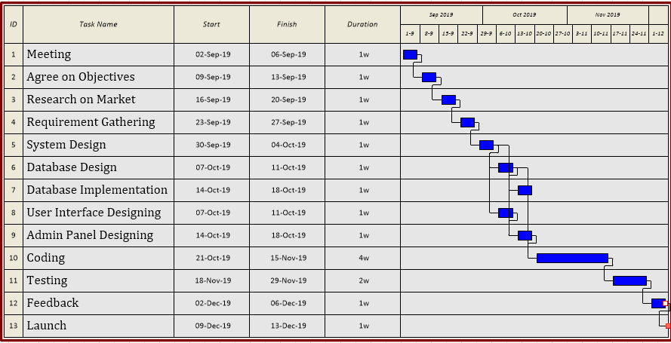

**Risk Analysis:**

* Server security needs to be hacked.
* database must be backup.
* Server all time Up to internet connect.
* Information taken from the customer should be kept secure.
* Database security should be maintained so as not to cause data loss.

**Objectives:**

* Interview questions
* Understanding the automated system
* Prerequisite and highlights Analysist
* Understanding the customer demand
* Use case diagram design
* Data flow diagram design
* Class diagram design
* Creating database and website.

**For information gathering we have chosen three methods.**

1. Interviewed a non-professional from another group(legends)

* Audio record of our investigation.
* 6 Open-Ended question.
* 4 Close-Ended question.

1. Survey from of users Questionnaires

There were 11 inquiries in the overview and every one of them were explicit.

1. Investigation

* Measurable

1. **Interview Information:**

**Project name:** OnlineChocolate shop management system.

**Author:**

Md Naeemul Hasan

Md Nazim Uddin

Janith Sultana Juthi

Priyanka Rani Satu

**Date:** 18/09/2019

**Time**: 11:00 AM

**Duration:** 5 mins

**Participants:** Designation

Tanjim Amin Koushik Student at Stamford University Bangladesh

Rijvi Alam Rabby Student at Stamford University Bangladesh

Nahidul Amin Student at Stamford University Bangladesh

**Comments:** Right now chocolate information collecting process of automated system in normal format.

**Reason for selecting the Professional:**

Mr. Tanjim Amin Koushik, Rijvi Alam Rabby and Nahidul Amin are the Student of Stamford University Bangladesh. They are read in the department of CSE 3rd year. So they don’t knows well good about how the software of this project runs their program and operates. But they are trying to give us some information to develop a efficient software.

**Interview Process:**

**01. How can i maintain this project by a software properly?**

Ans: You can maintain this project by a software to follow the similar types of software, Because we are not professional engineer. so we will give you that suggestion.

**02. How can i maintain the ordering system from the customer?**

Ans: When the customer order any product i give some rules for ordering system and then ask to confirm that order.

**03. What is the procedure behind choosing the customers of chocolate?**

Ans: Firstly they choice the brand and if they click this brand then they can see the price, categories, flavor and other etc.

**04. How does a customer speak with the framework?**

Ans: Customer can speak with the framework by massaging and phone call system.

**05. How can our increasing online customer service?**

Ans: you can give advertisement of this online chocolate service in popular online side.

**06. Do you think this types of chocolate product is highly cost for the customers?**

Ans: No, But it is the personal thinking side of customers.

**07. Could the customers get the information of the new chocolate the web?**

Ans: Of course.

**08. Automated system process is easier or difficult?**

Ans: Obviously easier.

**09. Do you think that the customers are satisfied of this products?**

Ans: Yes

**10. Do you see any bad side of our automated system?**

Ans: No.

1. **Questionnaire (Users):**

We made questionnaire by

https://docs.google.com/forms/d/1RPmD48NrQC0bwu6EONqJNsQnUASQcY_EH4nM8CRocUw/viewform?edit_requested=true form. So, that we want to know the customer think about our automated chocolate management system. We do this what by using social network. So that we collected data from users and our automated systems main fix on to contact with our regular based customer and other users.

**Close-Ended Question:**

1. Do you like chocolate?
   * Yes
   * No
   * Other
2. What is your favourite chocolate?
   * Kit kat
   * Dairy Milk Silk
   * Belgium chocolate
   * Others
3. Are you satisfied our service?
   * Yes
   * No
   * Other
4. Would you recommend about our product to your friends?
   * Yes
   * Of course
   * Never
5. Do you have any bad side of our chocolate category?

* Yes
* No
* Nothing

1. Which brands do you like?

* Snickers
* Galaxy
* Milky Way
* Others

1. Which chocolate is the best for your Boyfriend/girlfriend?

* Photo frame chocolate
* printed chocolate bar
* Creative chocolate design
* Others

**Open-Ended Question:**

1. Are you satisfied our product?

2. Which are the main reasons to chose our product?

3. Are you satisfied about our online customer service and why?

4. Do you think what is the most important feature of our automated system?

1. **Investigation:**

In outside countries chocolate is highly demanded and favourite ot people. Bangladesh has also a good demand of chocolate.

● Good quality and rate.

● Dark chocolate a popular health choice.

● Dairy milk, kitkat and sugary most demandable.

● Customer satisfaction is good.

● Cost is affordable.

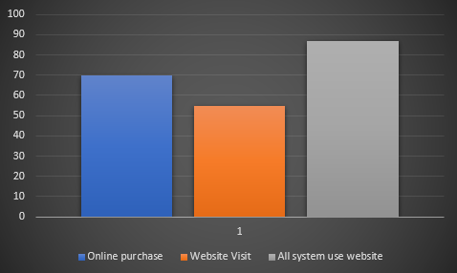

* Yearly report of the exploration 2019 shopno shop.

**Revised Requirement Analysis:**

We complete our analysis by the interview of the student of Stamford University Bangladesh which are the student of CSE. After a long time we take a few answered of this questionnaires by the people from survey, we have revised our requirement analysis.

* Customer think that they can find various type of foreign chocolate from this automated chocolate shop.
* Many customers think that they found various branded chocolate in one shop like automated chocolate shop.
* Customers think that they are benefited cause the whole chocolate management system is web based.
* From this type of chocolate shop our economical condition will be increased.
* Many of our customers are satisfied that if they are unable to go to shop to buy chocolate, they can buy chocolate with online ordering which is more beneficial for them.

**Summary:**

Added a new feature for the customer so that they will be more helpful from our services.

Publicity of the automated system in our to days whole project work.

Appendix

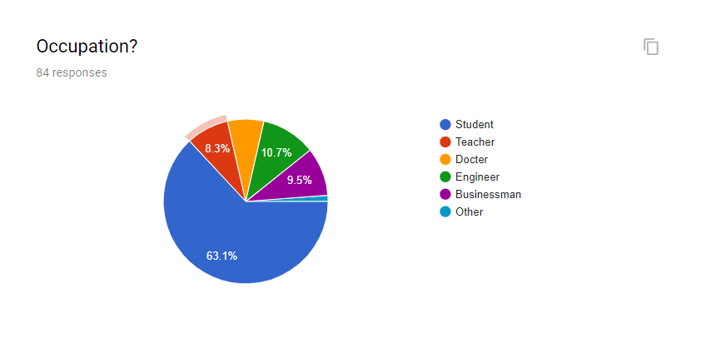

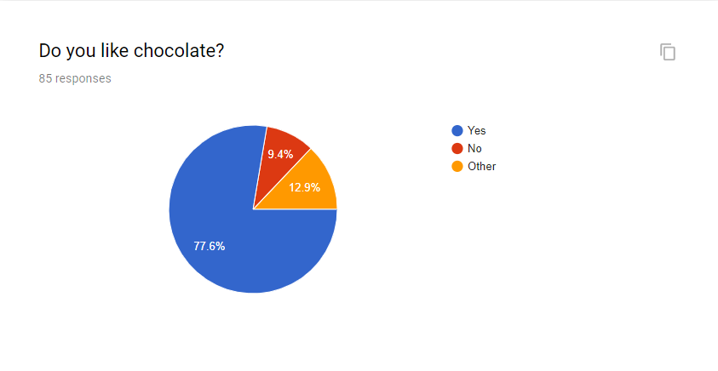

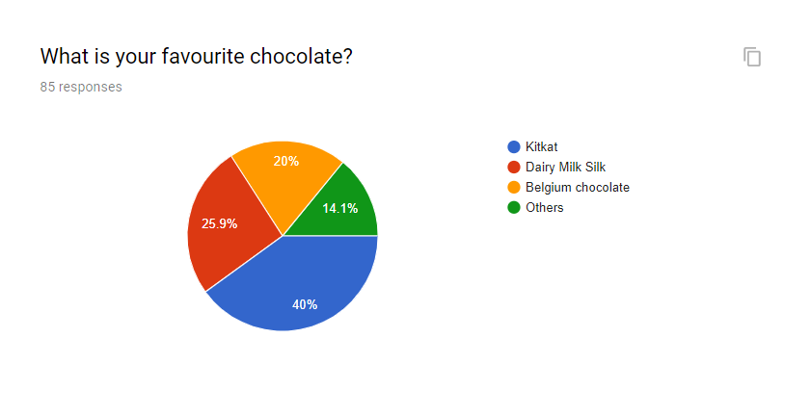

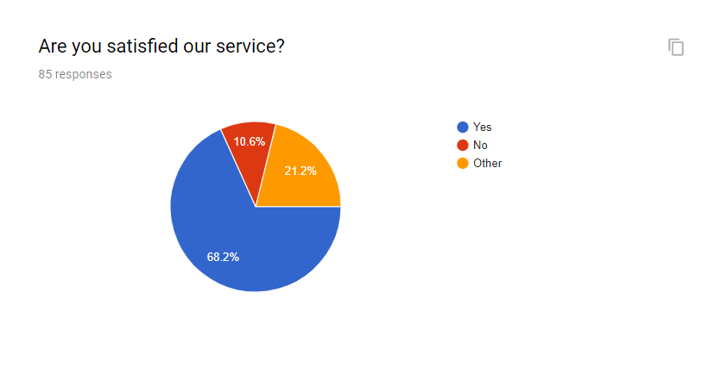

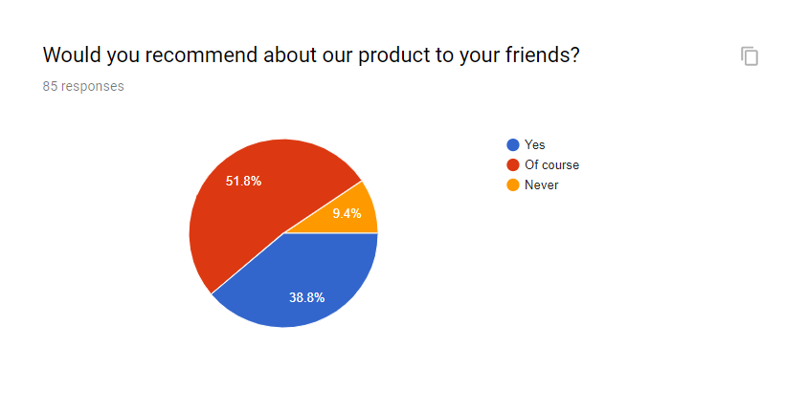

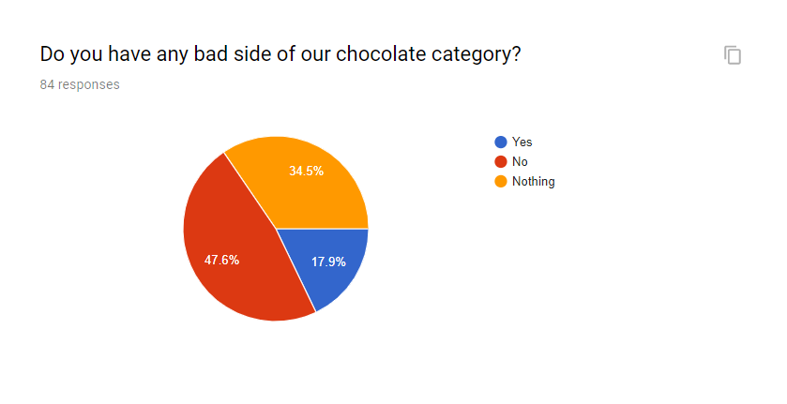

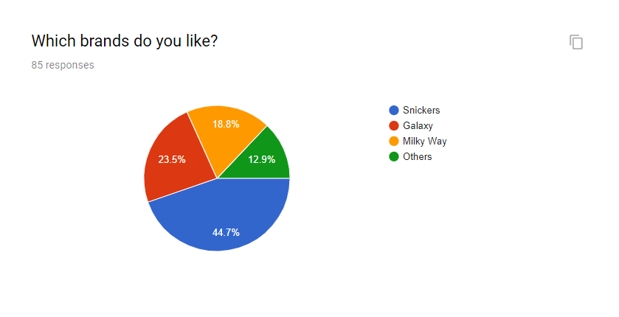

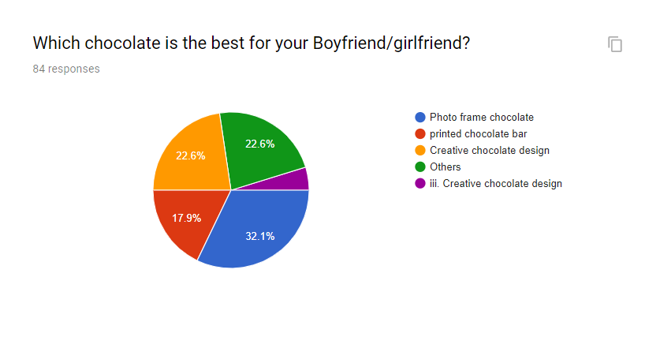

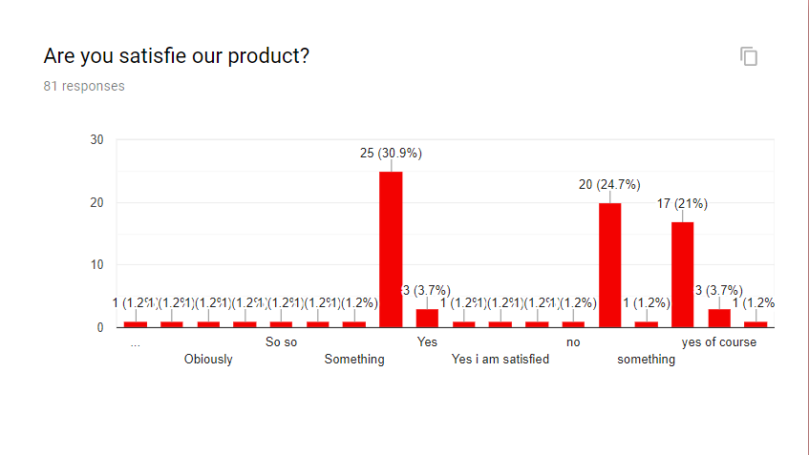

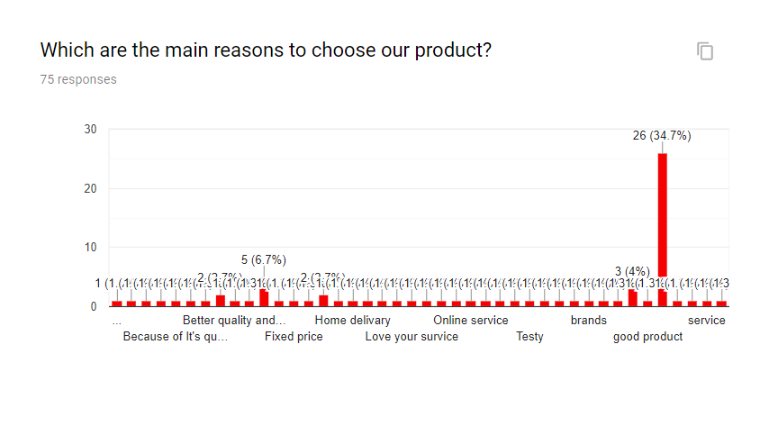

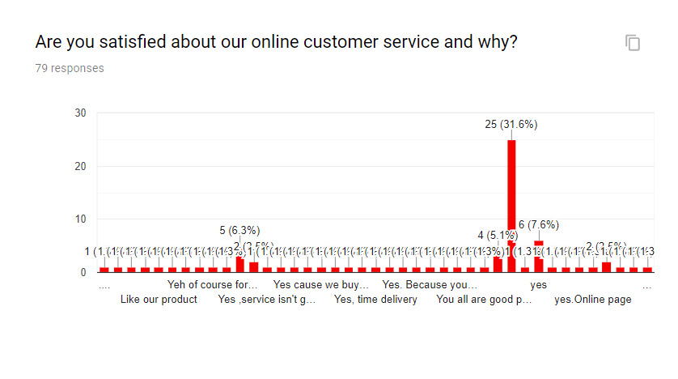

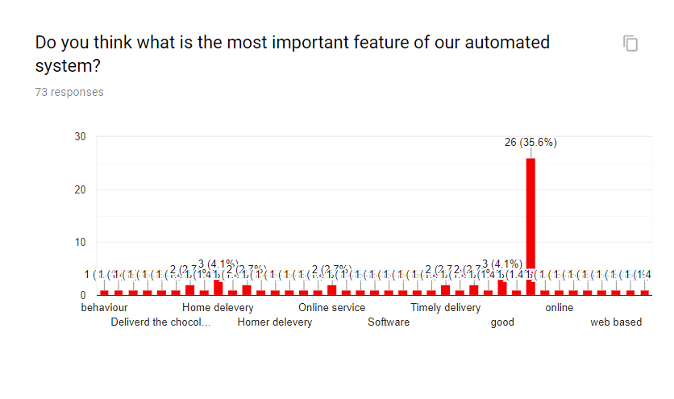

**Data Flow Diagram (DFD):**

**Activity List:**

|  |  |  |
| --- | --- | --- |
| **Purchase** | **Administration** | P**ayroll** |
| Visit | Content Add/Delete/Update | Employee Information |
| BillPay | Customer feedback monitoring | Salary Calculation |
| Online Purchase | Employee report monitoring | Work pace of Employee |
| Service Feedback | Product store monitoring |

**Main Process**: Online Chocolate Shop Management System

**Sub Process**: Purchase, Administration, Payroll

**Entity**: Customer, Employee, Manager, Admin,

**Database**: Order_Info, Product-Store_Info, Customer_Info, Content_Info, Employee_Info, Deliver_Info, WorkTime, Employee_Salary, Report, Feedbac

**DFD - Context Level:**

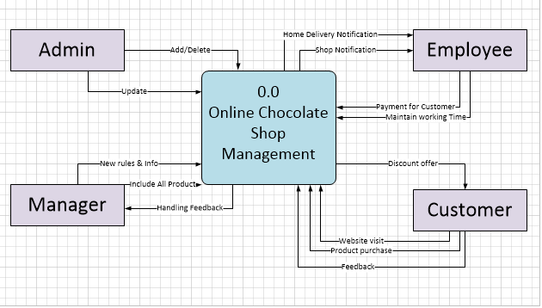

**DFD – Level 0:**

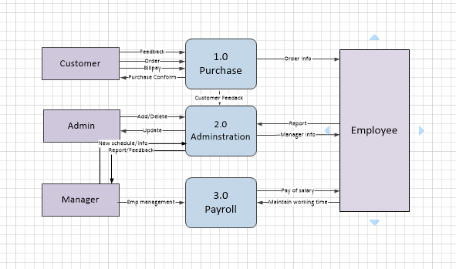

**DFD - Level 01:**

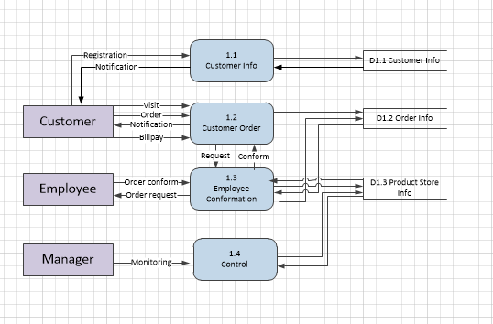

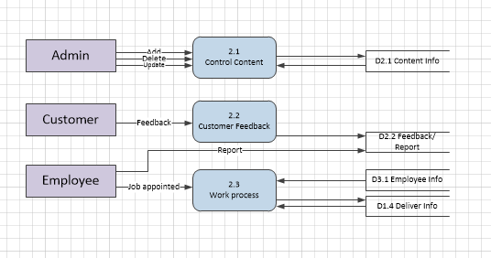

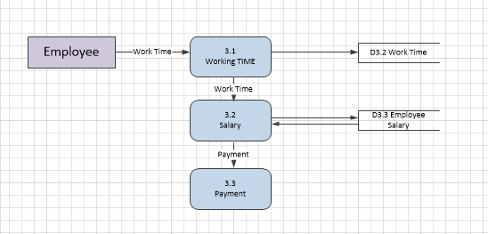

**Process Decomposition:**

|  |  |  |
| --- | --- | --- |
| **Context Level** | **Level -0** | **Level-1** |
| Online Chocolate Shop Management | 1.0 Purchase | 1.1 Customer Information |
|  | 1.2 Customer Order |
| 1.3 Employee Conformation |
| 1.4 Control |
| 2.0 Administration | 2.1 Control Content |
|  | 2.2 Customer Feedback |
| 2.3 Work process |
| 3.0 Payroll | 3.1 Working TIME |
|  | 3.2 Salary |
| 3.3 Payment |

Entity Relation Diagram

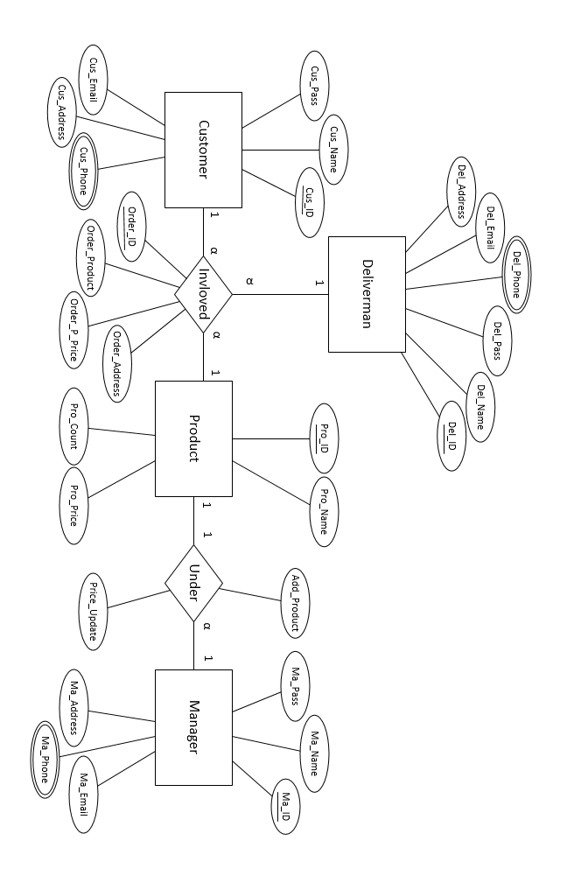

**Contibution:**

ID1 : CSE 063 07380 20%

ID2 : CSE 063 07429 40%

ID2 : CSE 063 07438 20%

ID4 : CSE 063 07477 20%

**Conclusion:**

We complete our final project of online chocolate shop management system which help us to know how the project will compete by using software development. This project will help us in our future life and our workplace.