**To be filled by the Student**

|  |  |
| --- | --- |
| Assignment Number | 1 |
| Name | Nazim Zerrouki |
| UWNetID | 1373533 |

### Part A: Step-By-Step Calculation for generating Decision Tree using ID3

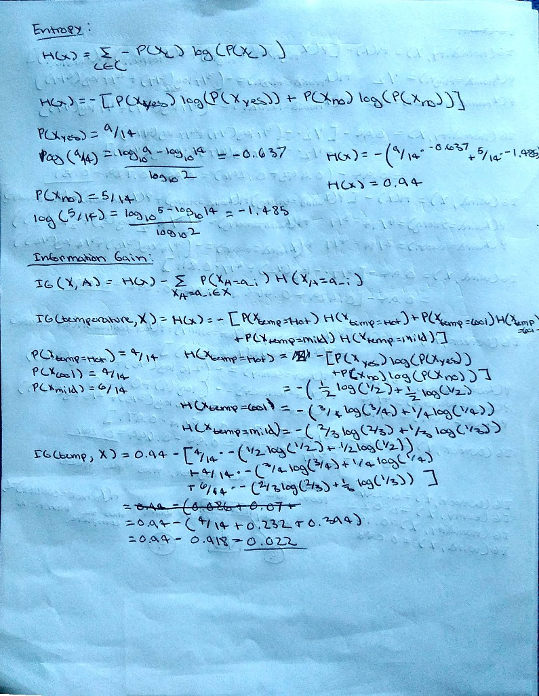

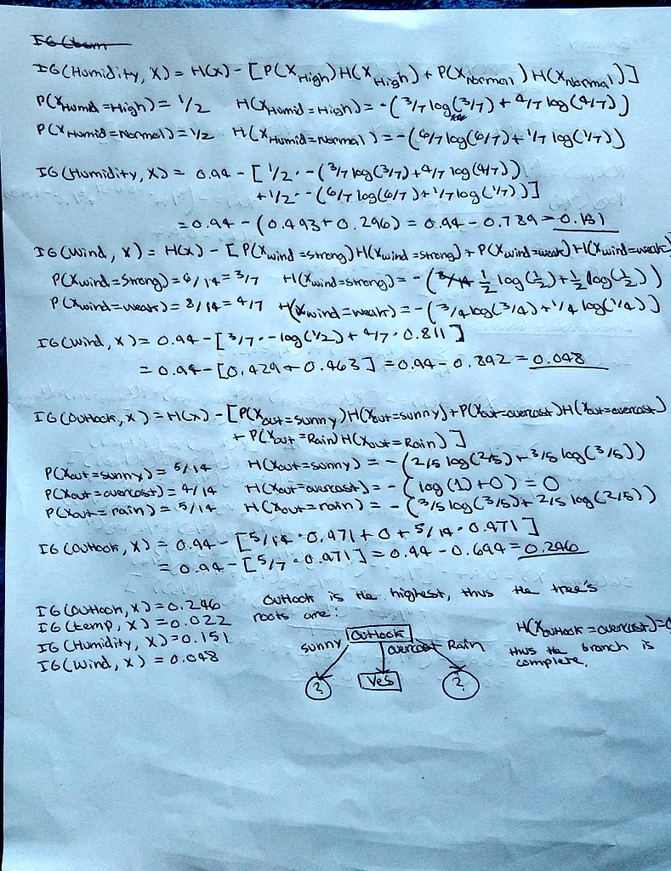

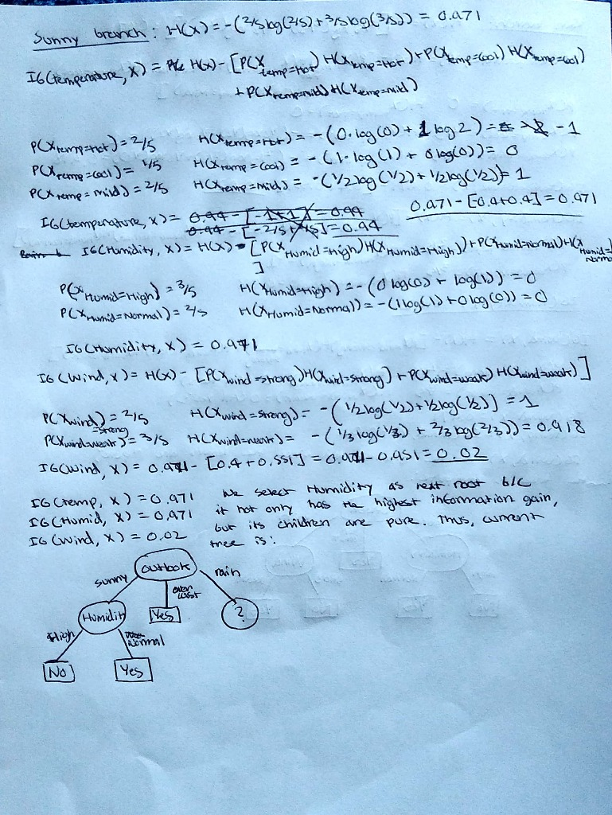

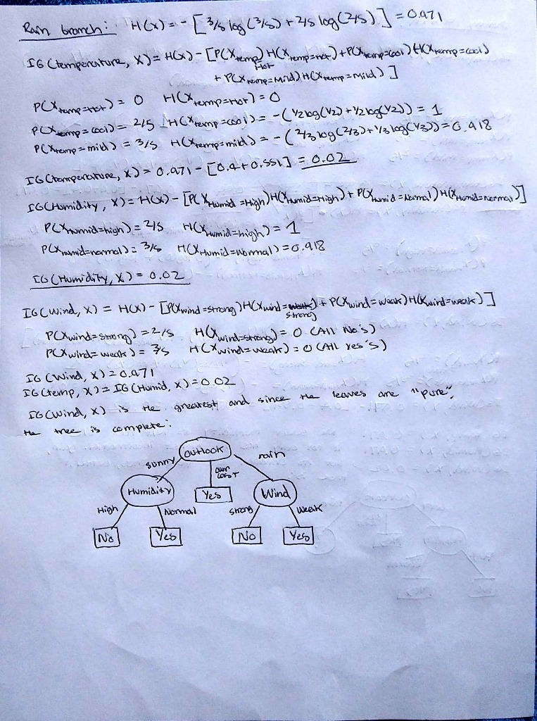

### Part B: Compare Classification Accuracy of KNN and Decision Trees

* Assignment1PartB.ipynb source code

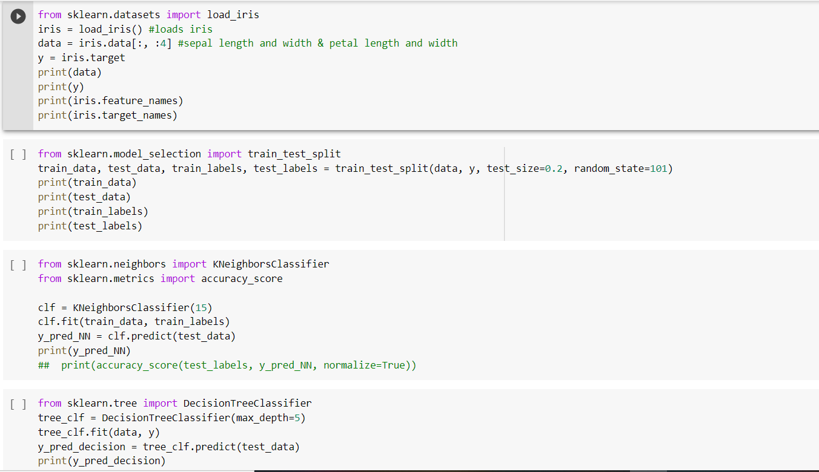

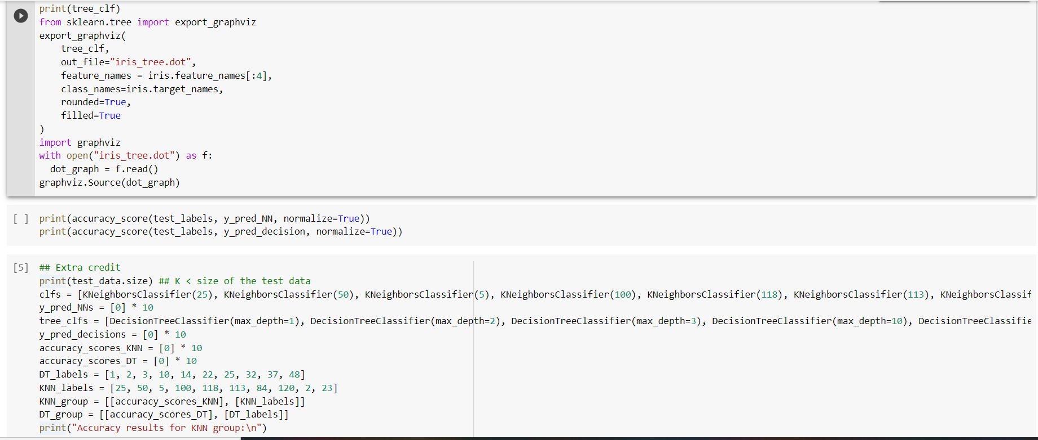

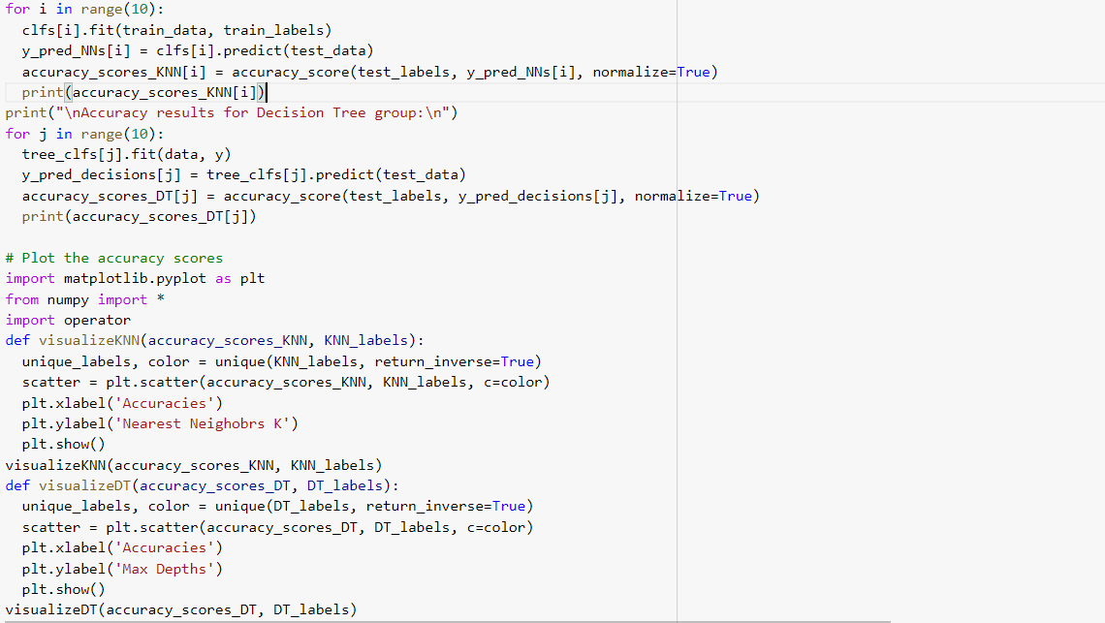

* Execution output showing generated Decision Tree

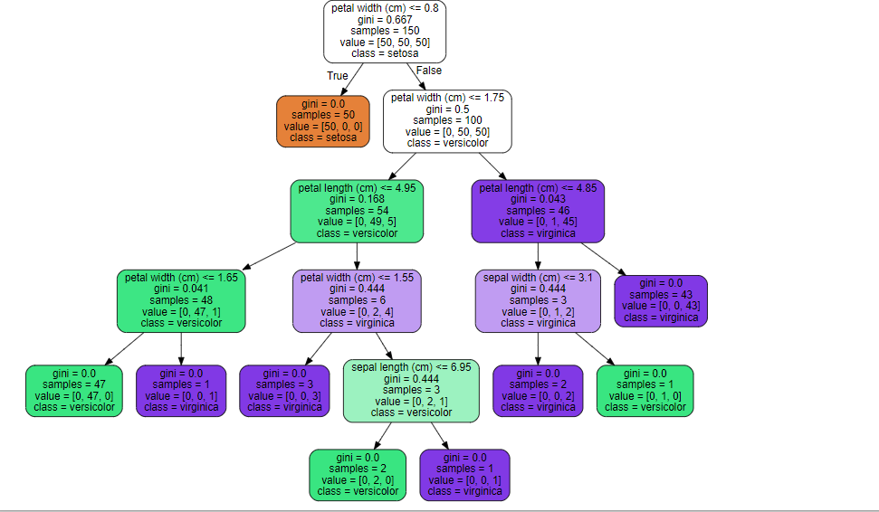

* Execution output showing Accuracy results

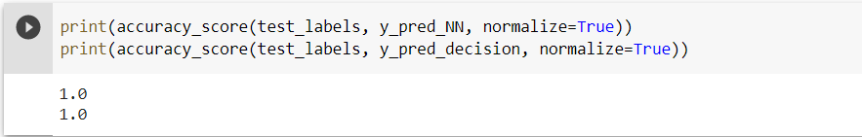

* Extra Credit (graphs, accuracy results)

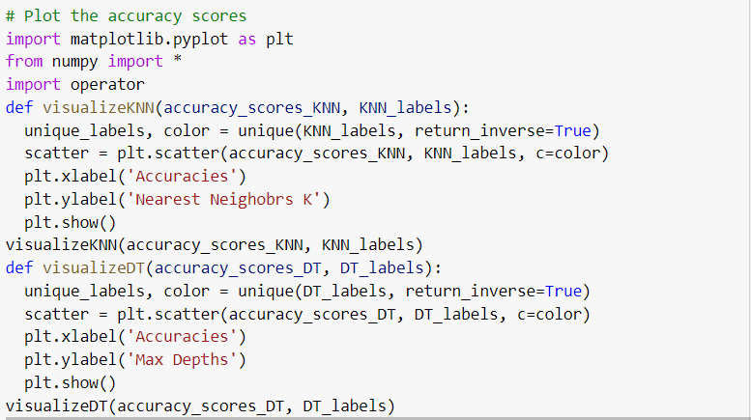

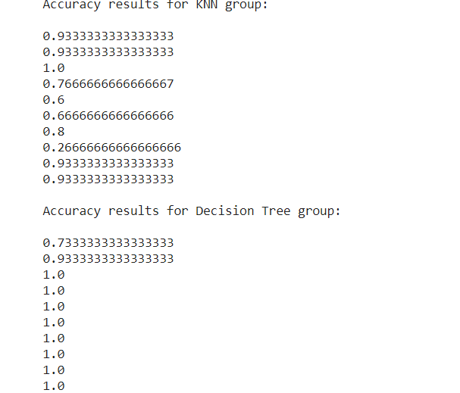

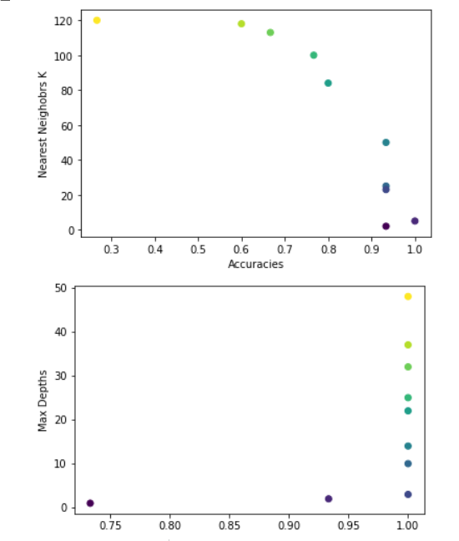

**Grading Rubric (For Grader Use Only):**

|  |  |  |  |
| --- | --- | --- | --- |
| Task | Max Score | Score Received | Comments |
| Proper Submission on canvas | 2 |  |  |
| Proper Hard Copy submission | 2 |  |  |
| Proper Naming and format of Files | 1 |  |  |
| Part A - Decision Tree Calculations | 30 |  |  |
| Part A – Final Decision Tree | 5 |  |  |
| Part A – Legibility of calculation & Diagram | 5 |  |  |
| Part B – Loading Iris Data (Code) | 5 |  |  |
| Part B – Train-Test-Split (Code) | 10 |  |  |
| Part B – KNN (Code) | 10 |  |  |
| Part B – Decision Tree (Code) | 10 |  |  |
| Part B – Accuracy Calculation (Code) | 10 |  |  |
| Part B – Display Decision Tree [output] | 5 |  |  |
| Part B – Display Accuracy [output] | 5 |  |  |
| Extra Credit |  |  |  |
| Change in K-values | 2.5 |  |  |
| Change in max_depth | 2.5 |  |  |
| Total | 100 (105 possible) |  |  |

Grader Comments