FusionVI
Adaptive RNA and protein fusion for pharmacodynamic response profiling
Technical report | Multimodal AI for therapeutic discovery

Research question
When immune stimulation produces disagreement between transcript and surface-protein evidence, can a cell-specific modality gate recover pharmacodynamic response states and activation markers in unseen donors more reliably than the standard totalVI encoder?

Main finding
FusionVI learned biologically structured modality weights, including increased protein reliance after anti-CD3/CD28 stimulation and in cells with discordant CD69 RNA and protein. The encoder change did not yield a reliable overall improvement in response classification or held-out marker reconstruction. Standard totalVI and simple PCA baselines already captured most of the available signal. This negative result narrows the method-development problem: adaptive fusion alone does not resolve the response-recovery ceiling in this dataset.

Study at a glance
Dataset | 16,382 PBMCs, 10 paired donors, 3 conditions, 4,000 RNA features and 39 ADTs
Comparison | Standard totalVI versus a dual-branch gated totalVI encoder
Validation | Ten leave-one-donor-out folds for each model, 800 total training epochs
Primary readouts | Held-out CD25, CD69 and HLA-DR recovery, including RNA-protein discordant cells
Conclusion | The gate changed modality use without a consistent performance gain

1 Background and biological rationale
CITE-seq measures messenger RNA and surface proteins in the same cell. These modalities describe related but non-identical biology because transcription, translation, protein trafficking and receptor internalization occur on different time scales. Drug and immune-perturbation studies therefore need integration methods that preserve meaningful disagreement rather than averaging it away.
The Lawlor et al. experiment profiled peripheral blood mononuclear cells from ten healthy donors at baseline and after 24 hours of LPS or anti-CD3/CD28 stimulation. LPS targets innate monocyte responses, whereas anti-CD3/CD28 directly activates T cells and indirectly alters B and NK cells. The paired design and shared sequencing lanes make the dataset suitable for testing donor generalization in pharmacodynamic biomarker detection.

Therapeutic discovery relevance
The study models an early therapeutic-development task: identifying cell-specific molecular response markers after a controlled perturbation. A method that reconstructs surface activation markers in a new donor could support biomarker selection for immunomodulatory compounds. The experiment contains one dose and one timepoint, so the project addresses biomarker detection rather than dose-response modelling.

Methodological contribution
Standard totalVI uses one joint encoder for concatenated RNA and protein inputs. FusionVI replaces that encoder with separate RNA and protein branches of equal hidden width. A learned scalar gate assigns a cell-specific mixture weight before the shared latent representation. The original totalVI decoder, count likelihoods and evidence lower bound remain unchanged.
RNA counts | RNA encoder
 |  | Per-cell gate | Latent state | totalVI decoders
Protein counts | Protein encoder
Figure 1. FusionVI changes the inference network while retaining totalVI's generative decoder and likelihoods.

2 Data and preprocessing
Processed RNA, ADT and cell-annotation matrices were downloaded from the Human Cell Atlas project linked by Lawlor et al. Expected file hashes were checked before conversion from R sparse matrices.
- Cells: 16,382 annotated singlets from ten donors across baseline, LPS and anti-CD3/CD28 conditions.
- Modalities: raw RNA counts and 39 biological ADTs after excluding antibody controls and technical rows.
- Genes: genes detected in fewer than ten cells were removed; 4,000 lane-aware highly variable genes were selected with the Cell Ranger dispersion method.
- Batch covariate: sequencing lane. Donor was reserved for validation and never used as a batch label.
- Held-out proteins: CD25, CD69 and HLA-DR were zeroed only at encoder input. Their counts remained targets in the totalVI likelihood.
CD80 was confirmed by external flow cytometry in the source study but is absent from the released 39-ADT matrix. HLA-DR was therefore used as an exploratory myeloid surface marker, and CD80 was not claimed as an input-panel endpoint.

3 Model implementation
Component | Standard totalVI | FusionVI
Encoder input | RNA and protein concatenation | Separate RNA and protein branches
Fusion | Implicit in joint dense layers | Scalar sigmoid gate per cell
Latent dimensions | 15 | 15
Hidden width | 192 | 192 per branch
Encoder layers | 2 | 2
Decoder layers | 1 | 1
Gene likelihood | Negative binomial | Negative binomial
Parameters | 3,408,959 | 2,710,273
Table 1. Matched model configuration. FusionVI contains 20.5% fewer parameters, which is reported as a capacity limitation rather than treated as an advantage.

Training
Both models used scvi-tools 1.4.2 and PyTorch 2.8.0 on one CUDA GPU. Each fold used seed 2026, batch size 256, a maximum of 40 epochs and early stopping with patience six. All 20 folds reached 40 epochs. The model generated held-out protein predictions from 25 posterior samples.

4 Validation and statistical analysis
The unit of replication was the donor. Each of ten folds trained on nine donors and evaluated the tenth, so every reported paired comparison contains one value per held-out donor.

Response-state classification
A logistic regression classifier was fit on each model's training-donor latent representation and evaluated on the held-out donor. Contrasts were T cells under anti-CD3/CD28, monocytes under LPS, and the indirect B- and NK-cell responses to anti-CD3/CD28, each against baseline.

Held-out marker reconstruction
Marker performance used Spearman correlation between measured and decoded protein abundance in the relevant cell population. CD25 and CD69 were evaluated in T cells; HLA-DR was evaluated in CD14 monocytes. The analysis also compared the predicted and measured direction of the stimulation effect.

RNA-protein discordance challenge
Within each donor and relevant population, cells entered the challenge subset when the percentile ranks of the marker's RNA proxy and measured surface protein differed by at least 0.50. RNA proxies were IL2RA for CD25, CD69 for CD69, and HLA-DRA plus HLA-DRB1 for HLA-DR. This subset tests whether the remaining protein panel can rescue a surface phenotype when transcript evidence points elsewhere.

Baselines and inference
Three transparent baselines used the same donor splits and held-out protein inputs: RNA PCA, protein PCA and equal late-fusion PCA. Model differences used paired Wilcoxon tests across donors. Confidence intervals came from 10,000 bootstrap resamples of donor-level paired differences. Benjamini-Hochberg correction covered the reported model-comparison endpoints.

5 Results

Condition labels were an easy endpoint
Standard totalVI already classified every stimulation contrast with mean held-out-donor ROC AUC between 0.995 and 1.000. FusionVI changed the mean by less than 0.004 for all contrasts. RNA PCA also achieved 0.989 to 1.000, confirming that broad stimulation labels do not provide a sensitive test of multimodal fusion in this dataset.
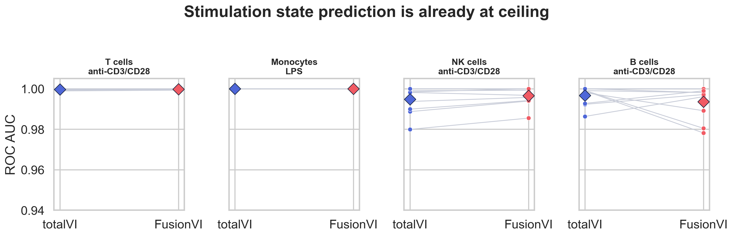
Figure 2. Donor-level response classification. Diamonds show model means and connected points show matched held-out donors.

Held-out marker recovery showed no consistent gain
Endpoint | totalVI | FusionVI | Difference | 95% bootstrap CI | BH q
CD25 global rho | 0.779 | 0.779 | −0.000 | −0.004 to 0.004 | 1.000
CD69 global rho | 0.822 | 0.826 | +0.005 | +0.001 to +0.008 | 0.165
HLA-DR global rho | 0.404 | 0.421 | +0.017 | −0.038 to +0.063 | 0.382
CD25 discordant rho | 0.642 | 0.661 | +0.019 | −0.010 to +0.045 | 0.382
CD69 discordant rho | 0.533 | 0.520 | −0.013 | −0.034 to +0.010 | 0.382
HLA-DR discordant rho | −0.175 | −0.057 | +0.118 | −0.058 to +0.284 | 0.383
Table 2. Mean donor-level held-out marker performance. Positive differences favor FusionVI. HLA-DR discordant correlations were defined for eight donors.

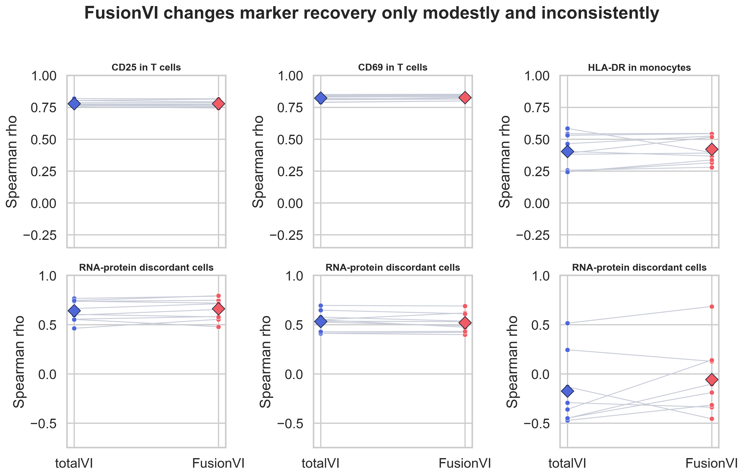
Figure 3. FusionVI produced small and inconsistent changes in global and discordant-cell marker reconstruction.

Simple baselines remained competitive
Equal-fusion PCA matched or exceeded the deep models for CD25 and CD69 reconstruction. RNA PCA produced the highest mean global HLA-DR correlation at 0.467, while protein PCA performed best in the discordant HLA-DR subset at 0.430. These results argue against claiming that a more complex encoder is necessary for this dataset.
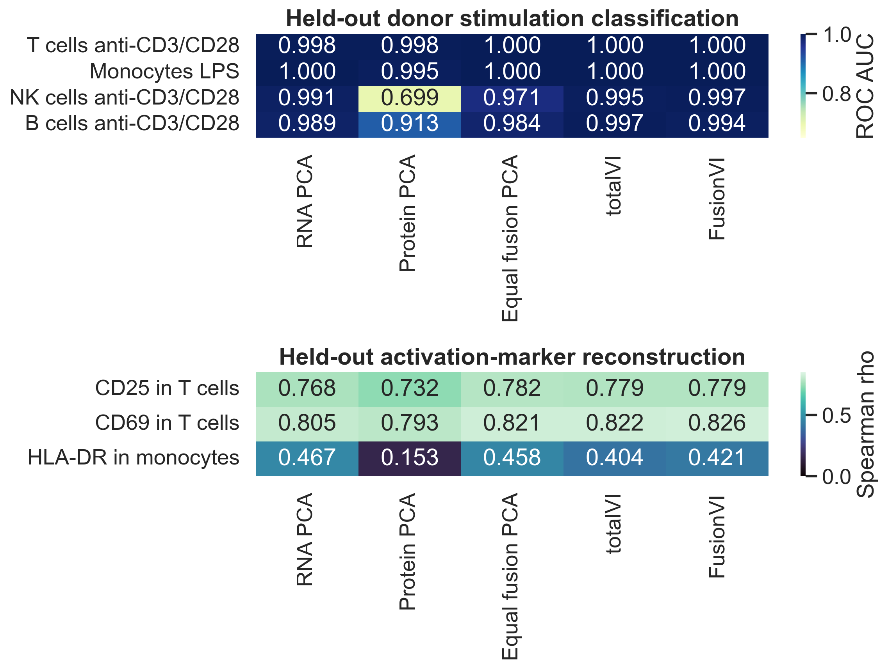
Figure 4. Mean held-out-donor performance for transparent PCA baselines and both deep generative models.

6 What the gate learned
Across all 16,382 cells, the mean protein branch weight was 0.375. It increased from 0.349 at baseline to 0.445 after anti-CD3/CD28 stimulation and decreased to 0.326 under LPS. The gate therefore learned stimulation-specific modality use rather than collapsing to a constant.
For CD69-discordant T cells, protein weight was 0.090 higher than in concordant cells across donors (paired Wilcoxon p = 0.00195). This was the clearest mechanistic result, but CD69 reconstruction in the same challenge subset decreased by 0.013. The gate recognized discordance without translating that behavior into better prediction. For CD25-discordant cells, protein weight was 0.025 lower (p = 0.027), showing that the unconstrained gate does not always move in the biologically desired direction.
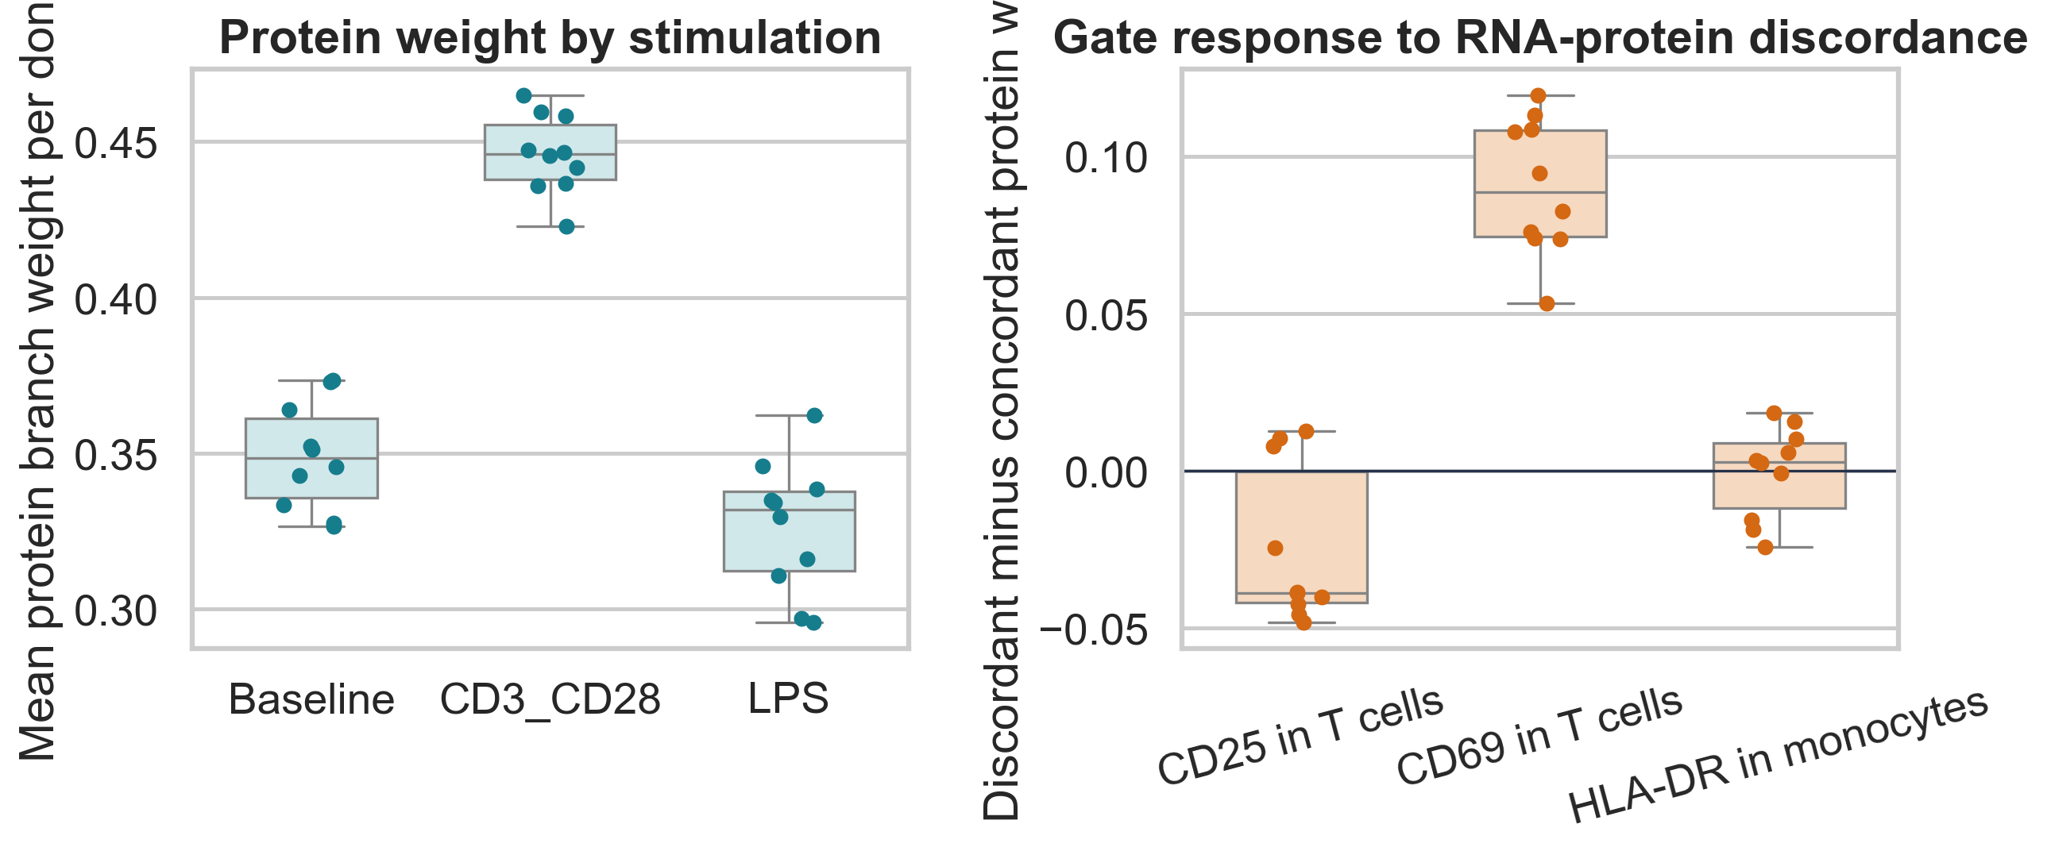
Figure 5. Donor-level protein weights by condition and by RNA-protein concordance status.

Biological interpretation
Anti-CD3/CD28 produced a coordinated protein-rich activation phenotype across lymphocytes, so increased protein weighting is biologically plausible. The absence of a reconstruction gain suggests that the standard totalVI latent and decoder already captured this signal, or that the scalar gate lacks enough structure to distinguish informative protein evidence from correlated activation markers. HLA-DR was the most difficult endpoint and showed large donor variation, consistent with a weak or heterogeneous surface response at this single timepoint.

7 Limitations
- The experiment contains one dose and one 24-hour timepoint. It cannot support dose-response, temporal or clinical-response claims.
- Ten donors limit statistical power. The HLA-DR discordant correlation was estimable in only eight donors.
- Broad stimulation labels were nearly perfectly separable even with RNA PCA, creating a ceiling for method comparison.
- The external flow-cytometry measurements were not available as a cell-level validation target in the processed matrix.
- FusionVI has fewer parameters than standard totalVI. A capacity-matched encoder would be needed to isolate fusion from model size.
- One fixed seed and one architecture were used. Hyperparameter search was intentionally avoided to reduce selective reporting, but robustness across seeds remains untested.

8 Conclusion and next experiment
FusionVI answered the project question with a useful negative result. Cell-specific gating learned biologically coherent changes in modality reliance, especially after anti-CD3/CD28 stimulation and during CD69 RNA-protein discordance. These changes did not improve held-out biomarker recovery across donors. The next justified method change is a constrained or supervised gate trained on held-out cross-modal prediction, evaluated in a larger perturbation dataset with multiple doses and timepoints. A capacity-matched totalVI encoder should remain the primary comparator.

Reproducibility
The repository contains checksum-verified data download, deterministic preprocessing, one-fold training, complete cross-validation, classical baselines, donor-level evaluation and figure-generation scripts. Raw data, processed AnnData, model weights and per-cell fold outputs are regenerated and excluded from version control. Compact metrics, figures and configuration files are retained.

References
Lawlor N et al. Single Cell Analysis of Blood Mononuclear Cells Stimulated Through Either LPS or Anti-CD3 and Anti-CD28. Frontiers in Immunology. 2021;12:636720. doi:10.3389/fimmu.2021.636720.
Gayoso A et al. Joint probabilistic modeling of single-cell multi-omic data with totalVI. Nature Methods. 2021;18:272–282. doi:10.1038/s41592-020-01050-x.
Stoeckius M et al. Simultaneous epitope and transcriptome measurement in single cells. Nature Methods. 2017;14:865–868. doi:10.1038/nmeth.4380.
scvi-tools documentation. totalVI user guide. https://docs.scvi-tools.org/en/latest/user_guide/models/totalvi.html.

