FusionVI-X
Cross-modal recovery of surface biomarkers in unseen donors and perturbations
Technical report | Multimodal AI for therapeutic discovery

Research question
When transcript and surface-protein evidence disagree, can targeted cross-modal context recover hidden therapeutic surface biomarkers in unseen donors and after unseen molecular perturbations more reliably than standard totalVI?

Main finding
The scalar FusionVI gate learned biologically structured modality weights but did not improve marker recovery by itself. A target-specific cross-modal readout produced the useful result. In the Lawlor donor-held-out experiment, FusionVI-X increased mean Spearman correlation from 0.779 to 0.825 for CD25, 0.822 to 0.873 for CD69 and 0.404 to 0.756 for HLA-DR relative to standard totalVI. In the Papalexi external validation, FusionVI-X predicted surface PD-L1 effects for unseen CRISPR targets with Spearman correlation 0.879 and 84% direction accuracy, compared with 0.587 and 64% for CD274 RNA alone.

Study at a glance
Experiment 1 | 16,382 PBMCs, 10 paired donors, 3 conditions, 4,000 RNA features and 39 ADTs
Experiment 2 | 20,729 IFN-gamma-treated THP-1 cells, 25 CRISPR targets, 3 replicates and 4 ADTs
Comparison | Standard totalVI, gated FusionVI and donor-nested cross-modal readouts
Validation | Ten leave-one-donor-out folds for each model, 800 total training epochs
Primary readouts | Held-out CD25, CD69 and HLA-DR recovery, including RNA-protein discordant cells
Conclusion | Cross-modal context improved hidden markers across donors and unseen perturbations

1 Background and biological rationale
CITE-seq measures messenger RNA and surface proteins in the same cell. These modalities describe related but non-identical biology because transcription, translation, protein trafficking and receptor internalization occur on different time scales. Drug and immune-perturbation studies therefore need integration methods that preserve meaningful disagreement rather than averaging it away.
The Lawlor et al. experiment profiled peripheral blood mononuclear cells from ten healthy donors at baseline and after 24 hours of LPS or anti-CD3/CD28 stimulation. LPS targets innate monocyte responses, whereas anti-CD3/CD28 directly activates T cells and indirectly alters B and NK cells. The paired design and shared sequencing lanes make the dataset suitable for testing donor generalization in pharmacodynamic biomarker detection.

Therapeutic discovery relevance
The study models an early therapeutic-development task: identifying cell-specific molecular response markers after a controlled perturbation. A method that reconstructs surface activation markers in a new donor could support biomarker selection for immunomodulatory compounds. The experiment contains one dose and one timepoint, so the project addresses biomarker detection rather than dose-response modelling.

Methodological contribution
Standard totalVI uses one joint encoder for concatenated RNA and protein inputs. FusionVI replaces that encoder with separate RNA and protein branches of equal hidden width. A learned scalar gate assigns a cell-specific mixture weight before the shared latent representation. The original totalVI decoder, count likelihoods and evidence lower bound remain unchanged.
FusionVI-X adds a target-specific supervised readout after representation learning. The hidden marker is predicted from the FusionVI latent state, the remaining 36 ADTs and a prespecified marker-matched RNA proxy. Within every outer donor fold, Ridge, histogram gradient boosting and Extra Trees are compared by three-fold grouped validation using only the nine training donors. The selected family is refit before the untouched tenth donor is evaluated. The same readout on standard totalVI is retained as totalVI-X.
RNA counts | RNA encoder
 |  | Per-cell gate | Latent state | totalVI decoders
Protein counts | Protein encoder
Figure 1. FusionVI changes the inference network while retaining totalVI's generative decoder and likelihoods; FusionVI-X adds a donor-nested cross-modal marker readout after the latent state.

2 Data and preprocessing
Processed RNA, ADT and cell-annotation matrices were downloaded from the Human Cell Atlas project linked by Lawlor et al. Expected file hashes were checked before conversion from R sparse matrices.
- Cells: 16,382 annotated singlets from ten donors across baseline, LPS and anti-CD3/CD28 conditions.
- Modalities: raw RNA counts and 39 biological ADTs after excluding antibody controls and technical rows.
- Genes: genes detected in fewer than ten cells were removed; 4,000 lane-aware highly variable genes were selected with the Cell Ranger dispersion method.
- Batch covariate: sequencing lane. Donor was reserved for validation and never used as a batch label.
- Held-out proteins: CD25, CD69 and HLA-DR were zeroed only at encoder input. Their counts remained targets in the totalVI likelihood.
- Readout inputs: the latent state, the remaining 36 ADTs and IL2RA, CD69 or HLA-DRA/HLA-DRB1 RNA proxies. The target marker was never an input.
CD80 was confirmed by external flow cytometry in the source study but is absent from the released 39-ADT matrix. HLA-DR was therefore used as an exploratory myeloid surface marker, and CD80 was not claimed as an input-panel endpoint.

3 Model implementation
Component | Standard totalVI | FusionVI
Encoder input | RNA and protein concatenation | Separate RNA and protein branches
Fusion | Implicit in joint dense layers | Scalar sigmoid gate per cell
Latent dimensions | 15 | 15
Hidden width | 192 | 192 per branch
Encoder layers | 2 | 2
Decoder layers | 1 | 1
Gene likelihood | Negative binomial | Negative binomial
Parameters | 3,408,959 | 2,710,273
Targeted readout | totalVI-X with nested head selection | FusionVI-X with nested head selection
Table 1. Matched model configuration. FusionVI contains 20.5% fewer parameters, which is reported as a capacity limitation rather than treated as an advantage.

Training
Both neural models used scvi-tools 1.4.2 and PyTorch 2.8.0 on one CUDA GPU. Each fold used seed 2026, batch size 256, a maximum of 40 epochs and early stopping with patience six. All 20 folds reached 40 epochs. The cross-modal heads were fit after neural training and selected separately for each marker and outer fold using grouped inner validation.

4 Validation and statistical analysis
The unit of replication was the donor. Each of ten folds trained on nine donors and evaluated the tenth, so every reported paired comparison contains one value per held-out donor.

Response-state classification
A logistic regression classifier was fit on each model's training-donor latent representation and evaluated on the held-out donor. Contrasts were T cells under anti-CD3/CD28, monocytes under LPS, and the indirect B- and NK-cell responses to anti-CD3/CD28, each against baseline.

Held-out marker reconstruction
Marker performance used Spearman correlation between measured and decoded protein abundance in the relevant cell population. CD25 and CD69 were evaluated in T cells; HLA-DR was evaluated in CD14 monocytes. The analysis also compared the predicted and measured direction of the stimulation effect.

Nested cross-modal readout
Readout family selection never used the outer held-out donor. Three grouped inner folds compared fixed Ridge, histogram-gradient-boosting and Extra-Trees candidates by Spearman correlation. The chosen family was then refit on all nine training donors. This prevents choosing the successful readout by looking directly at final test-donor performance.

RNA-protein discordance challenge
Within each donor and relevant population, cells entered the challenge subset when the percentile ranks of the marker's RNA proxy and measured surface protein differed by at least 0.50. RNA proxies were IL2RA for CD25, CD69 for CD69, and HLA-DRA plus HLA-DRB1 for HLA-DR. This subset tests whether the remaining protein panel can rescue a surface phenotype when transcript evidence points elsewhere.

Baselines and inference
Three transparent baselines used the same donor splits and held-out protein inputs: RNA PCA, protein PCA and equal late-fusion PCA. Model differences used paired Wilcoxon tests across donors. Confidence intervals came from 10,000 bootstrap resamples of donor-level paired differences. Benjamini-Hochberg correction covered the reported model-comparison endpoints.

5 Results

Condition labels were an easy endpoint
Standard totalVI already classified every stimulation contrast with mean held-out-donor ROC AUC between 0.995 and 1.000. FusionVI changed the mean by less than 0.004 for all contrasts. RNA PCA also achieved 0.989 to 1.000, confirming that broad stimulation labels do not provide a sensitive test of multimodal fusion in this dataset.
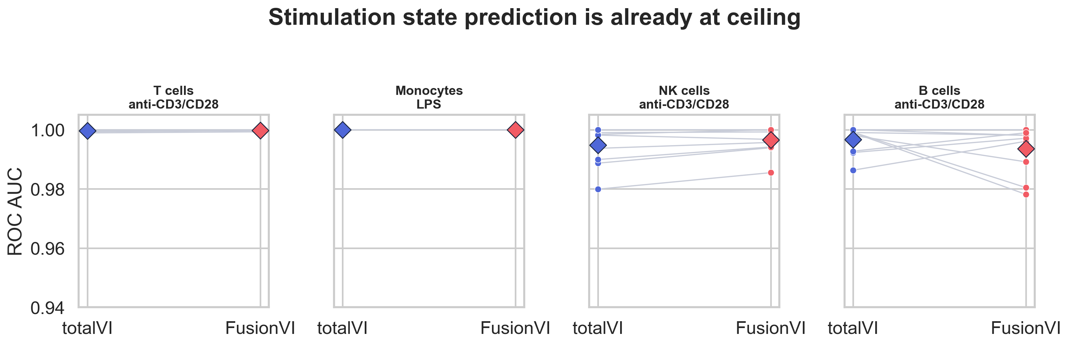
Figure 2. Donor-level response classification. Diamonds show model means and connected points show matched held-out donors.

Targeted cross-modal readout improved marker recovery
Endpoint | totalVI | FusionVI-X | Difference | 95% bootstrap CI | BH q
CD25 global rho | 0.779 | 0.825 | +0.046 | +0.041 to +0.051 | 0.0039
CD69 global rho | 0.822 | 0.873 | +0.051 | +0.046 to +0.059 | 0.0039
HLA-DR global rho | 0.404 | 0.756 | +0.352 | +0.283 to +0.416 | 0.0039
CD25 discordant rho | 0.642 | 0.687 | +0.045 | −0.009 to +0.098 | 0.211
CD69 discordant rho | 0.533 | 0.573 | +0.040 | −0.004 to +0.087 | 0.157
HLA-DR discordant rho | −0.175 | 0.637 | +0.812 | +0.495 to +1.084 | 0.0117
Table 2. Mean donor-level held-out marker performance. Positive differences favor FusionVI-X. HLA-DR discordant correlations were defined for eight donors.

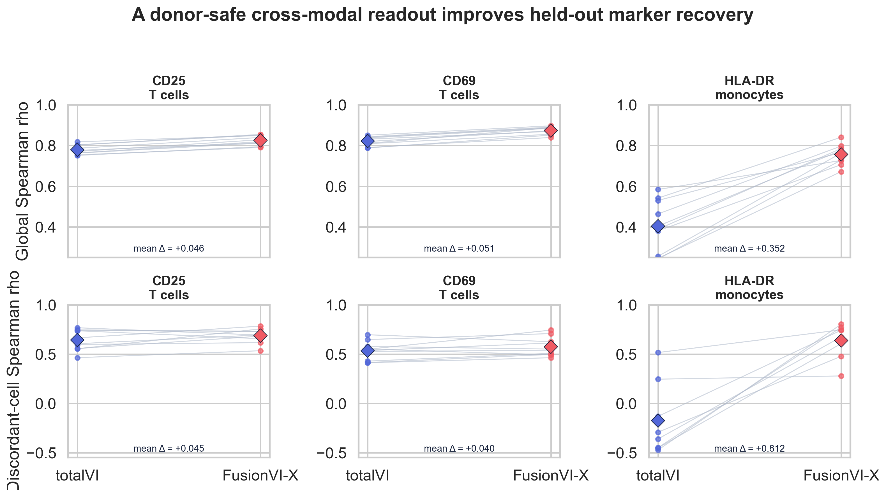
Figure 3. Paired held-out-donor marker recovery. Diamonds show means; lines connect the same donor before and after the targeted readout.

Ablation identifies the useful modality
The marker-matched RNA proxy performed well globally for CD25 but failed on every discordant subset. The remaining 36 surface proteins recovered positive signal without the target marker itself. Adding the learned latent state improved global HLA-DR recovery further. Similar gains for totalVI-X and FusionVI-X show that targeted cross-modal supervision, rather than the scalar gate alone, is the main source of improvement.
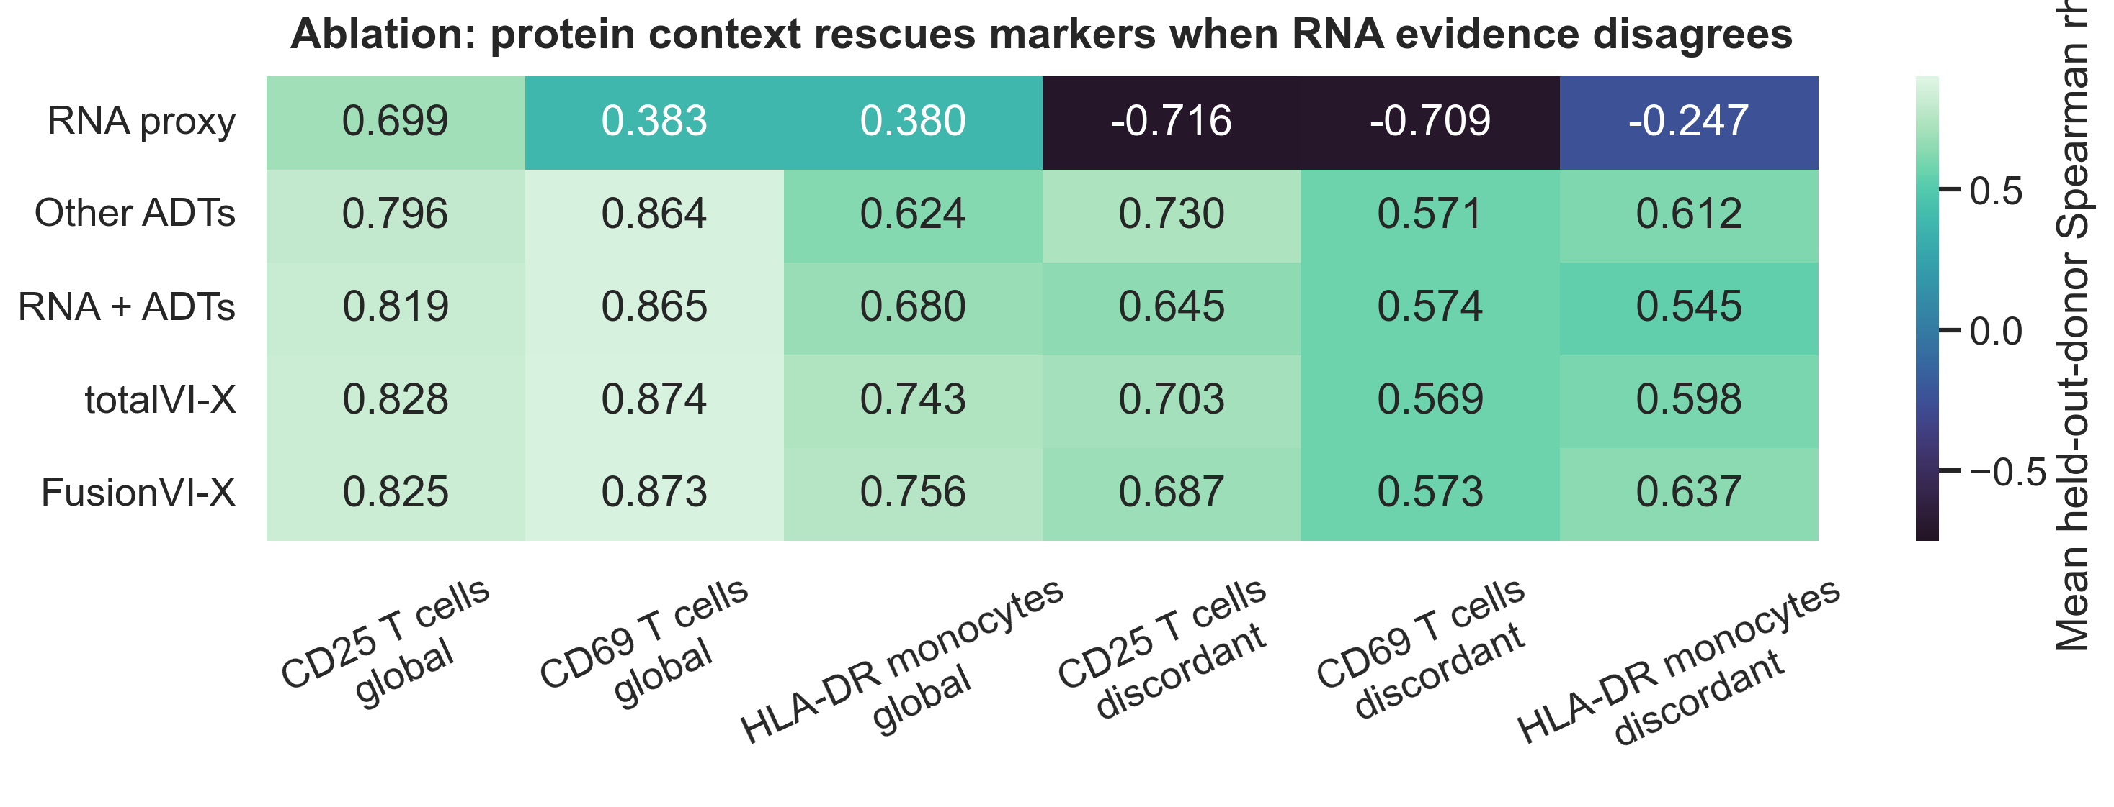
Figure 4. Modality ablation across global and RNA-protein-discordant endpoints. Every value is a mean across outer held-out donors.

6 What the gate learned
Across all 16,382 cells, the mean protein branch weight was 0.375. It increased from 0.349 at baseline to 0.445 after anti-CD3/CD28 stimulation and decreased to 0.326 under LPS. The gate therefore learned stimulation-specific modality use rather than collapsing to a constant.
For CD69-discordant T cells, protein weight was 0.090 higher than in concordant cells across donors (paired Wilcoxon p = 0.00195). This was the clearest mechanistic result, but CD69 reconstruction in the same challenge subset decreased by 0.013. The gate recognized discordance without translating that behavior into better prediction. For CD25-discordant cells, protein weight was 0.025 lower (p = 0.027), showing that the unconstrained gate does not always move in the biologically desired direction.
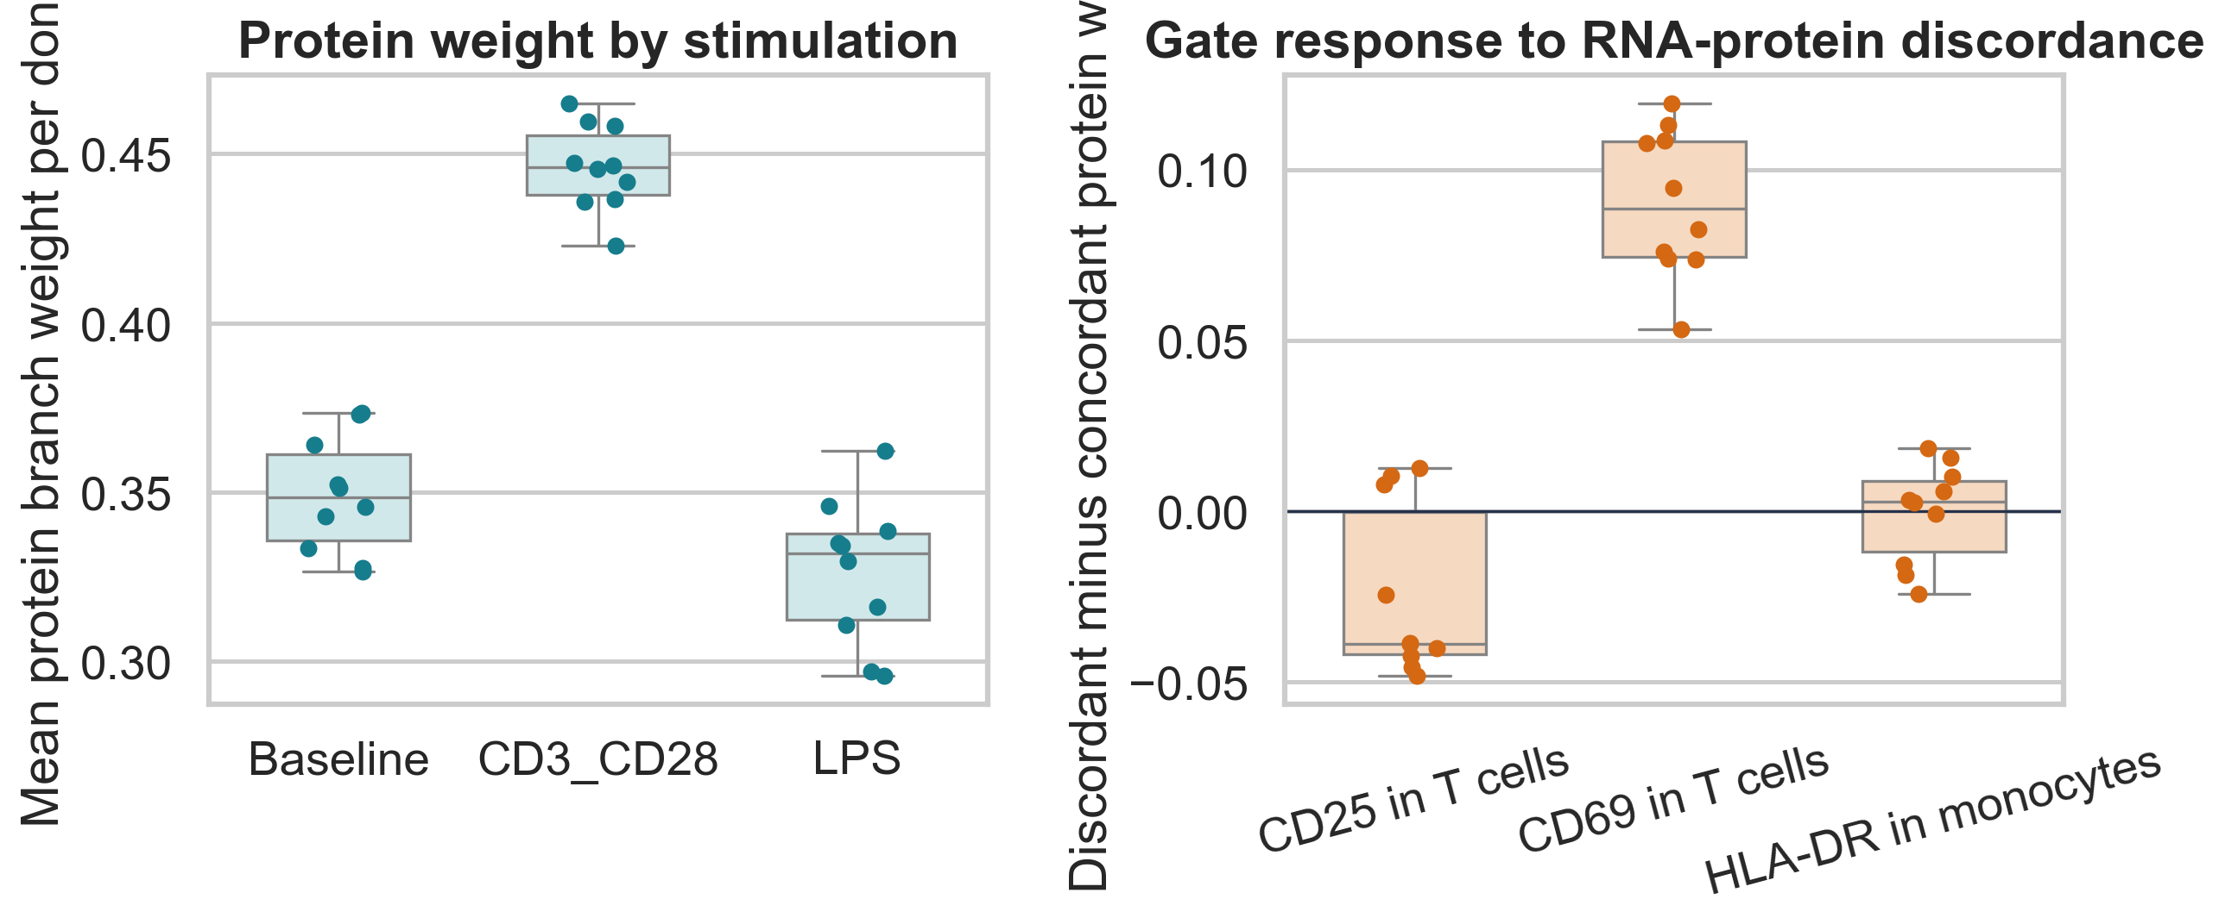
Figure 5. Donor-level protein weights by condition and by RNA-protein concordance status.

Biological interpretation
Anti-CD3/CD28 produced a coordinated protein-rich activation phenotype across lymphocytes, so increased protein weighting is biologically plausible. The readout ablation makes the stronger biological point: when marker RNA and surface abundance disagree, neighbouring surface markers retain information about the cell's activation state. This was most pronounced for HLA-DR in monocytes, where RNA evidence alone was insufficient and the protein context converted a negative correlation into a strong positive one.

7 Experiment 2: unseen CRISPR targets
The Papalexi et al. ECCITE-seq screen provides a direct therapeutic test of the same principle. It measured RNA, CRISPR guide identity and four surface proteins in 20,729 IFN-gamma-treated THP-1 cells across three biological replicates. The biological question was whether cross-modal context could predict how an unseen molecular perturbation changes surface PD-L1, a clinically used immune-checkpoint biomarker, when CD274 RNA may provide incomplete evidence.

Target-held-out design
PD-L1 was masked at the encoder input. The model retained 2,000 highly variable genes, including CD274, and the three other surface proteins CD86, PD-L2 and CD366. Five outer folds kept every cell targeting the same gene together, so each of 25 perturbed genes was evaluated exactly once and never appeared in that fold's training set. Non-targeting cells were partitioned within replicate to provide an untouched control reference. Ridge and Extra Trees readouts were selected through inner validation grouped by CRISPR target. Evaluation used 75 target-by-replicate effects rather than cell-level significance tests.
Model | Effect Spearman | Direction accuracy
CD274 RNA only | 0.587 | 64.0%
totalVI decoder | 0.767 | 76.0%
totalVI-X | 0.841 | 82.7%
FusionVI decoder | 0.820 | 77.3%
FusionVI-X | 0.879 | 84.0%
Table 3. Prediction of held-out PD-L1 effects across 75 target-by-replicate estimates.
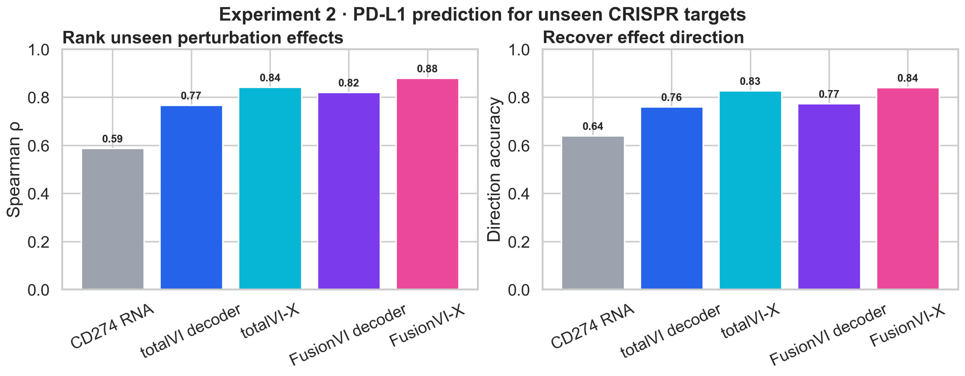
Figure 6. Cross-modal readouts improve the ranking and direction of PD-L1 effects for unseen CRISPR targets.

Biological recovery and a useful failure
FusionVI-X recovered the strong loss of surface PD-L1 after perturbing JAK2, IFNGR1, IFNGR2 or STAT1, which disrupt the canonical IFN-gamma response. It also recovered increased PD-L1 after CUL3 or BRD4 perturbation, consistent with their reported roles as negative regulators. At the gene level, FusionVI-X reduced median absolute error by 0.0042 relative to totalVI-X across the 25 targets (paired Wilcoxon p = 0.042). The increment is modest; the larger improvement comes from adding a target-safe cross-modal readout to either latent representation.
CMTM6 provides the clearest negative result. Its perturbation strongly reduced surface PD-L1 while CD274 RNA moved slightly upward. FusionVI-X predicted almost no decrease. The model therefore recovered many unseen pathway perturbations but failed on a known post-transcriptional PD-L1-stability mechanism. SPI1 also produced opposite RNA and protein directions, but FusionVI-X recovered the protein decrease. These cases show why the external experiment is more informative than a simple classification benchmark.
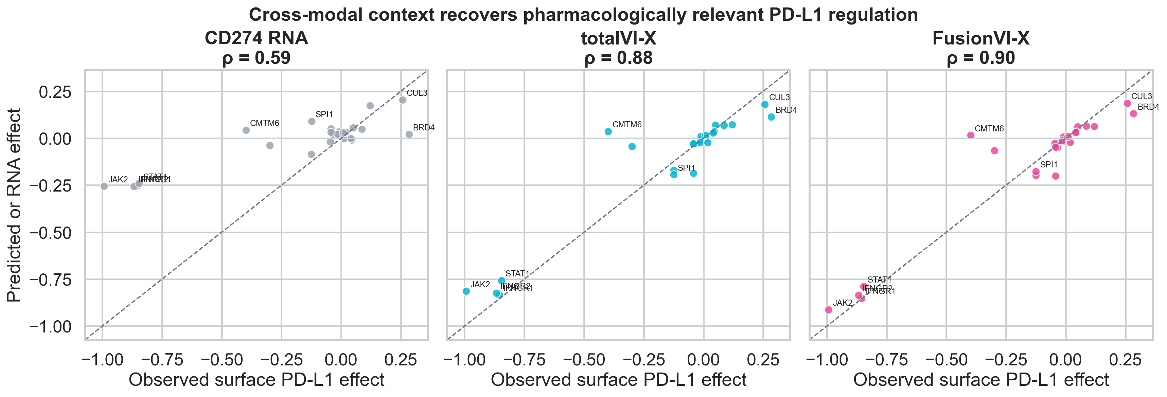
Figure 7. Gene-level observed surface PD-L1 effects versus CD274 RNA, totalVI-X and FusionVI-X predictions. Labels identify established IFN-gamma regulators and RNA-protein-discordant cases.

8 Limitations
- The experiment contains one dose and one 24-hour timepoint. It cannot support dose-response, temporal or clinical-response claims.
- Ten donors limit statistical power. The HLA-DR discordant correlation was estimable in only eight donors.
- Broad stimulation labels were nearly perfectly separable even with RNA PCA, creating a ceiling for method comparison.
- The external flow-cytometry measurements were not available as a cell-level validation target in the processed matrix.
- FusionVI has fewer parameters than standard totalVI. A capacity-matched encoder would be needed to isolate fusion from model size.
- One fixed seed and one architecture were used. Hyperparameter search was intentionally avoided to reduce selective reporting, but robustness across seeds remains untested.
- The cross-modal readout is marker-specific and supervised. It improves prediction but is not a replacement for a generative model of unseen proteins without training labels.
- The Papalexi validation contains one IFN-gamma-stimulated cell line and only four surface proteins. It tests unseen mechanisms, not patient generalization.
- The unseen-target split evaluates interpolation across related immune-regulatory pathways. It does not establish performance on a new drug, tissue or assay platform.

9 Conclusion
FusionVI-X answered the project question across two complementary settings. In primary PBMCs, a donor-nested readout improved recovery of CD25, CD69 and HLA-DR and strongly rescued HLA-DR when its RNA and protein measurements disagreed. In a separate CRISPR screen, the same cross-modal principle improved prediction of PD-L1 effects for unseen targets and recovered central IFN-gamma pathway regulators. The scalar gate alone remained weaker than the supervised readout, and the CMTM6 failure defines an important post-transcriptional boundary. The results support cross-modal context as a practical way to recover pharmacodynamic surface biomarkers while showing that specialized protein-stability mechanisms still require direct biological evidence.

Reproducibility
The repository contains checksum-verified data download, deterministic preprocessing, one-fold training, complete cross-validation, classical baselines, donor-level evaluation and figure-generation scripts. Raw data, processed AnnData, model weights and per-cell fold outputs are regenerated and excluded from version control. Compact metrics, figures and configuration files are retained.

References
Lawlor N et al. Single Cell Analysis of Blood Mononuclear Cells Stimulated Through Either LPS or Anti-CD3 and Anti-CD28. Frontiers in Immunology. 2021;12:636720. doi:10.3389/fimmu.2021.636720.
Gayoso A et al. Joint probabilistic modeling of single-cell multi-omic data with totalVI. Nature Methods. 2021;18:272–282. doi:10.1038/s41592-020-01050-x.
Stoeckius M et al. Simultaneous epitope and transcriptome measurement in single cells. Nature Methods. 2017;14:865–868. doi:10.1038/nmeth.4380.
Papalexi E et al. Characterizing the molecular regulation of inhibitory immune checkpoints with multimodal single-cell screens. Nature Genetics. 2021;53:322-331. doi:10.1038/s41588-021-00778-2.
scvi-tools documentation. totalVI user guide. https://docs.scvi-tools.org/en/latest/user_guide/models/totalvi.html.

