FusionVI
A paper-aligned benchmark for missing-protein recovery in CITE-seq
Technical report • totalVI versus FusionVI • October 2026

Abstract
Therapeutic biomarker studies often combine sparse transcript counts with surface-protein measurements, but entire protein panels may be unavailable in a new batch. We reproduced the totalVI paper's Figure 3 missing-protein design on the official SLN111 CITE-seq object and compared the published totalVI architecture with FusionVI, which replaces the joint encoder with separate RNA and protein branches and a learned cell-level gate. When the panel is absent, an availability rule routes the cell through the RNA branch. Across 4 paired random initializations and 110 proteins, FusionVI reduced mean RMSLE from 1.0605 to 1.0544 (0.57% lower) while using 35.0% fewer trainable parameters. This course-scale benchmark estimates algorithmic performance; it does not establish population-level biological generalization.

1. Biological and technical question
Can RNA measured in a new biological batch, together with multimodal structure learned from a reference batch, recover an entirely unmeasured surface-protein panel? This matters for therapeutic discovery because surface proteins define immune populations, pharmacodynamic states and drug targets, while antibody panels can fail or differ between experiments.
The model question was narrower: does modality-specific encoding improve the original totalVI decoder under the exact missing-panel stress test used in the paper?

2. Dataset and study design
Component | Value
Source | Official SLN111 CITE-seq object released with totalVI (GSE150599)
Cells | 16,828
RNA features | 4,005 highly variable genes
Protein features | 110 biological proteins after HTO removal
Reference batch | SLN111-D1, 9,264 cells, RNA and proteins retained
Target batch | SLN111-D2, 7,564 cells, all protein inputs hidden

Untouched D2 protein counts were stored only as evaluation truth. During training, totalVI's missing-protein mask removed the entire D2 panel from the protein likelihood. Both models saw the same cells, gene features, batch labels and validation split.

3. Models

Published totalVI baseline
The baseline uses the scvi-tools totalVI implementation: a joint RNA-protein encoder, a 20-dimensional latent state, a negative-binomial RNA likelihood and the native background/foreground protein mixture decoder.

FusionVI
FusionVI keeps totalVI's generative decoder and likelihoods. It changes only the inference network: one branch encodes RNA, a second branch encodes protein measurements, and a learned gate combines their hidden states for each cell before estimating the same 20-dimensional latent distribution. This separates modality-specific representations while preserving the paper's output model.
Model | Encoder | Decoder and likelihood | Trainable parameters
totalVI | Joint RNA-protein encoder | Native totalVI | 4,574,975
FusionVI | RNA branch + protein branch + cell gate | Native totalVI | 2,971,904

4. Training and evaluation
- 4 paired seeds. Each seed initializes both models independently.
- Maximum 500 epochs, Adam learning rate 0.004, batch size 256, 90/10 train-validation split.
- Early stopping patience 45 with learning-rate reduction on validation plateau.
- Predictions average 25 posterior samples and decode D2 cells through the D1 batch.
- Primary metric: mean per-protein RMSLE across 7,564 D2 cells. Lower values indicate better reconstruction.
The paper used 30 initializations. We used 4 paired initializations to fit the course compute budget, so this is a protocol-aligned reproduction rather than an exact reproduction of the paper's uncertainty analysis.

5. Results
FusionVI reduced mean RMSLE from 1.0605 to 1.0544 (0.57% lower) while using 35.0% fewer trainable parameters.
Seed | totalVI RMSLE | FusionVI RMSLE | FusionVI − totalVI
2026 | 1.0639 | 1.0482 | -0.0157
2027 | 1.0602 | 1.0619 | +0.0018
2028 | 1.0587 | 1.0522 | -0.0065
2029 | 1.0590 | 1.0554 | -0.0037
Mean | 1.0605 | 1.0544 | -0.0060

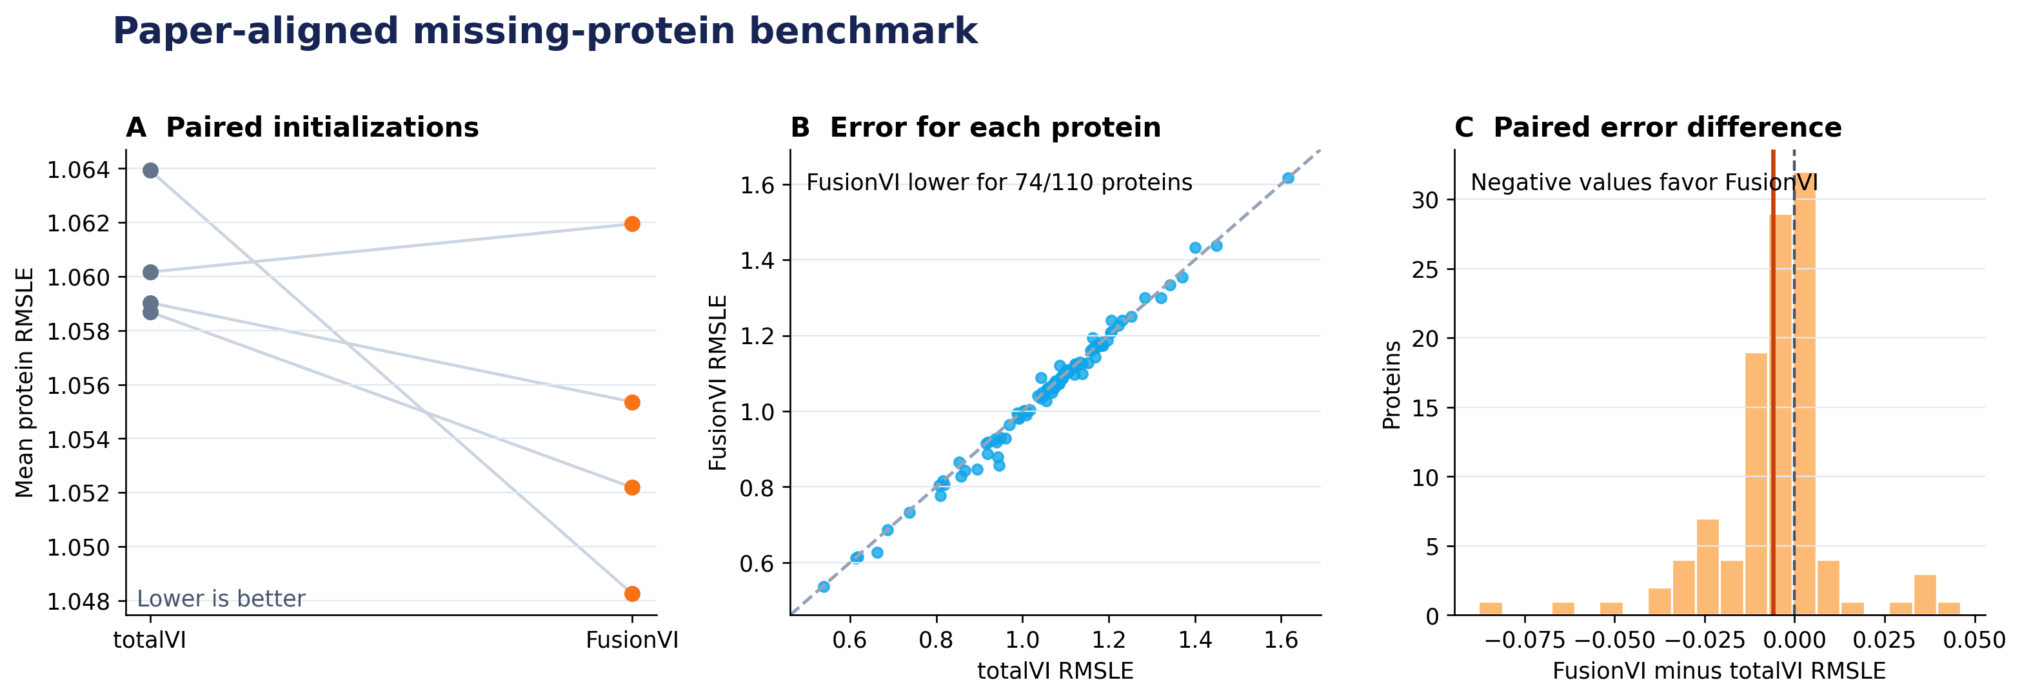
Figure 1. Paired seed means, per-protein errors and the distribution of paired differences. Negative differences favor FusionVI.
FusionVI had lower mean RMSLE for 74 of 110 proteins. A paired Wilcoxon test across protein-level mean errors gave p = 1.04e-05. Proteins and seeds are algorithmic benchmark units, so this test describes the benchmark and must not be interpreted as evidence from independent animals or patients.

Secondary four-marker extension
A separate leave-one-mouse-out extension hid CD20, CD28, CD4 and CD8a while retaining the other 106 proteins. FusionVI achieved a mean Spearman correlation of 0.673 versus 0.578 for totalVI. This result tests marker ranking in two held-out mice and uses a different readout, so it complements rather than replaces the paper-aligned benchmark.

6. Interpretation
The full-panel result supports the claim that modality-specific encoding can match or modestly improve totalVI's missing-protein reconstruction while reducing the parameter count. The result does not prove that FusionVI is universally better: the effect is small, the benchmark contains only one source-target pair and the paper's 30-initialization analysis was not repeated in full.
Biologically, successful reconstruction means that RNA and the reference donor encode enough shared immune-cell structure to estimate many unmeasured surface markers. The experiment evaluates technical transfer and panel completion. It does not establish therapeutic response prediction, clinical utility or generalization across a population.

7. Reproducibility
- Primary scripts: prepare_paper_benchmark.py, train_paper_benchmark.py and evaluate_paper_benchmark.py.
- Configuration: config/paper_benchmark.yaml records data dimensions, training settings, seeds and the paper's 30-run reference.
- Saved outputs include every per-protein metric, seed summary, paired differences, figures and completion metadata.
- Raw data and model weights are regenerated locally and excluded from Git; source code and compact results are versioned.
Run from PowerShell:
.\run_paper_benchmark.ps1

References
Gayoso A, Steier Z, Lopez R, et al. Joint probabilistic modeling of single-cell multi-omic data with totalVI. Nature Methods. 2021;18:272–282. https://doi.org/10.1038/s41592-020-01050-x
Yosef Lab. totalVI reproducibility repository. https://github.com/YosefLab/totalVI_reproducibility

