FusionVI multimodal validation experiments
Technical report covering four biomarker recovery and perturbation transfer studies
totalVI versus FusionVI • October 2026

Abstract
FusionVI tests whether modality-specific encoding improves recovery of therapeutic surface biomarkers when protein measurements are hidden, discordant with RNA or observed under an unseen perturbation. Four completed experiments cover held-out human donors, held-out CRISPR targets, cross-mouse transfer and the full missing-protein-panel benchmark from the totalVI paper. The evidence is deliberately mixed: multimodal context is useful in the PD-L1 perturbation task, while targeted marker studies show that measured protein context often matters more than the learned latent. In the complete-panel benchmark, FusionVI retains a small advantage over three matched joint-encoder controls across 16 seeds, although a source-only RNA ridge baseline outperforms every neural model on aggregate RMSLE. These results support a bounded biomarker-completion and perturbation-ranking contribution.

Project question
Can modality-specific fusion improve recovery of therapeutic surface biomarkers when protein measurements are missing, discordant with RNA, or observed under an unseen molecular perturbation?

Experiment overview
Experiment | Held-out unit | Primary finding
Lawlor activation | 10 human donors | Native encoders close; cross-modal context supplied most of the marker-recovery gain
Papalexi PD-L1 | 25 CRISPR targets | FusionVI-X reached 0.879 effect Spearman and 84.0% direction accuracy
SLN111 targeted markers | 2 mice | Protein context + RNA reached 0.670; either latent added no more than 0.003
SLN111 complete panel | 16 paired seeds | FusionVI beat three matched joint encoders; RNA ridge RMSLE was 0.638

Model and evaluation framework
totalVI is the published baseline. FusionVI retains its generative decoder and RNA and protein likelihoods, but replaces the joint encoder with separate RNA and protein branches combined by a learned cell-level gate. In the complete-panel benchmark, the gate follows an explicit availability rule: if every protein is absent, the cell is routed through RNA only.
Experiments 1 to 3 also evaluated FusionVI-X, a nested cross-modal readout using the latent state, remaining measured proteins and a prespecified matching transcript. The identical readout applied to totalVI is totalVI-X. Native-decoder and X-readout results are reported separately so the encoder contribution is not confused with the supervised readout.

Experiment 1 Lawlor donor held out activation

Biological question and design
Can hidden CD25, CD69 and HLA-DR be recovered in an unseen donor, particularly in cells where RNA and surface protein disagree? The dataset contains 16,382 PBMCs from 10 paired donors under baseline, LPS or anti-CD3/CD28 stimulation, with 4,000 genes and 39 antibody-derived tags. Each donor served once as the untouched test fold.
Target | totalVI | FusionVI | totalVI-X | FusionVI-X
CD25 in T cells | 0.779 | 0.779 | 0.828 | 0.825
CD69 in T cells | 0.822 | 0.826 | 0.874 | 0.873
HLA-DR in monocytes | 0.404 | 0.421 | 0.743 | 0.756

Result The encoder change alone produced small and inconsistent differences.
Both cross-modal readouts improved marker recovery, especially HLA-DR, but totalVI-X and FusionVI-X were nearly tied. The ablation supplies the biological insight: a matching transcript can become misleading when RNA and surface protein diverge, while the remaining protein panel restores predictive context.
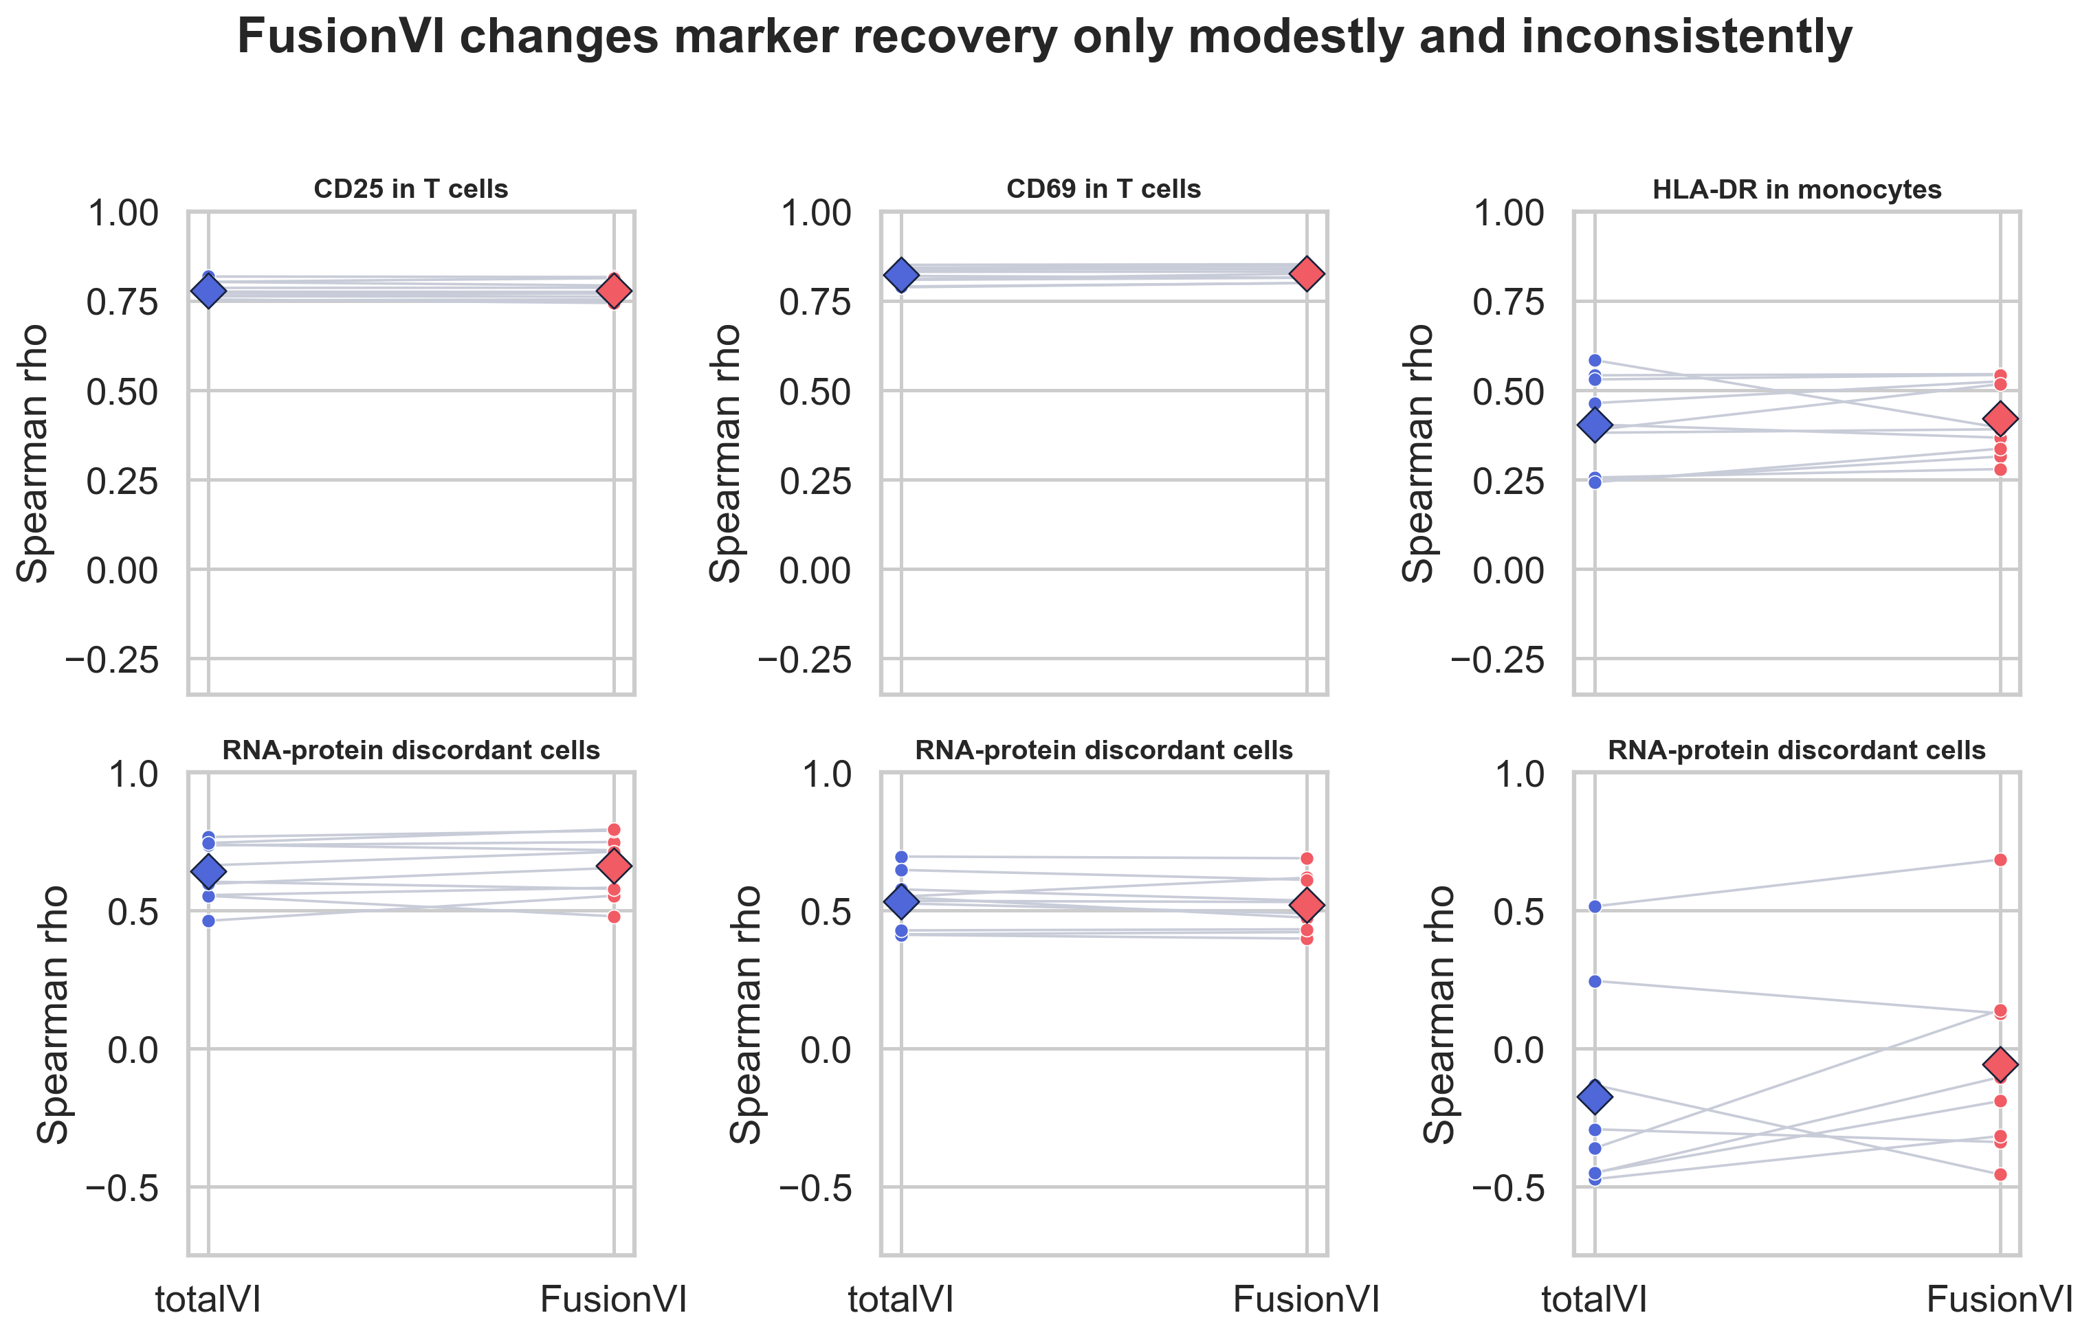
Figure 1. Donor-paired native-decoder marker recovery. Large diamonds show means.

Experiment 2 Papalexi unseen CRISPR targets

Biological question and design
Given a held-out perturbation cell's RNA and three measured proteins, can its hidden PD-L1 response be recovered? The ECCITE-seq screen contains 20,729 IFN-gamma-treated THP-1 cells, 25 perturbation targets, three biological replicates and four surface proteins. Five outer folds held out complete CRISPR targets. At test time, each cell's RNA and the other three measured proteins remain inputs; only PD-L1 is hidden, and the perturbation-target label is not used. Evaluation used 75 target-by-replicate effects.
Model | Effect Spearman | Direction accuracy | Effect MAE
CD274 RNA only | 0.587 | 64.0% | —
totalVI decoder | 0.767 | 76.0% | —
FusionVI decoder | 0.820 | 77.3% | —
totalVI-X | 0.841 | 82.7% | 0.085
FusionVI-X | 0.879 | 84.0% | 0.081

Result FusionVI-X ranked unseen perturbation effects best.
FusionVI-X reduced median per-target PD-L1 effect absolute error by 0.0042 relative to totalVI-X after replicate averaging (paired Wilcoxon p=0.042, 25 targets). A 5,000-sample target-cluster bootstrap estimated FusionVI-X effect Spearman at 0.879 (95% CI 0.728 to 0.967) and its difference from totalVI-X at +0.038 (95% CI +0.011 to +0.083). The MAE-difference interval included zero. It recovered expected PD-L1 loss after IFNGR1, IFNGR2, JAK2 and STAT1 perturbation and gain after CUL3 or BRD4 perturbation.
The model failed on CMTM6: measured PD-L1 decreased while CD274 RNA increased slightly. This is a useful boundary condition because CMTM6 regulates PD-L1 stability after translation, a mechanism that transcript-centered inference can miss.
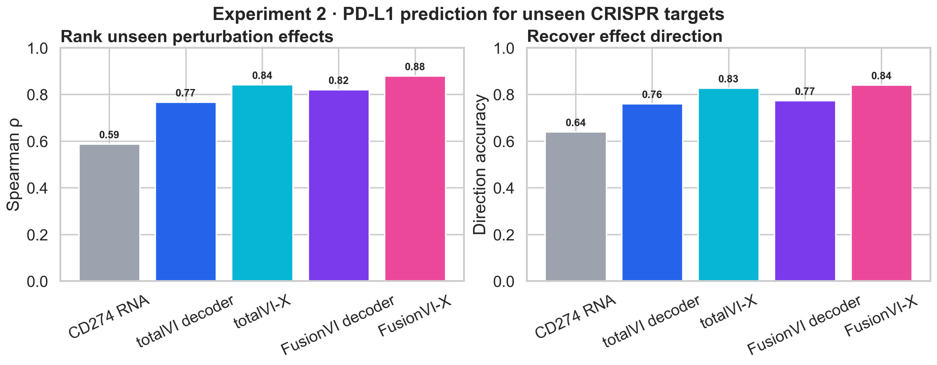
Figure 2. Prediction of PD-L1 effects for CRISPR targets excluded from training.

Experiment 3 original totalVI targeted marker transfer

Biological question and design
Can four hidden immune surface markers transfer to an unseen animal? The SLN111 object contains 16,813 mouse spleen and lymph-node cells, 4,000 genes and 110 proteins. CD20, CD28, CD4 and CD8a were masked together. Each model trained on one mouse and was evaluated on the other, then the direction was reversed.
Readout | totalVI | FusionVI | Difference
Native decoder mean Spearman | 0.578 | 0.589 | +0.012
Fixed cross-modal mean Spearman | 0.671 | 0.673 | +0.001
Protein context + matching RNA | 0.670 | 0.670 | shared baseline

Result Most cross-mouse performance came from measured protein context, not either latent.
The remaining 106 proteins plus matching transcript reached 0.670. Adding totalVI or FusionVI latents changed mean Spearman by only 0.002 and 0.003. Because the dataset contains only two mice, it supports technical transfer rather than a population-level biological claim.
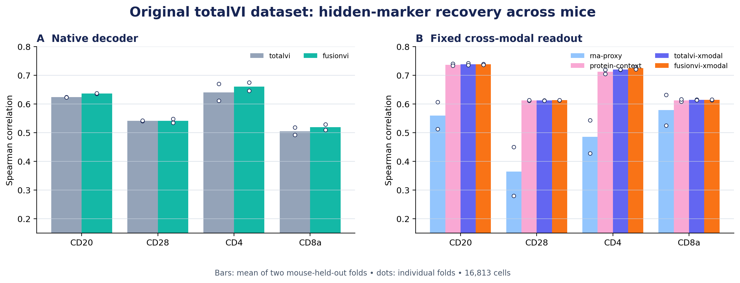
Figure 3. Hidden-marker recovery across the two mouse-held-out directions.

Experiment 4 paper aligned complete missing panel

Biological question and design
Can RNA recover all 110 surface proteins in a batch where no protein measurements enter training? This experiment follows the totalVI paper's Figure 3 design. SLN111-D1 retained RNA and proteins; the entire D2 panel was hidden and preserved only for evaluation. Decoder, likelihoods, latent size, optimizer, split and prediction procedure were controlled. Sixteen paired seeds were run for FusionVI, totalVI and all three Tier 1 controls.
Model | Encoder comparison | Mean RMSLE | Difference vs FusionVI
FusionVI | Separate branches and learned gate | 1.0539 | reference
totalVI | Published joint encoder, width 256 | 1.0601 | +0.0062
Joint same width | Width 128 | 1.0645 | +0.0106
Joint parameter matched | Width 70 | 1.0728 | +0.0189
Joint plus availability | Width 128 and panel indicator | 1.0651 | +0.0112

Result FusionVI's small advantage survives matched encoder controls across 16 seeds.
Against the same-width joint encoder, FusionVI reduced RMSLE by 0.0106 (95% CI -0.0135 to -0.0077; Holm p=3.4e-06) and won 15/16 seeds. Against the parameter-matched encoder, the reduction was 0.0189 (95% CI -0.0216 to -0.0162; Holm p=7.9e-10) with 16/16 wins. Against the missingness-aware joint encoder, the reduction was 0.0112 (95% CI -0.0143 to -0.0081; Holm p=3.4e-06) with 15/16 wins. The availability indicator alone did not help (difference +0.0006; p=0.51).
A source-only RNA baseline fit a 128-component SVD and multi-output ridge on D1, selected its penalty on a D1 validation split, and reached mean D2 protein RMSLE 0.6379. This is substantially below every neural model. Source-defined marker AUROC was 0.976 for CD4, 0.990 for CD8 and 0.995 for CD19, but mean within-cell-type Spearman was only 0.169. Aggregate marker separation therefore does not imply recovery of subtle within-cell-state variation. Modality-dropout arms are implemented but were not part of the completed Tier 1 claim.
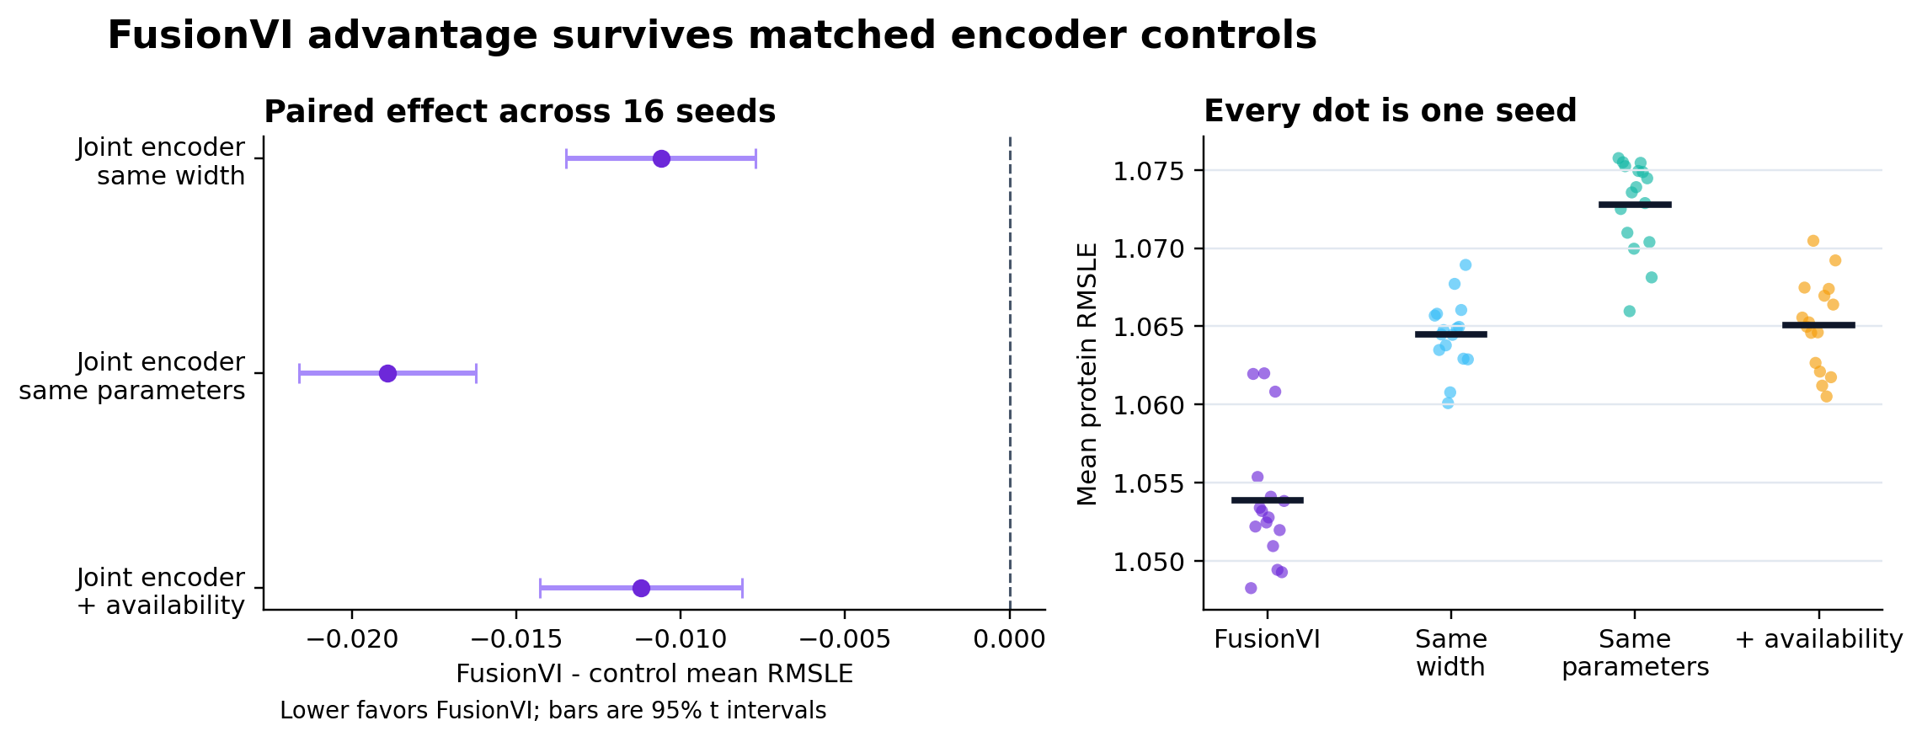
Figure 4. Seed-paired FusionVI contrasts against the three prespecified Tier 1 joint-encoder controls.

Combined interpretation
The experiments support a narrow and biologically coherent contribution. The complete-panel experiment shows a small, reproducible FusionVI advantage over matched joint encoders across 16 paired seeds, while an RNA ridge baseline still performs substantially better on aggregate RMSLE. When other proteins remain available, measured protein context often contributes more than the learned latent. The Papalexi result shows that multimodal context can rank unseen PD-L1 perturbation effects, while the CMTM6 failure exposes a post-transcriptional boundary.
- Controlled benchmark result: FusionVI beat same-width, parameter-matched and missingness-aware joint encoders.
- Negative benchmark result: RNA SVD-ridge outperformed every neural model on full-panel RMSLE.
- Positive result: improved ranking and direction of unseen PD-L1 perturbation effects.
- Negative result: the encoder alone did not consistently improve donor-held-out marker recovery.
- Boundary condition: RNA-centered evidence can fail for protein-stability mechanisms such as CMTM6.
The work is therefore a biomarker-completion and perturbation-ranking study for therapeutic discovery. It does not establish clinical utility, patient-level generalization or replacement of prospective protein measurements.

Reproducibility and limitations
- Lawlor: 10 donors, one dose and one 24-hour timepoint.
- Papalexi: one IFN-gamma-treated cell line and 25 molecular perturbations.
- Targeted SLN111 transfer: two mice, sufficient only for a technical check.
- Complete-panel benchmark: one source-target batch pair and 16 seeds rather than the paper's 30.
- Same-width, parameter-matched and missingness-aware controls are complete; modality-dropout arms remain pending.
- Seed-level inference is primary; per-protein tests are descriptive repeated-outcome summaries.
- Native and X-readout results are separated throughout the report.
- Neural-model foreground, cell-type and marker-AUROC analyses remain pending.
- Consolidated metrics are stored in results/fusionvi_experiments_summary.json.
The current full-panel benchmark is reproduced with .\run_paper_benchmark.ps1. The original Lawlor and Papalexi training pipelines were not retained, so Experiments 1 and 2 are documented from saved held-out predictions, metrics and figures and are not reproducible from a fresh clone. The versioned Papalexi effect table reproduces the target-cluster bootstrap.

References
Gayoso A, Steier Z, Lopez R, et al. Joint probabilistic modeling of single-cell multi-omic data with totalVI. Nature Methods. 2021;18:272–282. https://doi.org/10.1038/s41592-020-01050-x
Lawlor N, et al. Multiomic profiling identifies transcriptional and protein-level immune responses to stimulation. Frontiers in Immunology. 2021.
Papalexi E, et al. Mapping and analysis of perturbation responses in single cells by pooled CRISPR screening. Nature Genetics. 2021.

