Team: Bakhtiyar Rakhimzhanov, Nazira Tukeyeva

Group: BD-1903

Github Link to the Repository: <https://github.com/nazirait/Information-Theory-Project>

_____________________________________________________________________________________

Github Link of Bakhtiyar: <https://github.com/Godadoreu>

Github Link of Nazira: <https://github.com/nazirait>

**Assignment 3 Report**

|  |  |
| --- | --- |
| Task Part | Responsible team member |
| Part 1 – Sorting, dividing the list into parts, splitting text | Nazira |
| Part 2 - Encoding, calculating the compression ratio | Bakhtiyar |
| Assignment Report | Both |

**General Description:**

**Shannon-Fano Algorithm Implementation**

Step 1: Dividing the list and returning each part.

*Source code:*

def divide_parts(lists):

'''The given function divides the list into two parts with the equal

sum of occurences on the right and left parts'''

sums_left = 0

left = []

sums_right = 0

right = []

for x,y in lists:

# sum the probabilities of the elements

sums_left+=y

# store to the list 'left'

left.append(x)

if sums_left>=0.5:

break # stop when the sum is 0.5 or more

for x,y in lists:

if x not in left:

# sum the probabilities of the elements (excluding those in the 'left' list)

sums_right+=y

# store to the list 'left'

right.append(x)

# return the characters and sum of the probabilies on both sides (right and left)

return sums_left,left,sums_right,right

balance = divide_parts(result)

balance

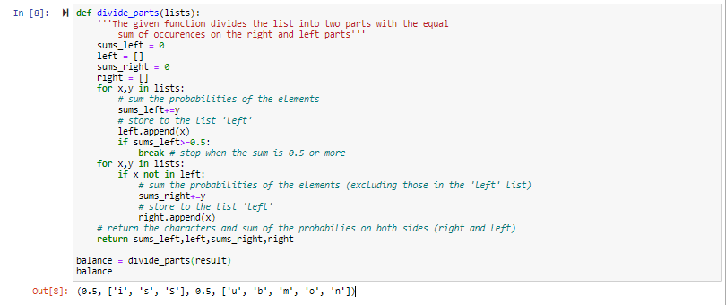

Fig. 1

Step 2: Labeling the elements on the left part as 0 and on the right part as 1.

*Source code:*

def encoding(lists_desc,list_balance):

'''The given function labels the left part

as 0 and the right part as 1'''

prob_left,word_left,prob_right,word_right = list_balance

symbols_left = '0'

symbols_right = '1'

symbols_for_lleft = []

mean_left = (prob_left/len(word_left))

print('Left avg: ', mean_left)

mean_right = (prob_right/len(word_right))

print('Right avg: ', mean_right)

sums_left= 0

sums_right = 0

symbols_for_lright = []

count = 0

symbols_for_rleft = []

symbols_for_rright = []

# left part

for x in word_left:

for key,value in lists_desc:

if key in x:

sums_left+=value

# if the probability value is greater or equal than the left average (0.16)

if sums_left>=mean_left:

symbols_left+='0' # assign those elements as 0 --> 00

# store the key and the encoded part into LeftLeft list

symbols_for_lleft.append((key,symbols_left))

break

else:

# assign those elements as 1 --> 01

symbols_left+='1'

# store the key and the encoded part into leftRight list

symbols_for_lright.append((key,symbols_left))

# ex.: i,s goes to the leftleft - 00, S goes to the leftright - 01

sums_left = 0

symbols_left='0'

# right part

for x in word_right:

for key,value in lists_desc:

if key in x:

symbols_right = '1'

sums_right+=value

# if the probability value is greater or equal than the right average (0.1)

if sums_right>=mean_right:

symbols_right+='0' # assign those elements as 0 --> 10

# store the key and the encoded part into rightLeft list

symbols_for_rleft.append((key,symbols_right))

break

else:

count+=1

# label those elements as '1' --> 11

symbols_right+='1'

# store the key and the encoded part into rightRight list

symbols_for_rright.append((key,symbols_right))

# ex.: all the elements in the right has the prob values of 0.1, so all are labeled as '10'

sums_right=0

return symbols_for_lleft,symbols_for_lright,symbols_for_rleft,symbols_for_rright

encoder = encoding(result,balance)

encoder

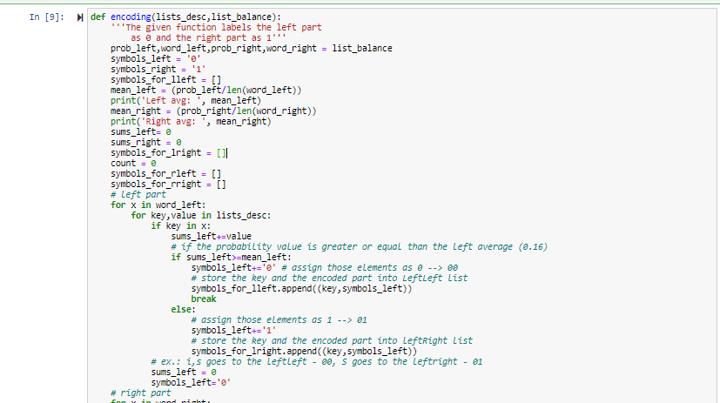

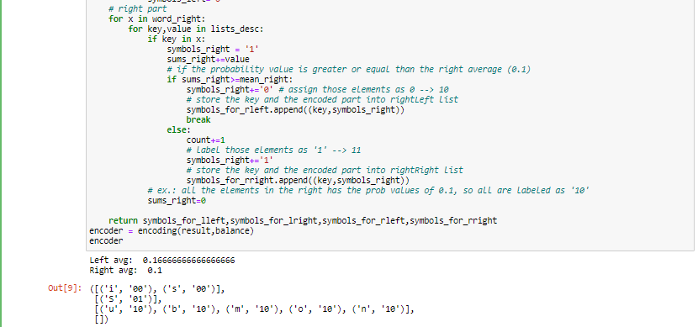

Fig. 2-2.1

Step 3: Displaying the elements along with their codewords sorted by the probability values in descending order.

*Source code:*

def adding(probabilities,code):

'''The given function returns the list with symbols and their

codewords sorted by their probabilities in descending order'''

result = []

symbols_lleft,symbols_lright,symbols_rleft,symbols_rright = code

for key,value in probabilities:

for key1,value1 in symbols_lleft: # s, i - 00

if key in key1:

result.append((key,value,value1))

for key,value in probabilities:

for key1,value1 in symbols_lright: # S - 01

if key in key1:

result.append((key,value,value1))

for key,value in probabilities:

for key1,value1 in symbols_rleft: # u,b,m,o,n - 10

if key in key1:

result.append((key,value,value1))

for key,value in probabilities:

for key1,value1 in symbols_rright:

if key in key1:

result.append((key,value,value1))

return result

third_function = adding(result,encoder)

third_function

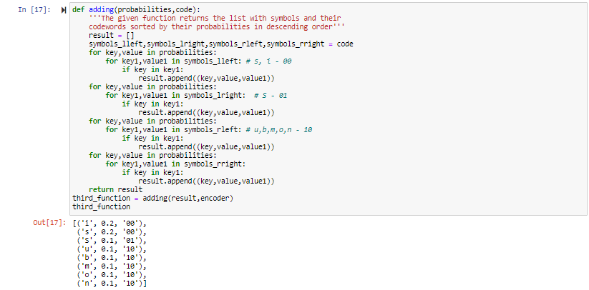

Fig. 3

Step 4: Splitting the text into separate characters.

*Source code:*

def split_text(text):

'''The given function splits the text into separate characters'''

f = open(text)

# reading the file

new_list = []

reading = f.readlines()

for x in reading:

list_x = list(x)

for d in list_x:

new_list.append(d)

return new_list

# Closing the file

f.close()

res = split_text('vil.txt')

res

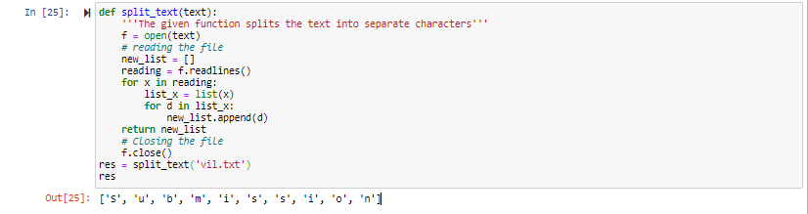

Fig. 4

Step 5: Outputting a sequence of binary digits and saving the result into a new txt file.

*Source code:*

def code_replacement(symbols,lists):

'''The given function returns the encoded part (a sequence of binary digits)

and saves the result into new txt file'''

symbols_lleft,symbols_lright,symbols_rleft,symbols_rright = symbols

resultant = []

new_string = []

for key,value in symbols_lleft:

for i,x in enumerate(lists):

if key==x:

lists[i] = value

else:

continue

for key,value in symbols_lright:

for i,x in enumerate(lists):

if key==x:

lists[i] = value

else:

continue

for key,value in symbols_rleft:

for i,x in enumerate(lists):

if key==x:

lists[i] = value

else:

continue

for key,value in symbols_rright:

for i,x in enumerate(lists):

if key==x:

lists[i] = value

else:

continue

encoded_variant = ''.join(lists)

file = open('new_file.txt','w')

file.write(encoded_variant)

file.close()

return encoded_variant

encoded = code_replacement(encoder,res)

encoded

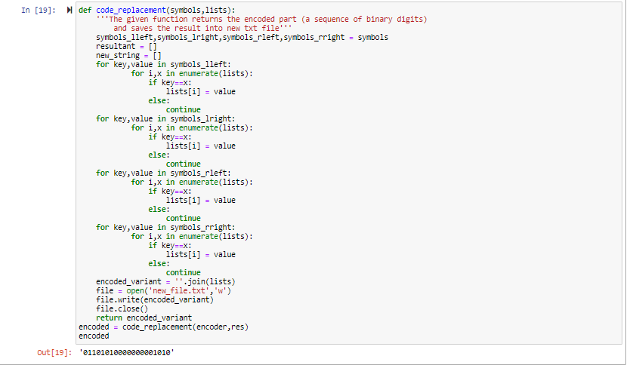

Fig. 5

Step 6: Calculating a data compression ratio including number of bits in original and compressed text, compression ratio and the average code length.

*Source code:*

def compress_ratio(dicte,comp_string,probs):

'''The given function calculates data compression ratio'''

original_string = sum(dicte.values())*7

comp_string_len = len(comp_string)

sums = 0

for key,prob,code in probs:

sums+=prob*len(code)

print('Number of bits in original text: ',original_string)

print('Number of bits in compressed text: ', comp_string_len)

print('Compression ratio: ',original_string/comp_string_len)

print('Average ratio: ', sums)

res = compress_ratio(dicts, encoded,third_function)

res

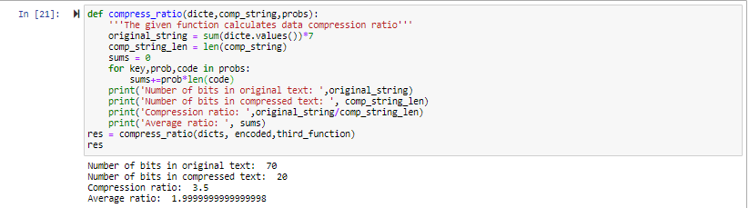

Fig. 6