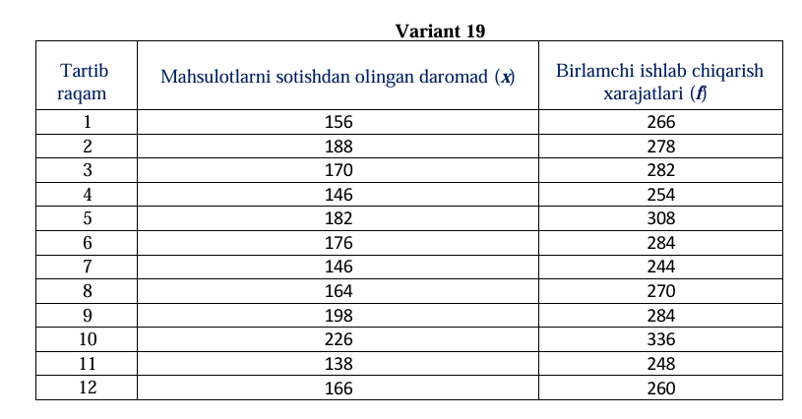
Mahsulotlarni sotishdan olingan daromadlar:
$$x_{i}=\{156, 188, 170, 146, 182, 176, 146, 164, 198, 226, 138, 166\}$$
Kuzatuvlar soni:
$$n=12$$

1️⃣ O‘rtacha qiymat
Formula:
$$\overset{ˉ}{x}=\frac{1}{n}∑x_{i}$$
Excel natijasi:
$$\overset{ˉ}{x}=171.3333$$

2️⃣ Variatsiya chegarasi
Formula:
$$R=x_{max}-x_{min} \\ x_{max}=226,x_{min}=138 \\ R=226-138=88$$

3️⃣ O‘rtacha chiziqli farq
Formula:
$$Δ=\frac{∑∣x_{i}-\overset{ˉ}{x}∣}{n}$$
Excel jadvalidan:
$$∑∣x_{i}-\overset{ˉ}{x}∣=226.6667 \\ Δ=\frac{226.6667}{12}=18.8889$$

4️⃣ Dispersiya
Formula:
$$D=\frac{∑(x_{i}-\overset{ˉ}{x})^{2}}{n}$$
Excel jadvalidan:
$$∑(x_{i}-\overset{ˉ}{x})^{2}=6826.667 \\ D=\frac{6826.667}{12}=568.8889$$

5️⃣ O‘rtacha kvadratik og‘ish
Formula:
$$σ=\sqrt{D} \\ σ=\sqrt{568.8889}=23.8514$$

6️⃣ Variatsiya koeffitsienti
Formula:
$$V_{σ}=\frac{σ}{\overset{ˉ}{x}}⋅100\% \\ V_{σ}=\frac{23.8514}{171.3333}⋅100=13.9211\%$$

7️⃣ Moda
Eng ko‘p takrorlangan qiymat:
$$\text{Mo}=146$$

8️⃣ Mediana
Tartiblangan qator:
$$138, 146, 146, 156, 164, 166, 170, 176, 182, 188, 198, 226 \\ \text{Me}=\frac{166+170}{2}=168$$