

Data Science Program
Department of Data Science
DATS 6501 - Capstone Project - Fall 2026

Post-Training Analysis & Novelty Detection Using
Neural Network Self-Organizing Maps (NNSOM)

Week 2 Report
Baseline Model Training & Latent Feature Extraction

Capstone - Group 5
Fyrooz Khan
Nazish Atta

The George Washington University
Washington, DC

Supervised by
Dr. Amir Jafari
Associate Professor of Data Science

1. Week 2 Overview
Week 2 completed the baseline modeling stage of the capstone. The MNIST dataset was prepared using a stratified 70/15/15 train-validation-test split, a LeNet-5 convolutional neural network was trained and evaluated, and 84-dimensional feature embeddings were extracted from the penultimate fc2 layer for later Self-Organizing Map analysis.

2. Methodology
Item | Week 2 Setup
Dataset | MNIST, 70,000 grayscale images (28 x 28)
Split | 49,000 train / 10,500 validation / 10,500 test
Model | LeNet-5 CNN
Training | 20 epochs, Adam optimizer, cross-entropy loss
Feature layer | fc2 penultimate layer, 84 dimensions

The best validation checkpoint was used for final test evaluation and feature extraction. The saved fc2 embeddings from all three splits provide the input for NNSOM in Week 3.

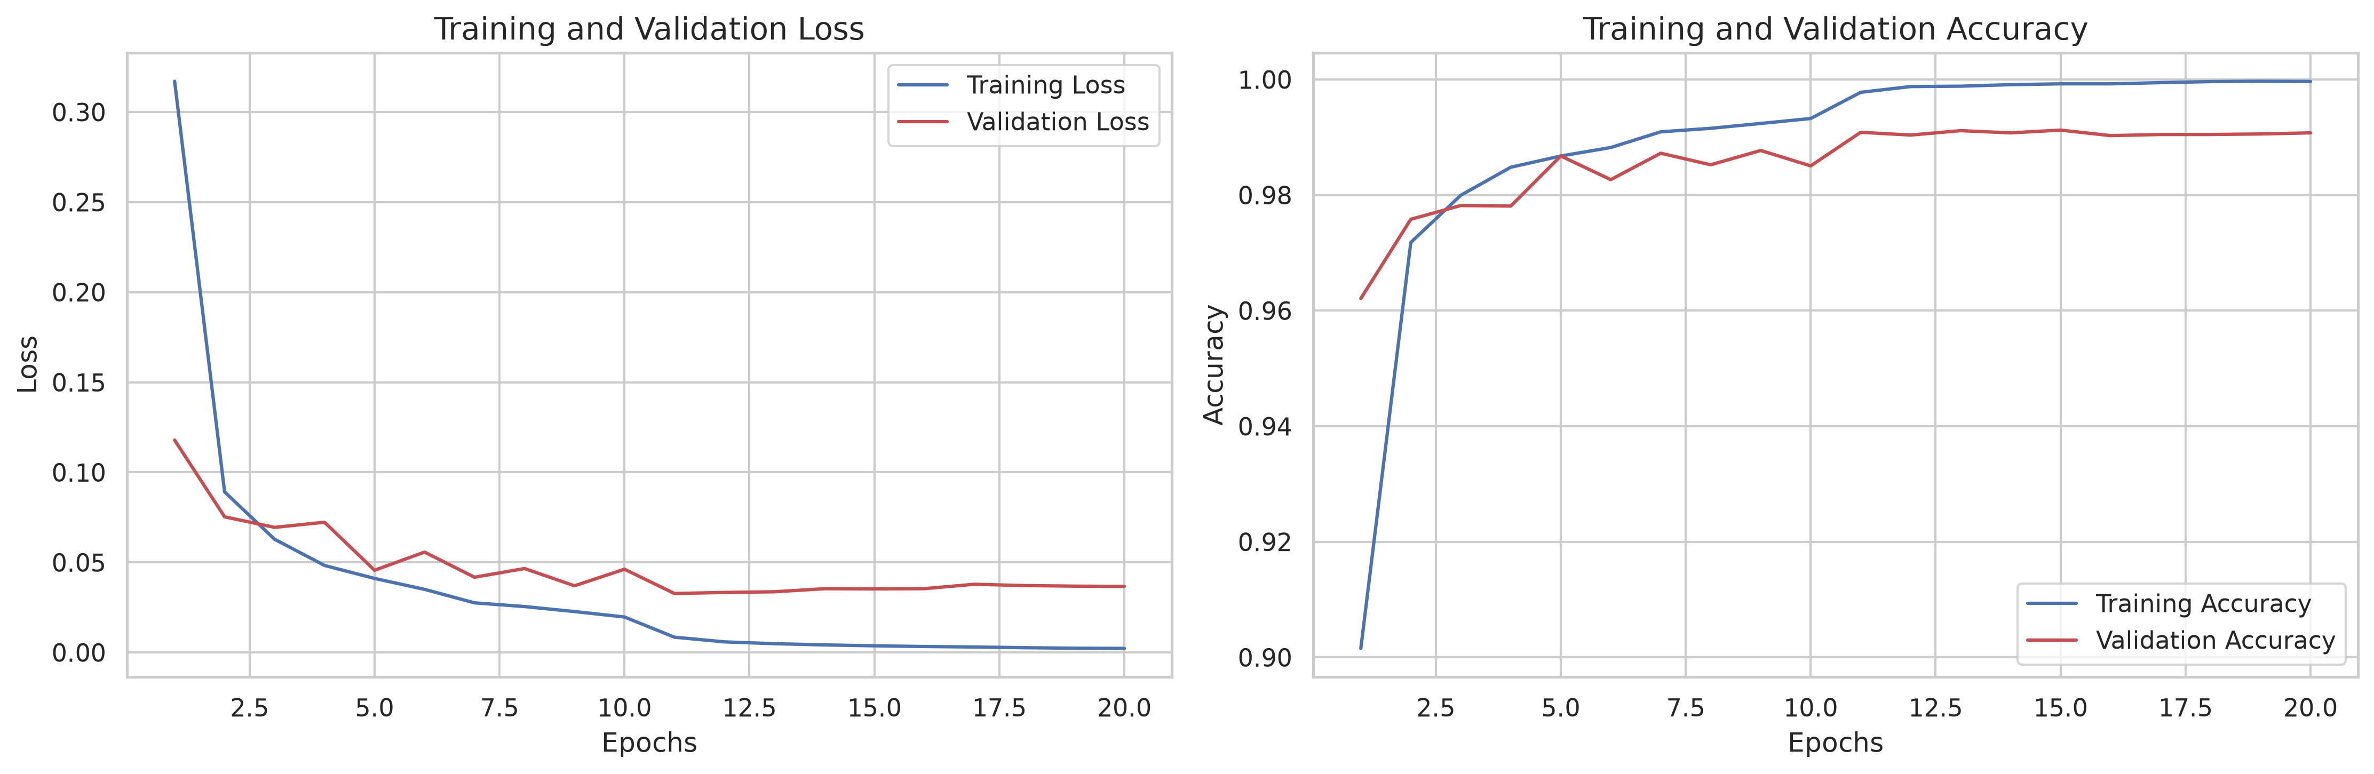
Figure 1. Training and validation loss/accuracy across 20 epochs.

3. Results
Metric | Result
Test accuracy | 99.18% (10,414 / 10,500)
Macro F1-score | 0.9918
Misclassified samples | 86 (0.82%)
Embedding output | 84-dimensional fc2 vectors

The baseline generalized well to the held-out test set. Errors were sparse and concentrated among a small number of class pairs; the most frequent individual confusions included 7 -> 1, 5 -> 8, and 2 -> 8, with four cases each. Digit 0 had only one misclassification.
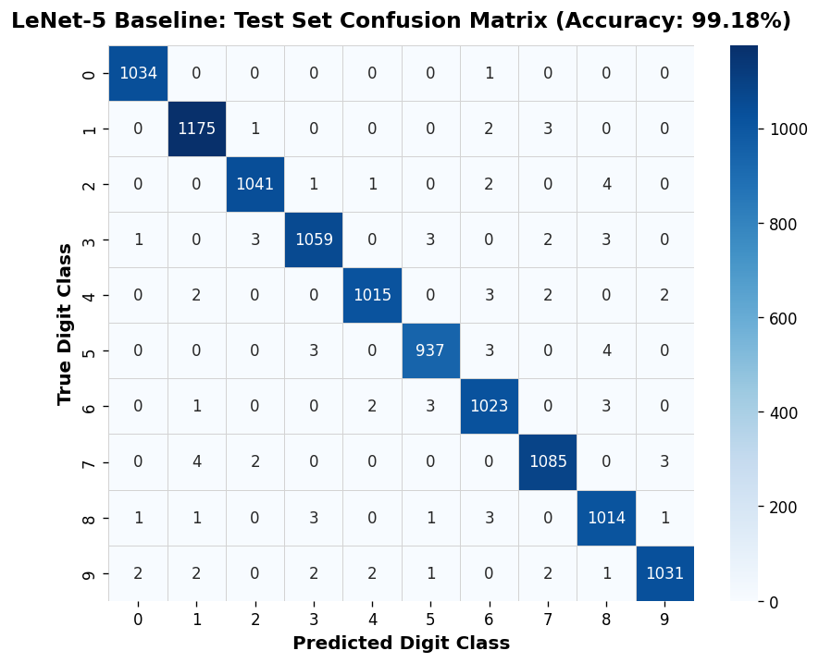
Figure 2. Test-set confusion matrix. The strong diagonal indicates high class-level accuracy.

4. Latent Feature Representation
For every sample, the 84-dimensional activation from the fc2 layer was extracted and saved. This representation captures the learned features immediately before the final classification layer and is the feature space that will be analyzed with NNSOM.
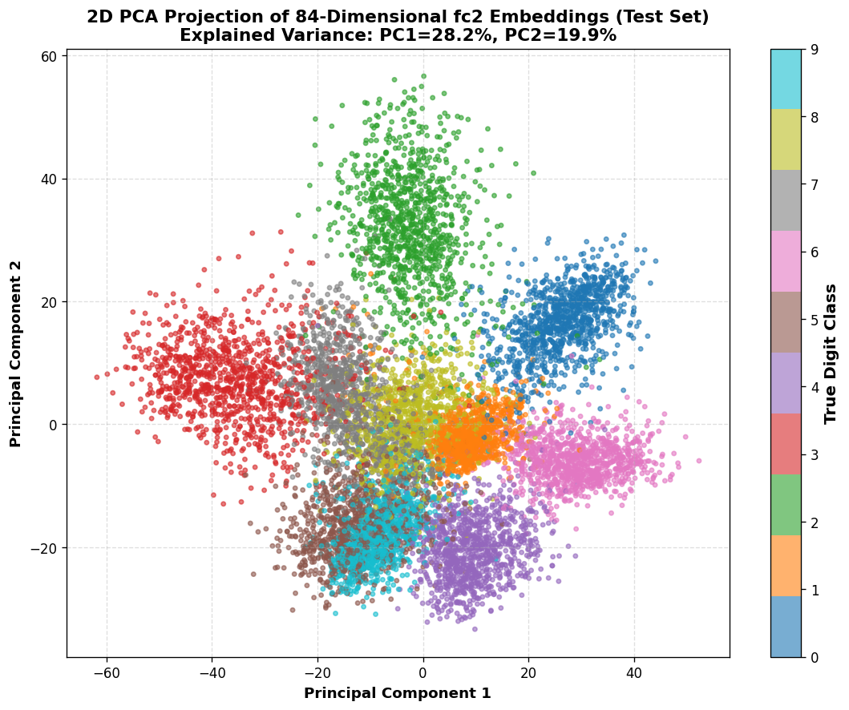
Figure 3. PCA projection of the 84-dimensional fc2 test embeddings for visualization only.

The PCA view is only a preliminary 2D visualization; Week 3 will use the full 84-dimensional training embeddings as the actual input to NNSOM.

5. Conclusion and Week 3 Transition
Week 2 established a reproducible MNIST baseline and produced the feature embeddings required for the next phase. In Week 3, NNSOM will be configured and trained on the 49,000 training embeddings to map samples to Best Matching Units, monitor quantization error, and visualize class organization using SOM-based plots such as hit maps and the U-Matrix.

References
LeCun, Y., Bottou, L., Bengio, Y., & Haffner, P. (1998). Gradient-based learning applied to document recognition. Proceedings of the IEEE, 86(11), 2278-2324.
Kohonen, T. (1990). The self-organizing map. Proceedings of the IEEE, 78(9), 1464-1480.
Jafari, A. NNSOM: Neural Network Self-Organizing Maps in Python. The George Washington University. https://amir-jafari.github.io/SOM/

