**POPULAR SOUTH**AFRICAN ATTRACTIONS

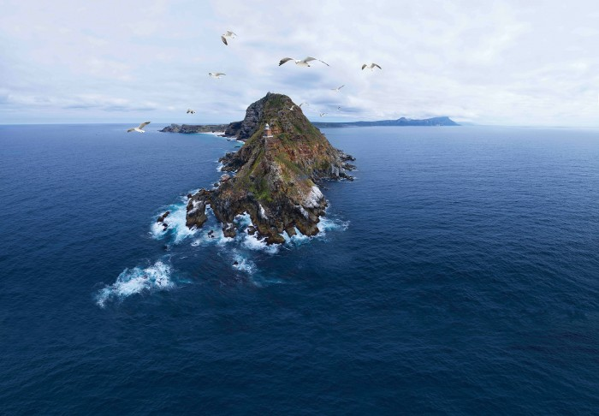

**1**

Cape Town & Cape Peninsula

Cape Town and the Cape Peninsula up to Cape Point, are famous for scenic beauty; celebrity beaches; Table Mountain; whale-watching; world-class shopping, nightlife, food & wine; and a laid-back atmosphere.

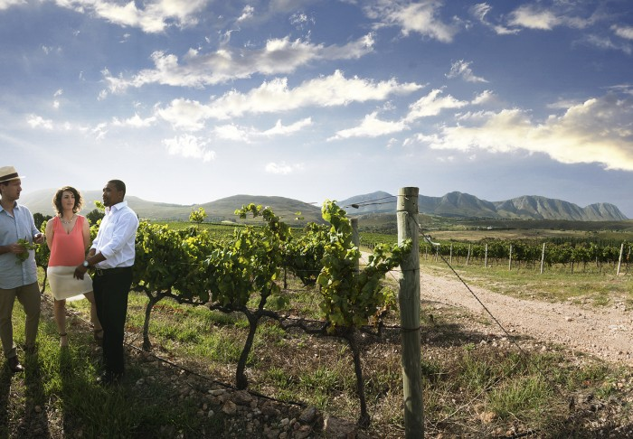

**2**

The Winelands

Discover the joys of SA’s award-winning wines and cuisine along any of the beautiful Cape wine routes, taking you through green valleys and historic towns.

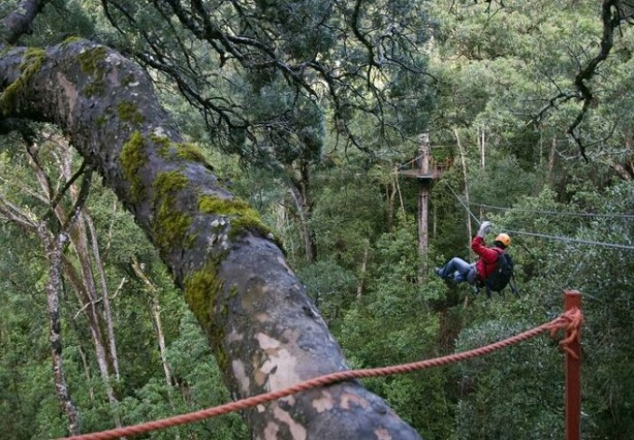

**3**

Garden Route

Known as South Africa’s Eden, the famous Garden Route traverses an area rich in natural beauty and charm, attracting adventure-seekers and outdoor enthusiasts.



**4**

Johannesburg

South Africa’s pulsating African heartbeat is felt in the ‘City of Gold’ with its endless opportunities for shopping, entertainment, freedom tours and eating out.

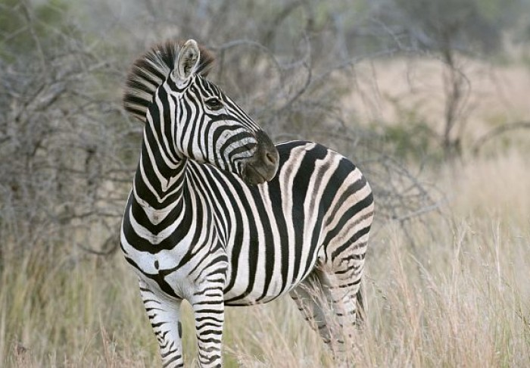

**5**

Kruger National Park

This world-renowned park of nearly 2 million hectares features 16 ecosystems. Spot the Big Five on a 4x4 game drive or walking safari.

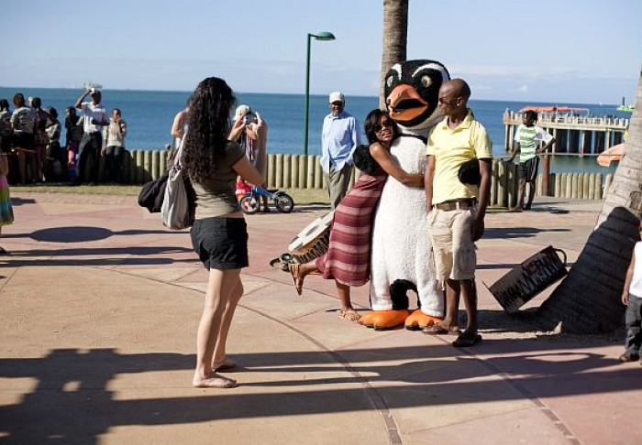

**6**

Durban beachfront

For those with fun and sun on their minds, SA’s sunshine city has something for the whole family - golden beaches, surfing and a marine park.

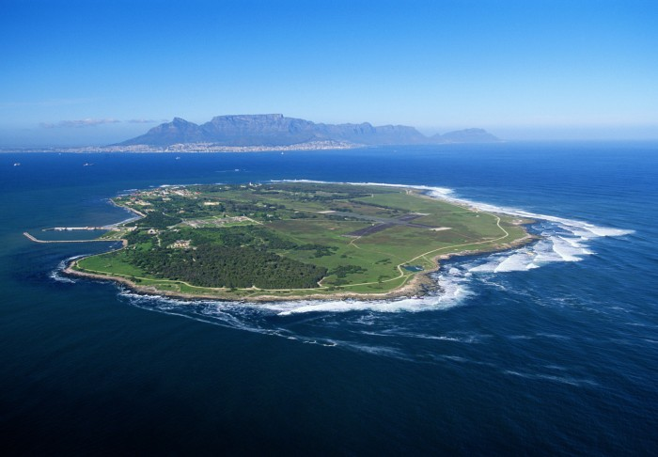

**7**

Robben Island

The island’s most famous prisoner, Nelson Mandela, has turned this institute of brutality into a symbol of the triumph of the human spirit over enormous hardship.

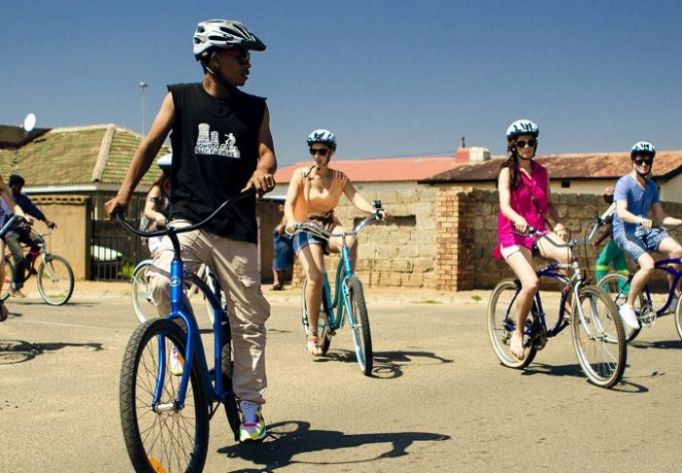

**8**

Soweto

South Africa’s largest and most famous township was a hotbed of anti-apartheid activity. Visit Freedom Struggle sites and eat at a shebeen or township restaurant.

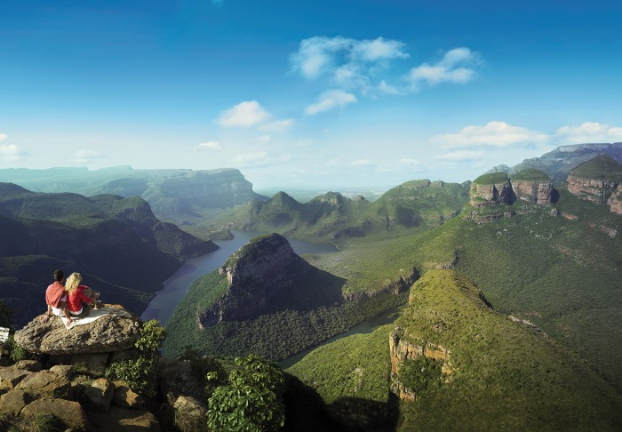

**9**

Blyde River Canyon Nature Reserve

Most famous for God’s Window, the panoramic splendour of the Blyde River Canyon makes it ideal for scenic drives and hiking trails.

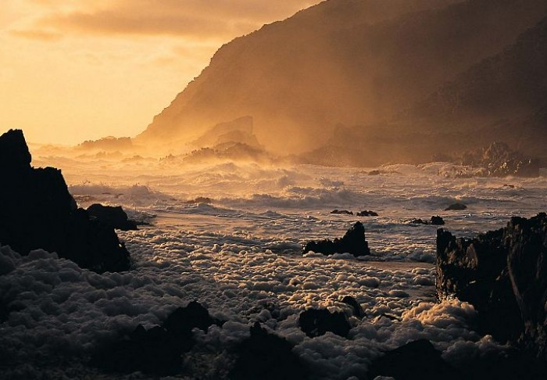

**10**

Wild Coast

Rugged and untamed, the Wild Coast offers deserted beaches, dolphins, horseback and hiking trails, cosy hotels, golf, gambling, mystical history, Xhosa heritage and the Hole-in-the-W