**1. Tiger’s Nest Temple, Bhutan**

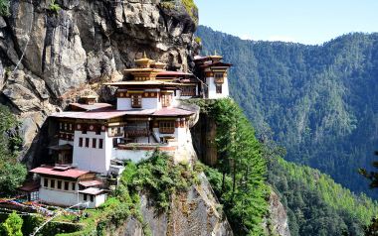

Also known as Taktsang, it is a sacred monastery built on a rocky cliff 3,000 feet above the Paro valley. Legend has it, some 1,300 years ago, Guru Rinpoche materialized on the back of a flying tigress and converted the Bhutanese to Buddhism at this place.

This is a must-visit place because of the unique location and view that will leave you mesmerized. The background story of this place makes it even more unique and worth seeing.

**2. Siem Reap, Cambodia**

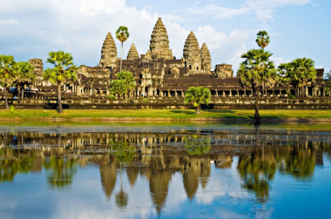

Siem Reap is the capital of the province Siem Reap in Cambodia. One of their most famous sites to visit is the Angkor Wat temple. Besides that, they have many more temples, museums, the Old Market and the Cambodian Cultural Village.

With plenty of touristic attractions, it still doesn’t feel overcrowded. You will be able to take in the culture and habits of locals.

**3. Bokeo Nature Reserve, Laos**

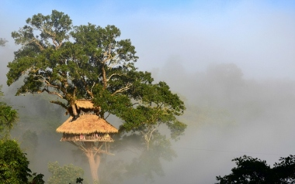

Located in the Bokeo province in Laos, this nature reserve was created to protect the black-cheeked gibbon. To view the gibbons or experience the beauty of the forest, you can use the Gibbon Experience. You can also join the Waterfall Gibbon Experience, which includes three hours of trekking along the Nam Nga River.

This amazing experience is nowhere else to be found. You get to see beautiful nature and the black-cheeked gibbon, which was thought to be extinct!

**4. Kuala Lumpur, Malaysia**

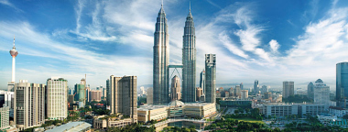

Kuala Lumpur is the capital of Malaysia. It is an amazing place to visit because of the variaty of things to do and see. The architecture ranges from cultural to modern. The most touristic sites are China Town, the Petronas Twin Towers, the Buta Caves and Central Market.

This city has such a wide variety of sites, everyone should see it for themselves. It has the beauty of old, traditonal buildings next to the modern towers.

**5. Ha Long Bay, Vietnam**

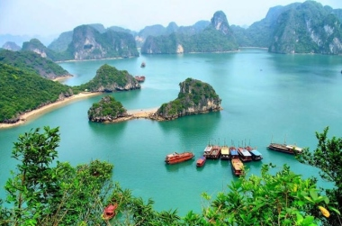

As one of the UNESCO World Heritage Sites, this bay is a must-visit. There exists over 3,000 islands and it is inhabited by about 1,600 people living in floating villages. To make the most out of your visit, you should take a cruise and experience life from the water.

The beauty of the nature will leave you in awe. This is for sure a must-visit place.

**6. Danxia Landform, China**

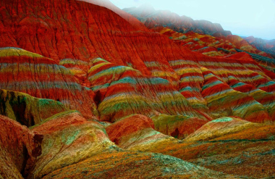

These beautiful landscapes are unique to China. Formed out of red sandstone and strong forces, these landscapes were added to the World Heritage List in 2010. This is one of the places you must see for yourselves!

**7. Rainbow Family Village, Taiwan**

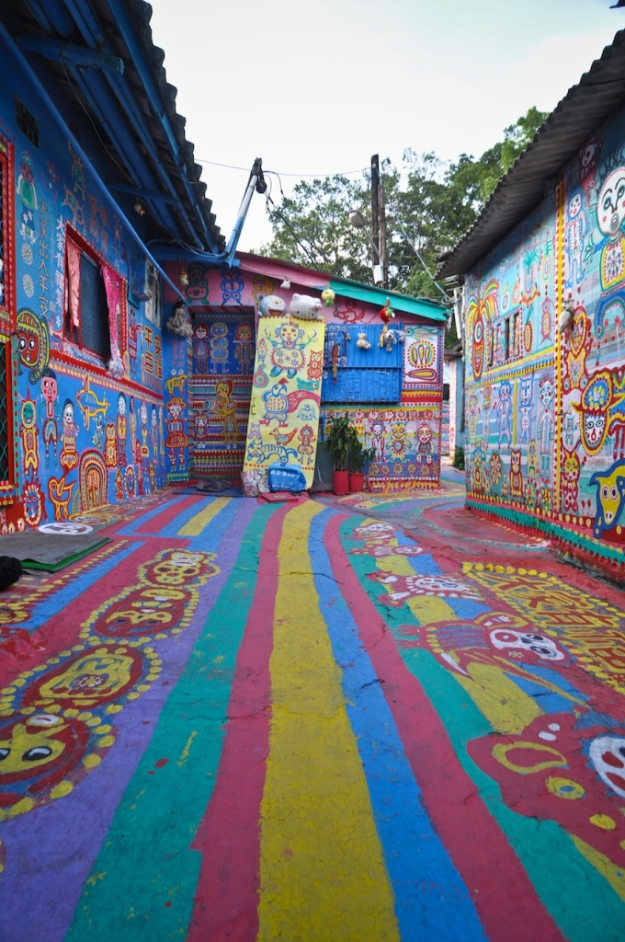

A little while ago, an old man began to paint. This man’s name was Huang Yung-Fu, also known as Grandpa Rainbow. He lives in a military dependents’ village and one day decided to make this place more colorful. It is a beautiful place with a unique story. You will love to see all the colors and it will move you deep inside your heart. Definitely a must-see!

**8. Taj Mahal, India**

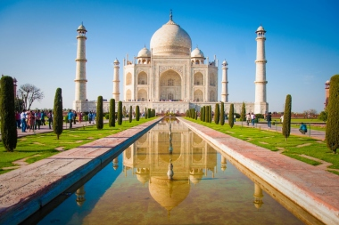

In 1632 an Emperor started with the construction of a mosque to commemorate his favorite wife. It was finished in 1648 and it is the jewel of the muslim community in India. It has beautiful gardens, symbolizing paradise, or a heaven on earth.

If you have not yet seen this beautiful white marble mosque, be sure to visit it when you can!

**9. Great Wall of China, China**

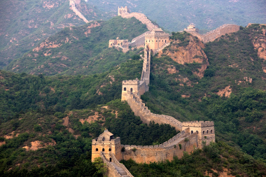

This massive structure was originally built as a defense wall. With a length of  3945 miles, it is the longest wall on earth. Many parts of the Wall have been damaged and are no longer accessible. To see the Great Wall yourself, you best go to Qinhuangdao or Beijing.

**10. Shinjuku Gyoen, Japan**

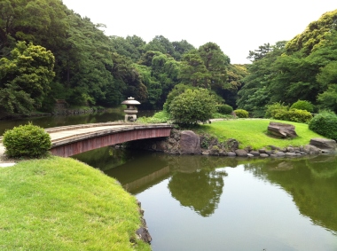

This beautiful park is located in Tokyo. It was originally completed in 1772, but the current layout was formed in 1906. The garden is 58.3 hectares in area, and it has over 20,000 trees. The greenhouse has over 1,700 different tropical and subtropical plant species on display.

**11. Yolyn Am, Mongolia**

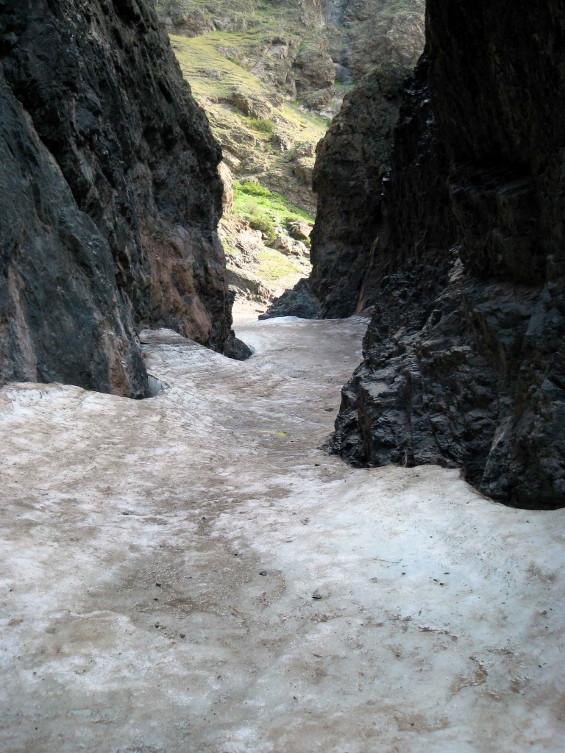

Also known as the Valley of Eagels, the deep, narrow gorge is unique for it’s thick ice field. It is located in the Gobi Dessert. Because it is so deep and narrow, it is like an oasis in the desert, always remaining cool.

**12. The War Memorial of Korea, South Korea**

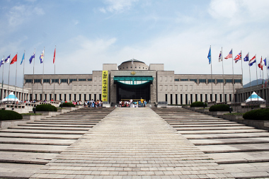

This former site of the army headquarters has six indoor exhibitions and over 13,000 memorabilia outside. In the combat experience room you can experience different situations that soldiers went through during the Korean war.

**13. Bali, Indonesia**

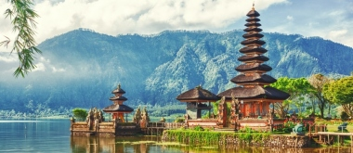

Sun, a deep blue sea and long beaches. Bali could be the tropical paradise for you!

Besides the beach, you can also visit caves, dive or visit temples. With a great climate and different places to discover, this is an amazing island to visit.

**14. Hong Kong, China**

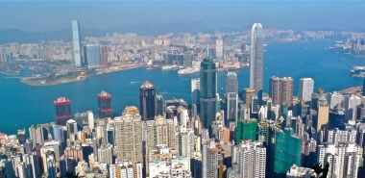

If you want to visit a city for shopping, you must go to Hong Kong. For designer fashion, visit the Landmark Mall, also known as Central. There are plenty of street markets for different interests too. You can simply shop till you drop!

**15. Daehan Dawon, South Korea**

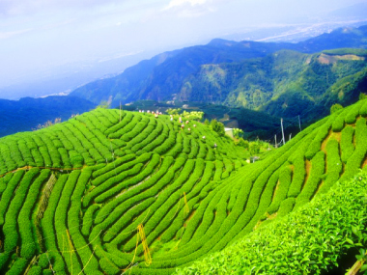

Boseong is the home of green tea plantation in South Korea. Deanna Dawon is a tourist plantation which provides 40% of the country’s green tea. Relax with the beautiful scenery of these tea fields.

**16. The Mekong Delta, Vietnam**

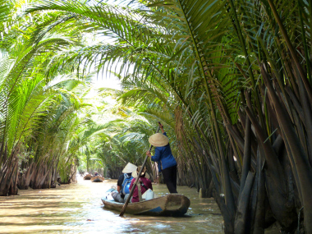

The Mekong River provides ways for the locals to sell their crops. You can find pretty much all the tropical fruits you can think of. Floating along the river, the view is beautiful and tropical. You can get off the river at different locations, to visit the city or temples. The friendly locals will welcome you with open arms.

**17. Patong, Thailand**

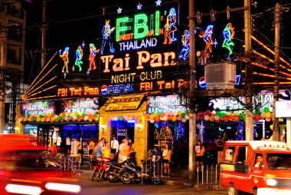

Patong is the place to go for a great nightlife. At night there are over a hunderd restaurants, bars and discos. The main goal; have a good time!

**18. Phewa Lake, Nepal**

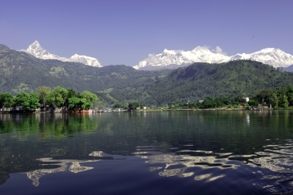

Phewa Lake is the second largest lake in Nepal. It is near the Tal Barahi Temple and Baidam, also known as the Lakeside. From here you can also take a tour to Pokhara, the most touristic city in Nepal.

**19. Banaue, Philippines**

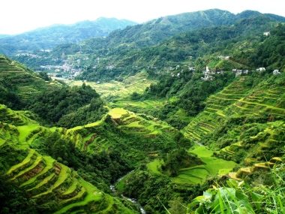

Banaue is a small town in the Philippines. It is well known for the rice terraces. The rice terraces were handmade many years ago and are now part of the UNESCO World Heritage Site.

You may see it many times in pictures or video, but you cannot grasp the amazing beauty until you see it for yourself!

**20. Shwedagon Pagoda, Maynmar**

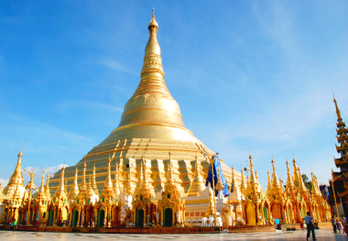

The Shwedagon Pagoda is the biggest, most sacred Buddhist pagoda in Maynmar. It is 325 feet tall, covered in gold and has over 7,000 gems. It is said to be over 2,500 years old, but there are no existing construction papers. This magnificent building is a must-see in Asia!