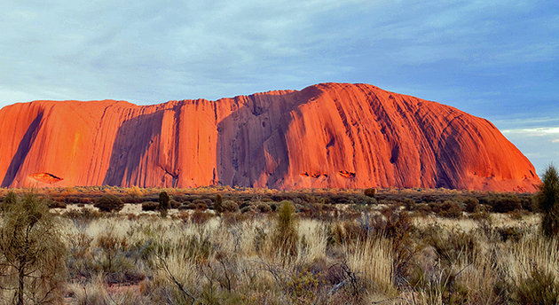**Uluru-Kata Tjuta National Park**

Deep in the heart of the Australia's Red Centre, **Uluru** (formerly **Ayers Rock**), is one of the most photographed natural wonders in the country. The striking red monolith forms the centerpiece of Uluru-Kata Tjuta National Park, a World Heritage Area jointly managed by Parks Australia and the traditional landowners, the Aṉangu people. Uluru, meaning "shadowy place" in the local aboriginal dialect, rises to a height of 348 m from the surrounding plain with most of its bulk hidden beneath the earth's surface. Also in the park are the red dome-shaped rocks called **Kata Tjuta** (the Olgas). As the sun dips in the sky, visitors gather to watch Uluru and Kata Tjuta transform in the shifting light. A great way to appreciate these sacred structures is to join a tour around the sites led by Aboriginal guides and rangers.

## Sydney Harbour Bridge

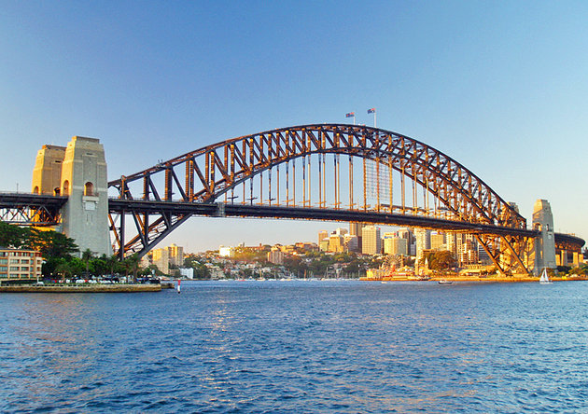

Along with the Opera House, the Sydney Harbour Bridge is one of Australia's most famous icons. Affectionately called "the Coathanger", this impressive feat of construction is the largest steel arch bridge in the world. It was completed in 1932, 40 years before the Sydney Opera House. Rising 134 m above the harbor, the bridge spans 500 m connecting Sydney's north shore to the central business district. In addition to the pedestrian path, two railway lines extend over the bridge as well as eight lanes for road traffic, the direction of which can be switched to accommodate traffic flow.

One of the top things to do in Sydney is a guided ascent to the top of the bridge where visitors can enjoy spectacular views over the harbor and city. For an overview on the bridge's history and construction visit the **museum**in the southeastern pier. Interestingly, Paul Hogan, of Crocodile Dundee fame, worked as a painter on the bridge before rocketing to international stardom.

## 5 Blue Mountains National Park

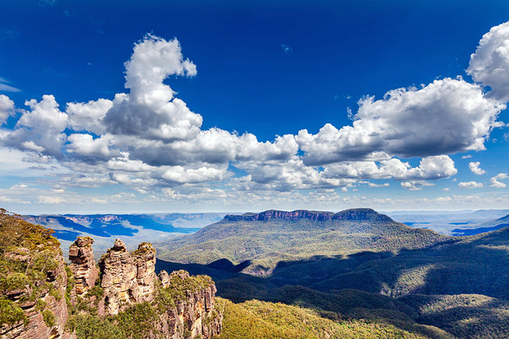

Blue Mountains National Park

A UNESCO World Heritage Site, beautiful Blue Mountains National Park lies 81 km west of Sydney and is a popular day trip from the city. Named for the blue haze emanating from the many eucalyptus trees, this stunning park protects more than 664,000 acres of bush land and encompasses dramatic gorges, waterfalls, aboriginal rock paintings, and 140 km of hiking trails. The most famous attractions in the park are the towering sandstone rock formations called the **Three Sisters**. Other highlights include the **Katoomba Scenic Railway**, the world's steepest, which whisks passengers down the Jamison Valley through a cliff side tunnel into an ancient rainforest. Hiking, abseiling, rock climbing, mountain biking, and horseback riding are all popular things to do in the park.

## 6 Melbourne

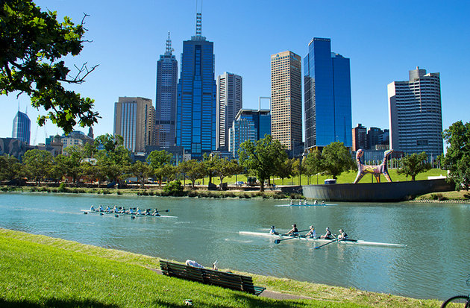

Melbourne, Australia's second largest city, is a popular stop on many Australia itineraries. Galleries, theaters, restaurants, shops, and a distinctly European feel are the main draws of this sophisticated city on the Yarra River. It's also a green city with parks, gardens, and open spaces occupying almost a third of its total area. Highlights of the city include the **Royal Botanic Gardens**, the **National Gallery of Victoria**, and the **Melbourne Cricket Ground** where sports fans can watch cricket in the summer and Australian Rules football in the winter. Shoppers flock to the elegant Royal Arcade on Bourke Street, as well as Chapel Street, the Melbourne Central Shopping Center, and the Queen Victoria Market, which has been selling fruits, vegetables, clothes, and crafts for more than a century. To the east, greater Melbourne extends into the beautiful Dandenong Ranges, and in the south to the Mornington Peninsula where many locals escape for seaside getaways.

## 7 Bondi Beach

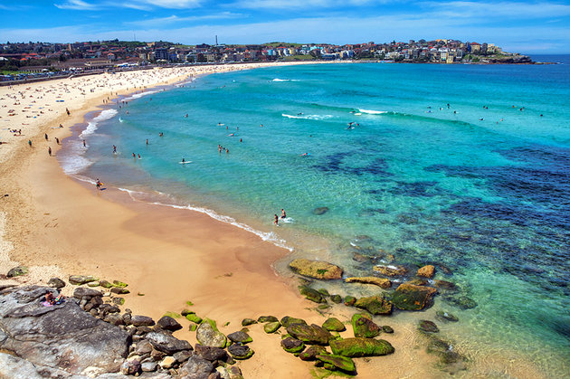

Bondi Beach

Bronzed bodies, blond sand, backpackers, and surf - throw it all together and you get one of the world's most famous beaches. Only 15 minutes by car from the city center, Bondi Beach is home to one of the oldest surf life-saving clubs in the world. It's also a great spot for a seaside stroll or picnic. The scenic **Bondi to Bronte** coastal walk begins at the southern end of the beach and follows the coastline for 6 km along sandstone cliffs. Shops, cafes, and restaurants lie across the street from this famous coastal strip, and the beach is a hotspot on Christmas Day and New Year's Eve. Tourists and locals alike visit the Sunday markets and frolic at the ocean pool and skate park. Strong rip tides often sweep unsuspecting swimmers out to sea, especially at the southern end of this kilometer-long strand, so swimmers should stay between the flags. There's a reason the Aussies made a reality TV show called "Bondi Rescue."