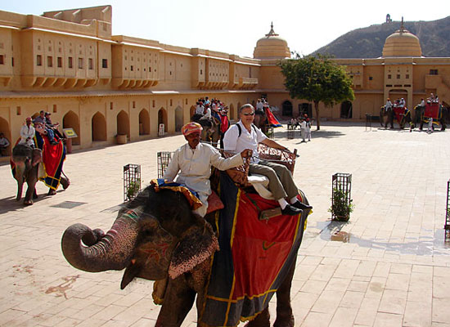**North India Forts And Palaces**

The Northern Region Of India Is Festooned With Some Marvelous Architectural Wonders Including Wonderful Forts And Palaces. This 6- Night And 7-Day North India Forts And Palaces Tour Is The Best As Well As The Shortest Way To Witness The Gems Of The Indian Culture. During This Well-Planned Tour, You Cover The Sought-After Golden Triangle Tour Destinations Of Delhi, Jaipur And Agra, Some Of The Most Well-Known Cities In The Global Circuit.  Every City Has To Offer Something Distinct To Tourists. Delhi Is An Amalgamation Of Every Caste, Religion, Food, And Monuments. While Agra Is Home To The Taj Mahal And Other Mughal Structures, Jaipur Has Numerous Rajputa Palaces And Forts.

**Mandu Tour**

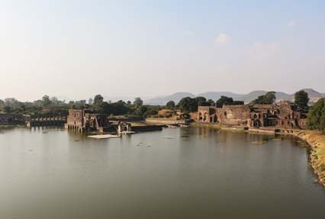

Short Escape To Mandu By Indian Holiday Is A Unique Tour Package Which Takes You Through Beautiful Destinations Including Mandu And Dhar. The Tour Promises You A Memorable Experience Which Will Be Set Amid The Beautiful Palaces, Forts And Mosques.

# Magnificent Rajasthan Tour

# 

He Name ‘Rajasthan’ Conjures Up Visions Of Forts, Palaces, Deserts And National Parks. Rajasthan Tourist Places Are All About Luxury, Lifestyle, Grandeur And Richness Of A State. Also, The Culture Of This City Has Something Wonderful To Offer. Jaipur, The Land Of Maharajas, Boasts Of An Elaborate Architecture And Breathtaking Views. Jodhpur, The Famous ‘Blue City’, Is Quite Famous For Its Blue Buildings. Jaisalmer And Bikaner Are Gateway To The Desert Expanse Of Rajasthan.

The ‘Magnificent Rajasthan’ Tour Package, Spans Over 5 Nights And 6 Days, Covers Some Of The Best Destinations In Rajasthan Which Include Jodhpur, Jaisalmer, Bikaner And Jaipur. Read The Itinerary Given Below For Your Kind Perusal.

# Glimpses Of Mewar

# 

Located In The Western Part Of The Country, Rajasthan Is Renowned For Its Royal Past And Famed Art And Culture. With Breathtaking Attractions, The State Allures Travelers From All Parts Of The World. From Legendary Forts To National Parks And Pre-Historic Buildings, The Tour Offers Great Sightseeing Options To All The Travelers. Through This Itinerary, You Have A Chance To Explore Rajasthan Culture Through The Artifacts, Wooden Carvings, Colorful Fabrics And Bright Turbans. In This Tour, We Take You To Major Cities Of Rajasthan Namely- Jaipur, Chittorgarh, Udaipur And Mt. Abu.

**Note :**This Is Just A Suggested Itinerary Indicative Of What Could Be Possible. We Tailor Holidays For Your Specific Needs. Contact Us If You Want Modifications So That We Could Tailor A Holiday To Suit Your Need For An Unforgettable India Tour.