***[Save up to 50% on India Hill Stations Tour Packages](http://www.tourmyindia.com/packages-tour-india/hill-stations/index.html)***

The most visited Hill stations in North India are as follows:

1. **Nainital**

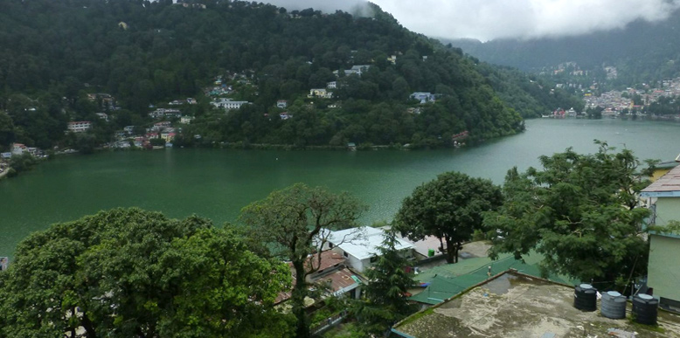

Based in the Kumaon region of Uttarakhand surrounding the volcanic lake Nani, [Nainital](http://www.tourmyindia.com/hill_stations/nainital.html) is adored by millions and is often referred as the ‘Lake District’ of India. It is a destination for all, whether you are looking for a perfect family outing, or a romantic getaway. It is well connected by the major cities and offers a lot to rejuvenate your body and soul. Nainital Mountaineering Club; the name is enough to cheer the adrenaline seekers. With the variety of treks and the picturesque locations, Nainital is surely a must visit location.

### 2- Shimla

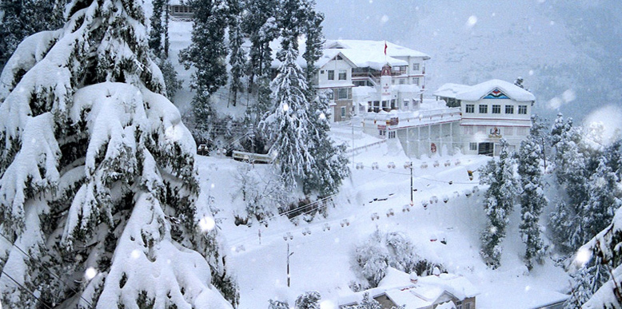

### The once summer capital of the British, now the capital of Himachal Pradesh, is surely a delight for the eyes. With its spectacular vista, [Shimla](http://www.tourmyindia.com/hill_stations/shimla.html) is a region that is highly appreciated for its ethnic culture and eternal beauty. “Nati”, a local form of dance could be seen performed by the ever-friendly jubilant locals. Shimla is also an architectural paradise, flaunting many splendid colonial architecture buildings.

### 3- Manali

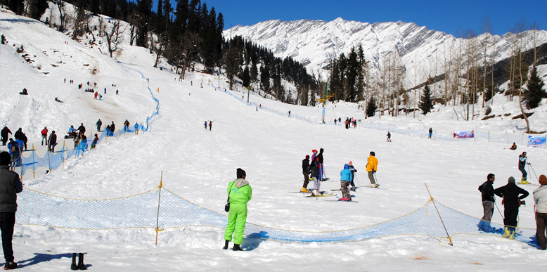

### It is a retreat in Himachal Pradesh, well known for its bewitching beauty and numerous adrenaline pumping activities. From Heli Skiing to the Temples, it has a varied diversity of everything. [Manali](http://www.tourmyindia.com/hill_stations/manali.html) is also renowned as the “Prime Honeymoon destination”, of India. Last but not the least, it the starting point of the most fascinating and enthralling highways in India – The Leh-Manali Highway.