**CAPSTONE PROJECT 1**

**1)Sales Data analysis using S3, EMRHive, tableau**

**Analyze and generate dashboards using the insights from the provided sales data using AWS S3, EMRHive and Tableau. Some important insights could be but not limited to Units sold by country, Total revenue and cost per country etc.**

**solution:**

There are 3 stages required in given project

1)data analysis using aws s3 bucket.

2)data load into EMR HIVE .

3)data load into tableau and generate a dashboards.

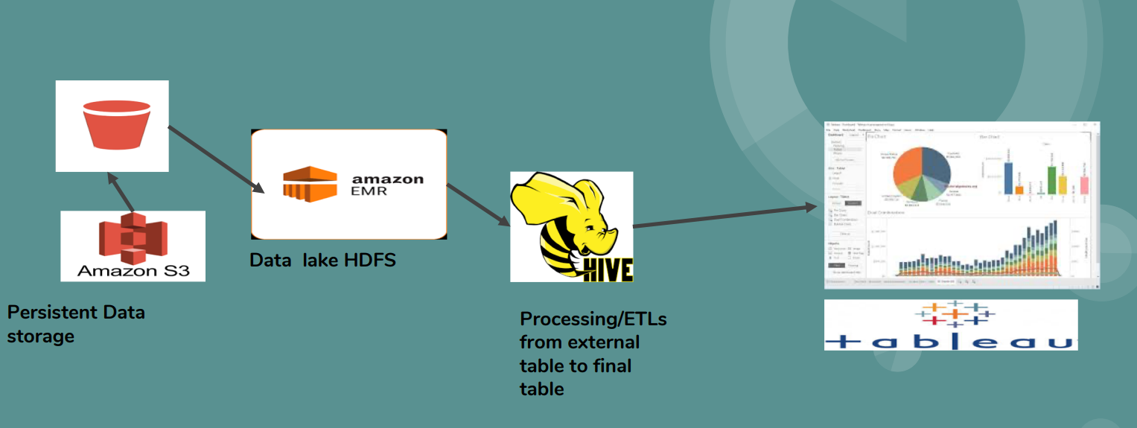

**stage1:**

--> login to AWS account and open Amazon s3 created new bucket "capstoneprjt".

--> I created new folder name"csv".

--> in that csv folder i uploaded given database"sales_data.csv".

--> by selecting the sales_data we can able to see how data is available in that given csv file.

select sales_data-->actions-->querry-->run the querry.

successfully uploaded data into s3 bucket.

**stage2:**

-->we have to create EMR cluster to connect EMR HIVE.

creation of cluster:

--> opened EMR and created new cluster name"capstone1".i choosed default values emr 5.36.0,m5.large,i kept auto termination 4hours.last we have to give keypair. so open EC2

select keypairs-->create keypairs-->'saleskeypair'-->.pem(here automatically .pem file will be download into our pc)-->open puttygen-->load our .pem file-->saveprivatekey-->.ppk file save.

-->choose the keypair name into creating cluster and hit on create cluster.

successfully EMR cluster created.

-->choose master link and edit inbounded rules(SSH& MYIP)save.

-->copy master node link

-->open putty-->paste the master node link-->add-->auth-->choose .ppk file -->open.

by accepting the window it will directly connect to EMRHIVE.

-->hive-->show databases;(default databse will shown)

-->create databse salesdb;

-->use salesdb;

**Creating external table:**

-->create external table if not exists sales_table

(

region string,

country string,

item_type string,

sales_channel string,

order_priority string,

order_date string,

order_id string,

ship_date string,

units_sold string,

unit_price string,

unit_cost string,

total_revenue string ,

total_cost string,

total_profit string)

ROW FORMAT DELIMITED

FIELDS TERMINATED BY ','

LOCATION "s3://capstoneprjt/csv/";

-->show tables;

-->select * from sales_table limit 20;

-->select count(*) from sales_table;

-->describe extended sales_table;

-->select distinct item_type from sales_table;

-->select item_type,count(distinct order_id)total_orders from sales_table group by item-type;

-->set hive.cli.print.header=true;

-->select item_type,count(distinct order_id)total_orders from sales_table group by item-type having item_type<>'item_type" order by total_orders;

-->select order_id,item_type,order_priority from sales_table limit 10;

-->select order_id,item_type,item_priority,count(distinct order_id)total_orders from sales_table group by item-type,order_priority having item_type<>'item_type" and order_priority='H' and total_priority>20 order by toatl_orders dsc;

-->select distinct sales_channel from sales_table;

**Creating target table:**

create table if not exists target_table

(

region string,

item_type string,

sales_channel string,

order_priority string,

order_date string,

order_id string,

ship_date string,

units_sold string,

unit_price string,

unit_cost string,

total_revenue string,

total_cost string,

total_profit string)

partitioned by (country string)

stored as ORC;

**To load data into target table:**

SET hive.exec.compress.intermediate=True;

SET hive.exec.dynamic.partition=True;

Set exec.dynamic.partition.mode=nonstrict;

SET hive.mapred.mode=nonstrict;

insert overwrite table target_table partition(country)

select

cast(region as string),

cast(item_type as string),

cast(sales_channel as string),

cast(order_priority as string),

coalesce(

cast(from_unixtime(unix_timestamp(order_date,'MM/dd/yyyy'),"yyyy")as string),

cast(from_unixtime(unix_timestamp(order_date,'dd/MM/yyyy'),"yyyy")as string)

)as order_date,

cast(order_id as int),

coalesce(

cast(from_unixtime(unix_timestamp(ship_date,'MM/dd/yyyy'),"yyyy")as string),

cast(from_unixtime(unix_timestamp(ship_date,'dd/MM/yyyy'),"yyyy")as string)

)as ship_date,

cast(units_sold as int),

cast(unit_price as float),

cast(unit_cost as float),

cast(total_revenue as float),

cast(total_cost as float),

cast(total_profit as float),

cast(country as string)

from sales_table;

**To see the loaded data in EMR HIVE:**

quit;

hdfs dfs -ls /user/hive/warehouse/salesdb/

hdfs dfs -ls /user/hive/warehouse/salesdb/target_table/

hsdf dfs -ls /user/hive//warehouse/salesdb/target_table/country=8809999934/

hive

use salesdb;

describe extended target_table;

select * from target_table where country='iceland';

**stage3:**

**connecting to tableau and generating dashboards to easy understand the given data in the form of visuals(graphs):**

-->downloded tableau deskktop latest version

-->in tableau -->Data-->new data source-->EMRHadoop Hive connector(if it is not visible then we have to download this connector)-->general-->paste the link(master node link)

-->give the user name-->hive-->next-->sign in

here i am unable connect to tableau .i am getting error .

Data Analysis:

there are 7 distinct Regions available

1.'Asia'-----27 countries

2.'Australia and Oceania'-------15 countries

3.'Central America and the Caribbean' ----20 countries

4.'Europe'------------48 countries

5.'Middle East and North Africa'----- 23 countries

6.'North America'-------------- 4 countries

7.'Sub-Saharan Africa'-----48 countries

NORTH AMERICA:

1.sales_channel: online=11,offline=8.

2.maximum profit=15,41,620.46.

greenland--household(item)--online(mode)--9302(units)

'North America', 'Greenland', 'Household', 'Online', 'L', '4/17/2014', '192721068', '5/20/2014', '9302', '668.27', '502.54', '6216247.54', '4674627.08', '1541620.46'

3.minimum profit=11,348.69

greenland--fruits--offline--9.33(units)

'North America', 'Greenland', 'Fruits', 'Offline', 'M', '1/31/2012', '469839179', '2/22/2012', '4709', '9.33', '6.92', '43934.97', '32586.28', '11348.69'

4. there are 10 item_types:

'Vegetables', 'Beverages', 'Fruits'

'Office Supplies', 'Clothes'

'Baby Food', 'Household'

'Personal Care', Meat', 'Snacks'

5.total item types are 12