**Abstract**

Title : “Histobot : Conversational AI for Historical Knowledge”

This project aims to develop a conversational chatbot leveraging the Rasa framework to provide accessible and interactive access to historical information. The primary objective is to create a user-friendly interface where users can engage in natural language conversations to query and learn about various historical events, figures, and periods. By harnessing natural language processing (NLP) techniques, the chatbot will understand user intents and provide relevant historical facts and narratives in real-time.

The procedure involves several key steps: (1) data collection and preprocessing of historical texts and documents to build a robust knowledge base, (2) designing and training dialogue management models using Rasa's machine learning capabilities to handle user queries effectively, (3) integrating the chatbot into a user-friendly interface for seamless interaction, and (4) iterative testing and refinement to enhance the chatbot's accuracy and responsiveness. Keywords for this project include natural language processing, dialogue management, historical knowledge base, and user interaction.

This chatbot project not only aims to democratize access to historical information but also showcases the potential of conversational AI in educational contexts by offering an engaging and informative platform for users to explore history through interactive dialogue

## **Chapter-1**

## **Introduction**

## **1. Emergence of Conversational AI:**

In recent years, the field of conversational AI has witnessed rapid growth, driven by advancements in natural language processing (NLP), machine learning (ML), and the increasing demand for personalized user interactions through chatbots and virtual assistants.

**2. Introduction to Rasa Framework:**

Rasa, first released in [year], has emerged as a leading open-source framework designed specifically for building AI-powered chatbots and virtual assistants. Unlike proprietary solutions, Rasa offers developers transparency, control, and flexibility throughout the development process.



**3. Key Features and Capabilities:**

* **Natural Language Understanding (NLU)**:

Rasa NLU employs machine learning models to accurately extract intents and entities from user messages, enabling precise understanding and response generation.

* **Dialogue Management**:

Rasa Core utilizes machine learning to manage dialogue flows dynamically, enabling contextually aware conversations and the handling of complex user interactions.

* **Custom Actions and Integrations**:

Rasa allows developers to create custom actions and integrate with external APIs, databases, and backend

systems, facilitating seamless interaction between the chatbot and external services.

* **Deployment Options**:

Rasa supports deployment on various platforms including cloud services, on-premises servers, and containers, ensuring flexibility and scalability.

* **Open-source Community**:

Rasa benefits from a global community of developers contributing to its improvement, expansion, and adoption across different industries.

**4. Technical Architecture of Rasa Framework :**

* **Components Overview**:

Detailed explanation of the architecture including NLU pipeline, dialogue management, and integration components.

* **Model Training and Evaluation**:

Insight into how models are trained using annotated data and techniques for evaluating model performance.

* **Scalability and Performance**:

Considerations for deploying Rasa in production environments and optimizing performance for handling large-scale applications.

**5. Applications Across Industries :**

* **Customer Service**:

Use cases in automating customer support, handling inquiries, and improving response times.

* **Healthcare**:

Applications in patient support, appointment scheduling, and symptom assessment.

* **Finance**:

Implementations in banking for transaction queries, account management, and financial advice.

**6. Comparison with Other Frameworks :**

* **Proprietary Solutions vs. Rasa**:

Advantages of open-source and customization over proprietary solutions.

* **Comparison with Dialogflow, IBM Watson**:

Feature-by-feature comparison including flexibility, integration capabilities, and cost considerations.

**7. Case Studies and Real-World Applications:**

* Detailed analyses of successful implementations of Rasa in different sectors, highlighting challenges, solutions, and outcomes.
* Examples of customized chatbots and virtual assistants deployed by organizations to enhance user experience and operational efficiency.

**8. Community Contributions and Ecosystem :**

* Role of the Rasa community in extending functionality, sharing best practices, and contributing to the framework’s evolution.
* Showcase of community-developed plugins, extensions, and integrations that enhance Rasa’s capabilities.

**9. Challenges and Considerations :**

* **Data Quality and Annotation**:

Importance of high-quality training data and strategies for data annotation.

* **Integration Complexity**:

Challenges in integrating with diverse systems and maintaining compatibility.

* **Model Performance**:

Techniques for improving model accuracy, handling ambiguity, and adapting to user feedback.

**10. Future Directions and Trends :**

* **Advancements in NLP and ML**:

Potential impacts of advancements such as transformer models, zero-shot learning, and transfer learning.

* **Integration with Emerging Technologies**:

Opportunities in integrating with AI assistants, Iot devices, and voice interfaces.

* **Ethical and Regulatory Considerations**:

Discussions on privacy, bias mitigation, and responsible AI practices in conversational AI development.

**11. Conclusion:**

* Recap of Rasa’s evolution, impact on conversational AI, and contributions to the developer community.
* Reflection on the future role of Rasa in shaping the next generation of intelligent chatbots and virtual assistants.

**Chapter-2**

Project definition

2.1-Introduction:

The evolution of conversational AI has marked a significant paradigm shift in how humans interact with technology, particularly through chatbots and virtual assistants. As the demand for more intuitive and responsive digital interfaces grew, so did the need for robust frameworks capable of facilitating natural language understanding (NLU) and dialogue management. Among these frameworks, Rasa has emerged as a prominent open-source solution, revolutionizing the landscape of conversational AI development.

1. Emergence of Conversational AI:

In recent years, advancements in natural language processing (NLP) and machine learning (ML) have propelled the development of conversational AI systems. These systems aim to simulate human-like interactions, enabling businesses to automate customer support, enhance user engagement, and streamline service delivery.

2. Introduction to Rasa Framework:

Rasa, introduced in [year], stands out as a leading open-source framework designed specifically for building AI-powered chatbots and virtual assistants. Unlike proprietary solutions, Rasa empowers developers with transparency, flexibility, and customization options, enabling them to tailor conversational experiences to meet specific business needs.

3. Key Features and Capabilities:

Rasa framework is distinguished by its modular architecture and comprehensive toolset, which includes:

* Natural Language Understanding (NLU):

Rasa NLU leverages machine learning models to extract intents and entities from user messages, enabling accurate interpretation and response generation.

* Dialogue Management:

Rasa Core employs machine learning techniques to manage dialogue flows dynamically, enabling contextually aware conversations and personalized interactions.

* Integration Capabilities:

Rasa integrates seamlessly with existing backend systems, APIs, and messaging platforms, facilitating interoperability and scalability.

* Open-source Community:

Supported by a vibrant community of developers, Rasa benefits from continuous improvements, extensions, and best practices shared across the community.

4. Historical Context of AI Frameworks:

The development of AI frameworks like Rasa reflects broader historical trends in computing and artificial intelligence. From early rule-based systems to the advent of statistical approaches and deep learning, AI frameworks have evolved to meet increasingly complex demands in data processing, pattern recognition, and decision-making.

5. Impact and Applications:

Rasa framework has had a profound impact across various industries, including:

* Customer Service:

Automating routine inquiries and providing personalized support.

* Healthcare:

Assisting with patient intake, symptom assessment, and appointment scheduling.

* Finance:

Facilitating transaction queries, financial advice, and account management.

6. Challenges and Future Directions:

While Rasa framework offers robust capabilities, challenges such as data quality, scalability, and integration complexity remain. Future advancements in AI and machine learning are expected to further enhance the framework's performance, expand language support, and integrate with emerging technologies such as AI assistants and Iot devices.

2.2-Scope of this project:

1. Historical Milestones and Evolution:

* Origins of Conversational AI:

Explore the historical development of conversational AI, tracing its roots from early rule-based systems to modern machine learning approaches

* Emergence of Rasa Framework:

Investigate the inception and evolution of the Rasa framework, including its key milestones, major releases, and the technological innovations that shaped its development.

2. Technical Evolution and Architecture:

* Technical Foundations:

Provide an overview of the technical foundations of the Rasa framework, including its modular architecture, components (NLU, Core), and machine learning models used for intent classification and dialogue management.

* Comparison with Other Frameworks:

Compare Rasa with other AI frameworks (e.g., Dialogflow, IBM Watson) in terms of architecture, flexibility, scalability, and customization capabilities.

3. Industry Applications and Case Studies:

* Customer Service:

Analyze how Rasa has been deployed in customer service applications to automate inquiries, improve response times, and enhance user satisfaction.

* Healthcare:

Explore the use of Rasa in healthcare settings for patient interaction, medical information retrieval, and symptom analysis.

* Finance:

Examine applications of Rasa in financial services for transaction support, personalized financial advice, and customer account management.

4. Impact and Challenges:

* Business and Social Impact:

Discuss the broader impact of Rasa on businesses, organizations, and society, including benefits such as cost savings, operational efficiency, and enhanced user experiences.

* Challenges:

Identify and analyze challenges faced in implementing Rasa, such as data privacy concerns, integration complexities, and maintaining convers

2.3-Importance of the Project:

The project on the historical context of the Rasa framework is significant for several reasons:

1.Understanding Technological Evolution:

It provides insights into the evolution of conversational AI technologies, illustrating how frameworks like Rasa have evolved from early rule-based systems to sophisticated machine learning-driven solutions.

1. Impact on Industry and Society:

Studying the historical context of Rasa helps in understanding its impact on various industries, such as customer service, healthcare, and finance, where AI-powered chatbots and virtual assistants have transformed operational efficiencies, customer interactions, and service delivery

1. Learning from Historical Milestones:

By examining the historical milestones of the Rasa framework, the project highlights key advancements, challenges faced, and lessons learned in the development and adoption of open-source AI technologies.

1. Future Directions in AI Development:

It provides insights into future trends and innovations in AI development, such as advancements in natural language processing (NLP), integration with emerging technologies like AI assistants and IoT devices, and ethical considerations in AI design and implementation.

1. Academic and Practical Insights:

The project contributes to academic scholarship by documenting the evolution of AI frameworks and their societal impacts. It also offers practical insights for developers, businesses, and policymakers involved in AI technology adoption and regulation.

2.4-Goals of the Project:

1.Historical Analysis:

Conduct a detailed historical analysis of the Rasa framework, tracing its origins, key developments, and technological advancements since its inception.

2. Technical Exploration:

Explore the technical foundations of Rasa, including its architecture, components (NLU, Core), and machine learning algorithms used for dialogue management and intent recognition.

3. Industry Applications:

Investigate real-world applications of Rasa in various industries, such as customer service, healthcare, and finance, to understand its role in improving operational efficiencies and user experiences.

1. Comparative Studies:

Compare Rasa with other AI frameworks and proprietary solutions to evaluate its advantages in terms of flexibility, customization, scalability, and integration capabilities.

1. Impact Assessment:

Assess the impact of Rasa on businesses, organizations, and society, focusing on benefits like cost savings, enhanced customer interactions, and implications for workforce automation.

1. Future Trends and Recommendations:

Identify emerging trends in AI development and provide recommendations for future research and development efforts in enhancing the capabilities and applications of the Rasa framework.

8.Ethical Considerations:

Discuss ethical considerations related to the use of AI technologies, such as data privacy, bias mitigation, transparency, and accountability in AI decision-making processes.

2.5-Objectives of the Project:

1. Historical Analysis:

Conduct a comprehensive historical analysis of the Rasa framework, tracing its development from its inception to its current state.

Explore the evolution of conversational AI technologies that preceded Rasa, highlighting key milestones, technological advancements, and influential figures.

2. Technical Exploration:

Examine the technical architecture of the Rasa framework, including its components such as Natural Language Understanding (NLU), dialogue management, and integration capabilities.

Investigate the machine learning models and algorithms used within Rasa for intent recognition, entity extraction, and context-aware dialogue management.

3. Comparative Studies:

Compare the architecture of Rasa with other AI frameworks and proprietary solutions, analyzing differences in flexibility, scalability, customization, and deployment options.

Evaluate the advantages and limitations of Rasa in different use cases and scenarios, considering its suitability for various industry applications.

4. Industry Applications:

Investigate real-world applications of Rasa in industries such as customer service, healthcare, finance, and more.

Analyze case studies to understand how organizations have implemented Rasa to improve operational efficiency, customer engagement, and service delivery.

5. Impact Assessment:

Assess the impact of the Rasa framework on businesses, organizations, and society, focusing on economic benefits, workforce implications, and user experiences.

Explore the ethical considerations and challenges associated with deploying AI-powered conversational agents in different sectors.

6. Future Trends and Recommendations:

Identify emerging trends in AI development and conversational AI technologies, predicting future directions for the Rasa framework.

Provide recommendations for enhancing the capabilities of Rasa, addressing technical challenges, and leveraging new opportunities in AI research and development.

2.6-Architecture of the Project:

1. Historical Analysis Component:

* Data Collection:

Gather historical data, documents, and publications related to the evolution of AI technologies and the development of the Rasa framework.

* Timeline Construction:

Build a chronological timeline illustrating key events, milestones, and technological advancements in AI and conversational AI.

2. Technical Exploration Component:

* Rasa Framework Overview:

Provide an in-depth overview of the Rasa framework’s architecture, focusing on its modular structure and key components (NLU, Core).

* Machine Learning Models:

Detail the machine learning models and algorithms used within Rasa for intent classification, entity recognition, and dialogue management.

3. Comparative Studies Component:

* Framework Comparison:

Compare the architecture of Rasa with other leading AI frameworks (e.g., Dialogflow, IBM Watson), highlighting differences in architecture, features, and performance metrics.

* Use Case Analysis:

Analyze specific use cases and scenarios where Rasa excels compared to other frameworks, considering factors such as customization, scalability, and integration capabilities.

4.Industry Applications Component:

* Case Studies:

Present case studies of organizations implementing Rasa in different industries, detailing deployment strategies, challenges faced, and outcomes achieved.

* Impact Assessment:

Evaluate the economic, operational, and societal impact of Rasa-powered solutions in improving customer service, healthcare delivery, financial services, and more.

5.Ethical Considerations and Future Trends Component:

* Ethical Framework:

Discuss ethical considerations related to AI technologies, including privacy, bias, transparency, and accountability in AI decision-making processes.

* Future Directions:

Predict future trends in AI and conversational AI, proposing research directions and development priorities for advancing the capabilities and applications of the Rasa framework.

Code for creating environment:

* First we have to create folder

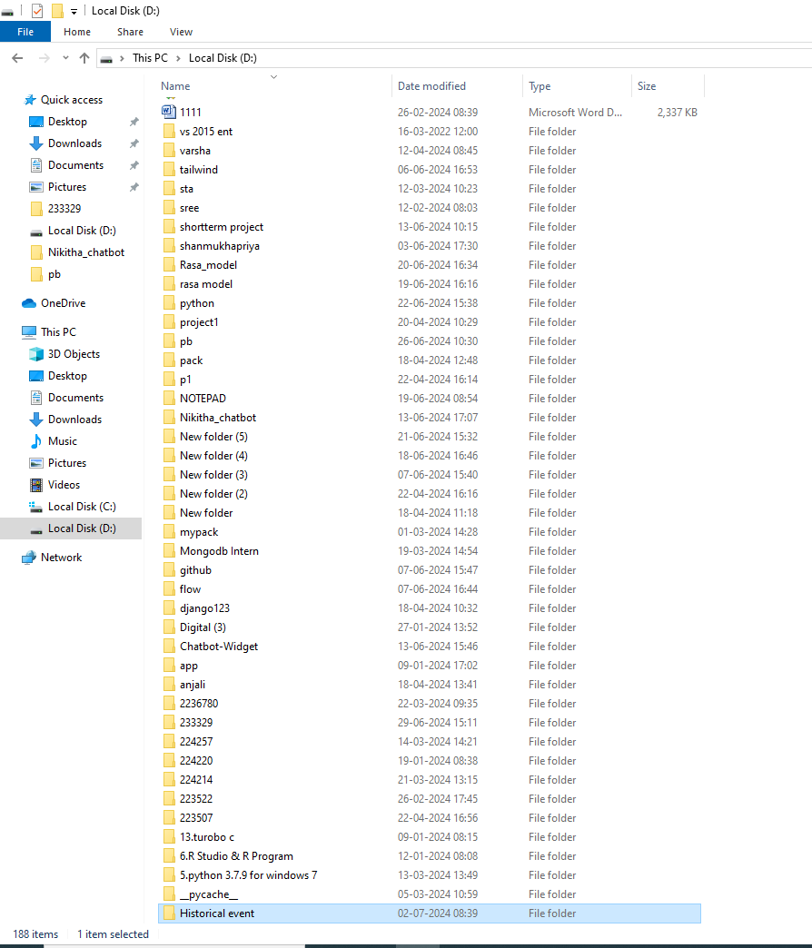

Python –m venv .\venv:

1. python: This is the Python interpreter executable.

2.-m venv: This part of the command tells Python to run the `venv` module as a script. The `venv` module is used for creating virtual environments.

3. .\venv: This specifies the directory where the virtual environment will be created. In this case, it creates a virtual environment named `venv` in the current directory (`.`).

Virtual Environments:

A virtual environment is an isolated Python environment that allows you to install packages and dependencies separately from the system Python installation. This isolation helps manage dependencies for different projects and prevents conflicts between them.

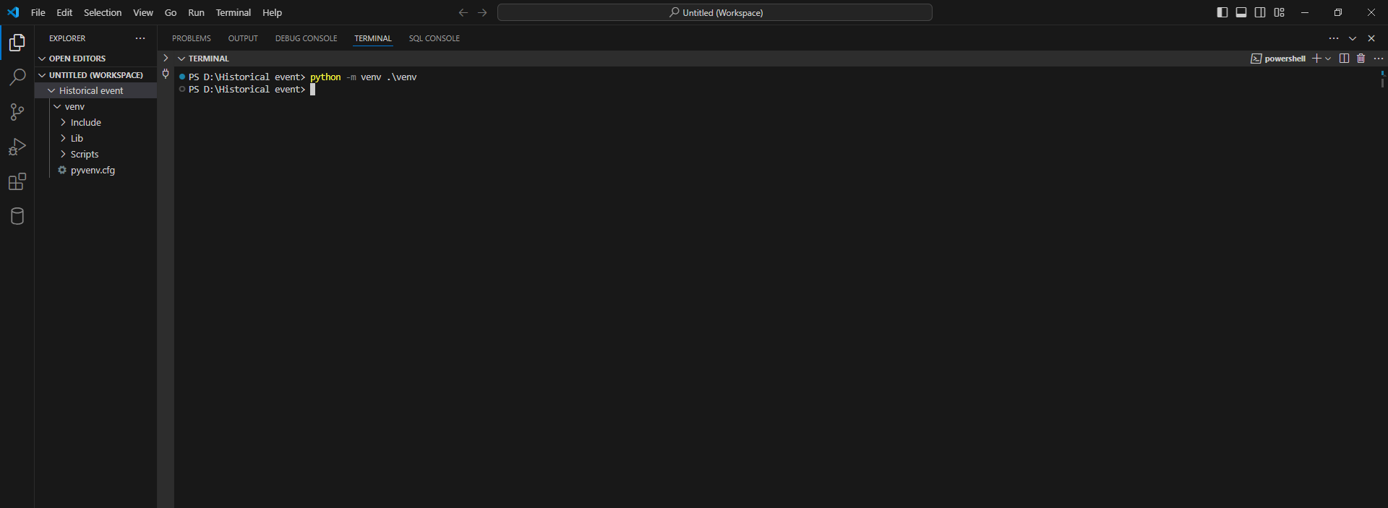

Command Prompt (CMD):

1. Open Command Prompt.

2. Navigate to the directory where your virtual environment `venv` is located. You might already be there if you created it in the current directory (`.\venv`).

3. Run the following command to activate the virtual environment:



The command `rasa init` is used to initialize a new Rasa project from the command line. Rasa is an open-source framework for building conversational AI chatbots and virtual assistants. Here’s what `rasa init` does and how you can use it:

Purpose of `rasa init`:

* Project Initialization:

`rasa init` sets up a new Rasa project with the necessary files and directories to get started with building a conversational AI application.

* Directory Structure:

It creates a basic directory structure including configuration files, training data, and other necessary components.

* Interactive Setup:

It might prompt you for certain configurations or choices depending on the Rasa version and setup.

* How to Use `rasa init`:

To use `rasa init`, follow these steps:

1. Install Rasa:

First, you need to have Rasa installed. If you haven’t installed it yet, you can install it using pip:



1. Navigate to Project Directory:

Open your terminal or command prompt and navigate to the directory where you want to create your new Rasa project.

3. Run `rasa init`: Once you're in the correct directory, simply run:

C:\Users\3LABSYSTEM22\Pictures\i.PNG

This command will initialize a new Rasa project in the current directory.

3.Follow the Prompts:

Depending on the Rasa version, `rasa init` may ask you some questions to set up your project. These might include choosing the language (e.g., English), providing a project name, selecting initial configuration options, and possibly downloading some necessary files or models.

5. Project Structure:

After running `rasa init`, you will typically see a directory structure like this:

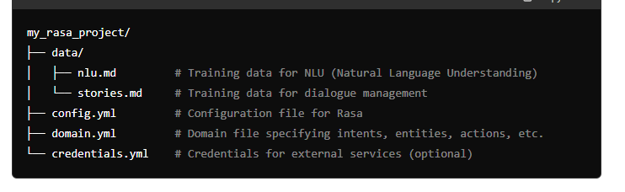

6. Start Developing:

Once the project is initialized, you can start developing your conversational AI application. You can edit the `nlu.md` and `stories.md` files to add training data, modify the `domain.yml` to define intents, entities, and actions, and adjust the `config.yml` for Rasa’s training and pipeline configuration.

The command `rasa train` is used to train a Rasa project's machine learning models based on the data and configurations provided in the project directory. Here’s a detailed explanation of what `rasa train` does and how to use it effectively:

* Purpose of `rasa train`:

1. Model Training:

The primary purpose of `rasa train` is to train the machine learning models that Rasa uses for natural language understanding (NLU) and dialogue management. These models are essential for understanding user inputs (intents and entities) and generating appropriate responses in a conversation.

2.Data Preparation:

Before running `rasa train`, ensure that you have prepared your project directory with necessary data files:

* NLU Data: Typically found in `data/nlu.md` or similar, containing examples of user messages with associated intents and entities.
* Stories:

Located in `data/stories.md` or a similar file, which defines example conversations (dialogues) between the user and the assistant, specifying sequences of intents and actions.

3.Configuration:

The `config.yml` file in your project directory specifies the pipeline and other settings used during training. It defines which components (e.g., tokenizers, machine learning models) and their configurations are used to process data and predict actions.

* How to Use `rasa train`:

1.Ensure Data and Configuration:

Ensure that your project directory contains:

- `data/nlu.md`: Training data for NLU.

- `data/stories.md`: Training data for dialogue management.

- `config.yml`: Configuration file specifying the pipeline and settings for Rasa.

3.Run `rasa train`:

Once everything is set up, simply run the following command:



This command triggers the training process based on the data and configurations provided in your project directory.

### Purpose of rasa shell:

* **Interactive Testing**:

rasa shell provides a convenient way to interact with your Rasa assistant in real-time. This is useful for testing and debugging your assistant's responses and behaviors before deploying it to production.

1. **Natural Language Understanding**:

During the session, rasa shell processes your inputs, extracts intents and entities, and predicts appropriate responses using the trained machine learning models.

**2.User Experience Evaluation**:

It allows you to experience how your chatbot handles different user inputs and scenarios, giving you insights into its performance and user interaction flow.

### Purpose of rasa run actions –debug:

1. **Action Server**:

The rasa run actions command starts an HTTP server that runs the custom actions defined in your Rasa project. These custom actions are typically used to perform backend operations, API calls, database queries, or any other tasks that require external interaction or computation beyond simple dialogue management.

1. **Debugging Model**:

Adding --debug as an option provides additional logging and debug information during the execution of the action server. This can be useful for troubleshooting issues related to action execution, API calls, or handling of requests and responses.

### How to Use rasa run actions –debug:

1. **Navigate to Project Directory**:

Open your terminal or command prompt and navigate to the directory where your Rasa project is located.

1. **Start Action Server**:

Once in the project directory, run the following command:

C:\Users\3LABSYSTEM22\Pictures\d.PNG

1. **Action Server Output**:

After starting the action server, you should see output similar to the following:

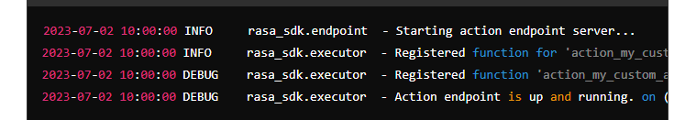

1. **Debug Mode Features**: With --debug enabled, you'll see more detailed logs about incoming requests to the action server, execution of custom actions, and responses sent back to Rasa Core during conversation interactions.
2. **Testing Actions**: You can test your custom actions by initiating conversations with your Rasa assistant via rasa shell (as described earlier). When the assistant encounters an action, it will send a request to the action server to execute the corresponding custom action logic.

### How to Use rasa shell:

1. **Ensure Models are Trained**:

Before starting the shell, make sure you have trained your Rasa models using rasa train. This step is crucial as the shell session relies on these trained models to understand and respond to user inputs.

1. **Navigate to Project Directory**:

Open your terminal or command prompt and navigate to the directory where your Rasa project is located.

1. **Start rasa shell**:

Once in the project directory, simply run the following command:

C:\Users\3LABSYSTEM22\Pictures\ss.PNG

This command starts the interactive shell session with your trained Rasa assistant.

### The final output :

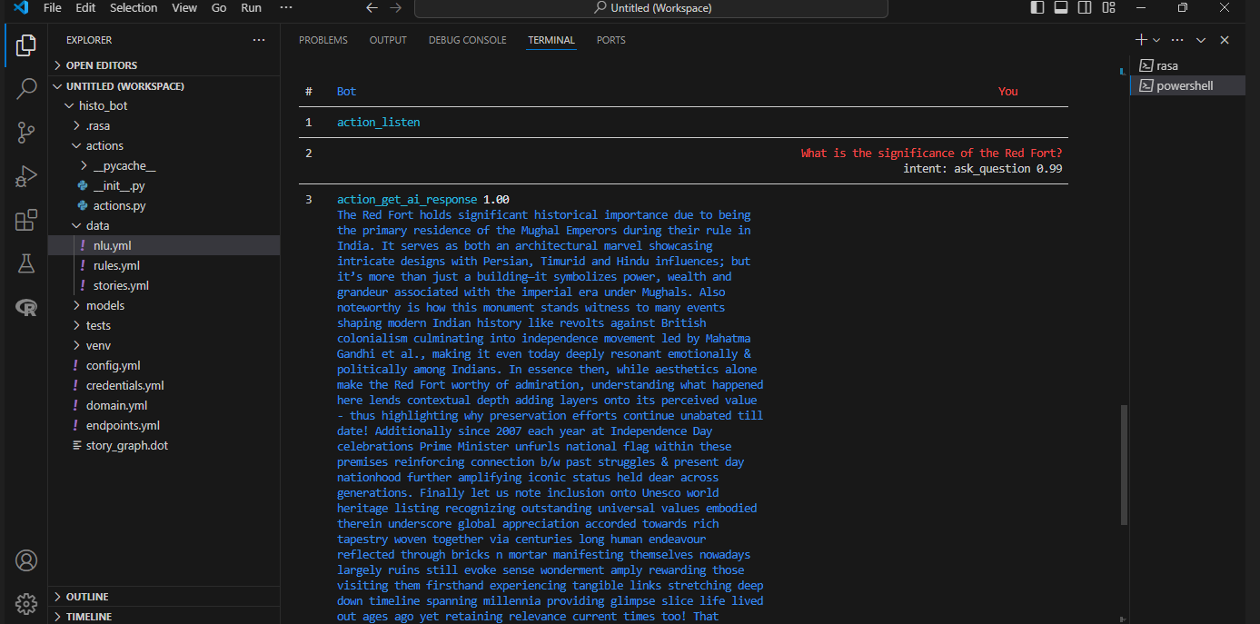

**Chapter-3**

Reason of the Project

**Introduction :**

* Brief overview of the importance of historical events
* Thesis statement: Exploring historical events is essential for understanding our past, present, and future.

**Historical Significance:**

* Explanation of how historical events shape our understanding of the world
* Examples of significant historical events that have impacted society

**Understanding Causality:**

* Analysis of how historical events demonstrate cause-and-effect relationships
* Case studies of historical events that illustrate causality

**Contextualizing Decisions:**

* Discussion of how historical events provide context for decision-making
* Examples of how historical events have influenced contemporary decision-making

**Appreciating Cultural Heritage:**

* Explanation of how historical events are a crucial part of our cultural heritage
* Examples of how historical events have shaped cultural traditions

**Promoting Empathy:**

* Discussion of how delving into historical events fosters empathy and compassion
* Case studies of historical events that demonstrate the importance of empathy

**Developing Critical Thinking:**

* Explanation of how investigating historical events promotes critical thinking
* Examples of how evaluating evidence and analyzing perspectives are essential skills developed through historical research

**Enhancing Research Skills:**

* Detailed explanation of how researching historical events hones research skills
* Examples of how locating, evaluating, and synthesizing information from various sources are essential skills developed through historical research

**Encouraging Interdisciplinary Learning:**

* Explanation of how historical events intersect with other disciplines, such as politics, economics, and sociology
* Examples of how exploring historical events promotes interdisciplinary learning and understanding

**Understanding Global Perspectives:**

* Discussion of how historical events provide a global perspective
* Examples of how historical events have impacted global relationships and international relations

**Learning from Failure:**

* Analysis of how historical events demonstrate the importance of learning from failure
* Case studies of historical events that illustrate the value of learning from mistakes

**Appreciating Progress:**

* Explanation of how historical events demonstrate progress and advancement
* Examples of how historical events have led to significant advancements in various fields

**Developing Historical Awareness:**

* Discussion of how exploring historical events promotes awareness and understanding of historical issues
* Examples of how historical awareness is essential for informed decision-making

**Encouraging Historical Preservation:**

* Explanation of how exploring historical events promotes preservation and conservation
* Examples of how historical preservation efforts have protected cultural heritage sites and artifacts

**Fostering National Identity:**

* Discussion of how historical events shape national identity
* Examples of how historical events have influenced national identity and patriotism

**Promoting International Understanding:**

* Explanation of how historical events promote international understanding
* Examples of how historical events have fostered global cooperation and diplomacy

**Supporting Education:**

* Discussion of how exploring historical events supports educational goals
* Examples of how historical events are used in educational settings to promote learning

**Encouraging Critical Analysis:**

* Explanation of how historical events promote critical analysis
* Examples of how evaluating historical events promotes critical thinking and analysis

**Developing Research Techniques:**

* Detailed explanation of how researching historical events develops research techniques
* Examples of how historical research skills are transferable to other fields of study

**Chapter-4**

Conclusion of the project

1. Finalize Training and Testing:

Training Models:

Ensure that you have trained your NLU (Natural Language Understanding) and dialogue management models (`rasa train`). Verify that they perform well with your training data and meet performance metrics.

Testing:

Conduct thorough testing using `rasa shell` to interact with your assistant. Test different scenarios and edge cases to identify any issues with responses or functionality.

2. Document Your Project:

1.Documentation:

Document key aspects of your project such as:

* + Project overview and goals.
  + Architecture and components (e.g., directory structure, configuration files).
  + Training data details (e.g., `nlu.md`, `stories.md`).
  + Custom actions and their functionality.
  + Deployment instructions and environment setup.
  + Any third-party integrations or APIs used.

2.User Guide:

Create a user guide or documentation for future maintainers or end-users, detailing how to interact with and use your Rasa assistant effectively.

3. Code Review and Refactoring:

* Code Review:

Conduct a code review to ensure code quality, adherence to best practices, and documentation within the codebase (`actions.py`, custom components, etc.).

* Refactoring:

Address any technical debt or areas for improvement identified during the development phase. Refactor code as needed for clarity, performance, and maintainability.

4. Prepare for Deployment:

* Environment Setup:

Ensure that deployment environments (e.g., staging, production) are set up correctly and meet the necessary requirements for hosting your Rasa assistant.

* Configuration:

Verify that configuration files (`config.yml`, `credentials.yml`, etc.) are appropriately configured for deployment environments, including any necessary security configurations.