WD-ACTIVITY
NAME: NAZIYA SHAIK
BRANCH: AIML
SECTION: 1
ROLL NO: 26001621
CASE: 6
Online Shopping Website Create an e-commerce interface displaying products, prices, discounts, ratings, categories, product descriptions, and shopping buttons. Design a responsive product grid, promotional banners, and a shopping navigation bar.
<!DOCTYPE html>
<html>
<head>
<title>Naziya's Shopping Store</title>
<style>
body{font-family:Arial;margin:0;background:#f5f5f5}
nav{background:#222;padding:18px;text-align:center}
nav a{color:white;margin:10px;text-decoration:none}
h1{text-align:center;color:#e91e63}
.banner{text-align:center;background:pink;padding:20px}
.products{display:flex;flex-wrap:wrap;justify-content:center;gap:15px;padding:20px}
.card{background:white;padding:12px;width:180px;text-align:center;border-radius:10px}
.card img{width:100%;height:160px;object-fit:cover}
button{background:#e91e63;color:white;border:0;padding:10px}
.category{display:none}
.category:target{display:flex;flex-wrap:wrap;justify-content:center;gap:15px}
#all:target{display:flex}
body:has(.category:target) #all{display:none}
</style>
</head>
<body>

<nav>
<a href="#all">Home / All</a>
<a href="#dresses">Dresses</a>
<a href="#shoes">Shoes</a>
<a href="#bags">Bags</a>
<a href="#accessories">Accessories</a>
<a href="#footwear">Footwear</a>
</nav>

<h1>Naziya's Shopping Store 🛍️</h1>
<div class="banner">MEGA SALE! Up to 50% OFF</div>

<div class="products" id="all">
<div class="card">
<img src="https://images.unsplash.com/photo-1595777457583-95e059d581b8?w=400">
<h3>Dresses</h3>₹799 | ⭐4.5
<p>35% OFF</p><a href="#dresses"><button>View Dresses</button></a>
</div>
<div class="card">
<img src="https://images.unsplash.com/photo-1542291026-7eec264c27ff?w=400">
<h3>Shoes</h3>₹999 | ⭐4.2
<p>30% OFF</p><a href="#shoes"><button>View Shoes</button></a>
</div>
<div class="card">
<img src="https://images.unsplash.com/photo-1584917865442-de89df76afd3?w=400">
<h3>Bags</h3>₹499 | ⭐4.4
<p>35% OFF</p><a href="#bags"><button>View Bags</button></a>
</div>
<div class="card">
<img src="https://images.unsplash.com/photo-1611652022419-a9419f74343d?w=400">
<h3>Accessories</h3>₹299 | ⭐4.3
<p>20% OFF</p><a href="#accessories"><button>View Accessories</button></a>
</div>
<div class="card">
<img src="https://images.unsplash.com/photo-1543163521-1bf539c55dd2?w=400">
<h3>Footwear</h3>₹699 | ⭐4.4
<p>25% OFF</p><a href="#footwear"><button>View Footwear</button></a>
</div>
</div>

<div class="products category" id="dresses">
<div class="card">
<img src="https://images.unsplash.com/photo-1595777457583-95e059d581b8?w=400">
<h3>Fashion Dress</h3>₹799 <p>⭐4.5 | 35% OFF</p>
<button>Buy Now</button>
</div>
</div>

<div class="products category" id="shoes">
<div class="card">
<img src="https://images.unsplash.com/photo-1542291026-7eec264c27ff?w=400">
<h3>Sports Shoes</h3>₹999 <p>⭐4.2 | 30% OFF</p>
<button>Buy Now</button>
</div>
</div>

<div class="products category" id="bags">
<div class="card">
<img src="https://images.unsplash.com/photo-1584917865442-de89df76afd3?w=400">
<h3>Handbag</h3>₹499 <p>⭐4.4 | 35% OFF</p>
<button>Buy Now</button>
</div>
</div>

<div class="products category" id="accessories">
<div class="card">
<img src="https://images.unsplash.com/photo-1611652022419-a9419f74343d?w=400">
<h3>Jewellery</h3>₹299 <p>⭐4.3 | 20% OFF</p>
<button>Buy Now</button>
</div>
</div>

<div class="products category" id="footwear">
<div class="card">
<img src="https://images.unsplash.com/photo-1543163521-1bf539c55dd2?w=400">
<h3>Women's Sandals</h3>₹699 <p>⭐4.4 | 25% OFF</p>
<button>Buy Now</button>
</div>
</div>

</body>
</html>

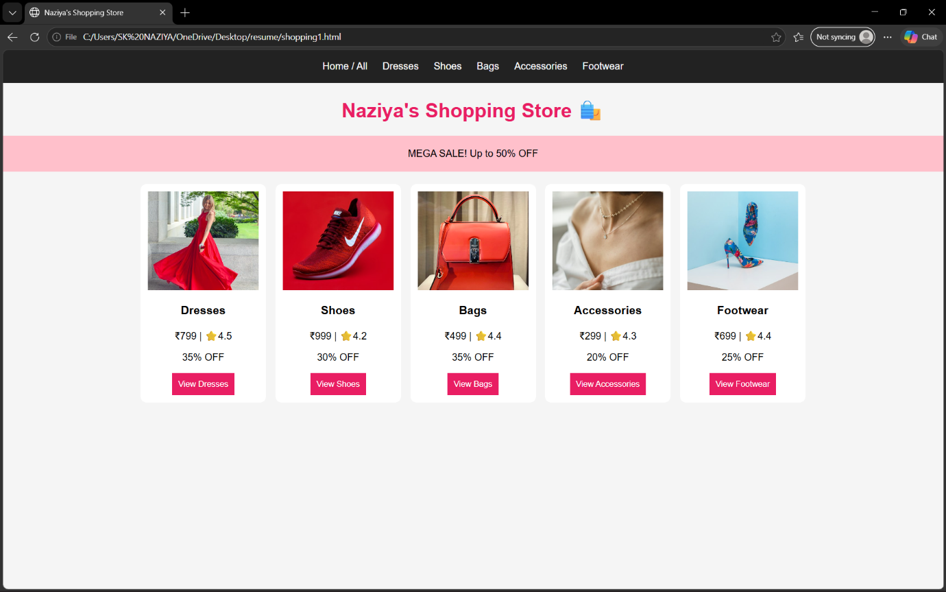

WD-ACTIVITY
NAME: NAZIYA SHAIK
BRANCH: AIML
SECTION: 1
ROLL NO: 26001621
CASE: 8
Online Food Ordering Website Design a food ordering interface with restaurant details, menu categories, food images, prices, special offers, customer reviews, and order buttons. Use card layouts, attractive backgrounds, and mobile-friendly navigation.

<!DOCTYPE html>
<html>
<head>
<title>Naziya'sFood Corner</title>
<style>
body{font-family:Arial;margin:0;background:#fff3e0}
header,footer{background:#e63946;color:white;text-align:center;padding:15px}
nav{text-align:center;background:#222;padding:15px}
nav a{color:white;margin:7px;text-decoration:none}
.banner{text-align:center;background:#ffd166;padding:10px}
.menu{display:flex;flex-wrap:wrap;justify-content:center;gap:15px;padding:15px}
.card{background:white;width:170px;padding:10px;text-align:center;border-radius:10px}
img{width:100%;height:120px;object-fit:cover}
button{background:#e63946;color:white;border:0;padding:8px}
.category{display:none}
.category:target{display:flex;flex-wrap:wrap;justify-content:center;gap:15px}
body:has(.category:target) #all{display:none}
</style>
</head>
<body>

<header><h1>🍔 Naziya's Food Corner</h1>
<p>Delicious Food | ⭐ 4.5 Rating</p></header>

<nav>
<a href="#all">Home</a>
<a href="#veg">Veg</a>
<a href="#nonveg">Non Veg</a>
<a href="#starters">Starters</a>
<a href="#desserts">Desserts</a>
<a href="#ice">Ice Creams</a>
<a href="#drinks">Beverages</a>
</nav>

<div class="banner">🔥 Special Offer: 20% OFF</div>

<div class="menu" id="all">
<div class="card"><img src="https://images.unsplash.com/photo-1603894584373-5ac82b2ae398?w=300"><h3>Veg Curry</h3>₹149 ⭐4.5<br><button>Order Now</button></div>
<div class="card"><img src="https://images.unsplash.com/photo-1565557623262-b51c2513a641?w=300"><h3>Chicken Biryani</h3>₹249 ⭐4.8<br><button>Order Now</button></div>
<div class="card"><img src="https://images.unsplash.com/photo-1565299624946-b28f40a0ae38?w=300"><h3>Pizza</h3>₹199 ⭐4.6<br><button>Order Now</button></div>
<div class="card"><img src="https://images.unsplash.com/photo-1551024506-0bccd828d307?w=300"><h3>Dessert</h3>₹99 ⭐4.4<br><button>Order Now</button></div>
<div class="card"><img src="https://images.unsplash.com/photo-1560008581-09826d1de69e?w=300"><h3>Ice Cream</h3>₹79 ⭐4.7<br><button>Order Now</button></div>
<div class="card"><img src="https://images.unsplash.com/photo-1544145945-f90425340c7e?w=300"><h3>Juice</h3>₹59 ⭐4.3<br><button>Order Now</button></div>
</div>

<div class="menu category" id="veg">
<div class="card"><img src="https://images.unsplash.com/photo-1603894584373-5ac82b2ae398?w=300"><h3>Veg Curry ₹149</h3><button>Order Now</button></div>
</div>
<div class="menu category" id="nonveg">
<div class="card"><img src="https://images.unsplash.com/photo-1565557623262-b51c2513a641?w=300"><h3>Chicken Biryani ₹249</h3><button>Order Now</button></div>
</div>
<div class="menu category" id="starters">
<div class="card"><img src="https://images.unsplash.com/photo-1565299624946-b28f40a0ae38?w=300"><h3>Pizza ₹199</h3><button>Order Now</button></div>
</div>
<div class="menu category" id="desserts">
<div class="card"><img src="https://images.unsplash.com/photo-1551024506-0bccd828d307?w=300"><h3>Dessert ₹99</h3><button>Order Now</button></div>
</div>
<div class="menu category" id="ice">
<div class="card"><img src="https://images.unsplash.com/photo-1560008581-09826d1de69e?w=300"><h3>Ice Cream ₹79</h3><button>Order Now</button></div>
</div>
<div class="menu category" id="drinks">
<div class="card"><img src="https://images.unsplash.com/photo-1544145945-f90425340c7e?w=300"><h3>Juice ₹59</h3><button>Order Now</button></div>
</div>

<footer>
<p>📍 vijayawada, Andhra pradesh</p>
<p>📞 9948291893</p>
<p>© Naziya'sFood Corner</p>
</footer>

</body>
</html>

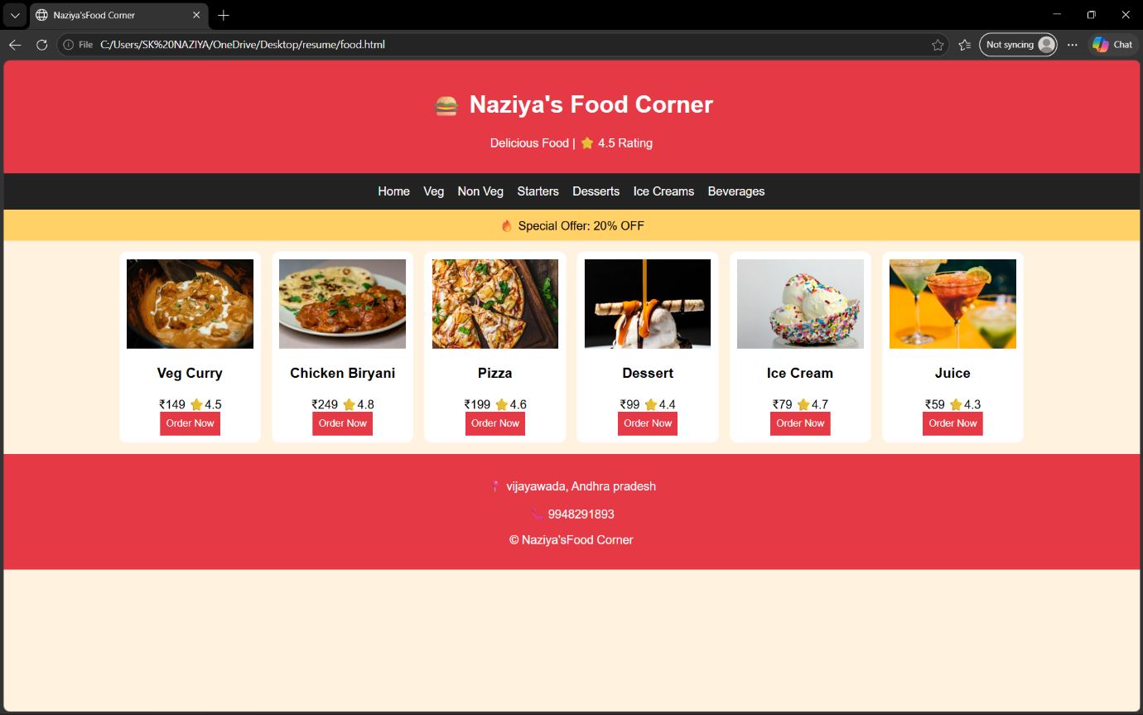

WD-ACTIVITY
NAME: NAZIYA SHAIK
BRANCH: AIML
SECTION: 1
ROLL NO: 26001621
CASE: 13
Fitness Center and Gym Website Develop a gym website featuring workout programs, trainers, membership plans, fitness facilities, class schedules, and registration forms. Use bold typography, responsive pricing tables, and CSS transitions.

<!DOCTYPE html>
<html>
<head>
<title>FitZone Gym</title>
<style>
* {box-sizing:border-box; scroll-behavior:smooth;}
body {
margin:0; font-family:Arial,sans-serif;
background:#111; color:white;
}
header {
background:#ff5722; padding:18px;
display:flex; justify-content:space-between;
flex-wrap:wrap;
}
header h2 {margin:0;}
nav a {
color:white; text-decoration:none;
margin:10px; font-weight:bold;
}
.hero {
text-align:center; padding:65px 15px;
background:linear-gradient(#0008,#0008),
url('https://images.unsplash.com/photo-1534438327276-14e5300c3a48?w=1200')
center/cover;
}
h1 {font-size:42px;}
span {color:#ff5722;}
button {
background:#ff5722; color:white; border:0;
padding:12px 22px; cursor:pointer;
border-radius:5px; transition:.3s;
}
button:hover {background:white;color:#ff5722;}
section {padding:30px 15px;text-align:center;}
.cards {
display:flex; justify-content:center;
flex-wrap:wrap; gap:18px;
}
.card {
background:#222; padding:15px;
border-radius:10px; width:260px;
transition:.3s;
}
.card:hover {transform:translateY(-6px);}
img {width:100%;height:150px;object-fit:cover;
border-radius:8px;}
.price {color:#ff5722;font-size:25px;font-weight:bold;}
input {
padding:12px; margin:7px; width:90%;
max-width:300px;
}
footer {background:#ff5722;padding:18px;text-align:center;}
</style>
</head>
<body>

<header>
<h2>💪 FitZone Gym</h2>
<nav>
<a href="#programs">Programs</a>
<a href="#trainers">Trainers</a>
<a href="#plans">Plans</a>
<a href="#join">Join</a>
</nav>
</header>

<div class="hero">
<h1>BUILD YOUR <span>BODY</span></h1>
<p>Your Fitness Journey Starts Here!</p>
<a href="#join"><button>Join Now</button></a>
</div>

<section id="programs">
<h2>Workout Programs</h2>
<div class="cards">
<div class="card">
<img src="https://images.unsplash.com/photo-1583454110551-21f2fa2afe61?w=500">
<h3>Strength Training</h3><p>Build strength and muscles.</p>
</div>
<div class="card">
<img src="https://images.unsplash.com/photo-1534258936925-c58bed479fcb?w=500">
<h3>Cardio Fitness</h3><p>Improve stamina and health.</p>
</div>
<div class="card">
<img src="https://images.unsplash.com/photo-1517836357463-d25dfeac3438?w=500">
<h3>Personal Training</h3><p>Train with expert guidance.</p>
</div>
</div>
</section>

<section id="trainers">
<h2>Our <span>Trainers</span></h2>
<div class="cards">
<div class="card">
<img src="https://images.unsplash.com/photo-1567013127542-490d757e51fc?w=500">
<h3>Fitness Coach</h3><p>Expert Workout Guidance</p>
</div>
<div class="card">
<img src="https://images.unsplash.com/photo-1534438327276-14e5300c3a48?w=500">
<h3>Gym Trainer</h3><p>Strength & Fitness Coach</p>
</div>
</div>
</section>

<section id="plans">
<h2>Membership Plans</h2>
<div class="cards">
<div class="card">
<h3>Basic</h3><p class="price">₹999</p>
<p>Gym Access</p><button onclick="location.href='#join'">Choose Plan</button>
</div>
<div class="card">
<h3>Standard</h3><p class="price">₹1999</p>
<p>Gym + Cardio</p><button onclick="location.href='#join'">Choose Plan</button>
</div>
<div class="card">
<h3>Premium</h3><p class="price">₹2999</p>
<p>All Facilities + Trainer</p><button onclick="location.href='#join'">Choose Plan</button>
</div>
</div>
<p>Class Schedule: Monday–Saturday | 6 AM–9 PM</p>
</section>

<section id="join">
<h2>Register <span>Now</span></h2>
<form>
<input type="text" placeholder="Your Name" required><br>
<input type="email" placeholder="Email Address" required><br>
<input type="tel" placeholder="Phone Number" required><br>
<button type="submit">Register Now</button>
</form>
</section>

<footer>
<p>Created by Naziya Shaik ❤️</p>
<p>© 2026 FitZone Gym | Stay Strong, Stay Fit!</p>
</footer>

</body>
</html>

