SOFTWARE DEVELOPMENT JOURNAL
Science Travel Grant System (STGS)

Course: Software Requirements and Analysis
Faculty of Computer Science and Engineering
Ss. Cyril and Methodius University

Team Members:
Naz Jonuzi [241508]
Erdi Shahini [241516]
Dea Hoxha [241527]
Date: May 2026

Contents
1. Introduction 3
2. Development Environment and Technologies 4
Technologies Used 4
Development Constraints 4
3. Team Workflow and Collaboration 5
Applicant Module 5
Reviewer Module 5
Administrator Module 5
4. Prompt Engineering Strategy 6
5. Development Process 7
5.1 Applicant Module 7
5.2 Reviewer Module 7
5.3 Administrator Module 8
6. Transition from Mock Data to Real Database Demonstration 9
7. Challenges and Iterative Improvements 11
Ambiguity Handling 11
Context Sensitivity 11
Modular Coordination 11
Prompt Precision 11
8. Advantages and Limitations of AI-Assisted Development 12
Advantages 12
Limitations 12
9. Conclusion 13
10. Appendices 14
A. Screenshots of Prompts 14
B. Screenshots of Claude Responses 14
C. Screenshots of UI 14
D. GitHub Branch Screenshots 14
E. Supabase Schema Screenshots 14
F. Workflow Diagrams 14
G. Generated File Plan Screenshots 14

1.Introduction

This journal explains how our team developed the Science Travel Grant System (STGS) for the Software Requirements and Analysis course. The work was based on our final Software Requirements Specification (SRS), and the implementation was done through prompt-based AI development, as required by the assignment.
The goal was to build a web prototype for managing university travel grant applications. The system covers the main flow: applicants submit requests, the Scientific Council and Dean's Office review them, administrators monitor records and budget, and each user role only sees the features meant for that role.
One important rule of the assignment was that we were not allowed to manually write the code. Because of that, all implementation, fixes, and changes were requested through text prompts. This made the process depend a lot on clear instructions, testing the generated result, and then improving the prompts when something was missing.
The final prototype was built with React, Vite, and JavaScript. Claude Sonnet 4.6 Adaptive was used as the main AI coding tool. We also used ChatGPT before some prompts to make our instructions clearer and easier to follow.

2. Development Environment and Technologies

Technologies Used

Technology | Purpose
React | Frontend framework
Vite | Development/build environment
JavaScript | Main programming language
VS Code | Development environment
GitHub | Version control and branch management
Claude Sonnet 4.6 Adaptive | AI-assisted software generation
ChatGPT | Prompt refinement and clarification
Supabase | Database and authentication demonstration

Development Constraints

The assignment gave us several clear rules to follow:
- Manual coding was not permitted.
- All software generation and modification had to be performed exclusively through prompts.
- The final SRS document had to serve as the primary implementation source.
- Initially, the system was required to use mock data only without a real backend or authentication system.
- The project had to remain modular and easily mergeable between separate team branches.

3. Team Workflow and Collaboration

We organized the project through GitHub branches. The team leader first created the React + Vite project and prepared the starting repository structure.

To work in parallel, we used three separate branches:
- Applicant Module Branch
- Reviewer Module Branch
- Administrator Module Branch

Each team member worked on one part of the system, but we followed the same general structure and prompting approach. After the separate modules were ready, they were merged into the main repository through GitHub. Keeping the modules separate made the project easier to manage and reduced merge problems. The work was divided like this:

Applicant Module

The applicant part focused on the application submission flow from the SRS. It included the form for applying, document upload checks, status tracking, notifications, and cancellation.
This part included:
- Applicant dashboard functionality
- Application submission forms
- Supporting document uploads
- Status tracking components
- Notification visibility
- Cancellation confirmation workflows
- Mock application and notification data
The Applicant Module was developed on its own branch and kept compatible with the shared React + Vite setup. We asked for the code to be split into smaller React components so it would be easier to connect later with the Reviewer and Administrator modules.

Reviewer Module

The reviewer part focused on the approval workflow from the SRS. It included the Scientific Council stage, the Dean's Office stage, approve/reject actions, reviewer comments, approval history, and budget checks.

Administrator Module

The Administrator Module covered the system management requirements from the SRS, mainly FR-7, FR-8, FR-9, FR-10, and OR-3.
This module had two jobs: it gave administrators control over users, records, and budget, and it also helped connect the Applicant and Reviewer parts into one working application.
The module included these main components:
- Administrator Dashboard with system-wide statistics and quick navigation
- Budget Overview with total, allocated, and available fund monitoring
- User Management with role assignment and account activation controls
- Record Management with cancellation and deletion workflows including referential integrity blocking
- Audit Log with paginated event history covering all system actions
- Role Switcher component enabling demo-mode switching between all four user roles
- Shared AppContext state management used by all three modules
- Shared UI primitive library (Card, Button, Table, Modal, Alert, Badge, ProgressBar) reused across all modules
- Unified navigation structure with role-based sidebar routing

4. Prompt Engineering Strategy

Before implementation started, we prepared a shared base prompt. Its purpose was to explain the project rules, the technology stack, and the limits of what the AI should generate.
Since manual coding was not allowed, we had to be very specific in our prompts. We used ChatGPT to improve some prompt wording before sending the final instructions to Claude.
This was the shared starting prompt used by the team:
"We are using React + Vite + JavaScript. We are working in VS Code and using Claude Web only. Manual coding is not allowed by our professor, so please generate complete file contents and explain exactly which files to create or replace. Use mock data only, no real backend, no database, no real authentication. The goal is a university prototype/demo based on our SRS document."

This prompt defined:
- the development stack,
- implementation limitations,
- AI generation expectations,
- and the requirement for complete file-level generation.
After that, each module had its own more specific prompts.

5. Development Process

5.1 Applicant Module

The Applicant Module was built from the SRS requirements and use cases, mostly FR-1, FR-2, FR-3, FR-6, and FR-9.
We started with a prompt that told Claude to focus only on the applicant side and to follow the rules: mock data only and no manual coding.
The prompt asked Claude to:
- implement applicant dashboard functionality,
- generate travel grant application forms,
- support document upload validation,
- implement application status tracking,
- include notifications and alerts,
- and support application cancellation workflows.
Claude first gave an implementation plan and then generated the needed files one by one.
The generated applicant part included:
- ApplicantDashboard component
- ApplicationForm component
- DocumentUpload component
- ApplicationStatusCard component
- NotificationPanel component
- Mock application and notification data
- Status validation utilities
The workflow followed the SRS behavior:
- Applicants can create and submit applications.
- Supporting documents are validated by format and size.
- Submitted applications receive the status “Submitted”.
- Applicants can track statuses including Submitted, Under Review, Approved, Rejected, and Canceled.
- Notifications inform applicants about submission events and status changes.
- Applications can be canceled before full approval.
During development, we had to send extra prompts to improve validation, responsive layout, reusable styling, notification visibility, and confirmation dialogs.
The Applicant Module was kept modular so it could be connected more easily with the Reviewer and Administrator modules, and later with Supabase for the live demo.

5.2 Reviewer Module

The Reviewer Module was based on FR-4 and FR-5 from the SRS. These requirements described the two-stage approval process and the budget rules.
The implementation started with this module-specific prompt:
"I am working on the Reviewer Module for our university course project..."

The prompt told Claude to:
- focus only on the reviewer subsystem,
- generate code step-by-step,
- avoid backend generation,
- implement sequential approval stages,
- include reviewer comments and approval history,
- and enforce budget constraints.

Claude responded with an 11-step plan and then generated the files step by step. This made it easier to check each part before moving on.
The generated reviewer part included:
- ReviewerDashboard component
- ScientificCouncilReview component
- DeansOfficeReview component
- ApplicationReviewCard component
- ApprovalHistory component
- ReviewerCommentBox component
- ReviewerContext state management
- Mock reviewer/application/budget data

The review logic followed the SRS:
- Scientific Council reviews first.
- Dean's Office reviews second.
- Dean's Office cannot access applications before Scientific Council approval.
- Approval and rejection actions update application status dynamically.
- Reviewer comments are stored within approval history records.
- Budget enforcement blocks approvals that exceed available funds.

During development, we noticed one issue with the budget validation. Claude first generated a simpler version that did not fully match the validation and verification notes in Section 4.5 of the SRS.

To fix this, we sent an additional prompt:

"About the budget, is this in line with the validation and verification part from the SRS document…"

This prompt clarified how the budget pools should work and that approvals still had to be checked transactionally. After that, Claude updated the budget logic.
The reviewer part was also kept modular so it could be integrated with the other modules later.

5.3 Administrator Module

The Administrator Module was implemented based on the functional and non-functional requirements defined in FR-7, FR-8, FR-9, FR-10, OR-3, and design constraints DC-4 and DC-5 of the SRS document.
The Administrator Module started with a larger prompt. We uploaded the final SRS and asked Claude to generate the administrator side together with the shared integration structure. The prompt was:
“I am working on the Administrator and Integration Module for our university course project…
Claude gave a complete multi-file plan and then generated the required files. The administrator part included these components:
- AdminDashboard – overview statistics, budget health widget, application status breakdown, recent activity feed, and quick-navigation action buttons
- BudgetOverview – total annual budget, allocated funds, available funds, utilisation progress bar, per-application approved grant breakdown, and budget impact indicators for all pending applications
- UserManagement – user listing with role badges, search and filter by role, role change modal with confirmation, and activate/deactivate user controls
- RecordManagement – full application table with status filters, detailed application view modal, administrator-only cancellation of approved applications with budget restoration, and permanent record deletion blocked when linked approval records exist
- AuditLog – paginated event history covering logins, submissions, approvals, rejections, cancellations, role changes, and deletions, with search and action-type filtering
- AppContext – a centralised useReducer-based state store serving as the single source of truth for all three modules, containing all state mutations and automatic audit log generation on every action
- mockData.js – a single shared data file containing all mock users, applications, documents, approvals, audit log entries, and budget configuration used across all three modules
- RoleSwitcher – a dropdown component fixed in the application header that allows switching between all six mock users across all four roles, simulating authentication without a real backend
- AppShell – the shared layout component containing the sidebar navigation and header, with navigation items dynamically rendered based on the current user’s role
- UI.jsx – a shared primitive library including Card, StatCard, Button, Table, Modal, Alert, Badge, ProgressBar, SearchInput, Select, and EmptyState components used across all three modules
The implementation covered these SRS behaviours:
- Administrators can monitor the total annual budget of €50,000, with allocated and available funds automatically recalculated whenever an application is approved or canceled.
- Budget enforcement (DC-4, FR-5) is applied transactionally within the AppContext reducer. If AllocatedFunds + RequestedAmount exceeds TotalFunds, the approval action is blocked and a descriptive error is displayed to the reviewer.
- Role-based access control (FR-8) is enforced at the routing level in App.jsx. Each role only renders the pages applicable to its permissions, and the sidebar navigation updates accordingly.
- Record deletion (FR-10) is blocked when the target application has linked approval records, consistent with the SRS referential integrity constraint. A descriptive error explains the reason for the block. All deletions require explicit confirmation.
- Cancellation of approved applications (FR-9) is restricted to administrators only. Canceling an approved application immediately restores the previously allocated funds to the available budget pool.
- All state mutations automatically generate a timestamped audit log entry (OR-3) including the acting user, action type, target entity, and a descriptive detail string. The audit log is append-only and cannot be modified.
One integration problem happened because Claude Web cut off a long response in the middle of generating files. We sent a continuation prompt, and the remaining files were generated correctly.
Another issue happened during setup because the default Vite template created its own App.jsx and logo files, which conflicted with our STGS files. We explained this in a new prompt, and Claude gave clear replacement steps without us manually editing the code.
The Administrator Module became the main integration part of the project. Shared files such as AppContext.jsx, mockData.js, UI.jsx, AppShell.jsx, and RoleSwitcher.jsx were placed in shared paths, while each team member's components stayed in their own folders. This helped the branches merge more cleanly.

6. Transition from Mock Data to Real Database Demonstration

At first, the whole project used mock data, which matched the assignment instructions and our original plan. After a consultation with the professor, we decided to add a small real-database demo so the final presentation could show a more complete workflow.

We then sent a refinement prompt asking for:
- one real applicant login,
- real application submission,
- and real reviewer interaction.

Claude suggested using Supabase for login and persistent storage.
The updated version added:
- Supabase authentication
- persistent application storage
- reviewer decision persistence
- role-based login flows

Claude also generated:
- Supabase configuration files
- authentication context management
- login components
- updated reviewer context integration
- database schema setup instructions

Three demo accounts were created for the presentation:

Role | Email
Applicant | applicant@stgs.mk
Scientific Council | council@stgs.mk
Dean's Office | deans@stgs.mk

This allowed us to demonstrate a full workflow:
- Applicant submits an application.
- Scientific Council reviews the application.
- Dean's Office performs final approval.
- Status updates persist across sessions.

7. Challenges and Iterative Improvements

Several challenges came up during development.

Ambiguity Handling
Sometimes Claude generated code that only partly matched the SRS. This happened especially with the budget validation, so we had to explain the requirement again in more detail.

Context Sensitivity
When prompts were too long, smaller validation rules or structure details were sometimes missed. Splitting the work into smaller steps helped.

Modular Coordination
Because each module was developed on a separate branch, we had to keep the same naming and architecture in our prompts so the modules would still fit together.

Prompt Precision
The quality of the generated code depended a lot on how specific the prompt was. Clearer prompts usually produced better results.

8. Advantages and Limitations of AI-Assisted Development

Advantages
- Rapid UI generation
- Fast prototyping
- Reduced repetitive coding effort
- Easier generation of boilerplate components
- Improved development speed for structured CRUD-like workflows
- Faster architectural experimentation

Limitations
- Occasional misunderstanding of requirements
- Context loss in long conversations
- Need for extensive prompt refinement
- Difficulty controlling implementation details precisely
- Risk of inconsistent architectural decisions
- Dependency on prompt clarity

9. Conclusion

Developing STGS showed both the strengths and weaknesses of AI-assisted development. The AI helped us quickly create a working prototype from the SRS, especially for screens, components, and repeated logic.
At the same time, the project showed that AI output still needs careful checking. Clear requirements, smaller steps, and repeated testing were important throughout the work.
Overall, the project implemented the main functionality from the SRS while still following the assignment rule that the code had to be generated through prompts.

10. Appendices

A. Screenshots of Prompts

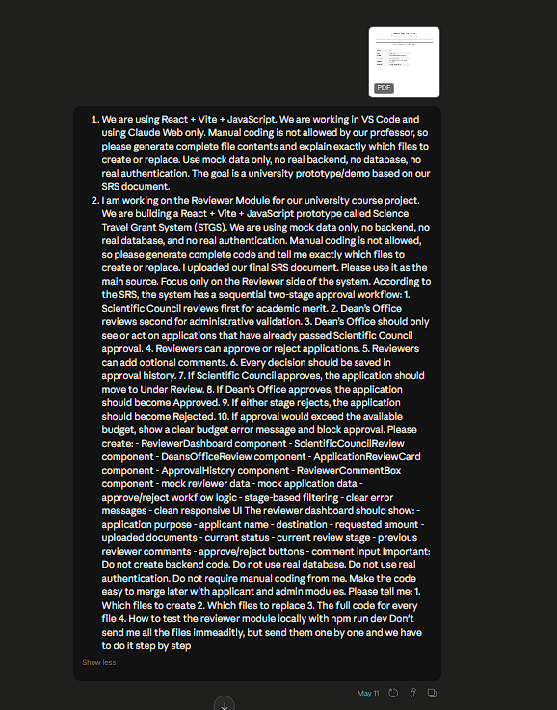
Prompt Screenshot a) Reviewer Module Prompt

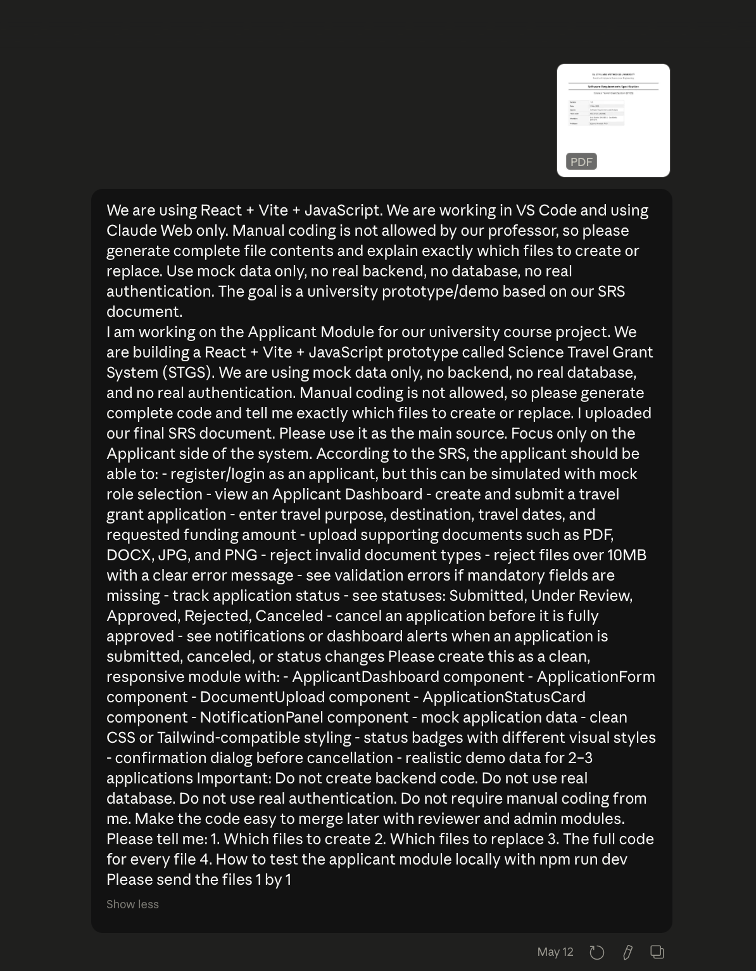
Prompt Screenshot b) Applicant Module Prompt

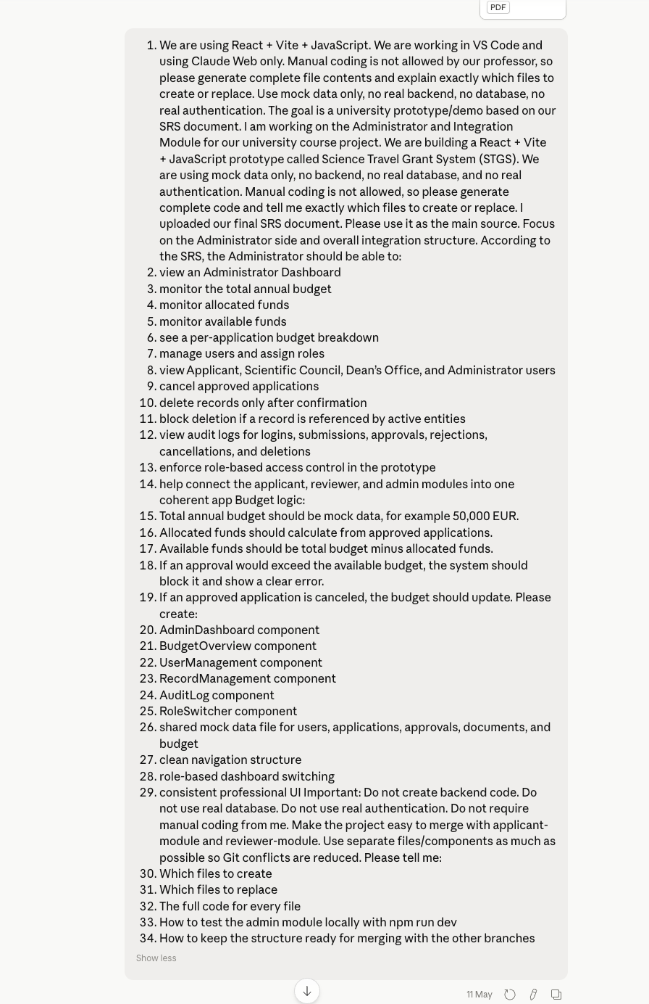
Prompt Screenshot c) Admin Module Prompt
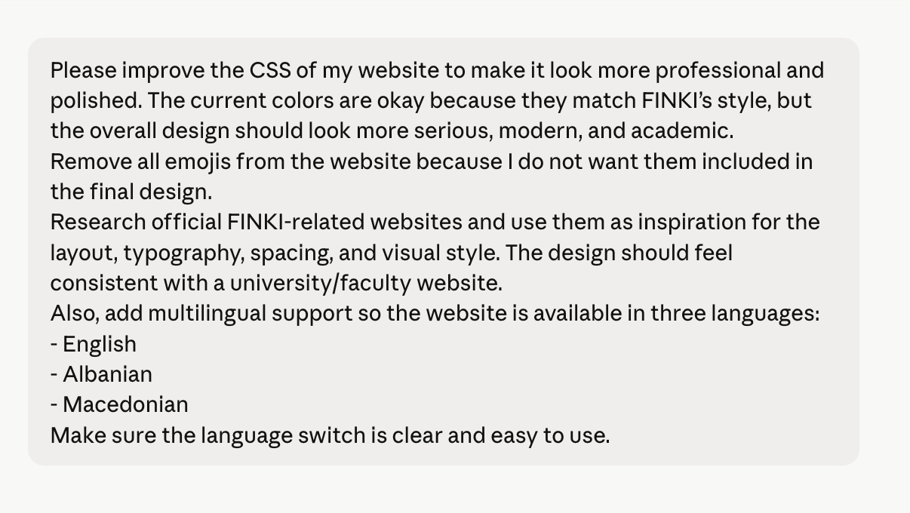
Prompt Screenshot d) Polishing Prompts

B. Screenshots of Claude Response

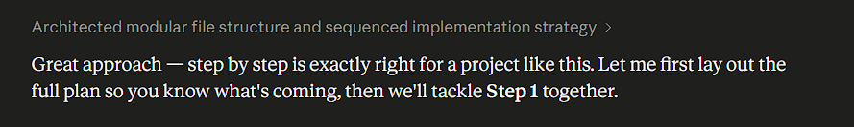
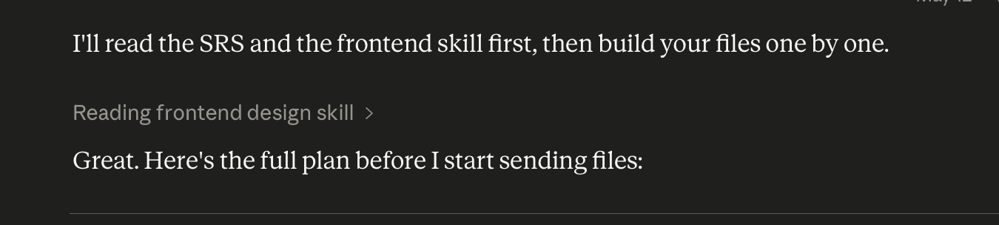

C. Screenshots of UI

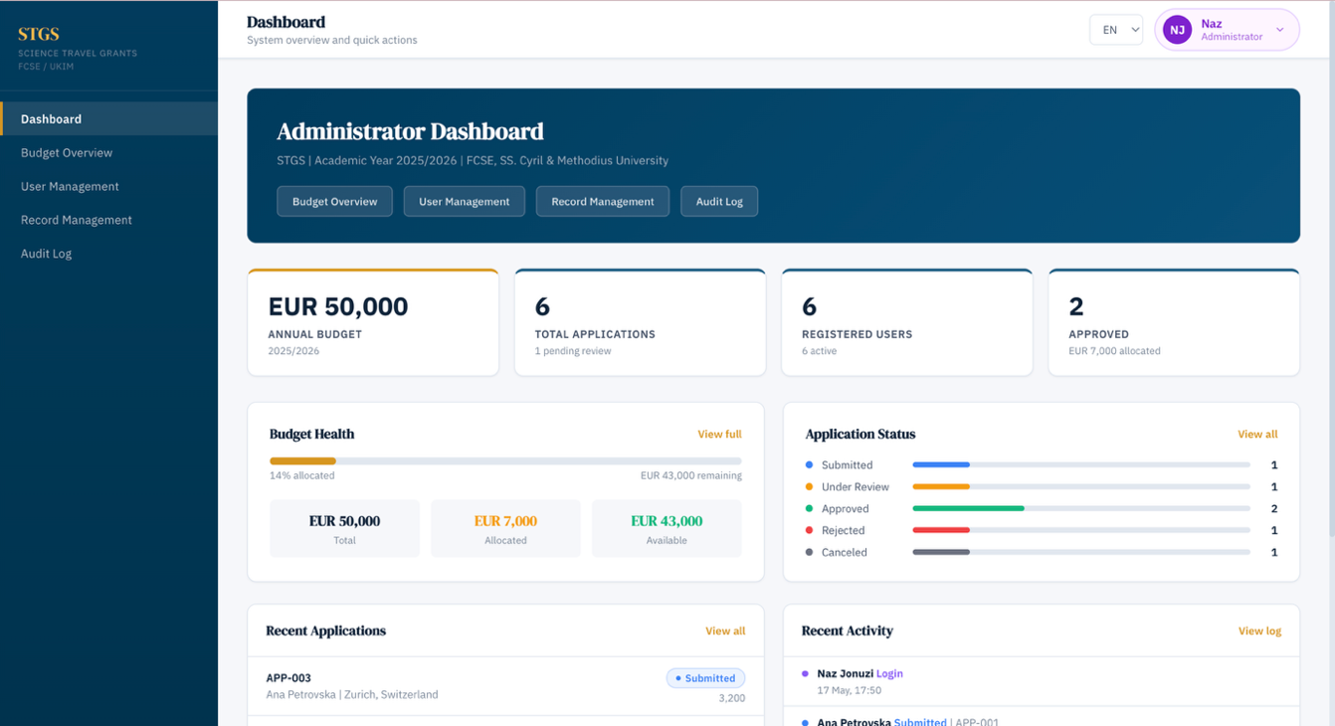
Screenshots of UI a) Administrator Dashboard

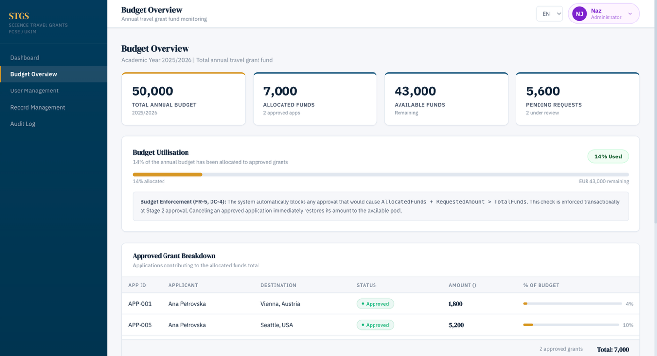
Screenshots of UI b) Budget Overview

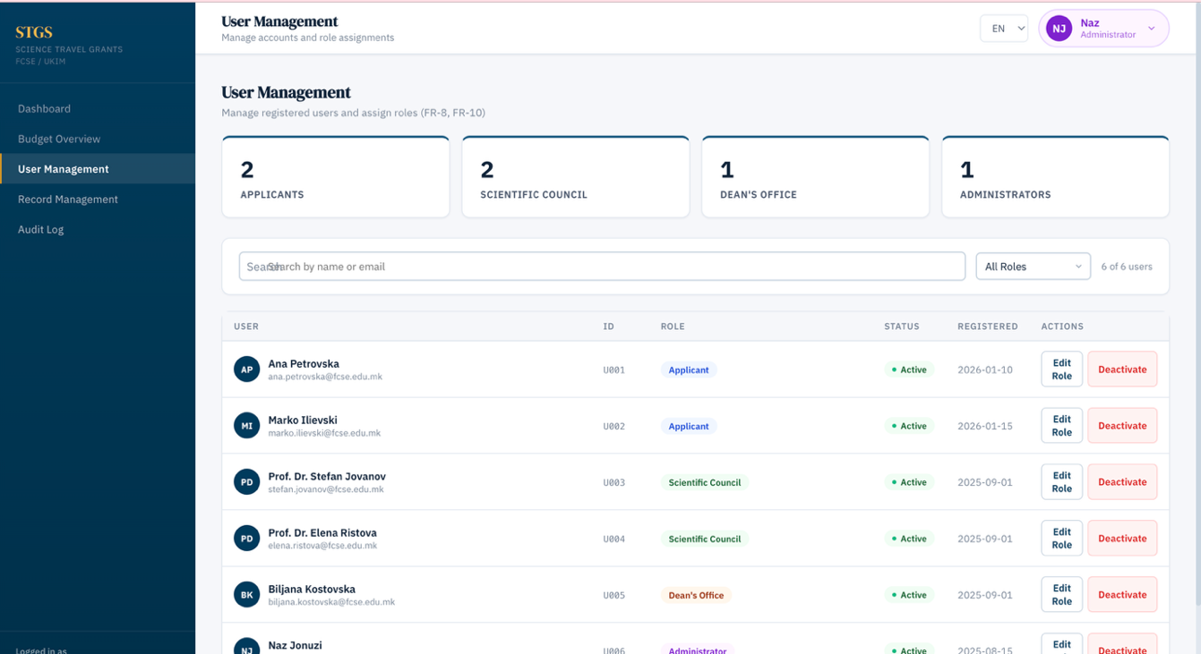
Screenshots of UI c) User Management

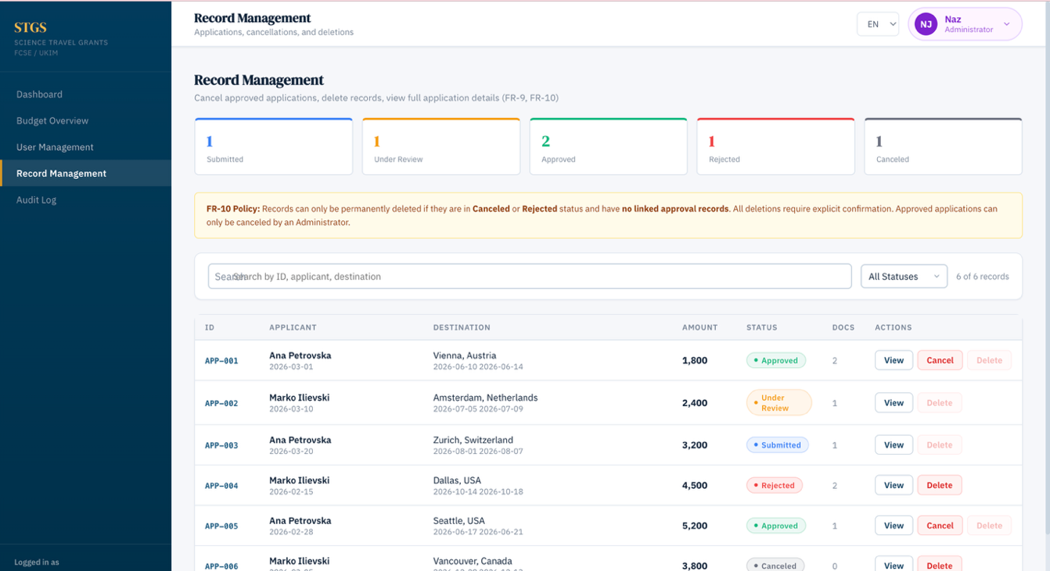
Screenshots of UI d) Record Management

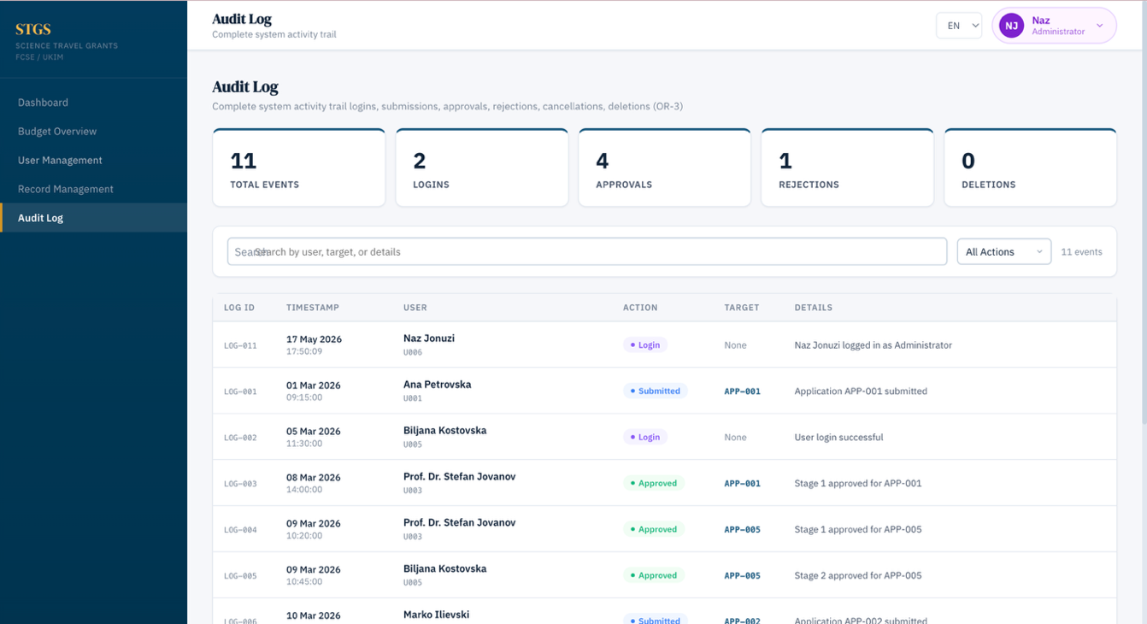
Screenshots of UI e) Audit Log

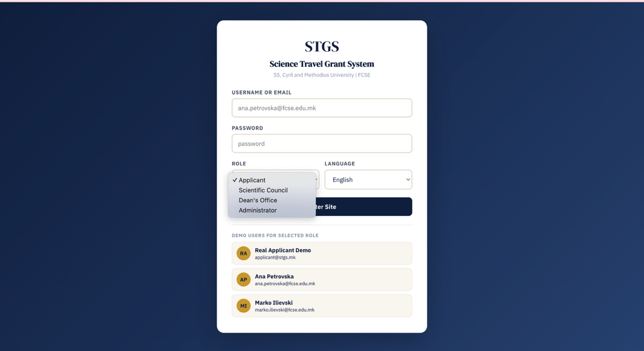
Screenshots of UI f) Log in Page

D. GitHub Branch Screenshot
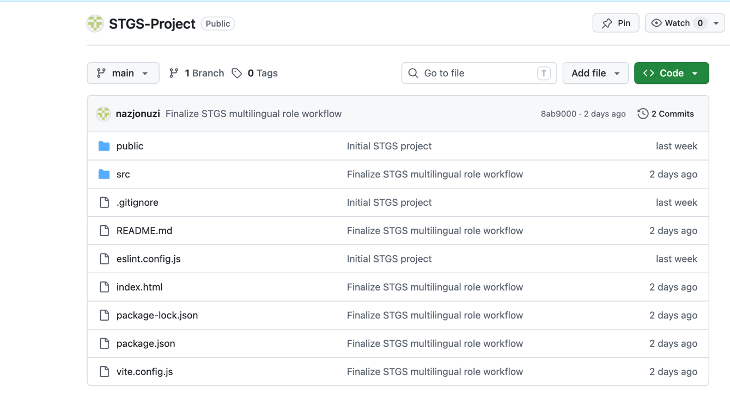

E. Supabase Schema Screenshots

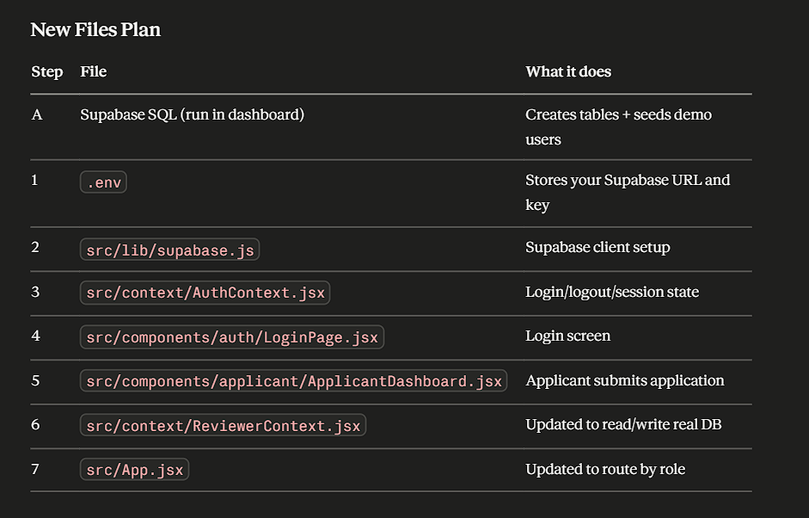
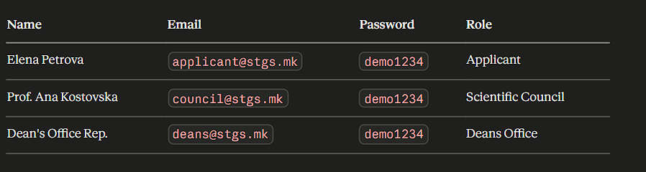

F. Workflow Diagrams

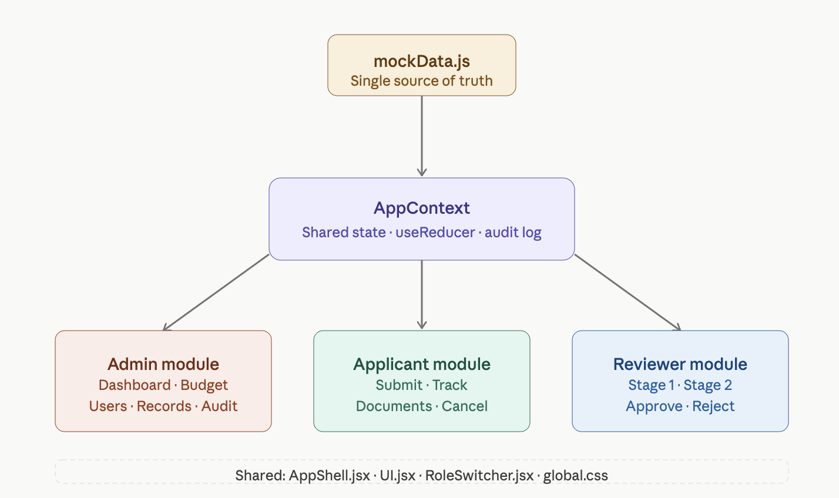

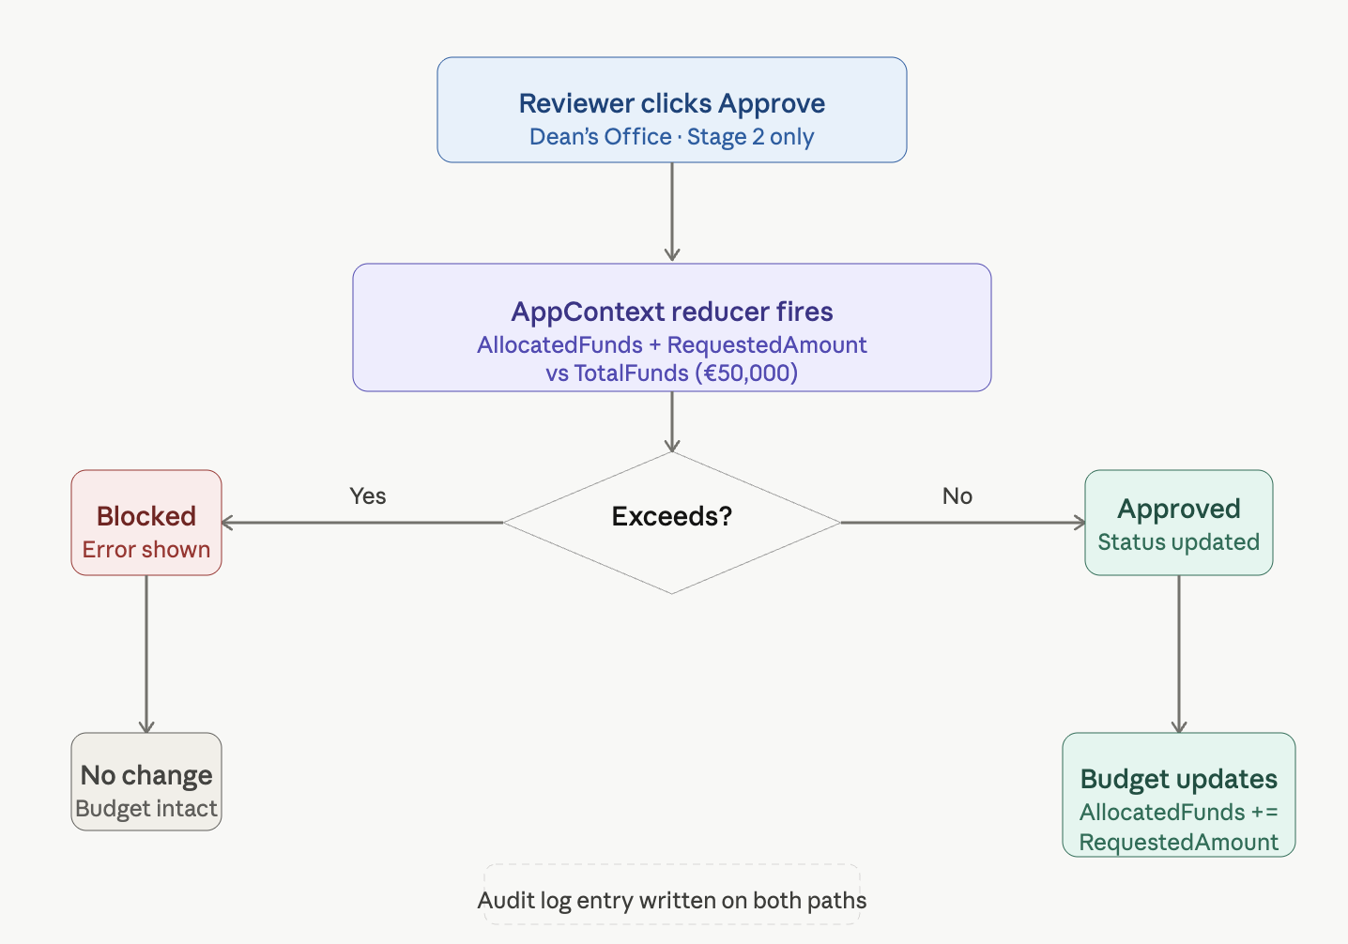

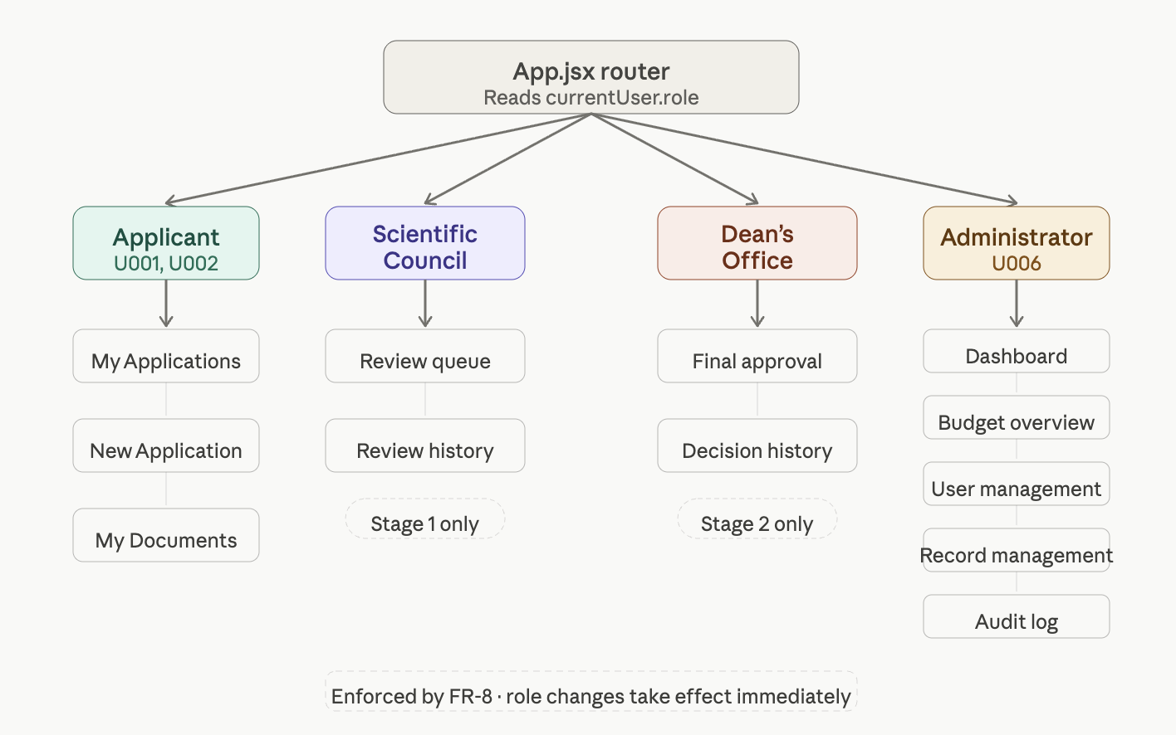

G. Generated File Plan Screenshots

