COVID-19 Case and Death Rates

State of State Name

As of: 2021-12-26

# Introduction

* Data for this report are Collected from [Newyork Times on Github](https://github.com/nytimes)
  + The primary data published here are the daily number of cases and deaths reported in each county of Washington State since the beginning of the pandemic
* This time series data is compiled from state and local governments and health departments in an attempt to provide a complete view of the ongoing outbreak
  + Because of the widespread shortage of testing, however, the data is necessarily limited in the picture it presents of the outbreak

# Table-1: Cases and Deaths

| **County** | **Cases** | **Deaths** | **Population** | **Cases/100K** | **Deaths/100K** |
| --- | --- | --- | --- | --- | --- |
| Adams | 3,003 | 27 | 20,625 | 14,560 | 131 |
| Asotin | 2,507 | 44 | 22,820 | 10,986 | 193 |
| Benton | 29,104 | 330 | 207,500 | 14,026 | 159 |
| Chelan | 10,230 | 96 | 80,630 | 12,688 | 119 |
| Clallam | 4,085 | 46 | 77,160 | 5,294 | 60 |
| Clark | 37,307 | 419 | 506,000 | 7,373 | 83 |
| Columbia | 310 | 6 | 4,192 | 7,395 | 143 |
| Cowlitz | 12,045 | 192 | 111,150 | 10,837 | 173 |
| Douglas | 5,596 | 33 | 44,175 | 12,668 | 75 |
| Ferry | 605 | 11 | 7,955 | 7,605 | 138 |
| Franklin | 19,075 | 162 | 98,130 | 19,438 | 165 |
| Garfield | 206 | 7 | 2,238 | 9,205 | 313 |
| Grant | 15,436 | 154 | 101,265 | 15,243 | 152 |
| Grays Harbor | 7,521 | 105 | 75,085 | 10,017 | 140 |
| Island | 3,412 | 43 | 85,940 | 3,970 | 50 |
| Jefferson | 956 | 12 | 32,320 | 2,958 | 37 |
| King | 151,128 | 1,885 | 2,277,050 | 6,637 | 83 |
| Kitsap | 14,864 | 188 | 273,900 | 5,427 | 69 |
| Kittitas | 4,506 | 48 | 47,770 | 9,433 | 100 |
| Klickitat | 1,630 | 14 | 22,960 | 7,099 | 61 |
| Lewis | 8,888 | 120 | 80,750 | 11,007 | 149 |
| Lincoln | 1,211 | 17 | 11,100 | 10,910 | 153 |
| Mason | 4,843 | 57 | 65,950 | 7,343 | 86 |
| Okanogan | 4,461 | 58 | 43,328 | 10,296 | 134 |
| Pacific | 1,656 | 25 | 21,958 | 7,542 | 114 |
| Pend Oreille | 1,312 | 19 | 13,925 | 9,422 | 136 |
| Pierce | 83,267 | 794 | 908,900 | 9,161 | 87 |
| San Juan | 292 | 0 | 17,420 | 1,676 | 0 |
| Skagit | 9,422 | 97 | 131,125 | 7,186 | 74 |
| Skamania | 652 | 4 | 12,335 | 5,286 | 32 |
| Snohomish | 58,768 | 697 | 837,450 | 7,017 | 83 |
| Spokane | 66,046 | 903 | 525,100 | 12,578 | 172 |
| Stevens | 4,288 | 71 | 46,160 | 9,289 | 154 |
| Thurston | 18,001 | 196 | 293,150 | 6,141 | 67 |
| Wahkiakum | 247 | 5 | 4,242 | 5,823 | 118 |
| Walla Walla | 8,315 | 90 | 62,465 | 13,311 | 144 |
| Whatcom | 14,521 | 134 | 228,350 | 6,359 | 59 |
| Whitman | 5,462 | 59 | 49,240 | 11,093 | 120 |
| Yakima | 42,106 | 536 | 259,750 | 16,210 | 206 |
| Total | 657,284 | 7,704 | 7,711,563 | 8,523 | 100 |

## Fig-1: Cumulative Cases by County

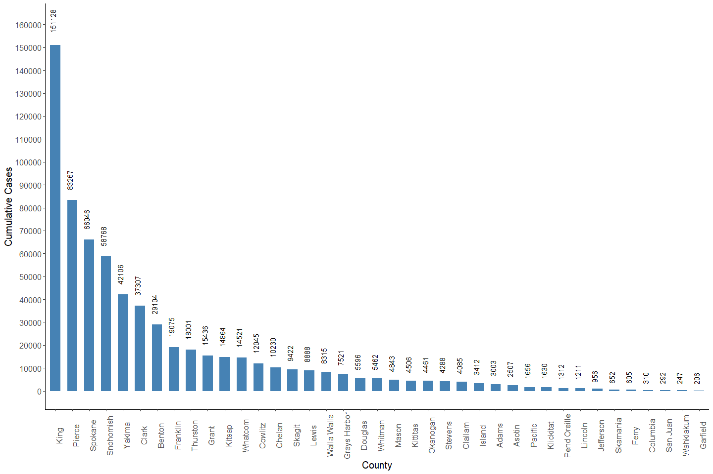

## Fig-2: Cumulative Deaths by County

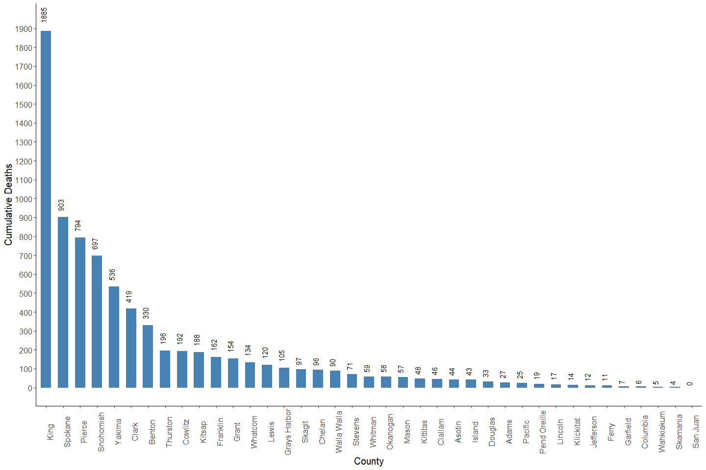

## Fig-3: Cumulative Cases Rate per 100,000 Population by County

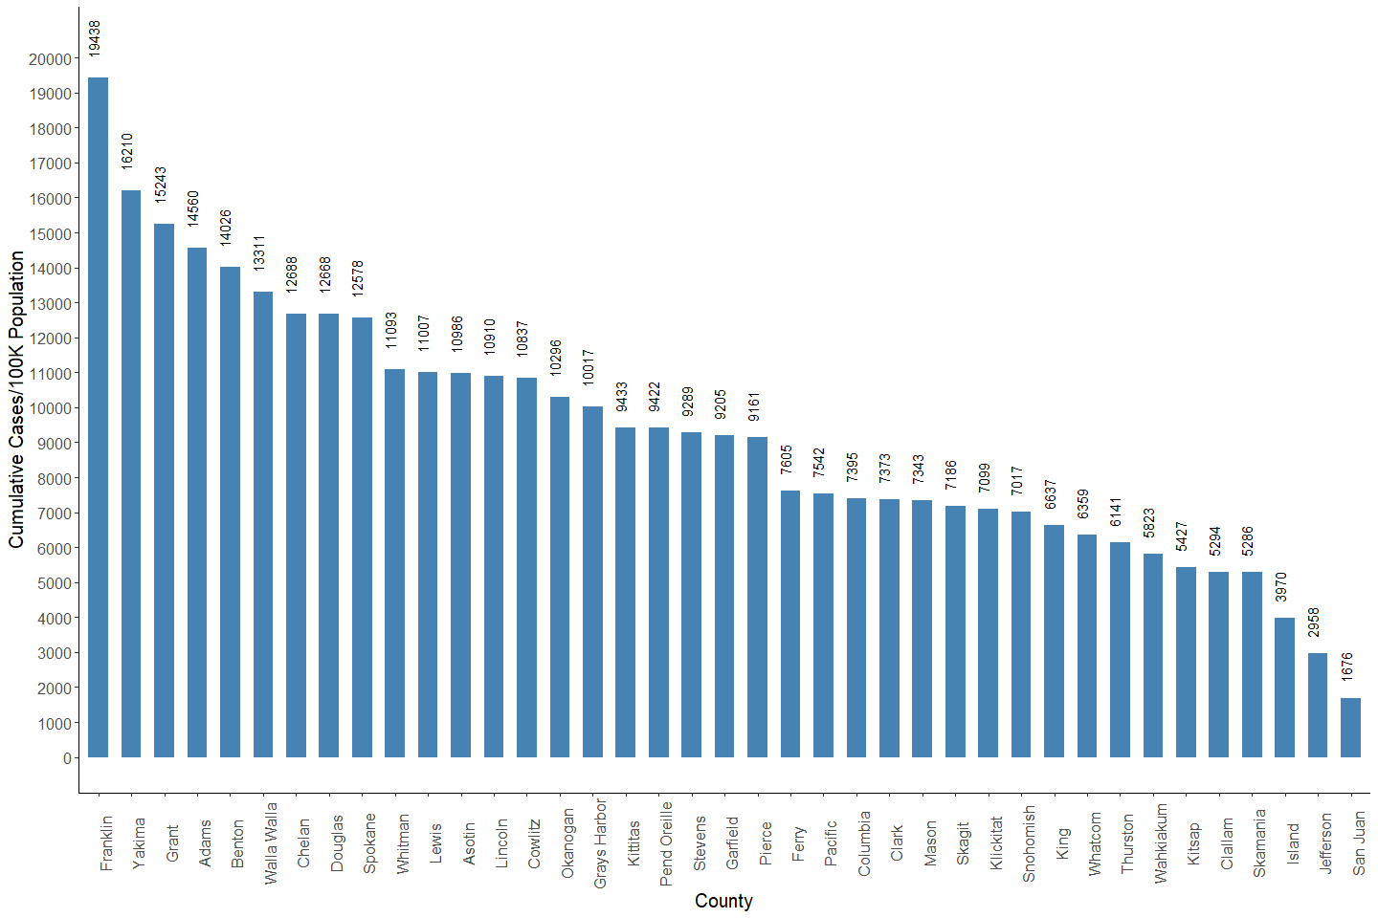

## Fig-4: Cumulative Cases Rate per 100,000 Population by County

